Cell Structure and Transport (Chapter 1) Exam Questions |  | Name: ________________________  Class: ________________________  Date: ________________________
Time: | 104 minutes
Marks: | 104 marks
Comments:

Q1.The diagram shows a cell.
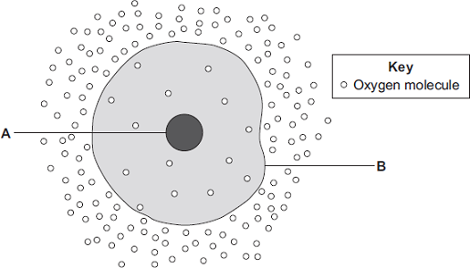
(a) (i) Use words from the box to name the structures labelled A and B .

 | cell membrane | chloroplast | cytoplasm | nucleus

A .......................................................
B .......................................................
(2)

(ii) The cell in the diagram is an animal cell.
How can you tell it is an animal cell and not a plant cell?
Give two reasons.
1 ............................................................................................................
...............................................................................................................
2 ............................................................................................................
...............................................................................................................
(2)

(b) Oxygen will diffuse into the cell in the diagram.
Why?
Use information from the diagram.
........................................................................................................................
........................................................................................................................
(1)

(c) The cell shown in the diagram is usually found with similar cells.
Draw a ring around the correct answer to complete the sentence.

 |  | an organ.
 | Scientists call a group of similar cells | a system.
 |  | a tissue.

(1)
(Total 6 marks)

Q2.The image below shows some cells in the lining of the stomach.
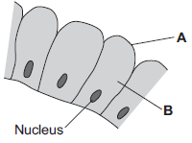

(a) (i) Use words from the box to name structures A and B.

 | cell membrane | chloroplast | cytoplasm | vacuole

A ..........................................................................
B ..........................................................................
(2)

(ii) What is the function of the nucleus?
Tick () one box.

To control the activities of the cell
To control movement of substances into and out of the cell
To release energy in respiration

(1)

(b) Draw one line from each part of the human body to its correct scientific name.

 | Part of human body |  | Scientific name
 |  |  | An organ
 | Layer of cells lining the stomach
 |  |  | An organism
 | Stomach
 |  |  | An organ system
Mouth, stomach, intestines,
liver and pancreas
 |  |  | A tissue

(3)
(Total 6 marks)

Q3.The diagrams show four types of cell, A, B, C and D.
Two of the cells are plant cells and two are animal cells.
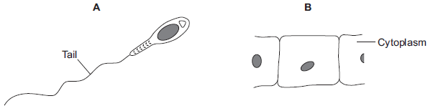
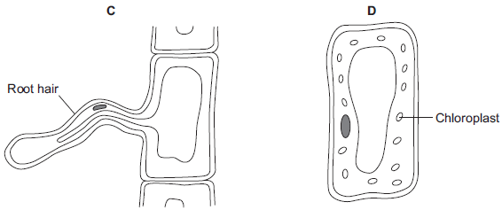
(a) (i) Which two of the cells are plant cells?
Tick () one box.
A and B
A and D
C and D
(1)

(ii) Give one reason for your answer.
...............................................................................................................
...............................................................................................................
(1)

(b) (i) Which cell, A, B, C or D, is adapted for swimming?
(1)

(ii) Which cell, A, B, C or D, can produce glucose by photosynthesis?
(1)

(c) Cells A, B, C and D all use oxygen.
For what process do cells use oxygen?
Draw a ring around one answer.

 | osmosis | photosynthesis | respiration

(1)
(Total 5 marks)

﻿
Q4. Diagram 1 shows a cell from a leaf.
Diagram 1
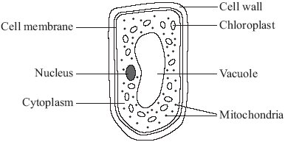

(a) How is the leaf cell specialised to carry out photosynthesis?
Tick () one box.

It has a permanent vacuole.
It has many chloroplasts.
It has cytoplasm.
It has many mitochondria.

(1)

(b) Diagram 2 shows another type of plant cell.
Diagram 2
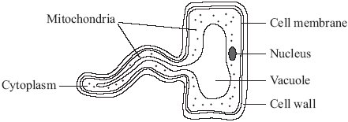
Give two ways in which this cell is different from an animal cell.
1 ..................................................................................................................................
.....................................................................................................................................
2 ..................................................................................................................................
.....................................................................................................................................
(2)
(Total 3 marks)

Q5. The diagram shows a group of muscle cells from the wall of the intestine.
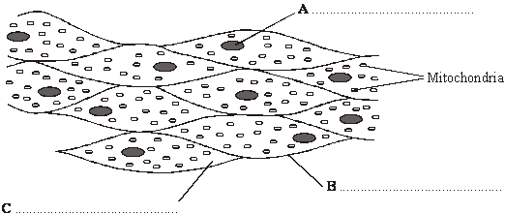

(a) On the diagram, use words from the box to name the structures labelled A, B and C.

cell membrane cell wall chloroplast cytoplasm nucleus

(3)

(b) How are these muscle cells adapted to release a lot of energy?
.....................................................................................................................................
.....................................................................................................................................
.....................................................................................................................................
(2)
(Total 5 marks)

Q6. The drawing shows the cell of a bacterium.
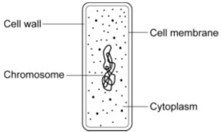

(a) List A gives the four structures labelled on the diagram.
List B includes information about each structure.
Draw one line from each structure in List A to the correct information about the structure in List B.
List A List B
Structure Information
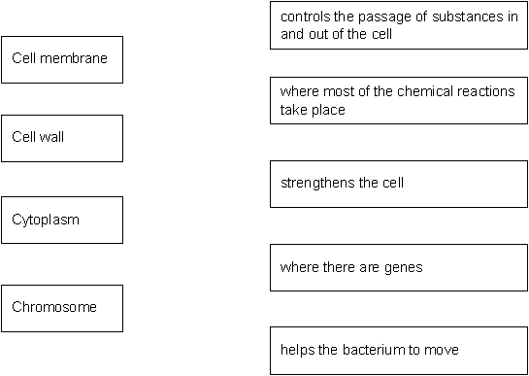
(4)

(b) Give two differences between an animal cell and the cell of a bacterium.
1 .....................................................................................................................
2 .....................................................................................................................
(2)

(c) The diagrams show cells containing and surrounded by oxygen molecules.
Oxygen can move into cells or out of cells.
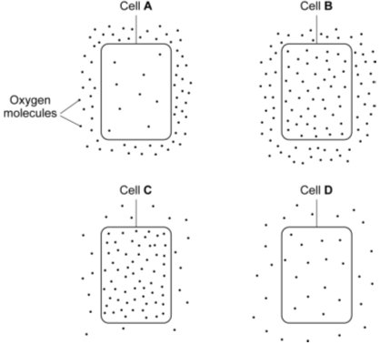

Into which cell, A, B, C or D, will oxygen move the fastest?
Write the correct letter, A, B, C or D, in the box.
(1)

(d) Complete the following sentence.
Oxygen is taken into the cell by the process of .............................................
(1)
(Total 8 marks)

Q7.The diagrams show an animal cell and a bacterial cell.
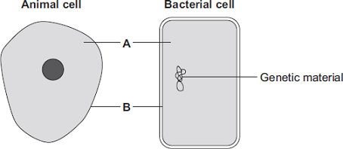
(a) (i) Structures A and B are found in both the animal cell and the bacterial cell.
Use words from the box to name structures A and B.

cell membrane | chloroplast | cytoplasm | vacuole

A ............................................................
B ............................................................

(2)

(ii) Both cells contain genetic material.
Name the structure in the animal cell that contains genetic material.
............................................................
(1)

(b) List A gives three structures found in animal cells.
List B gives four functions of cell structures.
Draw one line from each structure in List A to its correct function in List B.

List A – Structure |  | List B – Function
Controls what substances
enter the cell
Cell membrane
 |  | Photosynthesis
Mitochondrion
 |  | Protein synthesis
Ribosome
 |  | Respiration

(3)
(Total 6 marks)

Q8.Plant roots absorb water from the soil by osmosis.
(a) What is osmosis?
........................................................................................................................
........................................................................................................................
........................................................................................................................
........................................................................................................................
........................................................................................................................
........................................................................................................................
(3)

(b) The image below shows part of a plant root.
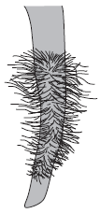

The plant root is adapted for absorbing water from the soil.
Use information from the diagram to explain how this plant root is adapted for absorbing water.
........................................................................................................................
........................................................................................................................
........................................................................................................................
........................................................................................................................
........................................................................................................................
........................................................................................................................
(3)
(Total 6 marks)

Q9. The diagram shows a plant cell from a leaf.
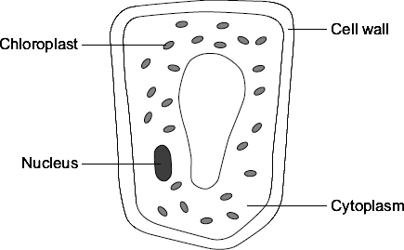
(a) List A gives the names of three parts of the cell.List B gives the functions of parts of the cell.
Draw a line from each part of the cell in List A to its function in List B.

List A  Parts of the cell |  | List B  Functions
Where most of the chemical
reactions take place
Nucleus
 |  | Absorbs light energy to make food
Cytoplasm
 |  | Strengthens the cell
Chloroplast
 |  | Controls the activities of the cell

(3)

(b) Respiration takes place in the cell.
Draw a ring around the correct answer to complete the sentence.

 | energy
All cells use respiration to release | oxygen.
 | sugar.

(1)
(Total 4 marks)

Q10. The diagram shows a human sperm. Inside the tail of the sperm is a filament mechanism that causes the side to side movement of the tail, which moves the sperm.
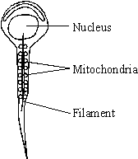

(a) Describe the function of the mitochondria and suggest a reason why they are arranged around the filament near the tail of the sperm.
.....................................................................................................................................
.....................................................................................................................................
.....................................................................................................................................
.....................................................................................................................................
(3)

(b) Explain the significance of the nucleus in determining the characteristics of the offspring.
.....................................................................................................................................
.....................................................................................................................................
.....................................................................................................................................
(2)
(Total 5 marks)

Q11. The drawing shows part of a root hair cell.
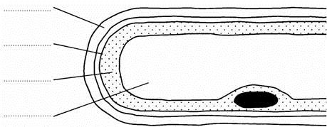

(a) Use words from the list to label the parts of the root hair cell.
cell membrane cell wall cytoplasm nucleus vacuole
(4)

(b) The diagram shows four ways in which molecules may move into and out of a cell. The dots show the concentration of molecules.
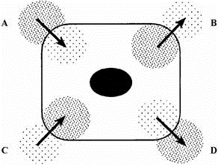

The cell is respiring aerobically.
Which arrow, A, B, C or D represents:
(i) movement of oxygen molecules; ....................
(ii) movement of carbon dioxide molecules? ....................
(2)

(c) Name the process by which these gases move into and out of the cell.
.....................................................................................................................................
(1)
(Total 7 marks)

Q12.The image below shows some muscle cells from the wall of the stomach, as seen through a light microscope.
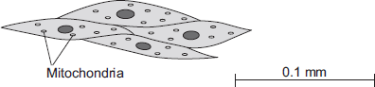
(a) Describe the function of muscle cells in the wall of the stomach.
........................................................................................................................
........................................................................................................................
........................................................................................................................
........................................................................................................................
(2)

(b) The image above is highly magnified.
The scale bar in the image above represents 0.1 mm.
Use a ruler to measure the length of the scale bar and then calculate the magnification of the image.
........................................................................................................................
........................................................................................................................
........................................................................................................................
........................................................................................................................
Magnification = ............................. times
(2)

(c) The muscle cells in the image contain many mitochondria.
What is the function of mitochondria?
........................................................................................................................
........................................................................................................................
........................................................................................................................
........................................................................................................................
(2)

(d) The muscle cells also contain many ribosomes. The ribosomes cannot be seen in Figure above.
(i) What is the function of a ribosome?
...............................................................................................................
...............................................................................................................
(1)

(ii) Suggest why the ribosomes cannot be seen through a light microscope.
...............................................................................................................
...............................................................................................................
(1)
(Total 8 marks)

Q13.Diagrams A, B and C show cells from different parts of the human body, all drawn to the same scale.
A B C
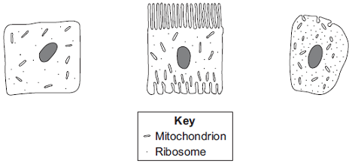
(a) Which cell, A, B or C, appears to be best adapted to increase diffusion into or out of the cell?
Give one reason for your choice.
........................................................................................................................
........................................................................................................................
(1)

(b) (i) Cell C is found in the salivary glands.
Name the enzyme produced by the salivary glands.
...............................................................................................................
(1)

(ii) Use information from the diagram to explain how cell C is adapted for producing this enzyme.
...............................................................................................................
...............................................................................................................
...............................................................................................................
...............................................................................................................
(2)
(Total 4 marks)

Q14.The photographs show the same cells of a common pond plant.
Photograph A shows the cells in a hypotonic solution.
Photograph B shows the same cells in a hypertonic solution.

Photograph A Photograph B
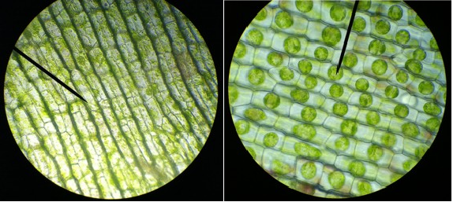
A & B AELODEA IN HYPOTONIC SOLUTION by fickleandfreckled [CC- BY-2.0], via Flickr.

(a) What is a hypertonic solution?
........................................................................................................................
........................................................................................................................
........................................................................................................................
........................................................................................................................
(2)

(b) What word is used to describe plant cells placed in:
(i) a hypotonic solution
...............................................................................................................
(1)

(ii) a hypertonic solution?
...............................................................................................................
(1)

(c) Explain what has happened to the plant cells in Photograph B.
........................................................................................................................
........................................................................................................................
........................................................................................................................
........................................................................................................................
........................................................................................................................
........................................................................................................................
........................................................................................................................
........................................................................................................................
(4)

(d) Animal cells will also change when placed in different solutions.
Some red blood cells are put in a hypotonic solution.
Describe what would happen to these red blood cells and explain why this is different from what happened to the plant cells in Photograph A.
........................................................................................................................
........................................................................................................................
........................................................................................................................
........................................................................................................................
........................................................................................................................
........................................................................................................................
........................................................................................................................
........................................................................................................................
........................................................................................................................
........................................................................................................................
(4)
(Total 12 marks)

Q15.The diagram below shows a single-celled alga which lives in fresh water.
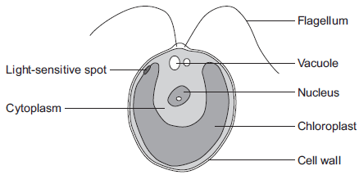

(a) Which part of the cell labelled above:
(i) traps light for photosynthesis
...............................................................................................................
(1)

(ii) is made of cellulose?
...............................................................................................................
(1)

(b) In the freshwater environment water enters the algal cell.
(i) What is the name of the process by which water moves into cells?
...............................................................................................................
(1)

(ii) Give the reason why the algal cell does not burst.
...............................................................................................................
...............................................................................................................
(1)

(c) (i) The alga can photosynthesise.
Complete the word equation for photosynthesis.
water + .............................. 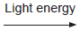 ............................... + oxygen
(2)

(ii) The flagellum helps the cell to move through water. Scientists think that the flagellum and the light-sensitive spot work together to increase photosynthesis.
Suggest how this might happen.
...............................................................................................................
...............................................................................................................
...............................................................................................................
...............................................................................................................
(2)

(d) Multicellular organisms often have complex structures, such as lungs, for gas exchange.
Explain why single-celled organisms, like algae, do not need complex structures for gas exchange.
........................................................................................................................
........................................................................................................................
........................................................................................................................
........................................................................................................................
........................................................................................................................
........................................................................................................................
(3)
(Total 11 marks)

Q16.The image below shows an epithelial cell from the lining of the small intestine.
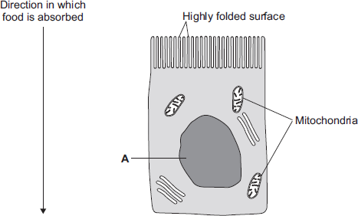
(a) (i) In the image above, the part of the cell labelled A contains chromosomes.
What is the name of part A?
...............................................................................................................
(1)

(ii) How are most soluble food molecules absorbed into the epithelial cells of the small intestine?
Draw a ring around the correct answer.

 | diffusion | osmosis | respiration

(1)

(b) Suggest how the highly folded cell surface helps the epithelial cell to absorb soluble food.
........................................................................................................................
........................................................................................................................
(1)

(c) Epithelial cells also carry out active transport.
(i) Name one food molecule absorbed into epithelial cells by active transport.
...............................................................................................................
(1)

(ii) Why is it necessary to absorb some food molecules by active transport?
...............................................................................................................
...............................................................................................................
(1)

(ii) Suggest why epithelial cells have many mitochondria.
...............................................................................................................
...............................................................................................................
...............................................................................................................
...............................................................................................................
(2)

(d) Some plants also carry out active transport.
Give one substance that plants absorb by active transport.
........................................................................................................................
(1)
(Total 8 marks)

Q17. Substances can move into and out of cells.
(a) (i) How does oxygen move into and out of cells?
Draw a ring around one answer.

 | diffusion | digestion | photosynthesis

(1)

(ii) Diagram 1 shows the percentage concentration of oxygen in three cells, A, B and C.
Diagram 1
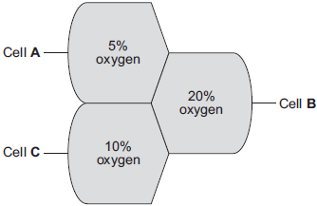
Oxygen can move from cell to cell.
Into which cell, A, B or C, will oxygen move the fastest?
(1)

(b) (i) How does water move into and out of cells?
Draw a ring around one answer.

 | breathing | osmosis | respiration

(1)

(ii) Differences in the concentration of sugars in cells cause water to move into or out of cells at different rates.
Diagram 2 shows three different cells, P, Q and R.
The information shows the percentage concentration of sugar solution
in cells P, Q and R.
Diagram 2
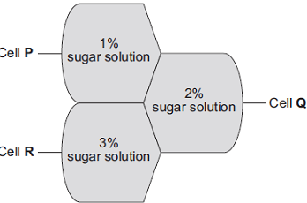
Water can move from cell to cell.
Into which cell, P, Q or R, will water move the fastest?
(1)
(Total 4 marks)

Q18. The photographs show the same cells of a common pond plant.
Photograph A shows the cells in a hypotonic solution.
Photograph B shows the same cells in a hypertonic solution.

Photograph A Photograph B
A & B AELODEA IN HYPOTONIC SOLUTION by fickleandfreckled [CC- BY-2.0], via Flickr.

(a) What is a hypertonic solution?
........................................................................................................................
........................................................................................................................
........................................................................................................................
........................................................................................................................
(2)

(b) What word is used to describe plant cells placed in:
(i) a hypotonic solution
...............................................................................................................
(1)

(ii) a hypertonic solution?
...............................................................................................................
(1)

(c) Explain what has happened to the plant cells in Photograph B.
........................................................................................................................
........................................................................................................................
........................................................................................................................
........................................................................................................................
........................................................................................................................
........................................................................................................................
........................................................................................................................
........................................................................................................................
(4)

(d) Animal cells will also change when placed in different solutions.
Some red blood cells are put in a hypotonic solution.
Describe what would happen to these red blood cells and explain why this is different from what happened to the plant cells in Photograph A.
........................................................................................................................
........................................................................................................................
........................................................................................................................
........................................................................................................................
........................................................................................................................
........................................................................................................................
........................................................................................................................
........................................................................................................................
........................................................................................................................
........................................................................................................................
(4)
(Total 12 marks)

Q19. In this question you will be assessed on using good English, organising information clearly and using specialist terms where appropriate.
Diffusion is an important process in animals and plants.
The movement of many substances into and out of cells occurs by diffusion.
Describe why diffusion is important to animals and plants.

In your answer you should refer to:
• animals
• plants
• examples of the diffusion of named substances.
......................................................................................................................................
......................................................................................................................................
......................................................................................................................................
......................................................................................................................................
......................................................................................................................................
......................................................................................................................................
......................................................................................................................................
......................................................................................................................................
......................................................................................................................................
......................................................................................................................................
......................................................................................................................................
......................................................................................................................................

Extra space ..................................................................................................................
......................................................................................................................................
......................................................................................................................................
......................................................................................................................................
......................................................................................................................................
......................................................................................................................................
......................................................................................................................................
(Total 6 marks)

Q20. Some substances move through membranes.
A student set up an investigation.
The student:
• tied a thin membrane across the end of a funnel
• put concentrated sugar solution in the funnel
• put the funnel in a beaker of water
• measured the level of the solution in the funnel every 30 minutes.
The diagram shows the apparatus.
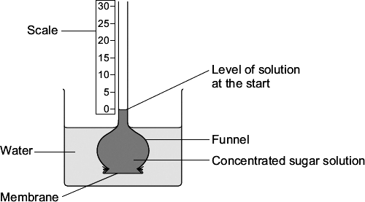
The graph shows the results.
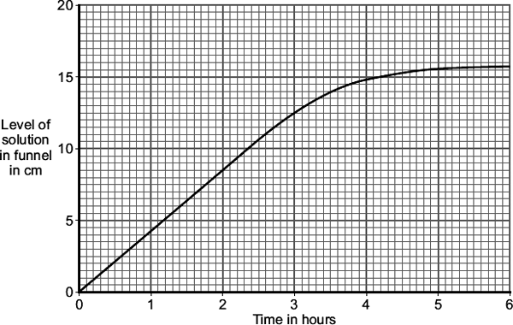
(a) After 3 hours, the level of the solution in the funnel is different from the level at the start.
Explain why, as fully as you can.
........................................................................................................................
........................................................................................................................
........................................................................................................................
........................................................................................................................
........................................................................................................................
........................................................................................................................
(3)

(b) The student repeated the investigation using dilute sugar solution instead of concentrated sugar solution.
In what way would you expect the results using dilute sugar solution to be different from the results using concentrated sugar solution?
Give the reason for your answer.
........................................................................................................................
........................................................................................................................
........................................................................................................................
........................................................................................................................
(2)
(Total 5 marks)

Q21. Substances can move into cells and out of cells.
(a) Draw a ring around the correct answer to complete each sentence.

 | Water moves into cells and out of cells by | active transport.  osmosis.  reabsorption.

 |  | freely permeable
 | The water moves through a | non-permeable | membrane.
 |  | partially permeable

(2)

(b) Students put plant cells into two different strengths of sugar solutions, A and B.
The diagram below shows what the cells looked like after 1 hour.
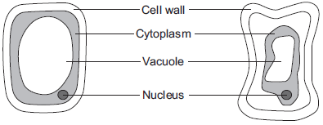
 | Cell in  sugar solution A  (after 1 hour) |  | Cell in  sugar solution B  (after 1 hour)

(i) Describe two ways in which the cell in sugar solution B is different from the cell in sugar solution A.
1 ............................................................................................................
...............................................................................................................
2 ............................................................................................................
...............................................................................................................
(2)

(ii) A student put red blood cells into water.
Suggest what would happen to the cells.
...............................................................................................................
...............................................................................................................
...............................................................................................................
(1)

(c) In the human body, glucose is absorbed into the blood from the small intestine.
The small intestine contains many villi.
Which two of the following help the absorption of glucose in the small intestine?

Tick () two boxes.
Villi have a cell wall.
Villi are covered in thick mucus.
Villi give the small intestine a large surface area.
Villi have many blood capillaries.

(2)
(Total 7 marks)

Q22. Drinking after exercise to replace the water lost in sweat is called rehydration.
Scientists at a Spanish university investigated rehydration after exercise.
• 24 students took part in the investigation.
• All the students ran on a treadmill in a temperature of 40 °C until they were
exhausted.
• 12 of the students were each given half a litre of beer to drink.
• The other 12 students were each given half a litre of tap water to drink.
• Both groups of students were then allowed to drink as much tap water as they
wanted.
• The scientists measured how quickly each student rehydrated.
• The students who had been given beer rehydrated ‘slightly better’ than the ones
given only water.
A newspaper reported the investigation.
The headline was
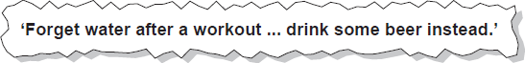
The newspaper headline was not justified.
Explain why.
.................................................................................................................................
.................................................................................................................................
.................................................................................................................................
.................................................................................................................................
.................................................................................................................................
.................................................................................................................................
.................................................................................................................................
.................................................................................................................................
(Total 3 marks)

Q7. In fish and chip shops, potatoes are cut into chips several hours before they are cooked.
The mass of water in the chips must be kept constant during this time.
To keep the water in the chips constant, the chips are kept in sodium chloride solution.
(a) The drawing shows some apparatus and materials.
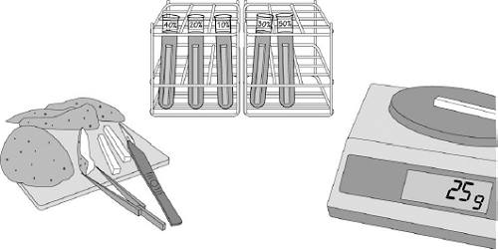

In this question you will be assessed on using good English, organising information clearly and using scientific terms where appropriate.
Describe how you would use the apparatus and materials shown in the drawing to find the concentration of sodium chloride in which to keep the chips so that the mass of water in the chips remains constant.

You should include:
• the measurements you would make
• how you would make the investigation a fair test.
........................................................................................................................
........................................................................................................................
........................................................................................................................
........................................................................................................................
........................................................................................................................
........................................................................................................................
........................................................................................................................
........................................................................................................................
........................................................................................................................
........................................................................................................................
........................................................................................................................
........................................................................................................................
........................................................................................................................
........................................................................................................................
(6)

(b) In a similar investigation a student investigated the effect of the concentration of sodium chloride solution on standard-sized cylinders cut from a potato.
The table shows the student’s results.

Concentration of sodium chloride solution
in mol dm ^{–3}
 |  | 0 | 0.2 | 0.4 | 0.6 | 0.8 | 1.0
 | Change in length  of cylinders in mm | +4.1 | +1.5 | –1.4 | –3.6 | –4.6 | –5.2

(i) On the graph paper below draw a graph to display the student's results.
• Add a suitable scale and label to the y axis.
• Plot the student’s results.
• Draw a line of best fit.
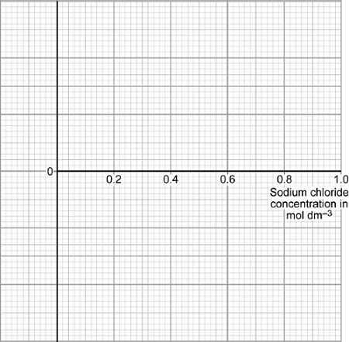
(4)

(ii) In which concentration of sodium chloride would the chips not change mass?
...............................................................................................................
Concentration ........................... . mol dm^{–3}
(1)

(iii) Explain the change in length of potato cylinders that were placed in the 1 mol dm^{–3} sodium chloride solution.
...............................................................................................................
...............................................................................................................
...............................................................................................................
...............................................................................................................
...............................................................................................................
...............................................................................................................
(3)
(Total 14 marks)

