M1.(a) (i) A = nucleus
1

B = (cell) membrane
1

(ii) any two from:
ignore shape
• no (cell) wall
• no (large / permanent) vacuole
• no chloroplasts / chlorophyll
2

(b) because high to low oxygen / concentration or down gradient
allow ‘more / a lot of oxygen molecules outside’
ignore along / across gradient
1

(c) a tissue
1
[6]

M2.(a) (i) A = (cell) membrane
1

B = cytoplasm
do not accept cytoplast
1

(ii) To control the activities of the cell
1

(b)
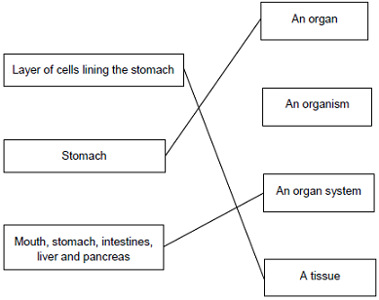
extra lines cancel
3
[6]

M3.(a) (i) C and D
no mark if more than one box is ticked
1

(ii) any one from:
do not allow if other cell parts are given in a list
• (have) cell wall(s)
• (have) vacuole(s)
1

(b) (i) A
apply list principle
1

(ii) D
apply list principle
1

(c) respiration
apply list principle
1
[5]

M4. (a) it has many chloroplasts.
1
(b) (has) cell wall
1
(has) vacuole or large / permanent vacuole
do not allow chloroplasts
assume plant cell throughout
accept converse for animal cell
1
[3]

M5. (a) A nucleus
1
B (cell) membrane
1
C cytoplasm
1

(b) any two from:
• (contain mitochondria
• many (mitochondria)
• respiration (occurs in mitochondria)
2
[5]

M6. (a)
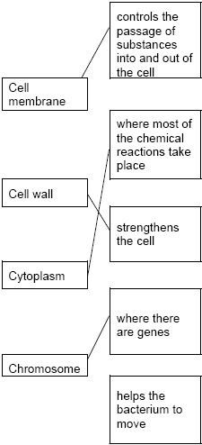

all four correct = 4 marks
three correct = 3 marks
two correct = 2 marks
one correct = 1 mark
extra line from a statement cancels the mark
4

(b) any two from:
• nucleus
• no cell wall
• separate chromosomes
2

(c) A
1

(d) diffusion
1
[8]

M7.(a) (i) A = cytoplasm
1

B = (cell) membrane
1

(ii) nucleus
accept chromosome / DNA / genes
accept phonetic
1

(b)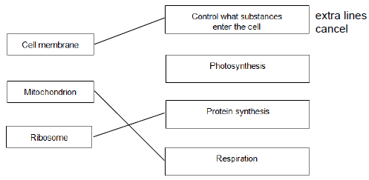
3
[6]

M8.(a) any three from:
• (water through a) partially permeable
accept ‘semi permeable’ / selectively permeable

• membrane
• from dilute to (more) concentrated solution
allow ‘from a high concentration of water to a lower concentration (of water)’
allow ‘from high water potential to low water potential’
allow ‘down a concentration gradient of water’
do not accept ‘along a concentration gradient of water’
• (it‘s a) passive (process)
allow requires no energy
3

(b) (there are) many hairs or thin hairs or hairs are one cell thick
1
(which gives) large / increased surface area or short diffusion pathway
1
(so there is) more diffusion / osmosis (of water into the root)
ignore absorption
1
[6]

M9. (a) 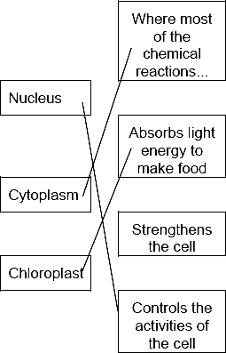
1 mark for each correct line
mark each line from left hand box
two lines from left hand box cancels mark for that box
3

(b) energy
1
[4]

M10. (a) award one mark for each key idea
energy released or energy transferred or respiration
allow provides or gives
do not allow produces or makes
3

near to the site of movement or
energy available quickly or more
energy
accept allows more mitochondria to fit in
(mitochondria) packed (around
filament) or efficient arrangement or
spiral arrangement

(b) contains chromosomes or genes or
DNA
not genetic material
1

(which) contribute half (the genes) to
the fetus or offspring
23 chromosomes or half the genes
or reference to X,Y chromosome determining sex (if the notion of halfness is there)
nucleus contains half genes for the offspring = 2 marks
1
[5]

M11. (a) (cell) wall
(cell) membrane
cytoplasm
vacuole
for 1 mark each
4

(b) (i) A
(ii) B
for 1 mark each
2

(c) diffusion (reject osmosis)
for 1 mark
1
[7]

M12.(a) contract / shorten
ignore relax
do not allow expand
1

to churn / move / mix food
accept peristalsis / mechanical digestion
ignore movement unqualified
1

(b) 400
acceptable range 390-410
allow 1 mark for answer in range of 39 to 41
allow 1 mark for answer in range of 3900 to 4100
2

(c) to transfer energy for use
allow to release / give / supply / provide energy
do not allow to ‘make’ / ߢproduce’ / ‘create’ energy
allow to make ATP
ignore to store energy
1

by (aerobic) respiration or from glucose
do not allow anaerobic
energy released for respiration = max 1 mark
1

(d) (i) to make protein / enzyme
ignore ‘antibody’ or other named protein
1

(ii) too small / very small
allow light microscope does not have sufficient magnification / resolution
allow ribosomes are smaller than mitochondria
ignore not sensitive enough
ignore ribosomes are transparent
1
[8]

M13.(a) B
no mark for “B” alone, the mark is for B and the explanation.
large(r) surface / area or large(r) membrane
accept reference to microvilli
ignore villi / hairs / cilia
accept reasonable descriptions of the surface eg folded membrane / surface
do not accept wall / cell wall
1

(b) (i) any one from:
• (salivary) amylase
• carbohydrase
1

(ii) many ribosomes
do not mix routes. If both routes given award marks for the greater.
1

ribosomes produce protein
accept amylase / enzyme / carbohydrase is made of protein
or
(allow)
many mitochondria (1)
mitochondria provide energy to build / make protein (1)
accept ATP instead of energy
1
[4]

M14.(a) more concentrated
must be a comparison
1
than the cell / cytoplasm
accept more salty / solutes / ions
accept cell is less concentrated than solution for 2 marks
1

(b) (i) turgid
1

(ii) plasmolysed
accept flaccid
1

(c) any four from:
• water left the cells (in A)
• by osmosis
• from dilute to more concentrated solution
accept high to low water potential or from high to low water concentration
• via partially permeable membrane
• so cell membrane shrank away from cell wall
4

(d) water enters the cells (by osmosis)
allow 1 mark for:
1
they burst / lyse / lysis occurs
water leaves and cell shrinks (if they think it is hypertonic solution)
1
animal cells have no cell wall or plant cells have a cell wall
1
cell wall prevents lysis / bursting / allows turgidity
allow correct description
1
[12]

M15.(a) (i) chloroplast
1

(ii) cell wall
1

(b) (i) osmosis
accept diffusion
1

(ii) cell wall (prevents bursting)
1

(c) (i) carbon dioxide
allow correct formula
1

glucose
allow sugar / starch
1

(ii) any two from:
• light sensitive spot detects light
• tells flagellum to move towards light
• more light = more photosynthesis
2

(d) (cell has) larger SA:volume ratio
1

short (diffusion) distance
allow correct description
1

(diffusion) via cell membrane is sufficient / good enough
or
flow of water maintains concentration gradient
1
[11]

M16.(a) (i) nucleus
1
(ii) diffusion
1

(b) increases / larger surface area (for diffusion)
ignore large surface area to volume ratio
1

(c) (i) sugar / glucose
accept amino acids / other named monosaccharides
1
(ii) against a concentration gradient
or
from low to high concentration
1
(iii) (active transport requires) energy
1
(from) respiration
1

(d) minerals / ions
accept named ion ignore nutrients
do not accept water
1
[8]

M17. (a) (i) diffusion
apply list principle
1

(ii) A
apply list principle
1

(b) (i) osmosis
apply list principle
1

(ii) R
apply list principle
1
[4]

M18. (a) more concentrated
must be a comparison
1
than the cell / cytoplasm
accept more salty / solutes / ions
accept cell is less concentrated than solution for 2 marks
1

(b) (i) turgid
1

(ii) plasmolysed
accept flaccid
1

(c) any four from:
• water left the cells (in A)
• by osmosis
• from dilute to more concentrated solution
accept high to low water potential or from high to low water concentration
• via partially permeable membrane
• so cell membrane shrank away from cell wall
4

(d) water enters the cells (by osmosis)
allow 1 mark for:
1
they burst / lyse / lysis occurs
water leaves and cell shrinks (if they think it is hypertonic solution)
1
animal cells have no cell wall or plant cells have a cell wall
1
cell wall prevents lysis / bursting / allows turgidity
allow correct description
1
[12]

M19. Marks awarded for this answer will be determined by the Quality of Written Communication (QWC) as well as the standard of the scientific response. Examiners should also apply a ‘best-fit’ approach to the marking.
0 marks
No relevant content.
Level 1 (1 – 2 marks)
An example is given of a named substance
or
a process
or
there is an idea of why diffusion is important eg definition.
Level 2 (3 – 4 marks)
At least one example of a substance is given
and
correctly linked to a process in either animals or plants.
Level 3 (5 – 6 marks)
There is a description of a process occurring in either animals or plants that is correctly linked to a substance
and
a process occurring in the other type of organism that is correctly linked to a substance.
examples of points made in the response
Importance of diffusion:
• to take in substances for use in cell processes
• products from cell processes removed
Examples of processes and substances:
• for gas exchange / respiration: O₂ in / CO₂ out
• for gas exchange / photosynthesis: CO₂ in / O₂ out
• food molecules absorbed: glucose, amino acids, etc
• water absorption in the large intestine
• water lost from leaves / transpiration
• water absorption by roots
• mineral ions absorbed by roots
extra information
Description of processes might include:
• movement of particles / molecules / ions
• through a partially permeable membrane
• (movement of substance) down a concentration gradient
• osmosis: turgor / support / stomatal movements
[6]

M20. (a) water enters (funnel / sugar solution) or water diffuses in (to the funnel)
do not accept if diffusion of sugar
1

membrane partially / selectively / semi permeable or by osmosis
allow description
1

because concentration (of sugar) greater
inside funnel than outside / water / in beaker
assume ‘concentration’ refers to sugar unless candidate indicates otherwise
the position of the solutions may be implied
1

(b) (level / it) rises more slowly or levels out earlier or does not rise as much
accept inference of less steep gradient (of graph)
allow less / slower osmosis / diffusion / less water passes through or less water enters funnel
allow water enters / passes through slower
1

less difference in concentration (between solution / funnel and water / beaker)
accept due to lower diffusion / concentration gradient / described
1
[5]

M21. (a) osmosis
1
partially permeable
1

(b) (i) any two from:
allow correct answers in terms of A
• vacuole is small(er)
• cytoplasm has shrunk
allow cytoplasm is smaller
• gap between cytoplasm and cell wall
• cell wall curves inwards
allow cell B is flaccid or cell A is turgid
• the (cell) membrane has moved away from the wall
2

(ii) any one from:
• water will move / diffuse in
• (cells) will swell
• (cells) will burst
ignore turgid
1

(c) villi give the small intestines a large surface area
1
villi have many blood capillaries
1
[7]

M22. only 24 students tested or only one test or reference to lack of controls eg gender / age
1

students could drink as much water as they wanted
or
some students drank more water than others
or
some students drank water and beer
1

differences only slight
ignore effects of beer or promotion of beer drinking
1
[3]

M23. (a) Marks awarded for this answer will be determined by the quality of communication as well as the standard of the scientific response.
0 marks
No relevant content
Level 1 (1–2 marks)
The method described is basic but shows some understanding of the sequence of an investigation.
Level 2 (3–4 marks)
The method described is clear and will enable valid results to be collected.
Level 3 (5–6 marks)
The method described is clear and detailed will; enable valid results to be collected.
examples of biology points made in the response:
• use of scalpel to cut chips to same dimensions
• use of range of sodium chloride concentrations
• use of forceps to transfer chips
• use of balance to measure mass of chips before immersion
• use of balance to measure mass of chips after immersion
• chips left in solutions for same length of time
6

(b) (i) y-axis: labelled ‘Change in length of cylinders in mm’
1

points or bars plotted correctly to within ± 1 mm
deduct one mark for each incorrect plot up to a maximum of 2
2

suitable line of best fit drawn on graph
1

(ii) 0.3
allow correct reading from student graph
1

(iii) there is a higher concentration of solutes outside the cylinders than inside
allow higher concentration of water inside cylinders than outside
1

so water molecules will move through partially permeable membranes
(by osmosis)
1

from the potato cylinder to the outside (solution)
1
[14]

