Digestion (Chapter 3) Exam Pack |  | Name: ________________________  Class: ________________________  Date: ________________________
Time: | 123 minutes
Marks: | 123 marks
Comments:

Q1.(a) Enzymes are used in body cells.
(i) What is an enzyme?
Draw a ring around the correct answer.

 | an antibody | a catalyst | a hormone

(1)

(ii) All enzymes are made of the same type of substance.
What is this substance?
Draw a ring around the correct answer.

 | carbohydrate | fat | protein

(1)

(iii) Where is the enzyme amylase produced in the human body?
Draw a ring around the correct answer.

 | liver | salivary glands | stomach

(1)

(b) Enzymes are sometimes used in industry.
Draw one line from each enzyme to the correct industrial use of that enzyme.

 | Enzyme |  | Industrial use
 |  |  | Changes starch into sugars
 | Carbohydrase
Removes grease stains from
clothes
 | Isomerase
Pre-digests proteins in some
baby foods
 | Protease
Changes glucose syrup into
fructose syrup

(3)
(Total 6 marks)

Q2. The body uses enzymes to digest (break down) large food molecules into smaller molecules.
(a) (i) Draw one line from each large food molecule to the enzyme that acts on it.

Large food  molecule |  | Enzyme
 |  | amylase
starch
 |  | protease
fat
 |  | lipase
protein
 |  | isomerase

(3)

(ii) Draw a ring around the correct answer to complete each sentence.

 | amino acids.
Starch is broken down into | fatty acids and glycerol.
 | sugars.

 | amino acids.
Fat is broken down into | fatty acids and glycerol.
 | fructose.

 | amino acids.
Protein is broken down into | fructose.
 | sugars.

(3)

(b) Bile helps digestion.
Where is bile produced?
Draw a ring around one answer.

liver | mouth | stomach

(1)
(Total 7 marks)

﻿
Q3. Enzymes have many uses in the home and in industry.
(a) Which type of organism is used to produce these enzymes?
Tick () one box.

Mammals
Microorganisms
Plants

(1)

(b) Babies may have difficulty digesting proteins in their food. Baby food manufacturers use enzymes to ‘pre-digest’ the protein in baby food to overcome this difficulty.
Use words from the box to complete the sentences.

amino acids amylases proteases sugars

(i) Proteins are ‘pre-digested’ using enzymes called ................................................... .
(1)

(ii) This pre-digestion produces .................................................................................... .
(1)

(c) A baby food manufacturer uses enzyme V to pre-digest protein.
He tries four new enzymes, W, X, Y and Z, to see if he can reduce the time taken to pre-digest the protein.
The graph shows the time taken for the enzymes to completely pre-digest the protein.
The manufacturer uses the same concentration of enzyme and the same mass of protein in each experiment.
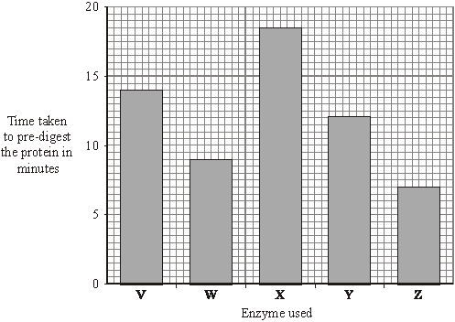

(i) How long did it take enzyme V to pre-digest the protein? minutes
(1)

(ii) Which enzyme would you advise the baby food manufacturer to use?
Draw a ring around your answer.
enzyme V enzyme W enzyme X enzyme Y enzyme Z
Give a reason for your answer.
...........................................................................................................................
...........................................................................................................................
(2)

(iii) Give two factors which should be controlled in the baby food manufacturer’s investigations.
Tick () two boxes.

Oxygen concentration
Temperature
Light intensity
pH

(2)
(Total 8 marks)

Q4. The diagram shows the human digestive system.
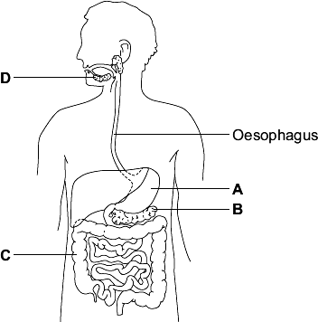
(a) Heartburn is a burning feeling caused when acid enters the oesophagus. The acid comes from the stomach.

(i) | Which letter on the diagram shows the stomach?

(1)

(ii) Name the acid the stomach produces.
........................................................................................................................
(1)

(iii) Medicines taken to treat heartburn contain chemicals that neutralise excess stomach acid.
What type of chemical will neutralise stomach acid?
........................................................................................................................
(1)

(b) Use words from the box and your own knowledge to describe how carbohydrates are digested.

amylase starch sugars

........................................................................................................................
........................................................................................................................
........................................................................................................................
........................................................................................................................
........................................................................................................................
........................................................................................................................
........................................................................................................................
........................................................................................................................
........................................................................................................................
........................................................................................................................
........................................................................................................................
........................................................................................................................
(5)

(c) Where in the body are the products of digestion absorbed?
........................................................................................................................
(1)
(Total 9 marks)

Q5. A manufacturer of slimming foods is investigating the effectiveness of carbohydrases from different microorganisms.
Iodine solution is a pale golden brown, transparent solution. Starch reacts with iodine to form a dark blue mixture.
Known concentrations of starch are added to iodine solution. The mixture is placed in a colorimeter which measures the percentage of light passing through the mixture.
Graph 1 shows the results.
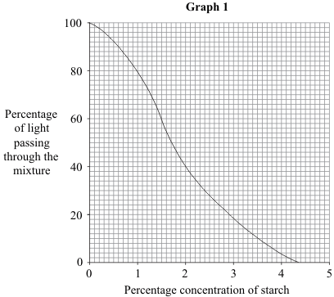

(a) Explain why less light passes through the mixture when the starch is more concentrated.
.....................................................................................................................................
.....................................................................................................................................
.....................................................................................................................................
(1)

(b) The manufacturer adds carbohydrase from each of three different microorganisms, A, B and C, to starch in flasks at 40 °C.
Every minute a sample of the mixture is added to iodine solution and placed in the colorimeter.
Graph 2 shows these results.
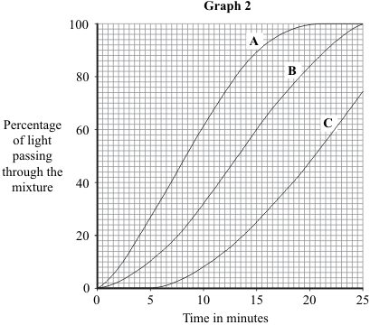

(i) When the concentration of starch reaches 2 %, digestion is considered to be sufficient for the next stage in the manufacture of the slimming food.
How long does this take for the most effective carbohydrase?
Show clearly how you work out your answer.
...........................................................................................................................
...........................................................................................................................
.............................. minutes
(2)

(ii) Explain why the manufacturer carried out the investigation at 40 °C.
...........................................................................................................................
...........................................................................................................................
...........................................................................................................................
...........................................................................................................................
...........................................................................................................................
(2)

(c) Carbohydrases convert starch into glucose. To complete the manufacture of the slimming food the glucose should be converted into fructose.
(i) Name the enzyme which would be used to convert glucose into fructose.
...........................................................................................................................
(1)

(ii) Explain why fructose, rather than glucose, is used in slimming foods.
...........................................................................................................................
...........................................................................................................................
...........................................................................................................................
...........................................................................................................................
...........................................................................................................................
(2)
(Total 8 marks)

Q6. A group of students investigated the effect of temperature on the action of the enzyme lipase.
The students:
• put 1 cm³ of lipase solution into a test tube
• put 5 cm³ of lipid into a different test tube
• put both tubes in a water bath at 5 C for 3 minutes
• mixed the lipid with the lipase solution.
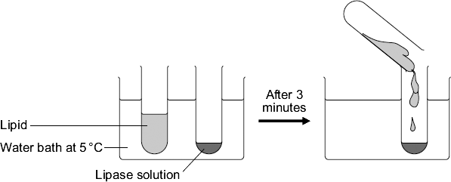
Every five minutes the students tested a sample of the mixture for lipid, until no lipid remained.
The students repeated the experiment at different temperatures.
(a) To make their investigation fair the students needed to control some variables.
Give one variable the students controlled in their investigation.
........................................................................................................................
(1)

(b) The tubes of lipase solution and lipid were kept separately in the water bath for 3 minutes before mixing. Why?
Tick ( ) one box.

So that the lipase broke down the lipid quickly

So that the lipase and the lipid reached the right temperature

To give enough time for the lipase to break down the lipid

To give enough time for the water bath to heat up

(1)

The table shows the students’ results.

Temperature  in C | Time taken until no lipid remained  in minutes
5 | 40
20 | 15
35 | 5
50 | 30
95 | lipid still there after 120 minutes

(c) Describe the effect on the breakdown of the lipid of increasing the temperature from 5 °C to 50 °C.
........................................................................................................................
........................................................................................................................
........................................................................................................................
........................................................................................................................
(2)

(d) Suggest two ways in which the students could have improved their investigation.
Use information from the students’ method and the results table to help you.
1 .....................................................................................................................
........................................................................................................................
........................................................................................................................
2 .....................................................................................................................
........................................................................................................................
........................................................................................................................
(2)

(e) (i) The lipase did not break down the lipid at 95 °C.
Why?
...............................................................................................................
...............................................................................................................
(1)

(ii) At 35 °C the lipase broke down the lipid after 5 minutes.
What new substances will be in the tube?
Draw a ring around one answer.

amino acids | fatty acids and glycerol | sugars

(1)
(Total 8 marks)

Q7. A patient has a disease. The disease damages his pancreas.
A doctor prescribes a course of treatment for the patient:
‘Take one capsule with each meal.’
Each capsule contains hundreds of small, dry beads.
The beads are made of enzymes. The pancreas normally produces these enzymes.
The outer coating of the capsule is made of lipid.
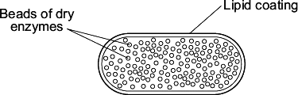
(a) One enzyme in the beads is lipase.
In a healthy person, lipase is made in the pancreas.
Name two other enzymes made in the pancreas of a healthy person.
1 .....................................................................................................................
2 .....................................................................................................................
(2)

(b) The lipid coating on the capsule makes sure that the enzymes are not released until the capsule reaches the small intestine.
Explain how.
........................................................................................................................
........................................................................................................................
........................................................................................................................
........................................................................................................................
........................................................................................................................
(2)

(c) The lipase in the beads does not digest the lipid coating around the capsule.
Suggest why.
........................................................................................................................
........................................................................................................................
(1)
(Total 5 marks)

Q8.(a) The graph shows the effect of pH on the activities of three enzymes, X, Y and Z.
These enzymes help to digest food in the human digestive system.
Each enzyme is produced by a different part of the digestive system.
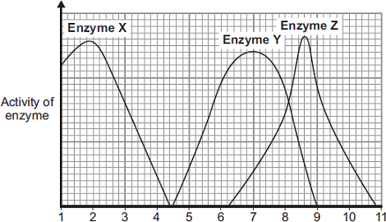
pH
(i) What is the optimum (best) pH for the action of enzyme Z?
..............................
(1)

(ii) The stomach makes a substance that gives the correct pH for enzyme action in the human stomach.
Name this substance. ..................................................................................................
(1)

(iii) Which enzyme, X, Y or Z, will work best in the human stomach?
..............................
(1)

(b) In this question you will be assessed on using good English, organising information clearly and using specialist terms where appropriate.
Different parts of the human digestive system help to break down molecules of fat so that they can be absorbed into the body.
Describe how.
To gain full marks you should refer to:
• the enzyme and where the enzyme is produced
• the products of digestion
• any other chemicals involved.
........................................................................................................................
........................................................................................................................
........................................................................................................................
........................................................................................................................
........................................................................................................................
........................................................................................................................
........................................................................................................................
........................................................................................................................
........................................................................................................................
........................................................................................................................
........................................................................................................................
........................................................................................................................
........................................................................................................................
........................................................................................................................
........................................................................................................................
........................................................................................................................
........................................................................................................................
(6)
(Total 9 marks)

Q9. Fruit is crushed to release fruit juice.
More juice can be collected if the plant cell walls in the fruit are broken down.
Some students tested the effect on the volume of fruit juice that they could collect of:
• either boiling the fruit
• or adding the enzyme pectinase to the fruit
• or adding the enzyme amylase to the fruit.
In their first experiment the students:
• crushed 20 g of apple
• added 10 drops of water
• measured the volume of fruit juice that they collected.
Diagram 1 shows how they collected the fruit juice.
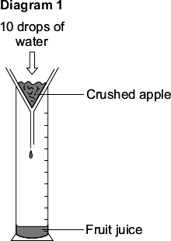
The students did three more experiments.
1 They added 10 drops of amylase solution to 20 g of crushed apple.
2 They added 10 drops of pectinase solution to 20 g of crushed apple.
3 They added 10 drops of water to 20 g of boiled, crushed apple.
Diagram 2 shows these experiments.
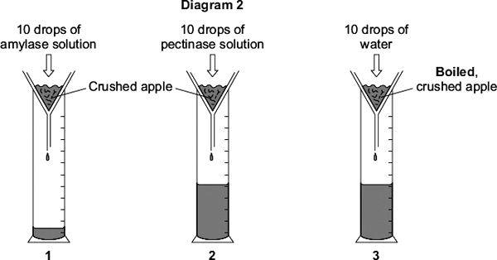
(a) Give one control variable in this investigation.
........................................................................................................................
(1)

(b) Using drops to measure the volume of water and enzyme added might lead to inaccurate results.
Give one reason why.
........................................................................................................................
(1)

(c) The students’ results are shown in the table.

What was added to the crushed apple | Was the apple boiled? | Volume of juice collected  in cm³
10 drops of water | No | 1.2
10 drops of amylase solution | No | 1.2
10 drops of pectinase solution | No | 11.3
10 drops of water | Yes | 11.6

Explain as fully as you can the students’ results shown in the table.
Use all the information given to help you answer this question.
........................................................................................................................
........................................................................................................................
........................................................................................................................
........................................................................................................................
........................................................................................................................
........................................................................................................................
(3)

(d) One student said:
‘If we add 10 drops of pectinase solution to crushed apple while it is boiling, we should collect more juice than if we add 10 drops of water to boiled apple.’
This is not correct.
What volume of juice would you predict the students would collect if 10 drops of pectinase solution were added to crushed apple while it was boiling?
Draw a ring around one answer.

1.2 cm³ | 11.3 cm³ | 11.6 cm³ | 22.9 cm³

(1)

Explain your answer.
........................................................................................................................
........................................................................................................................
........................................................................................................................
........................................................................................................................
(2)
(Total 8 marks)

Q10.Some students investigated the effect of pH on the digestion of boiled egg white by an enzyme called pepsin. Egg white contains protein.
The students:
• put a glass tube containing boiled egg white into a test tube
• added a solution containing pepsin at pH 7
• set up six more tubes with solutions of pepsin at different pH values
• left the test tubes for 24 hours at room temperature.
The image below shows one of the test tubes, at the start and at the end of the 24 hours.
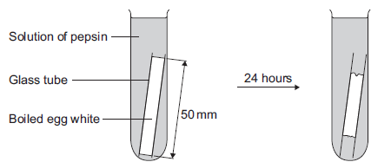

At start 24 hours later
(a) (i) Name the product of protein digestion.
...............................................................................................................
(1)

(ii) What type of enzyme digests protein?
Tick () one box.
amylase
lipase
protease

(1)

(b) The egg white in each tube was 50 mm long at the start of the investigation.
The table below shows the students’ results.

 | pH | Length in mm of boiled  egg white after 24 hours
 | 1 | 38
 | 2 | 20
 | 3 | 34
 | 4 | 45
 | 5 | 50
 | 6 | 50
 | 7 | 50

(i) At which pH did the pepsin work best?
pH ..................................
(1)

(ii) The answer you gave in part (b)(i) may not be the exact pH at which pepsin works best.
What could the students do to find a more accurate value for this pH?
...............................................................................................................
...............................................................................................................
...............................................................................................................
...............................................................................................................
(2)

(iii) There was no change in the length of the egg white from pH 5 to pH 7.
Explain why.
...............................................................................................................
...............................................................................................................
...............................................................................................................
...............................................................................................................
(2)

(c) Pepsin is made by the stomach.
Name the acid made by the stomach which allows pepsin to work well.
........................................................................................................................
(1)
(Total 8 marks)

Q11. The diagram shows the apparatus used to investigate the digestion of milk fat by an enzyme. The reaction mixture contained milk, sodium carbonate solution (an alkali) and the enzyme. In Experiment 1, bile was also added. In Experiment 2, an equal volume of water replaced the bile. In each experiment, the pH was recorded at 2-minute intervals.
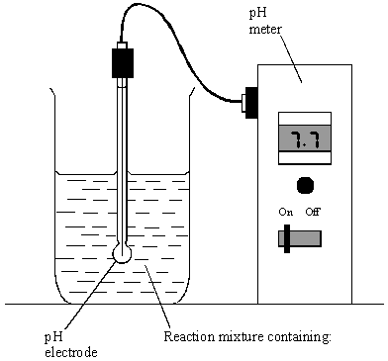
Either: Experiment 1 or: Experiment 2
milk (contains fat) milk (contains fat)
sodium carbonate solution sodium carbonate solution
bile water
enzyme enzyme

The results of the two experiments are given in the table.
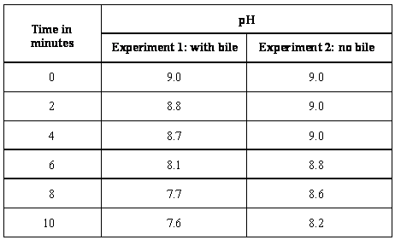

(a) Milk fat is a type of lipid. Give the name of an enzyme which catalyses the breakdown of lipids.
...................................................................................................................................
(1)

(b) What was produced in each experiment to cause the fall in pH?
...................................................................................................................................
(1)

(c) (i) For Experiment 1, calculate the average rate of fall in pH per minute, between
4 minutes and 8 minutes. Show clearly how you work out your final answer.
...........................................................................................................................
...........................................................................................................................
...........................................................................................................................
............................................. pH units per minute
(2)

(ii) Why was the fall in pH faster when bile was present?
...........................................................................................................................
...........................................................................................................................
(1)
(Total 5 marks)

Q12. A manufacturer is trying to improve the quality of the biological detergent he produces.
Scientists at his company carried out the following experiments on enzymes:
• Samples of lipase were collected from five different types of bacterium, A, B, C, D and E.
• The samples were diluted to give the same concentration of lipase.
• Agar jelly containing a lipid was prepared in a dish. This forms a cloudy mixture which becomes clear when the lipid is digested.
• Five small holes were cut into the agar.
• Two drops of lipase solution from bacterium A was added to hole A.
• This process was repeated for each sample of lipase.

Diagram 1 shows the appearance of the dish.
Diagram 1
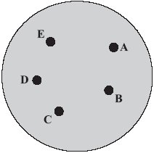

Diagram 2 shows the appearance of the dish 24 hours later.
Diagram 2
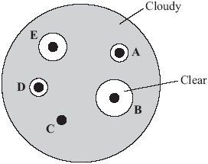

(a) (i) Which type of bacterium, A, B, C, D or E, produced the most effective lipase in this investigation?
Write your answer, A, B, C, D or E, in the box.
(1)

(ii) Explain your answer.
...........................................................................................................................
...........................................................................................................................
(1)

(b) The manufacturer plans to add the most effective lipase to the washing powders he produces.
Suggest two other factors he should investigate before deciding which lipase is the most effective.
1 ..................................................................................................................................
.....................................................................................................................................
2 ..................................................................................................................................
.....................................................................................................................................
(2)

(c) Many biological detergents cannot be used at high temperatures.
Explain why.
.....................................................................................................................................
.....................................................................................................................................
(1)
(Total 5 marks)

Q13. Fresh milk is a mixture of compounds including fat, protein and about 5 % lactose sugar. Lactose must be digested by the enzyme lactase, before the products can be absorbed.
Lactase can be added to fresh milk to pre-digest the lactose. This makes ‘lactose-free’ milk, which is suitable for people who do not produce enough lactase of their own.
A student investigated the effect of changing pH and temperature on the digestion of lactose in milk.
The results are shown in Tables 1 and 2.

Table 1  Effect of pH |  |  | Table 2  Effect of temperature
pH | Time taken to  digest lactose in  minutes |  | Temperature  in°C | Time taken to  digest lactose  in minutes
4.0 | 20 |  | 30 | 20
5.0 | 18 |  | 35 | 14
6.0 | 13 |  | 40 | 11
7.0 | 7 |  | 45 | 6
8.0 | 5 |  | 50 | 12
9.0 | 6 |  | 55 | 23

(a) The label on a carton of lactose-free milk states:
‘Lactase is normally produced in the stomach of mammals.’
The results in Table 1 show that this statement is unlikely to be true.
Explain how.
........................................................................................................................
........................................................................................................................
........................................................................................................................
........................................................................................................................
(2)

(b) Explain as fully as you can the results shown in Table 2.
........................................................................................................................
........................................................................................................................
........................................................................................................................
........................................................................................................................
........................................................................................................................
........................................................................................................................
........................................................................................................................
(3)

(c) Bile is produced in the liver and is released into the small intestine.
Explain how bile helps the digestion of milk.
........................................................................................................................
........................................................................................................................
........................................................................................................................
........................................................................................................................
(2)
(Total 7 marks)

Q14.The diagram shows part of the human digestive system.
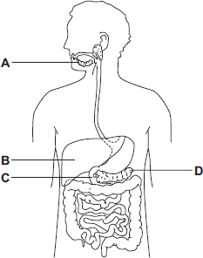

(a) Name the parts of the digestive system labelled A, B, C and D.
A ................................................................................
B ................................................................................
C ................................................................................
D ................................................................................
(4)

(b) A student has eaten a steak for dinner. The steak contains protein and fat.
(i) Describe how the protein is digested.
...............................................................................................................
...............................................................................................................
...............................................................................................................
...............................................................................................................
...............................................................................................................
...............................................................................................................
(3)

(ii) Explain two ways in which bile helps the body to digest fat.
...............................................................................................................
...............................................................................................................
...............................................................................................................
...............................................................................................................
...............................................................................................................
...............................................................................................................
(4)

(c) A group of students investigated the action of salivary amylase.
The students:
• collected a sample of salivary amylase
• put a different pH solution and 5 cm³ of a food substance in each of 6 test tubes
• added 1 cm³ of salivary amylase to each of the 6 test tubes
• recorded the amylase activity after 10 minutes.

The results are shown in the table.

 | pH | 7 | 6 | 5 | 4 | 3 | 2
 | Amylase activity in  arbitrary units | 12 | 10 | 3 | 0 | 0 | 0

(i) Name the food substance that amylase breaks down.
...............................................................................................................
(1)

(ii) Suggest what happens to the breakdown of this substance when food reaches the stomach.
Use information from the table to help you to answer this question.
...............................................................................................................
...............................................................................................................
...............................................................................................................
...............................................................................................................
...............................................................................................................
...............................................................................................................
(3)
(Total 15 marks)

Q15.Catalase is an enzyme found in many different tissues in plants and animals.It speeds up the rate of the following reaction.
hydrogen peroxide water + oxygen
Figure 1 shows a 25-day-old broad bean seedling.
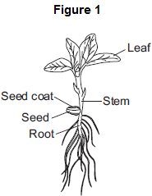
Some students investigated whether different parts of bean seedlings contained different amounts of catalase.
The students:
• put hydrogen peroxide into five test tubes
• added a different part of a bean seedling to each tube
• recorded the results after half a minute.
If there was catalase in part of the seedling, oxygen gas was given off.
When oxygen gas is given off, foam is produced in the tubes.

Figure 2 shows the results.
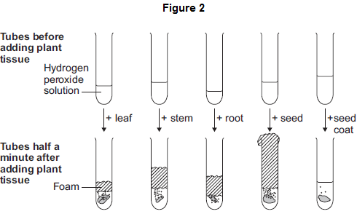
The students made the following conclusions:
• most parts of a bean seedling contain catalase
• the seed contains a lot of catalase
• stems and roots have quite a lot of catalase
• the leaves have a little bit of catalase
• the seed coat has hardly any catalase.
The students’ teacher said that the students needed to improve their investigation in order to make valid conclusions.
(a) In this question you will be assessed on using good English, organising information clearly and using specialist terms where appropriate.
Describe how you would carry out an investigation to compare the amounts of catalase in different parts of bean seedlings.
You should include details of how you would make sure your results give a valid comparison of the amounts of catalase.
........................................................................................................................
........................................................................................................................
........................................................................................................................
........................................................................................................................
........................................................................................................................
........................................................................................................................
........................................................................................................................
........................................................................................................................
........................................................................................................................
........................................................................................................................
(6)

(b) Scientists investigated the effect of pH on the activity of the enzyme catalase in a fungus.
The table below shows the scientists’ results.

 | pH | Enzyme activity in arbitrary units
 |  | Test 1 | Test 2 | Test 3 | Test 4 | Test 5 | Mean
 | 3.0 | 0 | 0 | 0 | 0 | 0 | 0
 | 4.0 | 6 | 5 | 8 | 4 | 7 | 6
 | 5.0 | 38 | 65 | 41 | 42 | 39
 | 5.5 | 80 | 86 | 82 | 84 | 88 | 84
 | 6.0 | 100 | 99 | 96 | 103 | 102 | 100
 | 6.5 | 94 | 92 | 90 | 93 | 91 | 92
 | 7.0 | 61 | 63 | 61 | 62 | 63 | 62
 | 8.0 | 22 | 22 | 21 | 24 | 21 | 22

(i) Calculate the mean enzyme activity at pH 5.0.
...............................................................................................................
...............................................................................................................
Mean = ......................... arbitrary units
(2)

(ii) On the graph paper in Figure 3, draw a graph to show the scientists’ results.
Remember to:
• add a label to the vertical axis
• plot the mean values of enzyme activity
• draw a line of best fit.
Figure 3
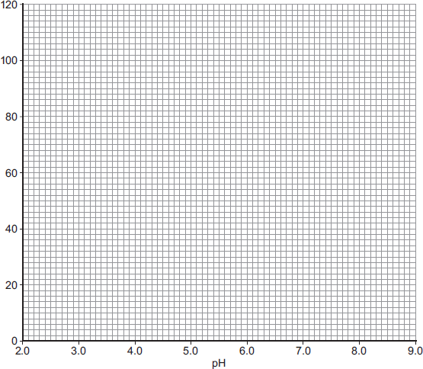
(4)

(iii) At what pH does the enzyme work best?
........................................
(1)
(iv) Predict the activity of the enzyme at pH 9.0.
........................................ arbitrary units
(1)
(v) Suggest why the enzyme’s activity at pH 3.0 is zero.
...............................................................................................................
...............................................................................................................
(1)
(Total 15 marks)

