Organisation in Animals (Chapter 4) Exam Pack |  | Name: ________________________  Class: ________________________  Date: ________________________
Time: | 129 minutes
Marks: | 129 marks
Comments:

Q1. Blood contains plasma, platelets, red cells and white cells. Each has one or more important functions.
In the table below draw a line from each part to its function.
One part has two functions. Draw lines from this part to both functions.
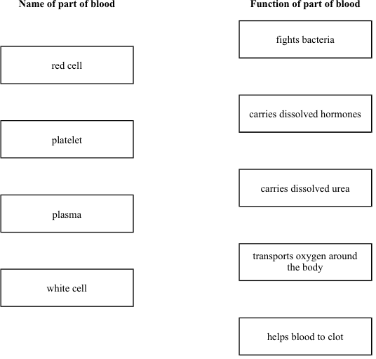
(Total 5 marks)

Q2. The diagram shows human blood seen through a microscope.
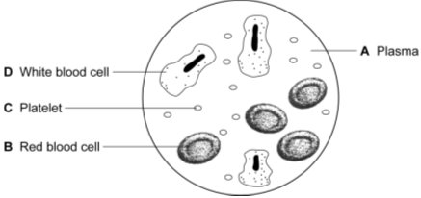

Write the correct letter, A, B, C or D, next to each function.

Function | Part of blood  A, B, C or D
Transports oxygen
Helps blood to clot at the site of a cut
Transports urea

(Total 3 marks)

Q3.(a) (i) Blood is part of the circulatory system.
Draw one line from each part of the blood to its correct function.

 | Part of the blood |  | Function
carry glucose around
the body
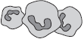
White blood cells
carry oxygen around
the body
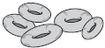
Red blood cells
 |  |  | help the blood to clot
 | Platelets
destroy
microorganisms

(3)

(ii) Name one waste product that is transported by the blood plasma.
...............................................................................................................
(1)

(b) The heart is also part of the circulatory system.
Figure 1 shows a section through the human heart.
Figure 1
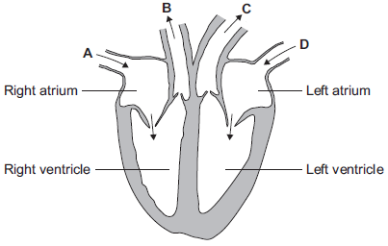
(i) Which arrow, A, B, C or D, shows blood leaving the heart in the pulmonary artery to go to the lungs?
(1)

(ii) Which arrow, A, B, C or D, shows blood from the lungs entering the heart in the pulmonary vein?
(1)

(iii) Valves in the circulatory system make sure blood only travels in one direction.
Name the type of blood vessel that has valves.
...............................................................................................................
(1)

(c) A person’s coronary artery has become narrower.
The person has a heart attack.
A doctor puts a stent into the person’s coronary artery.
Figure 2 shows a stent inside a coronary artery.
Figure 2
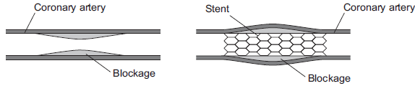

(i) How does the stent help to prevent another heart attack?
Give one way.
...............................................................................................................
...............................................................................................................
(1)

(ii) Figure 3 shows a surgeon putting a stent into a patient.
Figure 3
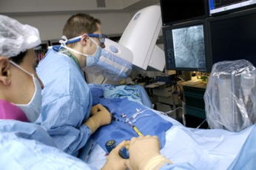
© Science Photo Library

The surgeon puts the stent into an artery in the leg. He moves the stent through the artery to the coronary artery.
Suggest two possible risks of this operation.
1 ............................................................................................................
...............................................................................................................
2 ............................................................................................................
...............................................................................................................
(2)
(Total 10 marks)

Q4. (a) The graph shows how the mass of oxygen you breathe in changes as you climb up a mountain.
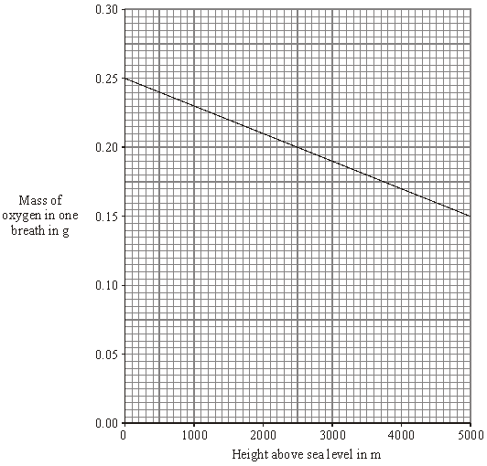

Describe, in as much detail as you can, how the mass of oxygen in one breath changes as you climb from sea level to 3000 m.
.....................................................................................................................................
.....................................................................................................................................
.....................................................................................................................................
.....................................................................................................................................
.....................................................................................................................................
.....................................................................................................................................
(3)

(b) People who live high up in mountainous areas have more red blood cells than people who live at sea level. The graph below shows how the number of red blood cells changes with height above sea level.
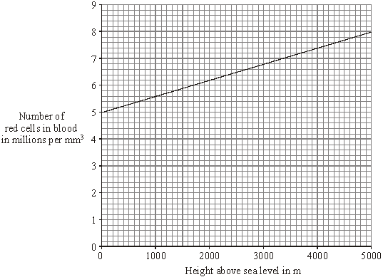

(i) How many more red blood cells does a person living at 3000 m above sea level have than someone living at sea level? Show clearly how you work out your answer.
...........................................................................................................................
...........................................................................................................................
Increase in number of red blood cells = ....................................millions per m³
(2)

(ii) What is the advantage of having more red blood cells?
...........................................................................................................................
...........................................................................................................................
(1)
(Total 6 marks)

Q5. The diagram represents the human blood circulation system.
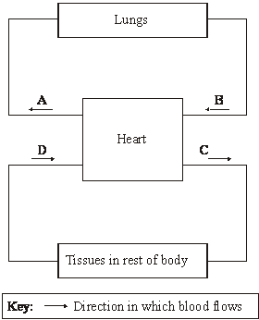
(a) A, B, C and D are blood vessels.

(i) Give the letter of one blood vessel that is an artery. ....................................
(1)
(ii) Give the letter of one blood vessel that is a vein. ....................................
(1)

(b) A student pedalled an exercise cycle at constant speed for 5 minutes. The student’s heart rate was recorded at one-minute intervals during the exercise. The results are shown in the graph.
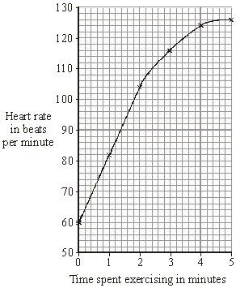

(i) What was the student’s heart rate before the exercise began?
................................................ per minute
(1)
(ii) How long was it before the student’s heart rate reached 124 beats per minute?
...................................................... .minutes
(1)

(c) Which of the following parts of the blood carries most oxygen?
Draw a circle around one answer.
plasma red blood cells white blood cells
(1)
(Total 5 marks)

-

Q6.Diagram 1 shows a section through the heart.
Diagram 1
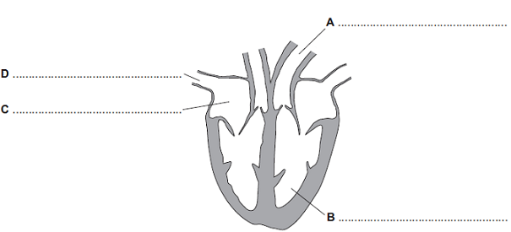
(a) Use words from the box to label parts A, B, C and D.

artery atrium capillary platelet vein ventricle

(4)

(b) Diagram 2 shows one treatment for a diseased coronary artery.
Diagram 2
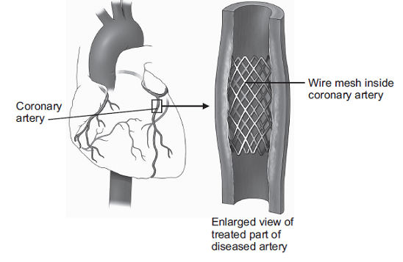
© Nucleus Medical Art/Visuals Unlimited/Corbis
(i) Name the treatment shown in Diagram 2.
...............................................................................................................
(1)

(ii) Explain how the treatment works.
...............................................................................................................
...............................................................................................................
...............................................................................................................
...............................................................................................................
(2)
(Total 7 marks)

Q7.The circulatory system transports substances such as glucose and oxygen around the body.
(a) Name two other substances that the circulatory system transports around the body.
1........................................................................................................................
2........................................................................................................................
(2)

(b) (i) Blood is a tissue. Blood contains red blood cells and white blood cells.
Name two other components of blood.
1...............................................................................................................
2...............................................................................................................
(2)
(ii) The heart is part of the circulatory system.
What type of tissue is the wall of the heart made of?
...............................................................................................................
(1)

(c) In this question you will be assessed on using good English, organising information clearly and using specialist terms where appropriate.
Every year, many patients need to have heart valve replacements.
The table gives information about two types of heart valve.

 | Living human heart valve | Cow tissue heart valve
 | • It has been used for transplants for  more than 12 years. | • It has been used since 2011.
 | • It can take many years to find a suitable  human donor. | • It is made from the artery tissue of a  cow.
 | • It is transplanted during an operation  after a donor has been found. | • It is attached to a stent and inserted  inside the existing faulty valve.
 | • During the operation, the patient's chest  is opened and the old valve is removed  before the new valve is transplanted. | • A doctor inserts the stent into a blood  vessel in the leg and pushes it through  the blood vessel to the heart.

A patient needs a heart valve replacement. A doctor recommends the use of a cow tissue heart valve.
Give the advantages and disadvantages of using a cow tissue heart valve compared with using a living human heart valve.
Use information from the table and your own knowledge in your answer.
........................................................................................................................
........................................................................................................................
........................................................................................................................
........................................................................................................................
........................................................................................................................
........................................................................................................................
........................................................................................................................
........................................................................................................................
........................................................................................................................
........................................................................................................................
(6)
(Total 11 marks)

Q8. A person did five different activities in turn. These activities needed increasing amounts of energy. For each activity two measurements were made. These were the rate of contraction of the left ventricle and its stroke volume (the volume of blood pumped at each beat). From these measurements the cardiac volume was calculated.
Some of these results are shown in the table and the bar chart.
Activity | Rate of contraction  of left ventricle in  beats per minute | Cardiac output  in cm³ per minute
Sitting upright  Slow walking  Moderate walking  Fast walking  Running | 68  98  130  150 | 5 500  8 000  12 000  17 500  19 000

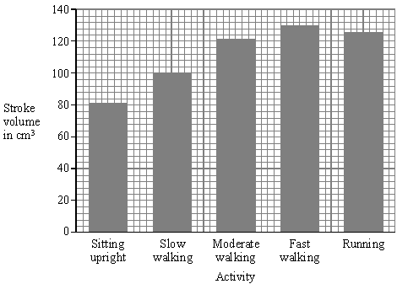

(a) (i) Describe how a person can count the rate of beating of the left ventricle.
..........................................................................................................................
..........................................................................................................................
(1)

(ii) Calculate the rate of ventricle contraction in beats per minute when the person was walking slowly. Show clearly how you work out your final answer.
..........................................................................................................................
..........................................................................................................................
..........................................................................................................................
..........................................................................................................................
Rate of ventricle contraction................................ beats per minute.
(2)

(iii) The pattern of results for stroke volume shows an anomalous result when the person is running. In what way is it anomalous?
..........................................................................................................................
..........................................................................................................................
(1)

(iv) There was a change in cardiac output when the person’s movement changed from fast walking to running. How did the heart produce this change?
..........................................................................................................................
..........................................................................................................................
(1)

(b) Over a period of time, regular exercise can strengthen the heart muscle. This change in the heart muscle enables a person to run for longer before lactic acid build up occurs. Explain the reason for this.
....................................................................................................................................
....................................................................................................................................
....................................................................................................................................
....................................................................................................................................
(2)
(Total 7 marks)

Q9. Oxygen is transported round the body by the blood.
Blood leaving the human lung can carry about 250 milligrams of oxygen per litre.
However, only 7 milligrams of oxygen will dissolve in one litre of water at body temperature.
(a) Suggest an explanation for the difference.
........................................................................................................................
........................................................................................................................
........................................................................................................................
........................................................................................................................
(2)

(b) Blood leaving the skeletal muscles during exercise may contain only 30 milligrams of oxygen per litre.
Explain what causes the difference in oxygen concentration between the blood leaving the lungs and the blood leaving the skeletal muscles.
........................................................................................................................
........................................................................................................................
........................................................................................................................
........................................................................................................................
........................................................................................................................
........................................................................................................................
........................................................................................................................
........................................................................................................................
(4)
(Total 6 marks)

Q10.The diagram in Figure 1 shows a section through the human heart, seen from the front.
Figure 1
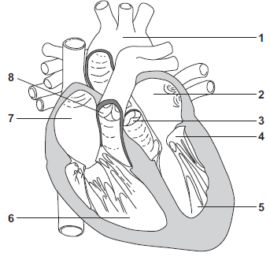

(a) Draw a ring around the correct answer to complete each sentence.

 | (i) | The wall of the heart is made mostly of | epithelial  glandular  muscular | tissue.

(1)

(ii) The resting heart rate is controlled by the pacemaker.

 | The pacemaker is located at position | 1.  6.  7.

(1)

(iii) If a person’s heart rate is irregular, the person may be fitted with an artificial pacemaker.

 | The artificial pacemaker is | an electrical device.  a pump.  a valve.

(1)

(b) (i) Write a number, 2, 5, 6 or 7, in each of the three boxes to answer this question.
Which chamber of the heart:
pumps oxygenated blood to the head and body
receives deoxygenated blood from the head and body
receives oxygenated blood from the lungs?

(3)

(ii) Give the number, 3, 4 or 8, of the valve that closes when the blood pressure in the aorta is greater than the blood pressure in the left ventricle.
Write the correct answer in the box.
(1)

(c) The diagram in Figure 2 shows one type of artificial heart valve. The plastic ball is in the closed position.
Figure 2
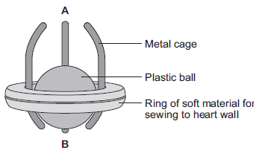

This type of artificial valve could be used to replace a faulty valve in the heart.
(i) What is the function of valves in the heart?
...............................................................................................................
...............................................................................................................
(1)

(ii) The artificial valve could be used to replace valve 4 shown in Figure 1.
The artificial valve opens to let blood through when the ball is moved towards A.
Which end of the valve, A or B, should point towards chamber 5?
Explain your answer.
...............................................................................................................
...............................................................................................................
...............................................................................................................
...............................................................................................................
...............................................................................................................
...............................................................................................................
...............................................................................................................
(3)

(d) (i) The artificial heart valve may cause blood clots to form on its surface.
Describe what happens during blood clotting.
...............................................................................................................
...............................................................................................................
...............................................................................................................
...............................................................................................................
(2)

(ii) Read the information in the passage.

Replacing a damaged heart valve can dramatically improve the blood circulation and the supply of oxygen to the body’s tissues. The operation to replace a heart valve is a long one during which the patient’s blood goes through a bypass machine.
Sometimes the artificial valve can fail to work. If the surface of the valve becomes rough, small blood clots can form on its surface then break away and be carried around the body by the blood.

Evaluate the advantages and disadvantages of artificial heart valves.
...............................................................................................................
...............................................................................................................
...............................................................................................................
...............................................................................................................
...............................................................................................................
...............................................................................................................
...............................................................................................................
...............................................................................................................
...............................................................................................................
...............................................................................................................
(4)
(Total 17 marks)

Q11.Diagram 1 shows a section through the heart.
Diagram 1
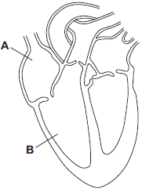

(a) Use words from the box to name the structures labelled A and B on Diagram 1.

 | arota | atrium | pulmonary artery | ventricle

A ......................................................................................................................
B ......................................................................................................................
(2)

(b) The tissue in the wall of the heart contracts.
(i) What type of tissue is this?
Tick () one box.
muscular
glandular
epithelial

(1)

(ii) What does the heart do when this tissue contracts?
...............................................................................................................
...............................................................................................................
(1)

(c) Draw arrows on Diagram 2 to complete the route taken by deoxygenated blood through the heart.
Diagram 2
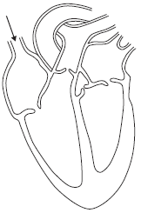
(2)

(d) The graph shows the percentage (%) of adults in the UK who have coronary heart disease.
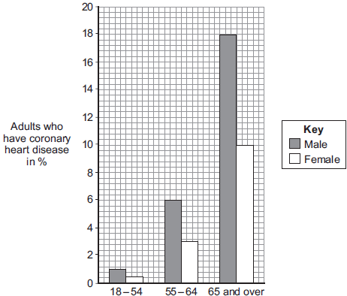
Age group

(i) Look at the graph.
Which group of people is most at risk of having coronary heart disease in the UK?
...............................................................................................................
(2)

(ii) Explain what happens to the heart in coronary heart disease.
...............................................................................................................
...............................................................................................................
...............................................................................................................
...............................................................................................................
...............................................................................................................
...............................................................................................................
(3)
(Total 11 marks)

Q12.A student ran on a treadmill for 5 minutes.
The speed of the treadmill was set at 12 km per hour.
The graph below shows the effect of the run on the student’s heart rate.
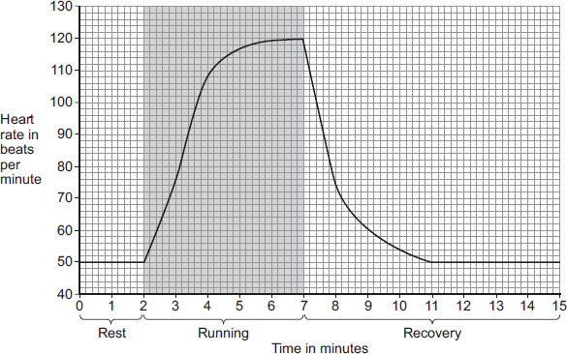
(a) (i) What was the student’s heart rate at rest?
.............................. beats per minute
(1)
(ii) After the end of the run, how long did it take for the student’s heart rate to return to the resting heart rate?
.............................. minutes
(1)

(b) During the run, the student’s muscles needed larger amounts of some substances than they needed at rest.
(i) Which two of the following substances were needed in larger amounts during the run?
Tick () two boxes.

carbon dioxide
glucose
lactic acid
oxygen
protein

(2)

(ii) Why are the two substances you chose in part (b)(i) needed in larger amounts during the run?
Tick () one box.

To help make more muscle fibres
To release more energy
To help the muscles to cool down

(1)

(c) After exercise, a fit person recovers faster than an unfit person.
Let the student’s heart rate at the end of exercise = a.
Let the student’s heart rate after 2 minutes of recovery = b.
The table below shows how the difference between a and b, (a − b), is related to a person’s level of fitness.

 | (a − b) | Level of fitness
 | < 22 | Unfit
 | 22 to 52 | Normal fitness
 | 53 to 58 | Fit
 | 59 to 65 | Very fit
 | > 65 | Top athlete

What is the student’s level of fitness?
Use information from the graph and the table.
a = ......................... beats per minute
b = ......................... beats per minute
(a − b) = ......................... beats per minute
Level of fitness = ......................................................................
(3)

(d) The student repeated the run with the treadmill set at 16 km per hour.
The student’s heart rate took 3 minutes longer to return to the normal resting rate than when running at 12 km per hour.
Give reasons why it took longer to recover after running faster.
........................................................................................................................
........................................................................................................................
........................................................................................................................
........................................................................................................................
........................................................................................................................
........................................................................................................................
........................................................................................................................
........................................................................................................................
........................................................................................................................
........................................................................................................................
(4)
(Total 12 marks)

Q13. The photograph shows a red blood cell in part of a blood clot. The fibres labelled X are produced in the early stages of the clotting process.
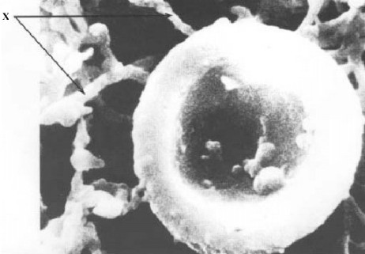

(a) Suggest how the fibres labelled X help in blood clot formation.
.....................................................................................................................................
(1)

(b) The average diameter of a real red blood cell is 0.008 millimetres.
On the photograph, the diameter of the red blood cell is 100 millimetres.
Use the formula to calculate the magnification of the photograph.
Diameter on photograph = Real diameter × Magnification
.....................................................................................................................................
.....................................................................................................................................
.....................................................................................................................................
Magnification = ..............................................................
(2)

(c) Some blood capillaries have an internal diameter of approximately 0.01 millimetres.
(i) Use information given in part (b) to explain why only one red blood cell at a time can pass through a capillary.
...........................................................................................................................
(1)

(ii) Explain the advantages of red blood cells passing through a capillary one at a time.
...........................................................................................................................
...........................................................................................................................
...........................................................................................................................
...........................................................................................................................
...........................................................................................................................
...........................................................................................................................
(3)
(Total 7 marks)

Q14.During exercise, the heart beats faster and with greater force.
The ‘heart rate’ is the number of times the heart beats each minute.The volume of blood that travels out of the heart each time the heart beats is called the ‘stroke volume’.
In an investigation, Person 1 and Person 2 ran as fast as they could for 1 minute. Scientists measured the heart rates and stroke volumes of Person 1 and Person 2 at rest, during the exercise and after the exercise.
The graph below shows the scientists’ results.
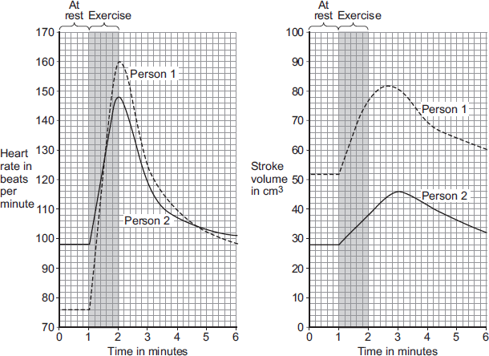
(a) The ‘cardiac output’ is the volume of blood sent from the heart to the muscles each minute.
Cardiac output = Heart rate × Stroke volume
At the end of the exercise, Person 1’s cardiac output = 160 × 77 = 12 320 cm³ per minute.
Use information from Figure above to complete the following calculation of Person 2’s cardiac output at the end of the exercise.
At the end of the exercise:
Person 2’s heart rate = .............................. beats per minute
Person 2’s stroke volume = .............................. cm³
Person 2’s cardiac output = .............................. cm³ per minute
(3)

(b) Person 2 had a much lower cardiac output than Person 1.
(i) Use information from the graphs to suggest the main reason for the lower cardiac output of Person 2.
...............................................................................................................
...............................................................................................................
(1)

(ii) Person 1 was able to run much faster than Person 2.
Use information from the graphs and your own knowledge to explain why.
...............................................................................................................
...............................................................................................................
...............................................................................................................
...............................................................................................................
...............................................................................................................
...............................................................................................................
...............................................................................................................
...............................................................................................................
...............................................................................................................
...............................................................................................................
(5)

(Total 9 marks)

