Organisation in Plants (Chapter 4) Exam Pack. |  | Name: ________________________  Class: ________________________  Date: ________________________
Time: | 86 minutes
Marks: | 86 marks
Comments:

Q1.Plants need different substances to survive.
Figure 1 shows the roots of a plant.
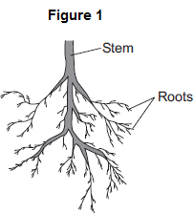
(a) (i) Mineral ions are absorbed through the roots.
Name one other substance absorbed through the roots.
...............................................................................................................
(1)

(ii) The plant in Figure 1 has a higher concentration of mineral ions in the cells of its roots than the concentration of mineral ions in the soil.
Which two statements correctly describe the absorption of mineral ions into the plant’s roots?
Tick () two boxes.

The mineral ions are absorbed by active transport.
The mineral ions are absorbed by diffusion.
The mineral ions are absorbed down the concentration gradient.
The absorption of mineral ions needs energy.

(2)

(iii) The plant in Figure 1 has roots adapted for absorption.
Figure 2 shows a magnified part of a root from Figure 1.
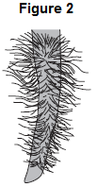
Describe how the root in Figure 2 is adapted for absorption.
...............................................................................................................
...............................................................................................................
...............................................................................................................
...............................................................................................................
(2)

(b) The leaves of plants have stomata.
What is the function of the stomata?
........................................................................................................................
........................................................................................................................
(1)

(c) Figure 3 shows the underside of two leaves, A and B, taken from a plant in a man’s house.
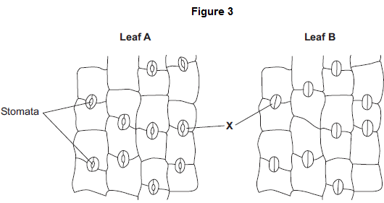
(i) In Figure 3, the cells labelled X control the size of the stomata.
What is the name of the cells labelled X?
Tick () one box.

Guard cells
Phloem cells
Xylem cells

(1)

(ii) Describe how the appearance of the stomata in leaf B is different from the appearance of the stomata in leaf A.
...............................................................................................................
...............................................................................................................
(1)

(iii) The man forgets to water the plant.
What might happen to the plant in the next few days if the stomata stay the same as shown in leaf A in Figure 3?
...............................................................................................................
...............................................................................................................
(1)
(Total 9 marks)

Q2.Some students used the apparatus shown in the diagram to measure the rate of water uptake by a plant cutting.
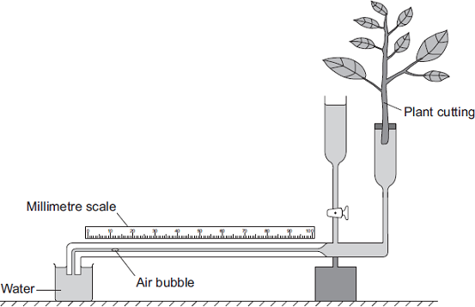
The students set up the apparatus in three different conditions:
• no wind at 15°C
• no wind at 25°C
• wind at 25°C
For each experiment, the students recorded the movement of the air bubble along the scale.
(a) (i) Name the two variables the students chose to change in these experiments.
1 ...............................................................................................................
2 ...............................................................................................................
(2)

(ii) It was important to use the same plant cutting each time to make these experiments fair.
Explain why.
...............................................................................................................
...............................................................................................................
(1)

(b) The graph shows the students’ results.
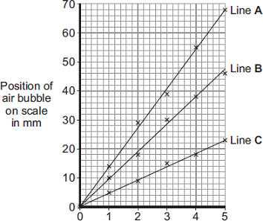
Time in minutes
Which line on the graph, A, B or C, shows the results for each of the three different experiments?
Write each of the letters, A, B and C, in the correct boxes in the table.

 | Conditions | Letter
 | No wind at 15°C
 | No wind at 25°C
 | Wind at 25°C

(2)

(c) Water is lost from the leaves of the plant cutting.
Name this process.
Draw a ring around one answer.

 | distillation | respiration | transpiration

(1)
(Total 6 marks)

Q3.Substances are transported through plants.
(a) Use the correct answer from the box to complete each sentence.

 | capillary | guard cells | phloem
 | stomata | transpiration | xylem

(i) Water is transported from the roots to the stem of a plant
in the ....................................................... .
(1)

(ii) Dissolved sugars are transported through the plant
in the ....................................................... .
(1)

(iii) Movement of water through the plant is called the
....................................................... stream.
(1)

(iv) Water vapour moves out of the plant through pores
called ....................................................... .
(1)

(b) Students investigated the effect of different conditions on water loss from leaves.
The apparatus is shown in Figure 1.
Figure 1
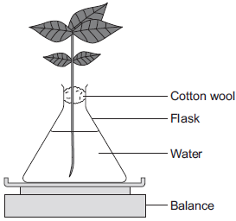

The students set up four flasks, A, B, C and D.
The students:
• used the same size plant shoot in each flask
• recorded the mass of the flask and plant shoot at the start of each experiment
• left each flask and plant shoot in different conditions
• recorded the mass of each flask and plant shoot after 2 hours.
Table 1 shows the conditions that flasks A, B, C and D were left in for 2 hours.

Table 1

 | Flask | Temperature in °C | Fan or no fan
 | A | 20 | No Fan
 | B | 20 | Fan
 | C | 35 | No Fan
 | D | 35 | Fan

(i) Suggest why the students used cotton wool in each flask.
...............................................................................................................
...............................................................................................................
(1)

(ii) The use of the same size of plant shoot made the investigation a fair test.
Explain why.
...............................................................................................................
...............................................................................................................
...............................................................................................................
...............................................................................................................
...............................................................................................................
(2)

(iii) Table 2 shows the students’ results.
Table 2

 |  | Conditions |  | Mass at  the start  in grams | Mass  after  2 hours  in grams | Mass of  water lost  in 2 hours  in grams
 | Flask | Temperature  in °C | Fan or  no fan
 | A | 20 | No Fan | 150.0 | 148.1 | 1.9
 | B | 20 | Fan | 152.0 | 148.5 | 3.5
 | C | 35 | No Fan | 149.0 | 145.9 | 3.1
 | D | 35 | Fan | 150.0 | 145.5

What mass of water was lost by the plant shoot in flask D?
...............................................................................................................
...............................................................................................................
.................... grams
(1)

(iv) Suggest what conclusion can be made about the effect of temperature on water loss from the plant shoot.
...............................................................................................................
...............................................................................................................
...............................................................................................................
(1)

(v) Suggest what conclusion can be made about the effect of the fan on water loss from the plant shoot.
...............................................................................................................
...............................................................................................................
...............................................................................................................
(1)

(c) The students carried out another experiment at 20 °C, with no fan.
The students used the apparatus in Figure 2.
Figure 2
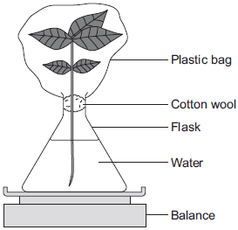

In this experiment, the students:
• recorded the mass of the flask and plant shoot before tying the plastic bag around the plant shoot
• removed the bag after 2 hours and recorded the mass again.

(i) What mass of water would be lost from the plant shoot in 2 hours?
Draw a ring around the correct answer.

 | 0.3 g | 1.9 g | 3.9 g

(1)

(ii) Give a reason for your answer to part (c)(i).
...............................................................................................................
...............................................................................................................
...............................................................................................................
(1)
(Total 12 marks)

Q4. The diagram shows part of a plant root. A large number of structures like the ones labelled X grow out of the surface of the root.
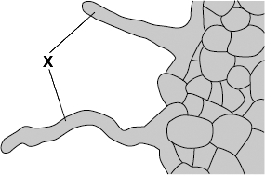
(a) (i) What is the name of structure X?
Draw a ring around one answer.

root hair | stoma | villus

(1)

(ii) Name two substances which structure X absorbs from the soil.
1 .....................................................................................................................
2 .....................................................................................................................
(2)

(b) The substances in (a)(ii) are transported from the roots to the leaves. Carbon dioxide also enters the leaves.
Draw a ring round the correct answer to complete each sentence.

 |  | alveoli.
(i) | Carbon dioxide enters leaves through | stomata.
 |  | villi.

(1)

 |  | active transport.
(ii) | Carbon dioxide enters leaf cells by | diffusion.
 |  | reabsorption.

(1)
(Total 5 marks)

Q5.The diagram shows a section through a plant leaf.
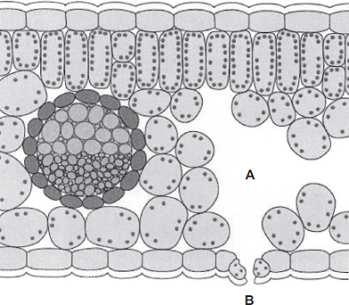
(a) Use words from the box to name two tissues in the leaf that transport substances around the plant.

epidermis | mesophyll | phloem | xylem

.................................................................. and ..................................................................
(1)

(b) Gases diffuse between the leaf and the surrounding air.
(i) What is diffusion?
...............................................................................................................
...............................................................................................................
...............................................................................................................
...............................................................................................................
(2)

(ii) Name one gas that will diffuse from point A to point B on the diagram on a sunny day.
...............................................................................................................
(1)
(Total 4 marks)

Q6.The leaves of most plants have stomata.
(a) (i) Name the cells which control the size of the stomata.
...............................................................................................................
(1)

(ii) Give one function of stomata.
...............................................................................................................
...............................................................................................................
(1)

(b) The image below shows part of the surface of a leaf.
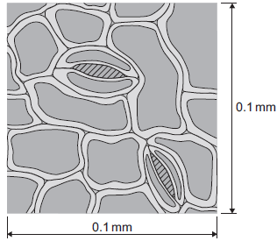
The length and width of this piece of leaf surface are both 0.1 mm.

(i) Calculate the number of stomata per mm² of this leaf surface.
...............................................................................................................
...............................................................................................................
.................................................. per mm²
(2)

(ii) A different plant species has 400 stomata per mm² of leaf surface.
Having a large number of stomata per mm² of leaf surface can be a disadvantage to a plant.
Give one disadvantage.
...............................................................................................................
...............................................................................................................
(1)

(c) A student investigated the loss of water from plant leaves.
The student did the following:
• Step 1: took ten leaves from a plant
• Step 2: weighed all ten leaves
• Step 3: hung the leaves up in a classroom for 4 days
• Step 4: weighed all ten leaves again
• Step 5: calculated the mass of water lost by the leaves
• Step 6: repeated steps 1 to 5 with grease spread on the upper surfaces of the leaves
• Step 7: repeated steps 1 to 5 with grease spread on both the upper and lower surfaces of the leaves.
All the leaves were taken from the same type of plant.

The table below shows the student’s results.

 | Treatment of leaves | Mass of water the leaves lost in g
 | No grease was used on the leaves | 0.98
 | Grease on upper surfaces of the leaves | 0.86
 | Grease on upper and lower surfaces of the leaves | 0.01

(i) What mass of water was lost in 4 days through the upper surfaces of the leaves?
...............................................................................................................
...............................................................................................................
Mass = .................... g
(1)

(ii) Very little water was lost when the lower surfaces of the leaves were covered in grease.
Explain why.
...............................................................................................................
...............................................................................................................
...............................................................................................................
...............................................................................................................
...............................................................................................................
...............................................................................................................
...............................................................................................................
(3)
(Total 9 marks)

Q7.Plants exchange substances with the environment.
(a) Plant roots absorb water mainly by osmosis.
Plant roots absorb ions mainly by active transport.
Explain why roots need to use the two different methods to absorb water and ions.
...............................................................................................................
...............................................................................................................
...............................................................................................................
...............................................................................................................
...............................................................................................................
...............................................................................................................
...............................................................................................................
...............................................................................................................
(4)

(b) What is meant by the transpiration stream?
...............................................................................................................
...............................................................................................................
...............................................................................................................
...............................................................................................................
...............................................................................................................
...............................................................................................................
(3)

(c) Students investigated the loss of water vapour from leaves.
The students:
• cut some leaves off a plant
• measured the mass of these leaves every 30 minutes for 180 minutes.
The graph shows the students’ results.
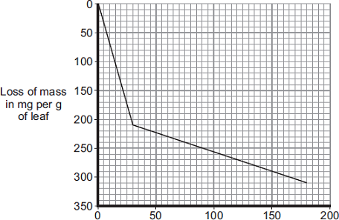
(i) The rate of mass loss in the first 30 minutes was 7 milligrams per gram of leaf per minute.
Calculate the rate of mass loss between 30 minutes and 180 minutes.
...............................................................................................................
...............................................................................................................
Rate of mass loss = .............................. milligrams per gram of leaf per minute
(2)

(ii) The rate of mass loss between 0 and 30 minutes was very different from the rate of
mass loss between 30 and 180 minutes.
Suggest an explanation for the difference between the two rates.
...............................................................................................................
...............................................................................................................
...............................................................................................................
...............................................................................................................
(2)
(Total 11 marks)

Q8.The diagram below shows a cross-section of a plant root. The transport tissues are labelled.
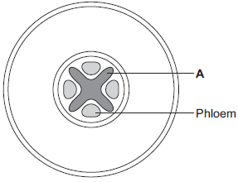

(a) (i) What is tissue A?
Draw a ring around the correct answer.
cuticle epidermis xylem
(1)

(ii) Name two substances transported by tissue A.
1 .............................................................................................................
2 .............................................................................................................
(2)

(b) Phloem is involved in a process called translocation.
(i) What is translocation?
...............................................................................................................
...............................................................................................................
...............................................................................................................
(1)

(ii) Explain why translocation is important to plants.
...............................................................................................................
...............................................................................................................
...............................................................................................................
...............................................................................................................
(2)

(c) Plants must use active transport to move some substances from the soil into root hair cells.
(i) Active transport needs energy.
Which part of the cell releases most of this energy?
Tick (✓) one box.
mitochondria
nucleus
ribosome

(1)

(ii) Explain why active transport is necessary in root hair cells.
...............................................................................................................
...............................................................................................................
...............................................................................................................
...............................................................................................................
...............................................................................................................
...............................................................................................................
(2)
(Total 9 marks)

Q9.A potometer is a piece of apparatus that can be used to measure water uptake by a leafy shoot.
Figure 1 shows a potometer.
Figure 1
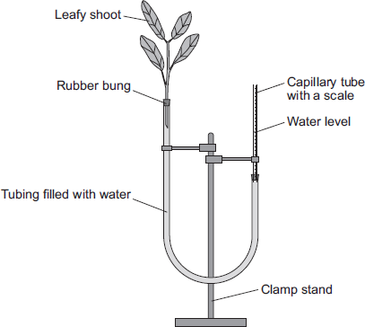

Some students used a potometer like the one shown in Figure 1.
• They measured the water taken up by a shoot in normal conditions in a classroom.
• As the water was taken up by the shoot, the level of water in the capillary tube went down.
• The students recorded the level of the water in the capillary tube at 2-minute intervals for 10 minutes.
Table 1 shows the students’ results.
Table 1

 | Time in minutes | 0 | 2 | 4 | 6 | 8 | 10
 | Level of water (on scale) in  capillary tube in mm | 2.5 | 3.6 | 4.4 | 5.4 | 6.5 | 7.5

The area of the cross section of the capillary tube was 0.8 mm².
(a) (i) Complete the following calculation to find the volume of water taken up by the shoot in mm³ per minute.
Distance water moved along the scale in 10 minutes = ...........mm
Volume of water taken up by the shoot in 10 minutes = ..........mm³
Therefore, volume of water taken up by the shoot in 1 minute = .......mm³
(3)
(ii) The students repeated the investigation but this time placed the potometer next to a fan blowing air over the leafy shoot.
Suggest how the results would be different. Give a reason for your answer.
...............................................................................................................
...............................................................................................................
...............................................................................................................
...............................................................................................................
(2)

(b) The students repeated the investigation at different temperatures.
The results are shown in Table 2.
Table 2

 | Temperature  in °C | Rate of water uptake  in mm³ per minute
 | 10 | 0
 | 15 | 0.4
 | 20 | 1.0
 | 25 | 2.1
 | 30 | 3.2
 | 35 | 4.0
 | 40 | 4.4

Plot the data from Table 2 on the graph paper in Figure 2.
Choose suitable scales, label both axes and draw a line of best fit.
Figure 2
(5)

(c) What would happen to the leaves if the potometer was left for a longer time at 40 °C?
Explain your answer.
........................................................................................................................
........................................................................................................................
........................................................................................................................
........................................................................................................................
........................................................................................................................
........................................................................................................................
(3)
(Total 13 marks)

Q10.The image below shows some cells on the lower surface of a leaf.
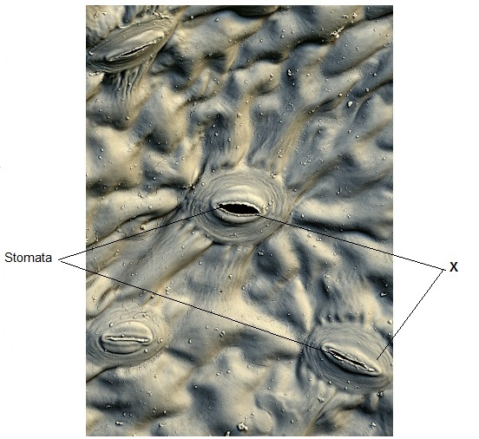
© Stefan Diller/Science Photo Library
(a) What are the cells labelled X called?
Draw a ring around the correct answer.
guard cells palisade cells mesophyll cells
(1)

(b) Water loss by evaporation from leaves is called transpiration.
A student set up an experiment to investigate water loss from leaves.
The student:
• took two leaves, A and B, from a plant
• put Vaseline (grease) on both sides of Leaf B; did nothing to Leaf A
• wrote down the mass of each leaf
• attached the leaves onto a string as shown in the diagram below.

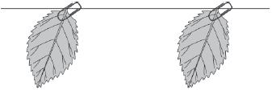

 | Leaf A  (no treatment) | Leaf B  (both surfaces covered in Vaseline)

• left the leaves for 48 hours
• wrote down the mass of each leaf again
• calculated the percentage (%) change in mass for each leaf.

(i) Give one variable that the student controlled in this investigation.
...............................................................................................................
...............................................................................................................
(1)

(ii) The mass of Leaf A was 1.60 g at the start of the investigation. After 48 hours it was 1.28 g.
Calculate the % decrease in mass over 48 hours.
...............................................................................................................
...............................................................................................................
% decrease = .....................................
(2)

(c) Vaseline blocks the stomata.
The % change in mass of Leaf B was less than Leaf A after 48 hours.
Explain why.
........................................................................................................................
........................................................................................................................
........................................................................................................................
(1)

(d) Give three environmental conditions that would increase transpiration.
1 ......................................................................................................................
2 ......................................................................................................................
3 ......................................................................................................................
(3)
(Total 8 marks)

