B5 Diseases |  | Name: ________________________  Class: ________________________  Date: ________________________
Time: | 177 minutes
Marks: | 177 marks
Comments:

Q1. Scientists began to keep records of cases of H5N1 bird flu in humans in January 2004.
The graph shows the total number of cases of bird flu in humans and the total number of deaths up to January 2006.
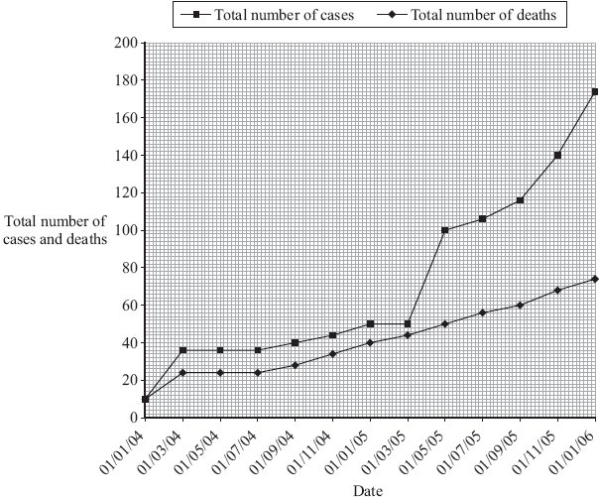
(a) (i) How many people had died from bird flu up to 01/07/05?
..........................................................................................................................
(1)

(ii) Describe, as fully as you can, how the number of cases of bird flu in humans changed between 01/07/04 and 01/01/06.
..........................................................................................................................
..........................................................................................................................
..........................................................................................................................
..........................................................................................................................
(2)

(b) At present, humans can only catch bird flu from contact with infected birds. The bird flu virus may mutate into a form that can be passed from one human to another.
Explain why millions of people may die if the bird flu virus mutates in this way.
.....................................................................................................................................
.....................................................................................................................................
.....................................................................................................................................
.....................................................................................................................................
(2)
(Total 5 marks)

Q2. In the eighteenth century, surgeons did not wear special clothing or wash their hands before operations. Many of their patients died from infections.
(a) Suggest why patients often died from infections after operations.
.....................................................................................................................................
(1)

(b) In the nineteenth century, Joseph Lister told surgeons to use sprays of carbolic acid in operating theatres and to wash their hands.
The graph shows the effect that using Lister’s instructions had on the number of patients who died from infections after surgery.
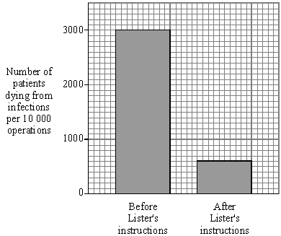

Describe how Lister’s instructions affected the number of patients dying from infections after surgery.
.....................................................................................................................................
.....................................................................................................................................
.....................................................................................................................................
(2)
(Total 3 marks)

Q3. Dr Semmelweiss collected data about the number of deaths in the two maternity wards in the hospital where he worked.
• From 1833 to 1838 there were the same number of doctors and midwives delivering babies in both Ward 1 and Ward 2.
• From 1839 to 1847 medical students and doctors delivered babies in Ward 1; midwives delivered babies in Ward 2.
Dr Semmelweiss also noticed that doctors often came straight from examining dead bodies to the delivery ward.

The table shows the number of patients and the number of deaths in the two wards.

Years | Ward | Number of patients | Number of deaths | Death rate as deaths per 1000 patients
1833–1838 | Ward 1 | 23 509 | 1505 | 64.0
 | Ward 2 | 13 097 | 731 | 55.8
1839–1847 | Ward 1 | 20 204 | 1989 | 98.4
 | Ward 2 | 17 791 | 691

(a) (i) Use the formula
death rate =
to calculate the death rate for Ward 2 in the years 1839 - 1847.
...............................................................................................................
...............................................................................................................
Death rate = .............................. deaths per thousand
(2)

(ii) Suggest a hypothesis for the difference in the death rates on Ward 1 and
Ward 2 in the years 1839 - 1847.
...............................................................................................................
...............................................................................................................
...............................................................................................................
...............................................................................................................
(2)

(b) Antibiotics are now used in hospitals.
What is an antibiotic, and what does it do?
........................................................................................................................
........................................................................................................................
........................................................................................................................
(2)

(c) MRSA is causing problems in hospitals.
Give one reason why.
........................................................................................................................
........................................................................................................................
(1)

(d) How can the work of Semmelweiss help to reduce the problems caused by MRSA?
........................................................................................................................
........................................................................................................................
(1)
(Total 8 marks)

Q4. Pathogens can enter the body and cause disease.
(a) (i) Name one type of medicine which kills bacteria in the body.
..........................................................................................................................
(1)
(ii) Name one type of medicine which helps to relieve the symptoms of infectious disease.
..........................................................................................................................
(1)

(b) Vaccination protects us from pathogens.
The graph shows the concentration of antibodies in the blood of a person after two injections of vaccine given four weeks apart.
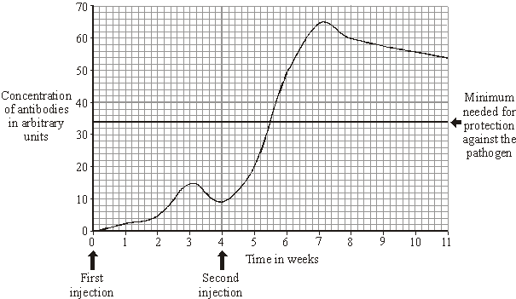

(i) How long after the first injection did it take for the concentration of antibodies to reach the minimum level for protection against the pathogen?
..................................... weeks
(1)

(ii) Describe what happened to the concentration of antibodies in the blood from week 0 to week 7.
..........................................................................................................................
..........................................................................................................................
..........................................................................................................................
..........................................................................................................................
..........................................................................................................................
..........................................................................................................................
..........................................................................................................................
(3)

(iii) Would you expect the concentration of antibodies to stay above the level needed for protection against the pathogen over the next ten years?
Draw a ring around your answer. Yes / No
Give a reason for your answer.
..........................................................................................................................
..........................................................................................................................
(1)
(Total 7 marks)

Q5. (a) List A gives the names of three substances. The substances can help ill people.
List B gives information about the three substances.
Draw a line from each substance in List A to the correct information in List B.
List A  Substance |  | List B  Information
White blood cells produce this
substance
Antibiotic
This substance is used to
kill bacteria
Antitoxin
This substance lowers blood
cholesterol levels
Painkiller
This substance relieves only the
symptoms of a disease

(3)

(b) Complete the sentences.
A vaccine contains an .......................................................... form of a pathogen.
(1)

The MMR vaccine protects children against measles,
mumps and ..........................................................................................................
(1)
(Total 5 marks)

Q6. Some students grew one species of bacterium in a flask.
Diagram 1 shows the flask.
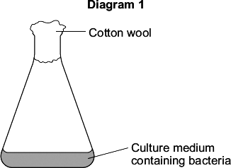
The students wanted to find the number of bacteria in 1 cm³ of the culture medium.
The students:
• diluted 1 cm³ of the culture medium from the flask with 999 cm³ of water
• added 1 cm³ of diluted culture to sterilised nutrient agar in a Petri dish
• placed the Petri dish in an incubator at 25 °C.
Diagram 2 shows the Petri dish after 3 days in the incubator.
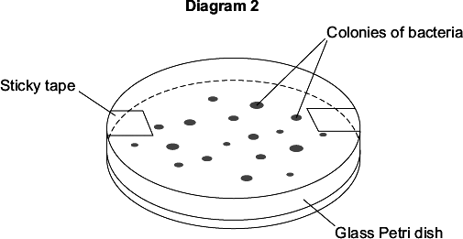
(a) Each colony of bacteria is formed where one bacterium landed on the agar jelly.
How is each colony formed?
........................................................................................................................
........................................................................................................................
(1)

(b) Complete the following calculation to find how many bacteria there were in 1 cm³ of the undiluted culture.
Number of colonies of bacteria in the Petri dish = ........................................
These colonies were formed from 1 cm³ of the culture diluted × 1000.
Therefore, number of bacteria in 1 cm³ of undiluted culture = .....................
(2)

(c) It is important to sterilise the culture medium and all the apparatus before use.
Explain why.
........................................................................................................................
........................................................................................................................
........................................................................................................................
........................................................................................................................
(2)

(d) The bacteria would grow faster at 35 °C. In a school laboratory, the Petri dish should not be incubated at a temperature higher than 25 °C.
Why?
........................................................................................................................
........................................................................................................................
(1)

(e) The students decided to repeat their investigation.
Why?
........................................................................................................................
........................................................................................................................
(1)
(Total 7 marks)

Q7. In the 19th century, Dr Semmelweiss investigated infection in a hospital.
He compared the number of deaths of mothers on two maternity wards.
• On Ward 1, babies were delivered mainly by doctors. These doctors worked on many different wards in the hospital.
• On Ward 2, babies were delivered by midwives. The midwives did not work on other wards.
The bar chart shows the results of his investigations.
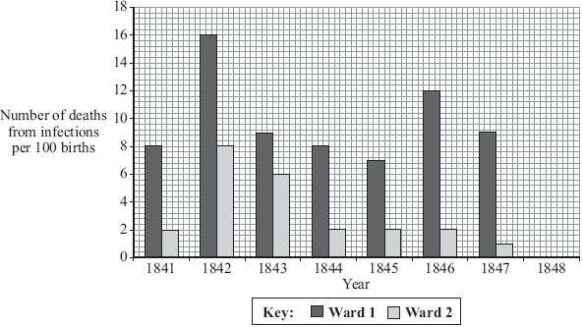

(a) (i) 600 mothers gave birth on Ward 2 in 1845.
How many mothers died from infections on Ward 2 in 1845?
Show clearly how you work out your answer.
...........................................................................................................................
...........................................................................................................................
Number of mothers who died ..............................
(2)

(ii) Which was the safer ward on which to have a baby?
Draw a ring around your answer. Ward 1 / Ward 2.
Using data from the bar chart, give a reason for your answer.
...........................................................................................................................
...........................................................................................................................
(1)

(b) In January 1848, Dr Semmelweiss asked all doctors to wash their hands before delivering babies.
The table shows the number of deaths on the two wards in 1848.

Ward | Number of deaths from infections per 100 births
Ward 1 | 3
Ward 2 | 1

(i) Plot this data on the bar chart above.
(1)

(ii) What was the effect on the death rate on Ward 1 of doctors washing their hands before delivering babies?
...........................................................................................................................
...........................................................................................................................
(1)

(iii) Suggest an explanation for this effect.
...........................................................................................................................
...........................................................................................................................
(1)
(Total 6 marks)

Q8.Viruses and bacteria cause diseases in humans.
(a) Draw a ring around the correct word to complete the sentence.

 |  | algae.
 | Organisms that cause disease are called | pathogens.
 |  | vaccines.

(1)

(b) In August 2011 the United Nations gave a warning that there was a new strain of the bird flu virus in China.
Bird flu may kill humans. The new strain of the bird flu virus could cause a pandemic very quickly.
(i) What is a pandemic?
Tick () one box.
A disease affecting the people all over one country.
A disease affecting hundreds of people.
A disease affecting people in many countries.
(1)

(ii) The swine flu virus is carried by pigs.
The bird flu virus is likely to spread much more quickly than the swine flu virus.
Suggest one reason why.
...............................................................................................................
...............................................................................................................
(1)

This notice is from a doctor’s surgery.

Unfortunately,
antibiotics
will NOT get
rid of your flu.

(c) (i) Why will antibiotics not get rid of flu?
...............................................................................................................
...............................................................................................................
(1)

(ii) The symptoms of flu include a sore throat and aching muscles.
What would a doctor give to a patient to relieve the symptoms of flu?
...............................................................................................................
(1)

(iii) It is important that antibiotics are not overused.
Explain why.
Use words from the box to complete the sentence.

 | antibody | bacteria | immune | resistant | viruses

Overuse of antibiotics might speed up the development
of ................................................... strains of ................................................... .
(2)
(Total 7 marks)

Q9. MRSA strains of bacteria are causing problems in many hospitals.
(a) The diagram shows a hand-gel dispenser.
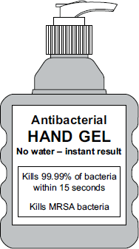
Hand-gel dispensers are now placed at the entrance of most hospital wards.
Explain why.
........................................................................................................................
........................................................................................................................
........................................................................................................................
........................................................................................................................
(2)

(b) Explain, as fully as you can, how MRSA strains of bacteria became difficult to treat.
........................................................................................................................
........................................................................................................................
........................................................................................................................
........................................................................................................................
........................................................................................................................
........................................................................................................................
(3)
(Total 5 marks)

Q10.The photograph below shows human skin highly magnified. Groups of microbes can be seen on the skin.
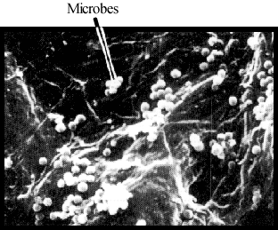

Give two ways in which the body protects itself from these microbes.
1 ............................................................................................................................................
...............................................................................................................................................
2 ............................................................................................................................................
...............................................................................................................................................
(Total 2 marks)

Q11. (a) Explain how diseases caused by bacteria are usually treated by doctors.
.....................................................................................................................................
.....................................................................................................................................
(2)

(b) Explain, as fully as you can, how white blood cells protect us from disease.
.....................................................................................................................................
.....................................................................................................................................
.....................................................................................................................................
.....................................................................................................................................
.....................................................................................................................................
.....................................................................................................................................
.....................................................................................................................................
.....................................................................................................................................
.....................................................................................................................................
.....................................................................................................................................
.....................................................................................................................................
.....................................................................................................................................
(5)
(Total 7 marks)

Q12. Hepatitis B is a liver disease caused by a virus. The virus is found in body fluids such as blood, saliva and urine. Diagram 1 shows the structure of the virus in cross section.
Diagram 1

(a) The human body has several natural defences against viruses. Some of these prevent viruses from entering the body. Others act once the viruses have entered.
(i) Diagram 2 shows a white blood cell attacking a group of viruses.
Complete diagram 2 by drawing the 2nd stage.
1st stage 2nd stage 3rd Stage
Diagram 2
(1)

(ii) What type of chemical is released by some white blood cells to attack viruses?
...........................................................................................................................
(1)

(b) Hepatitis B is more likely to be spread among people who share needles when they inject drugs. Use information given at the beginning of this question to explain why this is so.
.....................................................................................................................................
.....................................................................................................................................
.....................................................................................................................................
.....................................................................................................................................
(2)
(Total 4 marks)

Q13. Read the article.

Parents all over the world advise children to ‘wrap up warm or you’ll catch a cold’.
Scientists at Cardiff University recruited 180 volunteers to take part in an investigation to find out if the advice was true. The investigation took place during the city’s common cold season.
Half of the volunteers put their feet in bowls of ice cold water for 20 minutes. The other volunteers sat with their feet in empty bowls.
Over the next few days, almost a third of the volunteers who put their feet into cold water developed colds. Fewer than one in ten of the other volunteers developed colds.

(a) Draw a ring around the correct answer to complete the sentence.

 | hearsay.
The advice ‘wrap up warm or you’ll catch a cold’ is an example of | a hypothesis.
 | a prediction.

(1)

(b) What was the experimental control in the investigation?
........................................................................................................................
(1)

(c) The scientists did not prove that the advice ‘wrap up warm or you’ll catch a cold’ is true.
Explain why.
........................................................................................................................
........................................................................................................................
........................................................................................................................
........................................................................................................................
........................................................................................................................
........................................................................................................................
(3)
(Total 5 marks)

Q14. Controlling infections in hospitals has become much more difficult in recent years.
(a) Explain why MRSA is causing problems in many hospitals.
.....................................................................................................................................
.....................................................................................................................................
.....................................................................................................................................
.....................................................................................................................................
(2)

(b) The pioneer in methods of treating infections in hospitals was Ignaz Semmelweiss. He observed that women whose babies were delivered by doctors in hospital had a death rate of 18% from infections caught in the hospital. Women whose babies were delivered by midwives in the hospital had a death rate of 2%. He observed that doctors often came straight from examining dead bodies to the delivery ward.

(i) In a controlled experiment, Semmelweiss made doctors wash their hands in chloride of lime solution before delivering the babies. The death rate fell to about 2% – down to the same level as the death rate in mothers whose babies were delivered by midwives.
Explain why the death rate fell.
...........................................................................................................................
...........................................................................................................................
(1)

(ii) Explain how Semmelweiss’s results could be used to reduce the spread of MRSA in a modern hospital.
...........................................................................................................................
...........................................................................................................................
...........................................................................................................................
...........................................................................................................................
(2)
(Total 5 marks)

##
Read the following passage.
One of the deadliest diseases seems to be making a comeback in Britain. Doctors are alarmed at the rising number of cases of tuberculosis (TB).
TB is caused by microbes called bacteria. When people carrying the TB bacteria cough or sneeze, the TB bacteria get into the air. Other people may then breathe them in.

(a) Which organs will be infected first when someone breathes in the TB bacteria?
.....................................................................................................................................
(1)

(b) Explain how the TB bacteria inside the body may cause disease.
.....................................................................................................................................
.....................................................................................................................................
(2)

(c) Name one other group of microbes that often causes disease.
.....................................................................................................................................
(1)

(d) Suggest why people who live in overcrowded areas are more likely to catch TB than people who live in less crowded areas.
.....................................................................................................................................
.....................................................................................................................................
(1)

(e) People infected with a small number of TB bacteria often do not develop the disease.
Explain, as fully as you can, how the body defends itself against the TB bacteria.
.....................................................................................................................................
.....................................................................................................................................
.....................................................................................................................................
.....................................................................................................................................
.....................................................................................................................................
.....................................................................................................................................
(3)
(Total 8 marks)

Q16. Influenza is an infectious disease. The influenza virus often mutates. This has made the World Health Organisation worried about another influenza pandemic.
(a) What is meant by a pandemic?
........................................................................................................................
........................................................................................................................
(1)

(b) Explain why a mutation of the influenza virus might cause another influenza pandemic.
........................................................................................................................
........................................................................................................................
........................................................................................................................
........................................................................................................................
........................................................................................................................
........................................................................................................................
........................................................................................................................
........................................................................................................................
(3)
(Total 4 marks)

Q17.In the 1800s, many women died from disease after giving birth.
Dr Semmelweis compared the death rates of women in two hospital wards,Ward A and Ward B.
Table 1 shows some of the results.
Table 1

 | Year | Percentage (%) of women who died
 |  | Ward A | Ward B
 | 1834 | 7.7 | 7.4
 | 1836 | 7.5 | 7.8
 | 1844 | 8.4 | 2.1
 | 1846 | 11.3 | 2.8

Before 1840
Doctors and nurses worked in Ward A and in Ward B.
The doctors often worked in other wards with patients who had diseases.
The doctors did not wash their hands.
After 1840
Doctors only worked in Ward A and not in Ward B.
Only nurses worked in Ward B.
The nurses did not work in other wards with patients who had diseases.
(a) (i) Look at the data for Ward A and Ward B after 1840.
Describe the effect on death rate of having only nurses working in Ward B and not doctors.
To gain full marks you must refer to the data in Table 1.
...............................................................................................................
...............................................................................................................
...............................................................................................................
...............................................................................................................
(2)

(ii) Suggest an explanation for the difference you described in part (a)(i).
...............................................................................................................
...............................................................................................................
...............................................................................................................
...............................................................................................................
(2)

(b) In 1847, Dr Semmelweis told the doctors to wash their hands each time before they began to work in Ward A.
Table 2 shows the death rates in the two wards, after 1847.
Table 2

 | Year | Percentage (%) of women who died
 |  | Ward A | Ward B
 | 1848 | 2.7 | 2.8
 | 1849 | 2.0 | 1.9

Dr Semmelweis was right to tell the doctors to wash their hands.
What evidence is there to support Dr Semmelweis telling the doctors to wash their hands?
Use information from Table 1 and Table 2 in your answer.
........................................................................................................................
........................................................................................................................
........................................................................................................................
........................................................................................................................
........................................................................................................................
........................................................................................................................
(3)

(c) In modern hospitals less than 0.1% of women die from disease after giving birth.
Medical understanding has improved since the 1850s to reduce the death rate.
Other than improvements in hygiene, give two reasons for the low death rate from
infectious diseases in modern hospitals.
........................................................................................................................
........................................................................................................................
........................................................................................................................
........................................................................................................................
(2)
(Total 9 marks)

Q18. Influenza is caused by a virus.
(a) How do viruses cause illness?
........................................................................................................................
........................................................................................................................
(1)

(b) A British company making a reality television show in the Peruvian Amazon has been accused of starting an influenza epidemic. This epidemic allegedly killed four members of a remote Indian tribe and left others seriously ill.
The members of the television crew did not show symptoms of influenza, but members of the Indian tribe died from the disease.
Suggest an explanation for this.
........................................................................................................................
........................................................................................................................
........................................................................................................................
........................................................................................................................
........................................................................................................................
........................................................................................................................
........................................................................................................................
........................................................................................................................
(3)
(Total 4 marks)

Q19.White blood cells protect the body against pathogens such as bacteria and viruses.
(a) (i) Pathogens make us feel ill.
Give one reason why.
...............................................................................................................
...............................................................................................................
(1)

(ii) White blood cells produce antibodies. This is one way white blood cells protect us against pathogens.
Give two other ways that white blood cells protect us against pathogens.
1.............................................................................................................
...............................................................................................................
2.............................................................................................................
...............................................................................................................
(2)

(b) Vaccination can protect us from the diseases pathogens cause.
(i) One type of virus causes measles.
A doctor vaccinates a child against measles.
What does the doctor inject into the child to make the child immune to measles?
...............................................................................................................
...............................................................................................................
...............................................................................................................
...............................................................................................................
(2)

(ii) A few weeks after the vaccination, the child becomes infected with measles viruses from another person.
The graph shows the number of measles antibodies in the child’s blood from before the vaccination until after the infection.
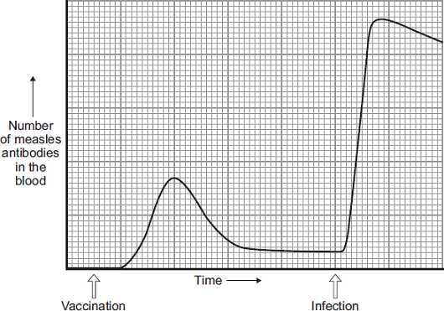
More measles antibodies are produced after the infection than after the vaccination.
Describe other differences in antibody production after infection compared with after vaccination.
...............................................................................................................
...............................................................................................................
...............................................................................................................
...............................................................................................................
...............................................................................................................
...............................................................................................................
(3)

(iii) Vaccination against the measles virus will not protect the child against the rubella virus.
Why?
...............................................................................................................
(1)

(c) What is the advantage of vaccinating a large proportion of the population against measles?
........................................................................................................................
(1)
(Total 10 marks)

Q20. Pathogenic bacteria and viruses may make us feel ill if they enter our bodies.
(a) Why do bacteria and viruses make us feel ill?
Bacteria .....................................................................................................................
....................................................................................................................................
Viruses .......................................................................................................................
....................................................................................................................................
(2)

(b) Most drugs that kill bacteria cannot be used to treat viral infections.
Explain why.
....................................................................................................................................
....................................................................................................................................
....................................................................................................................................
....................................................................................................................................
....................................................................................................................................
....................................................................................................................................
(2)

(c) Antibiotic-resistant strains of bacteria are causing problems in most hospitals.
Explain, as fully as you can, why there has been a large increase in the number of antibiotic-resistant strains of bacteria.
....................................................................................................................................
....................................................................................................................................
....................................................................................................................................
....................................................................................................................................
....................................................................................................................................
....................................................................................................................................
....................................................................................................................................
....................................................................................................................................
....................................................................................................................................
....................................................................................................................................
(4)
(Total 8 marks)

Q21.Some diseases can be cured by using antibiotics or prevented by vaccination.
(a) (i) Explain fully why antibiotics cannot be used to cure viral diseases.
...............................................................................................................
...............................................................................................................
...............................................................................................................
...............................................................................................................
(2)

(ii) There has been a large increase in the populations of many antibiotic-resistant strains of bacteria in recent years.
Explain why.
...............................................................................................................
...............................................................................................................
...............................................................................................................
...............................................................................................................
(2)

(b) A person can be immunised against a disease by injecting them with an inactive form of a pathogen.
Explain how this makes the person immune to the disease.
........................................................................................................................
........................................................................................................................
........................................................................................................................
........................................................................................................................
........................................................................................................................
........................................................................................................................
(3)
(Total 7 marks)

Q22. (a) Explain, as fully as you can, how the body’s white blood cells respond to infections.
.....................................................................................................................................
.....................................................................................................................................
.....................................................................................................................................
.....................................................................................................................................
.....................................................................................................................................
(4)

(b) Describe, in as much detail you can, how one method of immunisation protects us from a named disease.
Name of disease .........................................................................................................
How immunisation protects us from this disease.
.....................................................................................................................................
.....................................................................................................................................
.....................................................................................................................................
.....................................................................................................................................
.....................................................................................................................................
.....................................................................................................................................
(3)
(Total 7 marks)

Q23.Read the following passage.
‘The immune system is the body’s defence force. It protects against infections which
might enter the body. The potential invaders include bacteria and viruses. The two basic
defences are cells and chemicals. The best known action of defence cells is the ingesting
and killing of microbes. The best known chemical defence is the antibody - a protein
5 specially made to match with the surface of an invading microbe. Once covered with
antibody, the microbe becomes easier to destroy.
So how do the invaders ever win? Part of the answer is that the chemical defenders take
some time to become effective. When the body is infected for the first time by a
particular microbe, there is a race between the multiplying microbes and the multiplying
10 cells producing the antibody. Given time, the body usually wins; eventually enough
antibodies are formed to overcome the invaders. But if the initial invasion force is large,
or the immune system is weak, the battle may be lost.’

(a) (i) Which type of cells ingest and kill invading microbes? (lines 3 - 4)
...........................................................................................................................
(1)

(ii) Give two circumstances in which the initial invasion force might be very large (lines 11 - 12).
1 ........................................................................................................................
...........................................................................................................................
2 ........................................................................................................................
...........................................................................................................................
(2)

(iii) After being ingested, the microbes are digested in the cells. Briefly explain what happens to the proteins that the microbes contain.
...........................................................................................................................
...........................................................................................................................
...........................................................................................................................
...........................................................................................................................
(2)

(b) Explain how bacteria cause disease once they get into the body.
.....................................................................................................................................
.....................................................................................................................................
.....................................................................................................................................
.....................................................................................................................................
(2)

(c) Name a type of medicine that kills bacteria inside the body.
.....................................................................................................................................
(1)

(d) People often risk first-time infection by a particular microbe while visiting other countries. People can be immunised against the disease that the microbe causes.
Explain, as fully as you can, how immunisation works.
.....................................................................................................................................
.....................................................................................................................................
.....................................................................................................................................
.....................................................................................................................................
.....................................................................................................................................
.....................................................................................................................................
(3)
(Total 11 marks)

Q24. The influenza virus damages the cells lining the respiratory tract causing sore throats.
Coughing and sneezing spread the virus.
(a) Give the correct term for this method of spreading an infection.
....................................................................................................................................
(1)

(b) In an immunisation programme such as that for MMR (Measles, Mumps and Rubella), suggest why it is essential for a large proportion of the child population to be vaccinated in order to protect the few individuals who are unable to be vaccinated.
....................................................................................................................................
....................................................................................................................................
(1)

(c) In some modern influenza vaccines the protein surface sub-units are separated from the virus coat and used for the vaccine. This stimulates an effective immune response in the same way as inactive pathogens.
(i) Explain how this immunity is produced in the body following vaccination, and how further illness from the same virus is prevented.
...........................................................................................................................
...........................................................................................................................
...........................................................................................................................
...........................................................................................................................
...........................................................................................................................
(4)

(ii) This type of immunity resulting from an influenza injection is described
as ..................................................... immunity.
(1)

(d) The diagram shows the structure of an influenza virus.
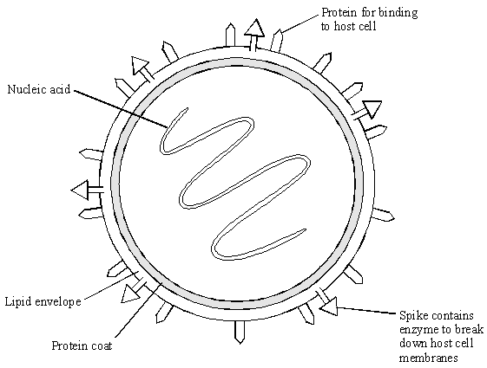

Influenza epidemics can arise because the nucleic acid of the virus frequently changes.
This results in changes in the virus structure and so a new strain of the virus is formed. A person who has had influenza or who has been vaccinated may not be immune to the new strain.
Explain why this is so, using the diagram of the influenza virus structure and your knowledge of immunity.
....................................................................................................................................
....................................................................................................................................
....................................................................................................................................
....................................................................................................................................
....................................................................................................................................
....................................................................................................................................
(3)
(Total 10 marks)

Q25. (a) Microorganisms can be grown on agar jelly in a Petri dish.
List A gives four actions that are sometimes used when growing microorganisms.
List B gives five possible effects of these actions.
Draw a line from each action in List A to its effect in List B.

 | List A – Action |  | List B – Effect
 |  |  | Increases the risk of contamination with bacteria
 | Heating loop in flame
 |  |  | Decreases the risk of bacteria entering
 | Placing loop on bench to cool
 |  |  | Kills bacteria
 | Only lifting lid of Petri dish a little
 |  |  | Prevents air entering
Placing Petri dish in incubator
at 25 °C rather than 35 °C
Decreases the risk of growth
of pathogens

(4)

(b) An investigator placed paper discs containing different concentrations of an antibiotic onto a culture of bacteria in a Petri dish.
After an incubation period of two days, the dish looked like this.
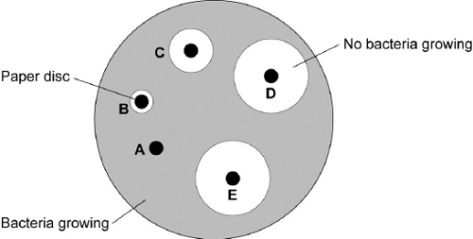
NB: Not to scale
(i) Explain why there are areas around some of the paper discs where no bacteria are growing.
...............................................................................................................
...............................................................................................................
...............................................................................................................
...............................................................................................................
(2)

(ii) The results of the investigation are given in the table.
The table shows the concentration of the antibiotic on the paper discs and the diameter of the circles where no bacteria are growing.

 | Disc | Concentration of the antibiotic in units | Diameter of circle where no bacteria are growing  in mm
 | A | 0 | 0
 | B | 2 | 8
 | C | 4 | 14
 | D | 6 | 26
 | E | 10 | 26

Why did the investigator include Disc A?
...............................................................................................................
(1)

(iii) Use the table to describe the effect of an increase in the concentration of the antibiotic on the growth of the bacteria.
...............................................................................................................
...............................................................................................................
...............................................................................................................
...............................................................................................................
(2)

(iv) The results of the investigation did not show the best concentration of antibiotic to kill the bacteria.
Describe how the experiment could be improved to find the best concentration.
...............................................................................................................
...............................................................................................................
...............................................................................................................
...............................................................................................................
(2)

(c) Scientists are concerned that many bacteria are developing resistance to antibiotic.
(i) Name an antibiotic-resistant strain of bacterium that is causing problems in many hospitals.
...............................................................................................................
(1)

(ii) Name the process that produces an antibiotic-resistant strain of a bacterium.
...............................................................................................................
(1)

(iii) Give one reason why the rate of development of new antibiotic-resistant strains of bacteria has increased.
...............................................................................................................
...............................................................................................................
(1)
(Total 14 marks)

Q26.The parts of the blood can be separated from each other by spinning the blood in a centrifuge.
The image below below shows the separated parts of a 10 cm³ blood sample.
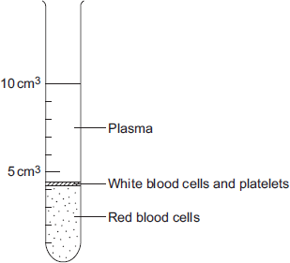
(a) Calculate the percentage of the blood that is made up of plasma.
........................................................................................................................
........................................................................................................................
Answer = .............................. %
(2)

(b) Name three chemical substances transported by the plasma.
1........................................................................................................................
2........................................................................................................................
3........................................................................................................................
(3)

(c) In this question you will be assessed on using good English, organising information clearly and using specialist terms where appropriate.
White blood cells are part of the immune system. White blood cells help the body to defend itself against pathogens.
Describe how pathogens cause infections and describe how the immune system defends the body against these pathogens.
........................................................................................................................
........................................................................................................................
........................................................................................................................
........................................................................................................................
........................................................................................................................
........................................................................................................................
........................................................................................................................
........................................................................................................................
........................................................................................................................
........................................................................................................................
(6)
(Total 11 marks)

