B6 Preventing and Treating Diseases |  | Name: ________________________  Class: ________________________  Date: ________________________
Time: | 135 minutes
Marks: | 135 marks
Comments:

Q1.(a) Use words from the box to complete the sentences about curing disease.

 | antibiotics | antibodies | antitoxins | painkillers | statins

The substances made by white blood cells to kill pathogens
are called ........................................ .
The substances made by white blood cells to counteract poisons produced by
pathogens are called ........................................ .
Medicines which kill bacteria are called ........................................ .
(3)

(b) The MMR vaccine protects people against three diseases.
Write down the names of two of these diseases.
1 .....................................................................................................................
2 .....................................................................................................................
(2)

(c) All vaccinations involve some risk.
The table shows the risk of developing harmful effects:
• from the disease if a child is not given the MMR vaccine
• if a child is given the MMR vaccine.

 | Harmful effect | Risk of developing the harmful effect from the disease if not given the MMR vaccine | Risk of developing the harmful effect if given the MMR vaccine
 | Convulsions | 1 in 200 | 1 in 1000
 | Meningitis | 1 in 3000 | Less than 1 in 1 000 000
 | Brain damage | 1 in 8000 | 0

A mother is considering if she should have her child vaccinated with the MMR vaccine.
Use information from the table to persuade the mother that she should have her child vaccinated.
........................................................................................................................
........................................................................................................................
........................................................................................................................
........................................................................................................................
........................................................................................................................
(2)
(Total 7 marks)

Q2. Polio is a disease caused by a virus. In the UK, children are given polio vaccine to protect them against the disease.
(a) In the sentences below, draw a ring around the correct words in each box.
(i) It is difficult to kill the polio virus inside the body

because the virus | is not affected by drugs  lives inside cells  produces antitoxins

(1)

(ii) The vaccine contains an | active  infective  inactive | form of the polio virus.

(1)

(iii) The vaccine stimulates the white blood cells to

produce | antibiotics  antibodies  drugs | which destroy the virus.

(1)

(b) The graph shows the number of cases of polio in the UK between 1948 and 1968.
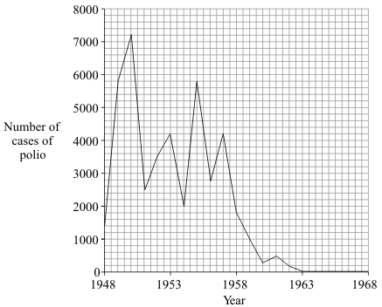
(i) In which year was the number of cases of polio highest?
..........................................................................................................................
(1)

(ii) Polio vaccination was first used in the UK in 1955.
How many years did it take for the number of cases of polio to fall to zero?
..........................................................................................................................
(1)

(iii) There have been no cases of polio in the UK for many years. But children are still vaccinated against the disease.
Suggest one reason for this.
..........................................................................................................................
..........................................................................................................................
(1)
(Total 6 marks)

Q3.Drugs affect the human body.
(a) Draw one line from each drug to the correct information about the drug.

 | Drug |  | Information
 |  |  | Used to boost heart rate
 | Cannabis
 |  |  | Used to treat leprosy
 | Steroid
 |  |  | May cause mental illness in some people
 | Stimulant
 |  |  | Used to increase muscle growth
 | Thalidomide
 |  |  | Used to treat measles

(4)

(b) New drugs must be tested and trialled before being used.
(i) New drugs are tested in a laboratory before they are trialled on people.
What are new drugs tested on in a laboratory?
...............................................................................................................
(1)

(ii) Why is it important that drugs are trialled before doctors give them to patients?
Tick (✓) two boxes.
To check that the drug works
To check the cost of the drug
To find out if the drug is legal
To find the best dose to use

(2)

(iii) In a double blind drug trial, only some people know which patients have been given the drug.
Who knows which patients have been given the drug?
Tick (✓) one box.
The patient and the doctor
Only the doctor
Only scientists at the drug company

(1)

(c) Doctors trialled four different treatments for reducing the risk of heart disease.
Each treatment was trialled on the same number of patients for 5 years.
The patients did not have heart disease at the start of the trial.
The graph below shows the results.
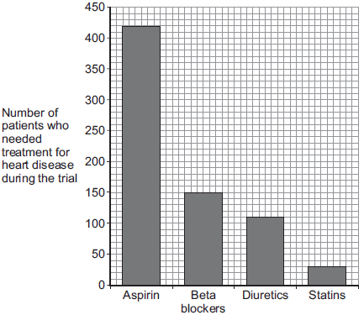
Treatment

(i) How many patients who took aspirin needed treatment for heart disease during the trial?
Number of patients = .............................................
(1)

(ii) Based only on the evidence in the graph, which would be the best treatment to reduce the risk of developing heart disease?
...............................................................................................................
(1)

(iii) Suggest one other factor that a doctor might consider before deciding which treatment to use for a patient.
...............................................................................................................
(1)
(Total 11 marks)

Q4. Scientists at a drug company developed a new pain-killing drug, drug X.
(a) Painkillers do not cure infectious diseases.
Why?
........................................................................................................................
(1)

(b) The scientists compared drug X with two other pain-killing drugs, drug A and drug B.
In their investigation the scientists: • chose 600 volunteers. The volunteers were all in pain • gave 200 of the volunteers a standard dose of drug A • gave 200 of the volunteers a standard dose of drug B • gave 200 of the volunteers a standard dose of drug X.
Over the next seven hours the volunteers recorded how much pain they felt.
To get valid results the three groups of volunteers should be matched for as many factors as possible.
Suggest two of the factors that should be matched.
........................................................................................................................
........................................................................................................................
(2)

(c) The graph shows the results of the investigation.
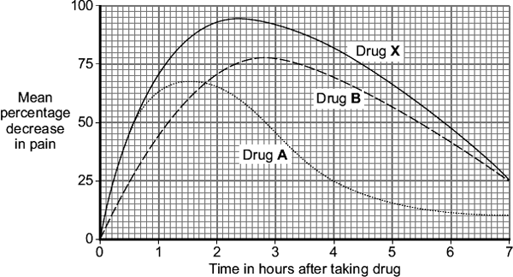
(i) How much pain did the volunteers still feel, four hours after taking drug A?
............................................................ percent
(1)

(ii) Give one advantage of taking drug A and not drug B.
........................................................................................................................
........................................................................................................................
(1)

(iii) Give two advantages of taking drug B and not drug A.
........................................................................................................................
........................................................................................................................
........................................................................................................................
........................................................................................................................
(2)

(d) Drug X is much more expensive than both drug A and drug B.
A pharmacist advised a customer that it would be just as good to take drug A and drug B together instead of drug X.
Do you agree with the pharmacist’s advice?
Give reasons for your answer.
........................................................................................................................
........................................................................................................................
........................................................................................................................
........................................................................................................................
........................................................................................................................
........................................................................................................................
........................................................................................................................
(3)
(Total 10 marks)

Q5. The graph shows the number of people with measles in the UK between 1940 and 2010.
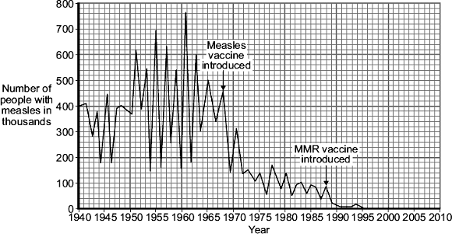
©Health Protection Agency

(a) Compare how effective introducing the measles vaccine was with introducing the MMR vaccine.
Use data from the graph.
........................................................................................................................
........................................................................................................................
........................................................................................................................
........................................................................................................................
........................................................................................................................
........................................................................................................................
........................................................................................................................
........................................................................................................................
(3)

(b) The MMR vaccine was introduced in 1988.
Other than measles, which two diseases does the MMR vaccine protect against?
1 ..................................................... 2 ......................................................
(2)

(c) To immunise someone against measles, a small quantity of the inactive measles pathogen is injected into the body.
Describe what happens in the body after immunisation to stop a person catching measles in the future.
........................................................................................................................
........................................................................................................................
........................................................................................................................

........................................................................................................................
........................................................................................................................
........................................................................................................................
........................................................................................................................
........................................................................................................................
(3)
(Total 8 marks)

Q6. Medicinal drugs are used to treat diseases.
(a) Draw one line from each drug to its correct use.

Drug |  | Use
 |  | Used as a fertility drug
Painkiller
 |  | Used to relieve disease symptoms
Statin
 |  | Used to treat leprosy
Thalidomide
 |  | Used to lower blood cholesterol

(3)

(b) New drugs need to be tested before going on sale.
The diagram shows a time line for the testing of a new drug.
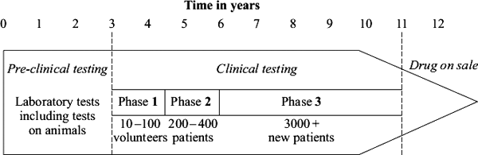
(i) How long do trials on humans take? .................................. years
(1)

(ii) What is the minimum number of humans the drug is tested on throughout clinical testing?
..................................
(1)

(c) Draw a ring around the correct answer to complete each sentence.

 |  | if it is toxic.
(i) | A new drug is first tested in the laboratory to find | if it is cost effective.
 |  | the optimum dose.

(1)

 |  | if it is cost effective.
(ii) | The drug is then tested on a few volunteers to find | if it has side effects.
 |  | the optimum dose.

(1)
(Total 7 marks)

Q7. New drugs have to be thoroughly tested before they are sold.
The diagram shows a time line for the testing of a new drug.
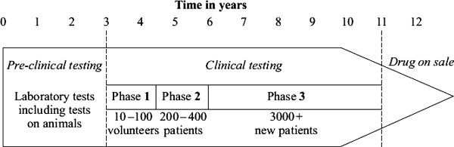
(a) What is the main purpose of pre-clinical testing?
........................................................................................................................
........................................................................................................................
(1)

(b) In Phase 1 of the clinical testing, very low doses of the new drug are used on a small number of volunteers.
(i) What is the main purpose of Phase 1 testing?
...............................................................................................................
...............................................................................................................
(1)

(ii) In Phase 1 testing, healthy volunteers are used rather than patients.
Suggest one reason for this.
...............................................................................................................
...............................................................................................................
(1)

(c) What is the main purpose of the Phase 2 and Phase 3 testing?
........................................................................................................................
........................................................................................................................
(1)

(d) During Phase 3 testing, many of the patients are given a placebo.
(i) What is meant by a placebo?
...............................................................................................................
...............................................................................................................
(1)

(ii) During the testing, who knows which patients are receiving the placebo?
Tick () one box.

Only the patients
Only the doctors
Both patients and doctors
Neither patients nor doctors

(1)
(Total 6 marks)

Q8. Mumps is a disease caused by a virus. Mumps vaccine is usually given to children as part of the MMR vaccine.
(a) What diseases, other than mumps, does the MMR vaccine protect against?
.....................................................................................................................................
(2)

(b) Mumps vaccines contain mumps viruses. Suggest why these viruses do not cause mumps.
.....................................................................................................................................
.....................................................................................................................................
(1)

(c) Explain how the vaccine makes someone immune to mumps.
To gain full marks in this question you should write your ideas in good English. Put them into a sensible order and use the correct scientific words.
.....................................................................................................................................
.....................................................................................................................................
.....................................................................................................................................
.....................................................................................................................................
.....................................................................................................................................
.....................................................................................................................................
.....................................................................................................................................
.....................................................................................................................................
.....................................................................................................................................
.....................................................................................................................................
(5)

(d) A child who has not been given the mumps vaccine catches mumps. Suggest why a doctor would not give antibiotics to cure the child of mumps.
.....................................................................................................................................
.....................................................................................................................................
(1)
(Total 9 marks)

Q9. Scientists have trialled a new statin called rosuvastatin.
• 17 802 people took part in the trial.
• All of these people had high levels of a protein called CRP in their blood.
• The higher the level of CRP in the blood, the higher the risk of a heart attack.
• None of these people had heart conditions at the beginning of the investigation.
• None of these people had high LDL (low density lipoprotein) levels.
• All of these people were aged 50 or above.
• Half the people were given a rosuvastatin tablet each day; the other half were given a placebo.
• The trial was stopped 7 months early when it was found that the people given rosuvastatin were 54% less likely to have a heart attack than people given the placebo.
(a) Give two control variables in this investigation.
1 .....................................................................................................................
2 .....................................................................................................................
(2)

(b) What would the placebo be in this investigation?
........................................................................................................................
........................................................................................................................
(1)

(c) The trial gave reliable results.
Give one reason why.
........................................................................................................................
........................................................................................................................
(1)

(d) The trial was stopped 7 months early.
Give one reason why.
........................................................................................................................
........................................................................................................................
(1)

(e) The manufacturers of rosuvastatin paid for the trial.
However, the manufacturers took no part in the trial.
Suggest one reason why the manufacturers did not take part in the trial.
........................................................................................................................
........................................................................................................................
(1)

(f) The table shows some of the results of the trial.

Substance | Concentration in blood in mg per  100 cm³ after 3 years of trial
 | People given  rosuvastatin | People given  placebo
LDL cholesterol | 53 | 106
HDL cholesterol | 50 | 49
Saturated fats | 106 | 123

Rosuvastatin reduces the risk of heart attacks.
Use the data in the table to explain why.
........................................................................................................................
........................................................................................................................
........................................................................................................................
........................................................................................................................
(2)
(Total 8 marks)

Q10.Many people in the UK take sleeping pills.
(a) The drug thalidomide was developed as a sleeping pill in the 1950s. In the 1960s thalidomide was banned. Recently thalidomide has been used to treat other diseases.
Name one disease thalidomide is used to treat now.
........................................................................................................................
(1)

(b) The table shows information about the development of a new sleeping pill.

 | Type of test  or trial | Preclinical | Clinical  phase 1 | Clinical  phase 2 | Clinical  phase 3
 | Tested or  trialled on | Cells,  tissues or  animals | 20 −100  healthy  volunteers | 100 − 500  volunteer  patients | 1000 − 5000  volunteer  patients
 | Number of  compounds  tested | >10 000 | 5 −10 | 2 − 3 | 1  (new sleeping  pill)
 | Time taken  for test or  trial in years | 1− 4 | 2− 4 | 1 − 3 | 2 − 4

(i) What is the shortest time taken to develop a new sleeping pill?
.......................... years
(1)
(ii) What is the range for the number of volunteers needed to complete all the clinical trials for the new sleeping pill?
...............................................................................................................
(1)

(c) Drugs are trialled to check for side effects on people.
Give one other reason why drugs are trialled.
........................................................................................................................
........................................................................................................................
(1)

(d) The pie chart shows the impact on the health of the population caused by drugs from different sources.
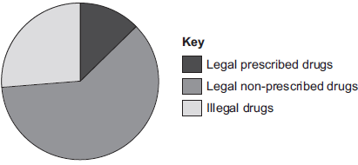
(i) Legal non-prescribed drugs have a greater impact on the health of the population than illegal drugs.
Suggest two reasons why.
...............................................................................................................
...............................................................................................................
...............................................................................................................
...............................................................................................................
...............................................................................................................
...............................................................................................................
(2)

(ii) Drugs change chemical processes in a person’s body.
Why is it difficult for a person to stop taking certain drugs?
...............................................................................................................
...............................................................................................................
(1)
(Total 7 marks)

Q11. Many diseases are caused by viruses. Children are given vaccines to protect them against viral disease.
(a) Complete the following sentences.
It is difficult to kill viruses inside the body because
viruses ......................................................................................................... .
A vaccine contains an ............................................... form of the virus.
The vaccine stimulates the white blood cells to produce ............................. .
(3)

(b) In the 1990s many people thought that the MMR vaccine caused autism in some children. This is why the Japanese government stopped using the MMR vaccine.
The graph gives information about the percentage of Japanese children who developed autism during the 1990s.
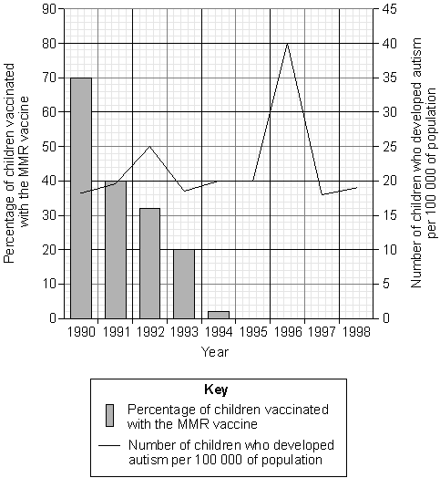

The data in the graph support the view that there is no link between MMR vaccination and autism.
Explain why.
........................................................................................................................
........................................................................................................................
........................................................................................................................
........................................................................................................................
........................................................................................................................
........................................................................................................................
........................................................................................................................
........................................................................................................................
........................................................................................................................
(4)
(Total 7 marks)

Q12.Antibiotics can be used to protect our bodies from pathogens.
(a) What is a pathogen?
........................................................................................................................
........................................................................................................................
(1)

(b) Bacteria may become resistant to antibiotics.
How can doctors reduce the number of bacteria that become resistant to antibiotics?
........................................................................................................................
........................................................................................................................
........................................................................................................................
........................................................................................................................
(2)

(c) Scientists grow microorganisms in industrial conditions at a higher temperature than is used in school laboratories.
(i) Which temperature would be most suitable for growing bacteria in industrial conditions?
Draw a ring around the correct answer.

 | 25 °C | 40 °C | 100 °C

(1)
(iii) What is the advantage of using the temperature you gave in part (c)(i)?
...............................................................................................................
...............................................................................................................
(1)
(Total 5 marks)

Q13. People may be immunised against diseases using vaccines.
(a) (i) Which part of the vaccine stimulates the body’s defence system?
...............................................................................................................
...............................................................................................................
...............................................................................................................
...............................................................................................................
(2)

(ii) A person has been vaccinated against measles. The person comes in contact with the measles pathogen. The person does not catch measles.
Explain why.
...............................................................................................................
...............................................................................................................
...............................................................................................................
...............................................................................................................
...............................................................................................................
...............................................................................................................
(3)

(b) A man catches a disease. The man has not been immunised against this disease. A doctor gives the man a course of antibiotics.
The graph shows how the number of live disease bacteria in the body changes when the man is taking the antibiotics.
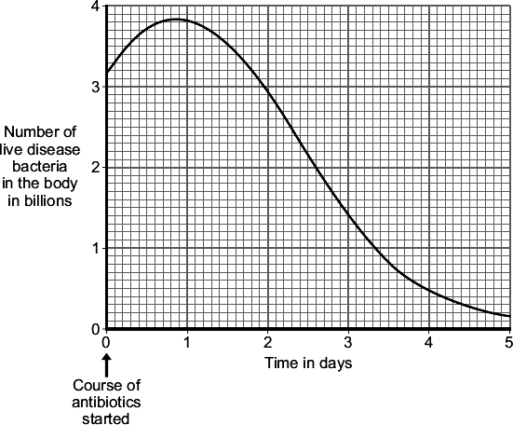

(i) Four days after starting the course of antibiotics the man feels well again.
It is important that the man does not stop taking the antibiotics.
Explain why.
Use information from the graph.
...............................................................................................................
...............................................................................................................
...............................................................................................................
...............................................................................................................
(2)

(ii) Occasionally a new, resistant strain of a pathogen appears.
The new strain may spread rapidly.
Explain why.
...............................................................................................................
...............................................................................................................
...............................................................................................................
...............................................................................................................

...............................................................................................................
...............................................................................................................
(3)
(Total 10 marks)

Q14. The diagram shows two methods which are used to give humans protection against disease. Method A shows active immunity and Method B shows passive immunity. Method A can be used against polio. Method B is often used against tetanus.
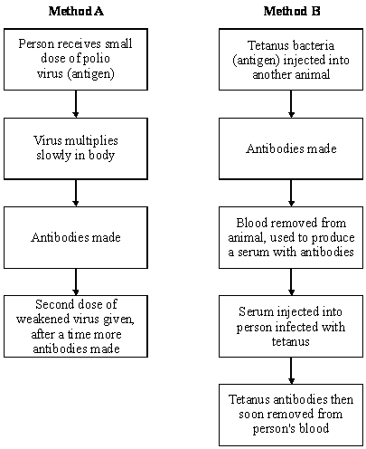

(a) What is the name of the substances produced by the body which destroy harmful viruses and bacteria?
.....................................................................................................................................
(1)

(b) Why does Method A give long lasting protection against polio?
.....................................................................................................................................
(1)

(c) Why does Method B not give long lasting protection against tetanus?
.....................................................................................................................................
(1)

(d) In immunisation against polio a second dose of the weakened virus is given (this is known as a booster). Suggest why this booster is necessary.
.....................................................................................................................................
(1)

(e) Method A would not be helpful for a person who had just been infected with tetanus bacteria. Explain the reason for this.
.....................................................................................................................................
.....................................................................................................................................
(2)

(f) Why is Method B very good for dealing quickly with an infection of tetanus?
.....................................................................................................................................
(1)
(Total 7 marks)

Q15. (a) Antibodies help to defend the body against disease. The diagram represents the reaction of antibody and antigen for disease X.
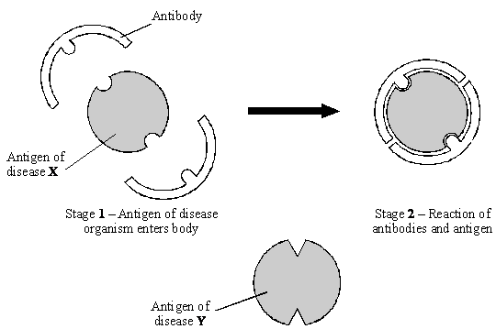

Using the diagram to help you, suggest why the body's defence against disease X would not be effective against disease Y.
...................................................................................................................................
...................................................................................................................................
...................................................................................................................................
(2)

(b) Tuberculosis is a disease which is caused by a bacterium. The body is able to produce antibodies to destroy the bacteria which cause the disease. Some people are naturally immune. A person can be tested to find if they are immune.
Use information in the diagrams to help you answer the questions.
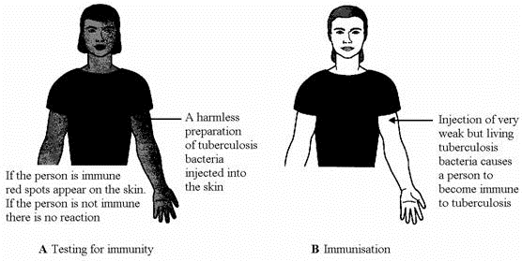

(i) Suggest the possible cause of the reaction when a person who is already immune is tested, as shown in diagram A.
...........................................................................................................................
...........................................................................................................................
...........................................................................................................................
(2)

(ii) Explain why the injection of tuberculosis bacteria (diagram B) causes immunity but does not cause the disease.
...........................................................................................................................
...........................................................................................................................
...........................................................................................................................
...........................................................................................................................
...........................................................................................................................
(3)
(Total 7 marks)

Q16. Drugs must be trialled before the drugs can be used on patients.
(a) (i) Before the clinical trials, drugs are tested in the laboratory.
The laboratory trials are not trials on people.
What is the drug tested on in these laboratory trials?
........................................................................................................................
(1)

(ii) Drugs must be trialled before the drugs can be used on patients.
Give three reasons why.
........................................................................................................................
........................................................................................................................
........................................................................................................................
........................................................................................................................
........................................................................................................................
........................................................................................................................
(3)

(b) Read the information about cholesterol and ways of treating high cholesterol levels.
Diet and inherited factors affect the level of cholesterol in a person’s blood.
Too much cholesterol may cause deposits of fat to build up in blood vessels and reduce the flow of blood. This may cause the person to have a heart attack.
Some drugs can lower the amount of cholesterol in the blood.
The body needs cholesterol. Cells use cholesterol to make new cell membranes and some hormones. The liver makes cholesterol for the body.

Some drugs can help people with high cholesterol levels.
Statins block the enzyme in the liver that is used to produce cholesterol.
People will normally have to take statins for the rest of their lives. Statins can lead to muscle damage and kidney problems. Using some statins for a long time has caused high numbers of deaths.
Cholesterol blockers reduce the absorption of cholesterol from the intestine into the blood.
Cholesterol blockers can sometimes cause problems if the person is using other drugs.

Evaluate the use of the two types of drug for a person with high cholesterol levels.
........................................................................................................................
........................................................................................................................
........................................................................................................................
........................................................................................................................
........................................................................................................................
........................................................................................................................
........................................................................................................................
........................................................................................................................
........................................................................................................................
........................................................................................................................
........................................................................................................................
........................................................................................................................
........................................................................................................................
........................................................................................................................
(6)
(Total 10 marks)

Q17.Infections by antibiotic resistant bacteria cause many deaths.
The bar chart below shows information about the number of deaths per year in England from Methicillin-resistant Staphylococcus aureus (MRSA) and from Clostridium difficile (C.difficile) over 4 years.
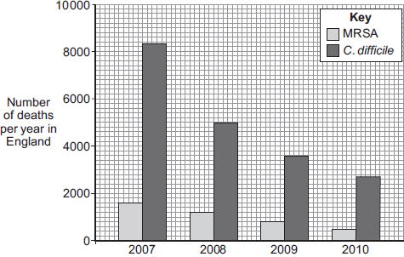
Year

(a) (i) Describe the trend for deaths caused by C.difficile.
...............................................................................................................
...............................................................................................................
...............................................................................................................
...............................................................................................................
(2)

(ii) Suggest a reason for the trend you have described in part (a)(i).
Explain your answer.
...............................................................................................................
...............................................................................................................
...............................................................................................................
...............................................................................................................
(2)

(iii) Calculate the percentage change in deaths caused by MRSA from 2009 to 2010.
...............................................................................................................
...............................................................................................................
...............................................................................................................
Percentage change in deaths caused by MRSA = .......................... %
(2)

(iv) Numbers have not yet been published for 2011.
When the numbers are published, scientists do not expect to see such a large percentage change from 2010 to 2011 as the one you have calculated for 2009 to 2010.
Suggest one reason why.
...............................................................................................................
...............................................................................................................
(1)

(b) Before 2007 there was a rapid increase in the number of deaths caused by MRSA.
Describe how the overuse of the antibiotic methicillin led to this increase.
........................................................................................................................
........................................................................................................................
........................................................................................................................
........................................................................................................................
........................................................................................................................
........................................................................................................................
(3)
(Total 10 marks)

