B7 Non Communicable Diseases |  | Name: ________________________  Class: ________________________  Date: ________________________
Time: | 46 minutes
Marks: | 46 marks
Comments:

Q1.A healthy diet contains the right balance of different foods and the right amount of energy.
(a) An unbalanced diet can lead to health problems.
One problem caused by an unbalanced diet is being overweight.
Name one health problem, other than being overweight, that is linked to an unbalanced diet.
........................................................................................................................
(1)

(b) Sugar is a type of carbohydrate.
(i) Eating too much sugar can make a person overweight.
Suggest why.
...............................................................................................................
...............................................................................................................
(1)

(ii) Which other substance in food is linked to people being overweight?
Draw a ring around the correct answer.

 | fat | mineral ions | vitamins

(1)

(c) Sugar substitutes taste sweet.
Taking sugar substitutes helps to reduce the chance of becoming overweight.
The table below gives information about four sugar substitutes, A, B, C and D.

 | Sugar substitute | Number of times sweeter than sugar | Effects on health
 | A | × 200 | Harmful to some people
 | B | × 250 | Not known
 | C | × 600 | Not known
 | D | × 500 | None

(i) Which sugar substitute, A, B, C or D, is the sweetest?
(1)

(ii) A person is advised to use sugar substitute D and not sugar substitutes A, B or C.
Suggest a reason why.
...............................................................................................................
...............................................................................................................
(1)

(iii) A food has a sugar substitute in it.
Why must it say on the packet which sugar substitute it is?
...............................................................................................................
...............................................................................................................
(1)
(Total 6 marks)

Q2. Obesity is linked to several diseases.
(a) Name two diseases linked to obesity.
1 .....................................................................................................................
2 .....................................................................................................................
(2)

(b) Scientists trialled a new slimming drug.
The table shows their results after one year.
Percentage change in mass  of each volunteer | Number of volunteers | gained mass or lost 0 to 3.9 % | 1900
lost 4.0 to 4.9 % | 1100
lost 5.0 to 9.9 % | 1500
lost 10 % or more | 1500

(i) Calculate the proportion of the volunteers who lost 10 % or more of their mass.
You should first calculate the total number of volunteers, then work out the proportion.
...............................................................................................................
...............................................................................................................
Proportion of volunteers = ..................................................
(2)

(ii) The National Health Service (NHS) gave permission for the drug to be used.
Use information from the table to suggest a reason why the NHS gave permission for the drug to be used.
...............................................................................................................
...............................................................................................................
(1)
(Total 5 marks)

Q3.Scientists investigated the effect of different factors on health.
(a) People who are not active may have health problems.
The graph shows the percentage of 16-year-olds in some countries who are not active.
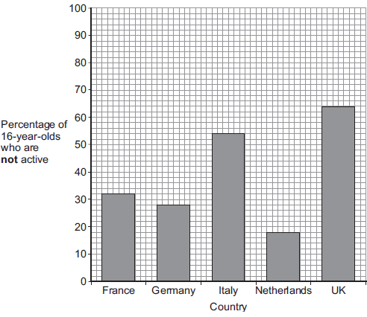
(i) What percentage of 16-year-olds in the UK are not active?
.......................... %
(1)
(ii) What percentage of 16-year-olds in the UK are active?
.......................... %
(1)
(iii) A newspaper headline states:
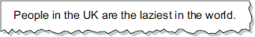
Information in Figure 1 does not support the newspaper headline.
Suggest one reason why the newspaper headline may be wrong.
...............................................................................................................
...............................................................................................................
(1)

(b) Doctors gave a percentage rating to the health of 16-year-olds.
100% is perfect health.
The table shows the amount of exercise 16-year-olds do and their health rating.

 | Amount of exercise done in minutes every week | Health rating as %
 | Less than 30 | 72
 | 90 | 76
 | 180 | 82
 | 300 | 92

What conclusion can be made about the effect of exercise on health?
Use information from the table.
........................................................................................................................
........................................................................................................................
(1)

(c) Inherited factors can also affect health.
Give one health problem that may be affected by the genes someone inherits.
Draw a ring around the correct answer.

 | being  malnourished | having a high  cholesterol level | having a  deficiency disease

(1)

(d) White blood cells are part of the immune system.
Use the correct answer from the box to complete each sentence.

 | antibiotics | antibodies | pathogens | vaccines

(i) When we are ill, white blood cells produce .............................................. to kill microorganisms.
(1)
(ii) Many strains of bacteria, including MRSA, have developed resistance to drugs called
...............................................................................................................
(1)
(Total 7 marks)

Q4. Nicotine is a drug in tobacco smoke. Smoking tobacco is harmful.
(a) (i) Many smokers find it difficult to stop smoking.
Complete the sentence.
It is difficult to stop smoking because nicotine is very ........................ .
(1)

(ii) Nicotine affects synapses in the brain.
What is a synapse?
...............................................................................................................
...............................................................................................................
(1)

(b) A drug company has developed a new drug, Drug A, to help people stop smoking.
Doctors tested the drug in a double-blind trial with over 2000 volunteers who were smokers.
The volunteers wanted to stop smoking.
The volunteers were divided into three groups. Each volunteer took a tablet once a day for 12 weeks:
• group 1 took Drug A
• group 2 took Drug B (a drug already in use to stop people smoking)
• group 3 took a placebo.
The smoking habits of each group were recorded for a year.
(i) What is a placebo?
...............................................................................................................
(1)

(ii) Why is a placebo group used in drug trials?
...............................................................................................................
...............................................................................................................
(1)

(iii) Which people knew what was in each tablet, in this trial?
Tick () one box.
Both doctors and volunteers
Doctors but not volunteers
Neither doctors nor volunteers

(1)

(iv) It is important that the three groups of volunteers should be similar.
Give two factors that should be similar in the groups of volunteers.
1 ............................................................................................................
2 ............................................................................................................
(2)

(c) The table shows the results of the trials.
Tablet | Percentage of volunteers who had stopped smoking
 | After 12 weeks | After 1 year
Drug A | 44 | 23
Drug B | 30 | 15
Placebo | 18 | 10

A doctor looked at the results of the tests.
The doctor suggested that a smoker who wanted to give up smoking should use Drug A.
Why?
........................................................................................................................
........................................................................................................................
(1)
(Total 8 marks)

Q5. Diet and exercise affect health.
(a) Many people are obese (very overweight).
Obesity can lead to heart disease.
Other than heart disease, name two conditions which are linked to obesity.
1 .....................................................................................................................
2 .....................................................................................................................
(2)

(b) The graph shows the number of deaths from heart disease each year in the UK.
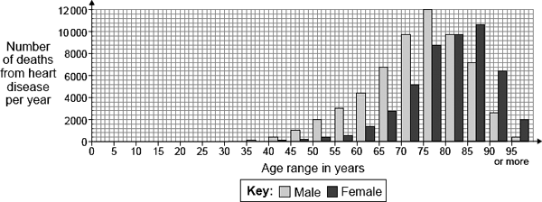
The pattern for deaths from heart disease in men is different from the pattern in women.
(i) Give two differences between the patterns for men and women.
1 ............................................................................................................
...............................................................................................................
2 ............................................................................................................
...............................................................................................................
(2)

(ii) Suggest two reasons for the difference in the number of deaths from heart disease in men and women between the ages of 40 and 60.
1 ............................................................................................................
...............................................................................................................
2 ............................................................................................................
...............................................................................................................
(2)

(c) Scientists have developed drugs to reduce the concentration of cholesterol in the blood.
Give the three main stages in testing a new drug before it is sold to the public.
1 .....................................................................................................................
........................................................................................................................
2 .....................................................................................................................
........................................................................................................................
3 .....................................................................................................................
........................................................................................................................
(3)
(Total 9 marks)

Q6. Scientists estimate that about one third of cancers in the UK may be linked to obesity.
Name two diseases linked to obesity.
Do not give cancer as one of your answers.
1 .....................................................................................................................
2 .....................................................................................................................
(2)

(Total 2 marks)

Q7.(a) A healthy diet should be balanced.
What is meant by a balanced diet?
........................................................................................................................
........................................................................................................................
........................................................................................................................
........................................................................................................................
(2)

(b) Cholesterol has important functions in the body.
Some cholesterol is produced by the liver.
Cholesterol is needed in the body to make the hormone oestrogen.
(i) Name the organ in the body which produces oestrogen.
...............................................................................................................
(1)
(ii) What effect does oestrogen have on the female reproductive cycle?
...............................................................................................................
...............................................................................................................
(1)
(iii) Oestrogen is a naturally occurring steroid hormone.
Give one artificial use of a steroid hormone in the body.
...............................................................................................................
...............................................................................................................
(1)

(c) The graph below shows the effect of the mass of cholesterol in the diet on:
• the concentration of cholesterol in the blood
• the mass of cholesterol produced by the liver.
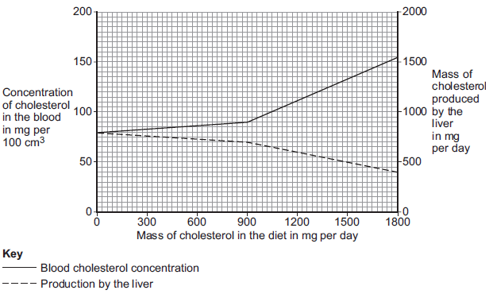
Describe the effect of increasing the mass of cholesterol in the diet on the mass of cholesterol produced by the liver.
To gain full marks you should include data from the graph in your answer.
........................................................................................................................
........................................................................................................................
........................................................................................................................
........................................................................................................................
........................................................................................................................
........................................................................................................................
(2)

(d) Large amounts of cholesterol in the diet switch off the production of an enzyme called reductase, in the liver.
An increase of the enzyme reductase increases the production of cholesterol by the liver.
(i) Which part of a liver cell is responsible for controlling the production of reductase?
...............................................................................................................
...............................................................................................................
(1)
(ii) High blood cholesterol concentrations increase the likelihood of heart and circulatory diseases.
Doctors can prescribe statins to control the concentration of cholesterol in the blood.
Suggest how statins work.
...............................................................................................................
...............................................................................................................
(1)
(Total 9 marks)

