B8 Photosynthesis Exam Pack |  | Name: ________________________  Class: ________________________  Date: ________________________
Time: | 132 minutes
Marks: | 132 marks
Comments:

Q1.Duckweed is a plant. Duckweed grows in ponds. The leaves of duckweed float on the surface of the water and its roots hang down in the water.
The drawing shows a duckweed plant.
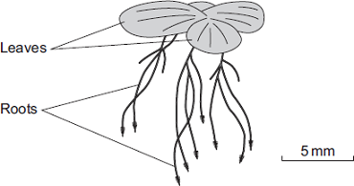
(a) Duckweed roots absorb nitrate ions from the water.
The nitrate ions help the duckweed to grow.
Draw a ring around the correct answer to complete the sentence.

 | carbohydrate.
Duckweed needs nitrate ions to make | fat.
 | protein.

(1)

(b) Some students grew duckweed plants in three different solutions of mineral ions, A, B and C, and in distilled water (D).
Table 1 shows the concentrations of mineral ions in each of A, B, C and D at the start of the investigation.
Table 1

Mineral ion | Concentration of mineral ions  in mg per dm ³ at the start of  the investigation
 | A | B | C | D
Nitrate | 1000 | 4 | 4 | 0
Phosphate | 300 | 0 | 0 | 0
Magnesium | 200 | 84 | 24 | 0

The students counted the number of duckweed leaves in A, B, C and D at the start of the investigation and after 28 days.
Table 2 shows their results.
Table 2

 | A | B | C | D
Number of leaves at start | 4 | 4 | 4 | 4
Number of leaves after 28 days | 50 | 27 | 14 | 6

(i) Using Table 1 and Table 2, describe the effect of magnesium ions on the growth of duckweed.
...............................................................................................................
...............................................................................................................
(1)

(ii) Solution A contained the highest concentration of nitrate ions.
One student said, ‘The results show that nitrate ions are needed for the growth of duckweed.’
What evidence in Table 2 supports what the student said?
...............................................................................................................
...............................................................................................................
(1)

(c) The students measured the growth of the duckweed by counting the number of leaves.
(i) Suggest a better method of measuring the growth of the duckweed.
...............................................................................................................
...............................................................................................................
(1)

(ii) Suggest why your method is better than the students’ method.
...............................................................................................................
...............................................................................................................
(1)
(Total 5 marks)

Q2. (a) Complete the word equation for photosynthesis.
Use words from the box.

chlorophyll | minerals | oxygen | water

carbon dioxide + ........................ → glucose + ........................
(2)

(b) Plants may grow faster if they have more carbon dioxide.
Indigestion tablets dissolve in water to form a solution.
This solution slowly gives off carbon dioxide.
A student set up an investigation to see what concentration of carbon dioxide is best for increasing the growth of geranium plants.
The student:
• put a geranium plant in a clear plastic bag
• put a dish containing water and one tablet in the bag
• sealed the top of the bag.
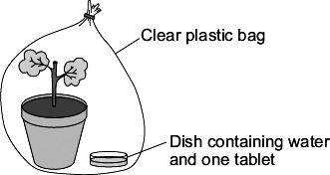
The student:
• set up 5 more experiments each with water and a different number of tablets
• left all the plants in a well-lit place for four weeks.
The student used a clear plastic bag, not a black plastic bag.
Explain why.
........................................................................................................................
........................................................................................................................
........................................................................................................................
........................................................................................................................
(2)

(c) After four weeks, the student counted the number of new leaves on each plant.
The graph shows his results.
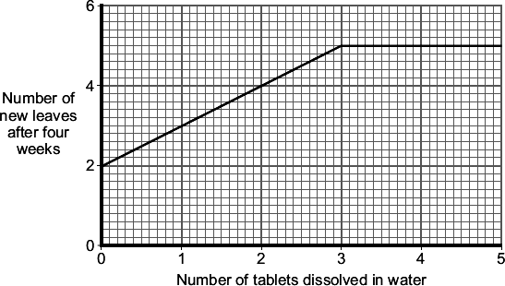
Describe the effect of increasing the number of tablets dissolved in water on the number of new leaves that grew in four weeks.
........................................................................................................................
........................................................................................................................
........................................................................................................................
........................................................................................................................
........................................................................................................................
........................................................................................................................
(3)
(Total 7 marks)

Q3.Photosynthesis uses carbon dioxide to make glucose.
(a) (i) Complete the equation for photosynthesis.
carbon dioxide + ..........................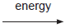 glucose + ....................
(2)
(ii) What type of energy does a plant use in photosynthesis?
...............................................................................................................
(1)
(iii) Which part of a plant cell absorbs the energy needed for photosynthesis?
...............................................................................................................
(1)

(b) The graph shows the effect of the concentration of carbon dioxide on the rate of photosynthesis in tomato plants at 20 °C.
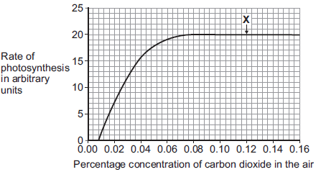

(i) What is the maximum rate of photosynthesis of the tomato plants shown in the graph?
.......................... arbitrary units
(1)
(ii) At point X, carbon dioxide is not a limiting factor of photosynthesis.
Suggest one factor that is limiting the rate of photosynthesis at point X.
...............................................................................................................
(1)

(c) A farmer plans to grow tomatoes in a large greenhouse.
The concentration of carbon dioxide in the atmosphere is 0.04%.
The farmer adds carbon dioxide to the greenhouse so that its concentration is 0.08%.
(i) Why does the farmer use 0.08% carbon dioxide?
Tick () one box.

To increase the rate of growth of the tomato plants
To increase the rate of respiration of the tomato plants
To increase water uptake by the tomato plants

(1)

(ii) Why does the farmer not use a concentration of carbon dioxide higher than 0.08%?
Tick () two boxes.

Because it would cost more money than using 0.08%
Because it would decrease the temperature of the greenhouse
Because it would not increase the rate of photosynthesis of the
tomato plants any further
Because it would increase water loss from the tomato plants

(2)
(Total 9 marks)

Q4. The diagram shows bushes in a hedge growing near to a house.
The bushes were the same species and the same age.
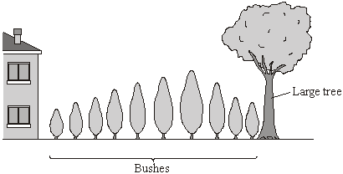
(a) (i) The student said, “I have noticed that the short bushes grow next to the house. I think that the more light the bushes get, the faster they will grow.”
Draw lines to match each of the student’s statements to the correct term.
Draw only two lines.
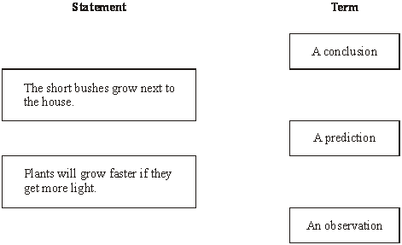
(2)

(ii) Complete the word equation for photosynthesis.
..................................... +water (+ light energy) → ................................ + oxygen
(2)

(b) The student decided to investigate the effect of light intensity on the rate of photosynthesis.
She used the apparatus shown in the diagram.
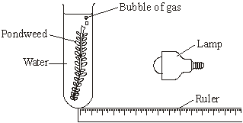
She measured the rate of photosynthesis by counting the number of gas bubbles given off each minute.

(i) Suggest how the student varied the intensity of the light received by the pondweed.
...........................................................................................................................
...........................................................................................................................
(1)

(ii) The student’s results are shown on the graph.
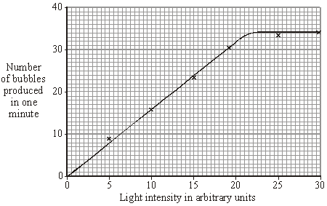
Describe the pattern shown on the graph.
...........................................................................................................................
...........................................................................................................................
...........................................................................................................................
...........................................................................................................................
(2)

(iii) This is what the student wrote for her conclusion.
“Increasing the light intensity increases the rate of photosynthesis of the pondweed.”
Why was her conclusion incomplete?
...........................................................................................................................
...........................................................................................................................
(1)
(Total 8 marks)

Q5.(a) A student carried out the following investigation using a plant with variegated leaves. A variegated leaf has green and white stripes.
The student:
• left the plant in the dark for 3 days to remove the starch
• fixed two pieces of card to a leaf on the plant
• left the plant in the light for 2 days
• removed the leaf from the plant
• tested the leaf for starch.
Figure 1 shows how the two pieces of card were attached to the leaf.

Figure 1

 | Leaf without card |  | Leaf with card

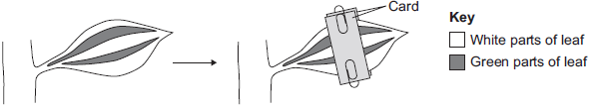

Figure 2 shows the same leaf after 2 days in the light.
The leaf has been tested for starch.
Figure 2
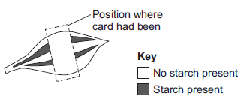
Give two conclusions from this investigation.
Tick () two boxes.
Carbon dioxide is needed for photosynthesis.
Chlorophyll is needed for photosynthesis.
Light is needed for photosynthesis.
Water is needed for photosynthesis.

(2)

(b) Scientists investigated the effect of light intensity on the rate of photosynthesis.
Figure 3 shows the scientists’ results.
Figure 3
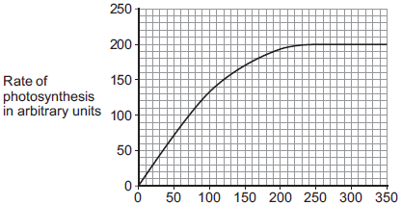
Light intensity in arbitrary units

Describe the effect of increasing light intensity on the rate of photosynthesis.
You should include numbers from Figure 3 in your description.
........................................................................................................................
........................................................................................................................
........................................................................................................................
........................................................................................................................
........................................................................................................................
........................................................................................................................
(3)

(c) At a light intensity of 250 arbitrary units, light is not a limiting factor of photosynthesis.
(i) What is the evidence for this in Figure 3?
...............................................................................................................
...............................................................................................................
(1)

(ii) Give two factors that could be limiting the rate of photosynthesis at a light intensity of 250 arbitrary units.
1 ............................................................................................................
2 ............................................................................................................
(2)
(Total 8 marks)

Q6. People often grow pondweed in fishponds to oxygenate the water.
(a) Name the process that the pondweed uses to produce oxygen.
........................................................................................................................
(1)

(b) A student investigated oxygen production in three different pondweeds, Elodea,Cabomba and Egeria.
The student:
• cut a piece of pondweed from an Elodea plant
• put the pondweed into a tube of water
• counted the bubbles given off in one minute
• did the experiment again using a piece of pondweed from a Cabomba plant
• did the experiment a third time using a piece of pondweed from an Egeria plant.
The diagram shows the student’s investigation.
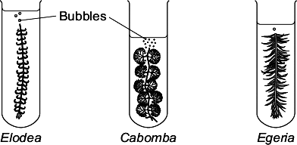
The table shows the results.
Pondweed | Number of bubbles  produced in 1 minute
Elodea | 17
Cabomba | 28
Egeria | 8

(i) The student said:
“I suggest that people grow Cabomba in garden ponds to oxygenate the water fastest.”
Give three variables the student should have controlled to make sure his conclusion was valid.
Use information from the student’s method and the diagram.
1 ............................................................................................................
...............................................................................................................
2 ............................................................................................................
...............................................................................................................
3 ............................................................................................................
...............................................................................................................
(3)

(ii) The three pondweeds all cost about the same.
Suggest one other factor that people with fishponds might think about before deciding which type of pondweed to use.
...............................................................................................................
(1)

(c) A person grows Cabomba in his pond.
The Cabomba plants develop yellow leaves.
Which mineral ion would stop the leaves turning yellow?
........................................................................................................................
(1)
(Total 6 marks)

Q7.This question is about photosynthesis.
(a) Plants make glucose during photosynthesis. Some of the glucose is changed into insoluble starch.
What happens to this starch?
Tick () one box.
The starch is converted into oxygen.
The starch is stored for use later.
The starch is used to make the leaf green.
(1)

(b) A student investigated the effect of temperature on the rate of photosynthesis in pondweed.
The diagram shows the way the experiment was set up.
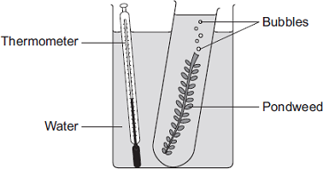
(i) The student needed to control some variables to make the investigation fair.
State two variables the student needed to control in this investigation.
1.............................................................................................................
2.............................................................................................................
(2)

(ii) The bubbles of gas are only produced while photosynthesis is taking place.
What two measurements would the student make to calculate the rate of photosynthesis?
1.............................................................................................................
2.............................................................................................................
(2)

(c) The graph shows the effect of temperature on the rate of photosynthesis in the pondweed.
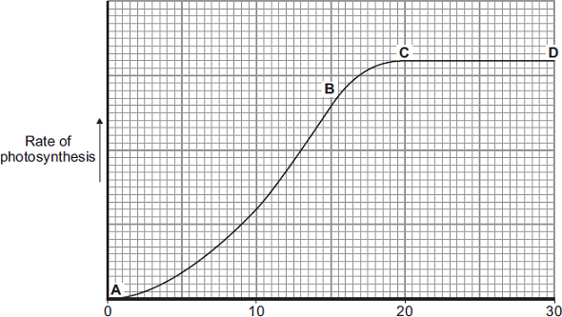
Temperature in °C
(i) Name the factor that limits the rate of photosynthesis between the points labelled A and B on the graph.
...............................................................................................................
(1)

(ii) Suggest which factor, carbon dioxide, oxygen or water, might limit the rate of photosynthesis between the points labelled C and D on the graph.
...............................................................................................................
(1)
(Total 7 marks)

Q8. A student measured the concentration of carbon dioxide in the air around a potted plant on two different days.
The diagram shows the student’s apparatus.
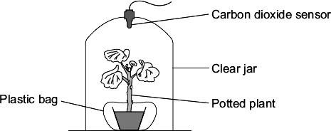
There was a plastic bag round the plant pot to stop microorganisms in the soil affecting the concentration of gases in the air inside the jar.
The apparatus was put near a window.
The graph shows the results.
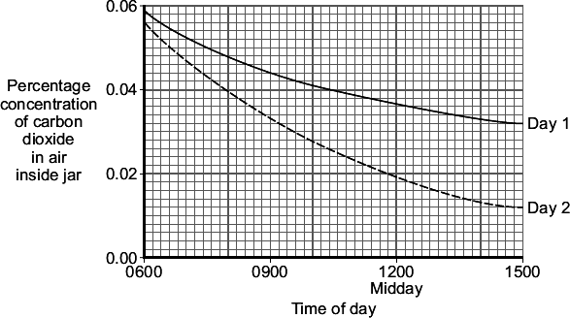
(a) Day 1 was cloudier than Day 2.
What evidence from the graph shows that Day 1 was cloudier?
Explain your answer.
.................................................................................................................................
.................................................................................................................................
.................................................................................................................................
.................................................................................................................................
(2)

(b) A potted plant sometimes develops yellow leaves.
The development of yellow leaves could be due to the lack of a mineral ion.
Suggest the mineral ion that could be lacking.
.................................................................................................................................
(1)

(Total 3 marks)

Q9.Some students investigated the effect of light intensity on the rate of photosynthesis.
They used the apparatus shown in Diagram 1.
Diagram 1
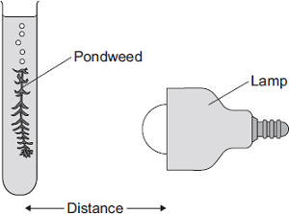
The students:
• placed the lamp 10 cm from the pondweed
• counted the number of bubbles of gas released from the pondweed in 1 minute
• repeated this for different distances between the lamp and the pondweed.
(a) The lamp gives out heat as well as light.
What could the students do to make sure that heat from the lamp did not affect the rate of photosynthesis?
........................................................................................................................
........................................................................................................................
(1)

(b) The table shows the students’ results.

 | Distance in cm | Number of bubbles  per minute
 | 10 | 84
 | 15 | 84
 | 20 | 76
 | 40 | 52
 | 50 | 26

(i) At distances between 15 cm and 50 cm, light was a limiting factor for photosynthesis.
What evidence is there for this in the table?
...............................................................................................................
...............................................................................................................
(1)

(ii) Give one factor that could have limited the rate of photosynthesis when the distance was between 10 cm and 15 cm.
...............................................................................................................
(1)

(c) In this question you will be assessed on using good English, organising information clearly and using specialist terms where appropriate.
Diagram 2 shows a section through a plant leaf.
Diagram 2
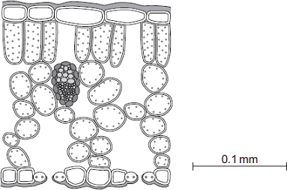
Describe the structure of the leaf and the functions of the tissues in the leaf.
You should use the names of the tissues in your answer.
........................................................................................................................
........................................................................................................................
........................................................................................................................
........................................................................................................................
........................................................................................................................
........................................................................................................................
........................................................................................................................
........................................................................................................................
........................................................................................................................
........................................................................................................................
........................................................................................................................
........................................................................................................................
(6)
(Total 9 marks)

Q10.In this question you will be assessed on using good English, organising information clearly and using specialist terms where appropriate.
Ivy plants can grow up trees and walls.
Figure 1 shows two ivy leaves. One leaf is from an ivy plant growing up a tree in the centre of a shady woodland area. The other leaf is from an ivy plant growing up a tree in a sunny area at the edge of the woodland.
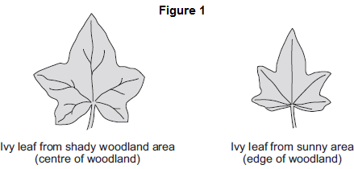

A student makes the following hypothesis.
“The size of ivy leaves decreases as light intensity increases.”
How would you use the apparatus shown in Figure 2 to test this hypothesis?
You should include details of how you would make sure the results are valid.
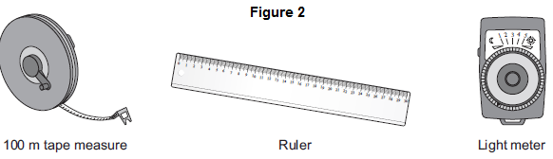
.................................................................................................................................
.................................................................................................................................
.................................................................................................................................
.................................................................................................................................
.................................................................................................................................
.................................................................................................................................
.................................................................................................................................
.................................................................................................................................
.................................................................................................................................
.................................................................................................................................
(Total 6 marks)

Q11. The graph shows the uptake of carbon dioxide and the release of carbon dioxide by a bean plant on a hot summer’s day.
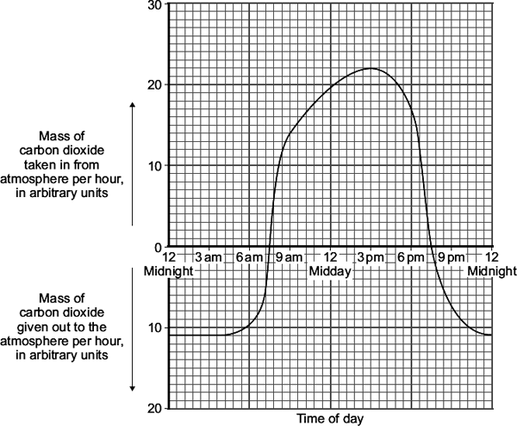
(a) At which two times in the day did the rate of photosynthesis exactly match the rate of respiration in the bean plant?
1 ......................................................... 2 .........................................................
(1)

(b) The bean plant respires at the same rate all through the 24 hour period.
(i) How much carbon dioxide is released each hour during respiration?
......................................................... arbitrary units
(1)

(ii) How much carbon dioxide is used by photosynthesis in the hour beginning at 3 pm?
...............................................................................................................
...............................................................................................................
Answer = ......................................................... arbitrary units
(1)

(c) Over the 24 hour period, the total amount of carbon dioxide taken in by the bean plant was greater than the total amount of carbon dioxide given out by the bean plant.
Explain, in detail, why this was important for the bean plant.
........................................................................................................................
........................................................................................................................
........................................................................................................................
........................................................................................................................
........................................................................................................................
........................................................................................................................
(2)
(Total 5 marks)

Q12. Photosynthesis takes place the leaves of green plants.
(a) Write a balanced chemical equation for the formation of glucose by photosynthesis.
....................................................................................................................................
(3)

(b) Describe two ways that the rate of photosynthesis can be decreased without lowering the temperature.
....................................................................................................................................
....................................................................................................................................
....................................................................................................................................
....................................................................................................................................
....................................................................................................................................
(2)

(c) Some students decided to investigate the effect of temperature on the rate of photosynthesis in pond weed. They set up the apparatus and altered the temperature using ice and hot water. The counted the number of bubbles given off in a minute at different temperatures. They obtained the following results.
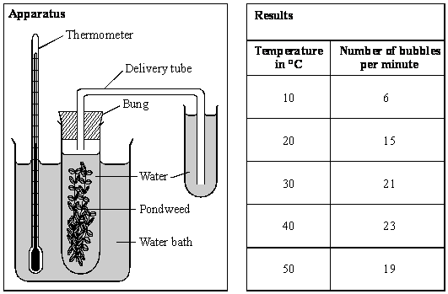

(i) Plot the points on the graph.
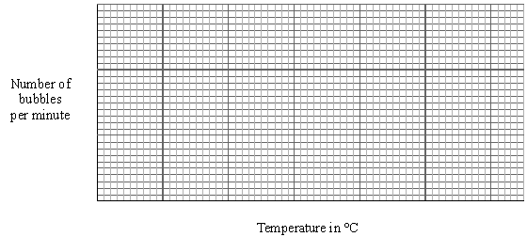
(3)

(ii) Use your graph to predict the number of bubbles per minute at 25 °C.
..........................................................................................................................
(1)

(iii) Suggest a reason why the rate of photosynthesis seems to decrease in this pondweed after 40 °C.
..........................................................................................................................
..........................................................................................................................
(1)
(Total 10 marks)

Q13.(a) Complete the equation for photosynthesis.
.............................. + water 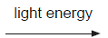 .............................. + ..............................
(3)

(b) The rate of photosynthesis in a plant depends on several factors in the environment.
These factors include light intensity and the availability of water.
Describe and explain the effects of two other factors that affect the rate of photosynthesis.
You may include one or more sketch graphs in your answer.

........................................................................................................................
........................................................................................................................
........................................................................................................................
........................................................................................................................
........................................................................................................................
........................................................................................................................
........................................................................................................................
........................................................................................................................
........................................................................................................................
........................................................................................................................
........................................................................................................................
........................................................................................................................
(5)
(Total 8 marks)

Q14. The diagram shows some plants growing in a greenhouse on a hot summer’s day.
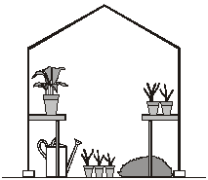
Which one of the following factors is most likely to limit the rate of photosynthesis at this time?
• carbon dioxide concentration
• light intensity
• temperature
Factor ............................................................................................
Explain the reason for your answer.
...............................................................................................................................................
...............................................................................................................................................
...............................................................................................................................................
...............................................................................................................................................
...............................................................................................................................................
...............................................................................................................................................
(Total 4 marks)

Q15. The diagram shows where three seaweeds live on a seashore.
As the tide moves in and out, these seaweeds are covered with seawater for different lengths of time.
Some students investigated the rate of photosynthesis in these seaweeds.
• They cut ten small discs from one seaweed.
• They dropped the discs into seawater in a beaker.
• They recorded the time taken for the fifth disc to float to the surface.
• They repeated this experiment with the other two seaweeds.
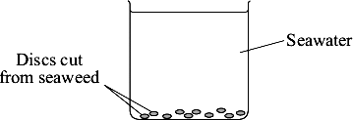
(a) (i) Suggest why the discs floated to the surface.
...............................................................................................................
...............................................................................................................
(1)

(ii) Suggest the advantage of recording the time taken for the fifth disc to reach the surface, rather than for the tenth disc.
...............................................................................................................
...............................................................................................................
(1)

(b) The students carried out their experiments at different light intensities.
The graph shows the results they collected.
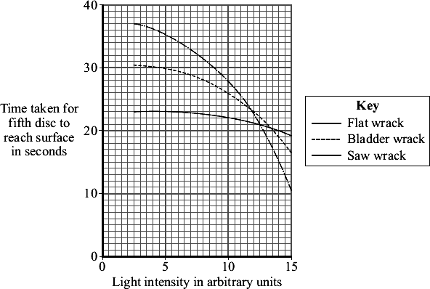
(i) Compare the rate of photosynthesis for flat wrack with the rate for saw wrack at different light intensities.
...............................................................................................................
...............................................................................................................
...............................................................................................................
...............................................................................................................
(2)

(ii) Seawater absorbs light.
The growth rate of saw wrack is less than the growth rate of bladder wrack.
Suggest why.
...............................................................................................................
...............................................................................................................
...............................................................................................................
...............................................................................................................
(2)
(Total 6 marks)

Q16.Green plants can make glucose.
(a) Plants need energy to make glucose.
How do plants get this energy?
........................................................................................................................
........................................................................................................................
........................................................................................................................
........................................................................................................................
(2)

(b) Plants can use the glucose they have made to supply them with energy.
Give four other ways in which plants use the glucose they have made.
........................................................................................................................
........................................................................................................................
........................................................................................................................
........................................................................................................................
........................................................................................................................
........................................................................................................................
........................................................................................................................
........................................................................................................................
(4)
(Total 6 marks)

Q17.(a) Complete the equation for photosynthesis. Draw a ring around each correct answer.

 |  |  | hydrogen |  | alcohol
 | Carbon dioxide | + | nitrogen | light energy | glucose | + | oxygen
 |  |  | water |  | methane

(2)

Some students investigated the effect of light intensity on the rate of photosynthesis in pondweed.
The diagram shows the apparatus the students used.
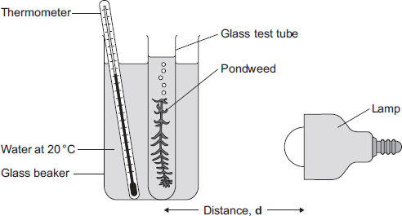

The closer the lamp is to the pondweed, the more light the pondweed receives.
The students placed the lamp at different distances, d, from the pondweed.
They counted the number of bubbles of gas released from the pondweed in 1 minute for each distance.
(b) A thermometer was placed in the glass beaker.
Why was it important to use a thermometer in this investigation?
........................................................................................................................
........................................................................................................................
........................................................................................................................
........................................................................................................................
........................................................................................................................
........................................................................................................................
(3)

(c) The students counted the bubbles four times at each distance and calculated the correct mean value of their results.
The table shows the students’ results.

 | Distance  d in cm | Number of bubbles per minute
 |  | 1 | 2 | 3 | 4 | Mean
 | 10 | 52 | 52 | 54 | 54 | 53
 | 20 | 49 | 51 | 48 | 52 | 50
 | 30 | 32 | 30 | 27 | 31 | 30
 | 40 | 30 | 10 | 9 | 11

(i) Calculate the mean number of bubbles released per minute when the lamp was 40 cm from the pondweed.
...............................................................................................................
...............................................................................................................
Mean number of bubbles at 40 cm = ............................................
(2)

(ii) On the graph paper below, draw a graph to show the students’ results:
• add a label to the vertical axis
• plot the mean values of the number of bubbles
• draw a line of best fit.
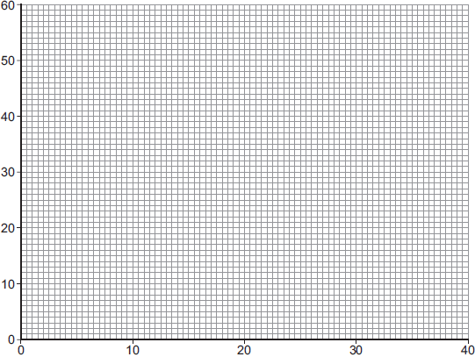
Distance d in cm
(4)

(iii) One student concluded that the rate of photosynthesis was inversely proportional to the distance of the lamp from the plant.
Does the data support this conclusion?
Explain your answer.
...............................................................................................................
...............................................................................................................
...............................................................................................................
...............................................................................................................
...............................................................................................................
...............................................................................................................
(2)

(d) Light intensity, temperature and concentration of carbon dioxide are factors that affect the rate of photosynthesis.
Scientists investigated the effects of these three factors on the rate of photosynthesis in tomato plants growing in a greenhouse.
The graph below shows the scientists’ results.
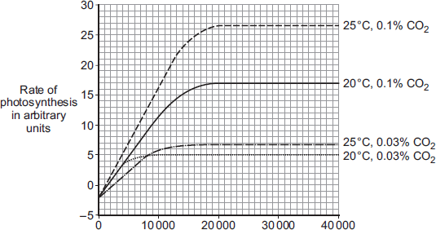
Light intensity in lux

A farmer in the UK wants to grow tomatoes commercially in a greenhouse.
The farmer read about the scientists’ investigation.
During the growing season for tomatoes in the UK, natural daylight has an intensity higher than 30 000 lux.
The farmer therefore decided to use the following conditions in his greenhouse during the day:
• 20°C
• 0.1% CO₂
• no extra lighting.
Suggest why the farmer decided to use these conditions for growing the tomatoes.
You should use information from the scientists’ graph in your answer.
........................................................................................................................
........................................................................................................................
........................................................................................................................
........................................................................................................................
........................................................................................................................
........................................................................................................................
........................................................................................................................
........................................................................................................................
........................................................................................................................
........................................................................................................................
........................................................................................................................
........................................................................................................................
(4)
(Total 17 marks)

Q18.Photosynthesis needs light.
(a) Complete the balanced symbol equation for photosynthesis.
light
6CO₂ + .......................................... ........................................... + 6O₂
(2)

(b) A green chemical indicator shows changes in the concentration of carbon dioxide (CO₂) in a solution.
The indicator solution is green when the concentration of CO₂ is normal.
The indicator solution turns yellow when the concentration of CO₂ is high.
The indicator solution turns blue when the concentration of CO₂ is very low or when there is no CO₂.
The indicator solution does not harm aquatic organisms.
Students investigated the balance of respiration and photosynthesis using an aquatic snail and some pondweed.
The students set up four tubes, A, B, C and D, as shown in the table below.
The colour change in each tube, after 24 hours in the light, is recorded.

 | Tube A | Tube B | Tube C | Tube D
 | Indicator solution  only | Indicator solution  + pondweed | Indicator solution  + snail | Indicator solution  + pondweed  + snail
 | Stays green | Turns blue | Turns yellow | Stays green

(i) What is the purpose of Tube A?
...............................................................................................................
...............................................................................................................
(1)

(ii) Explain why the indicator solution in Tube C turns yellow.
...............................................................................................................
...............................................................................................................
...............................................................................................................
...............................................................................................................
(2)
(iii) Predict the result for Tube D if it had been placed in the dark for 24 hours and not in the light.
Explain your prediction.
Prediction...............................................................................................
...............................................................................................................
Explanation............................................................................................
...............................................................................................................
...............................................................................................................
(3)
(Total 8 marks)

