B9 Respiration Exam Pack |  | Name: ________________________  Class: ________________________  Date: ________________________
Time: | 116 minutes
Marks: | 116 marks
Comments:

Q1. (a) (i) Complete the word equation for the process of aerobic respiration.
Glucose + ........................... → carbon dioxide + water
(1)
(ii) Which organ removes carbon dioxide from your body?
.................................................................................................................
(1)

(b) Use names from the box to complete the two spaces in the passage.
carbon dioxide lactic acid nitrogen oxygen water

Anaerobic respiration can occur when an athlete does vigorous exercise.
This is because there is not enough ....................................................... in the body.
The product of anaerobic respiration is ................................................................. .
(2)
(Total 4 marks)

Q2.The diagram below shows the parts of the body that digest and absorb food.
It also shows some details about the structure of the stomach.
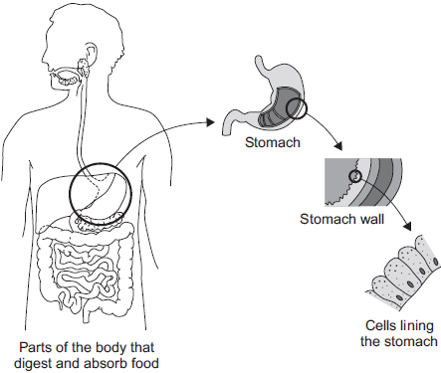
(a) Complete the table to show whether each structure is an organ, an organ system or a tissue.
For each structure, tick () one box.

 | Structure | Organ | Organ  system | Tissue
 | Stomach
 | Cells lining the stomach
Mouth, oesophagus, stomach, liver,
pancreas, small and large intestine

(2)

(b) (i) The blood going to the stomach has a high concentration of oxygen.
The cells lining the stomach have a low concentration of oxygen.
Complete the following sentence.
Oxygen moves from the blood to the cells lining the stomach by
the process of ..................................................................... .
(1)

(ii) What other substance must move from the blood to the cells lining the stomach so that respiration can take place?
Draw a ring around the correct answer.

 | glucose | protein | starch

(1)

(iii) In which part of a cell does aerobic respiration take place?
Draw a ring around the correct answer.

 | cell membrane | mitochondria | nucleus

(1)
(Total 5 marks)

Q3.(a) Use words from the box to complete the equation for aerobic respiration.

alcohol | glucose | lactic acid | water

................................ + oxygen carbon dioxide + .............................. (+ energy)
(2)

(b) Some students investigated the effect of temperature on the rate of aerobic respiration in earthworms.
The diagram shows the apparatus the students used.
When the tap is closed, the bead of liquid moves to the left as the earthworms take in oxygen.
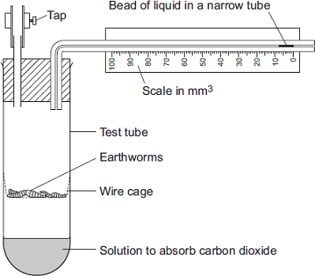
The students put the test tube into a water bath at 20°C for 10 minutes.
They left the tap open during this time.
Why did the students put the test tube in the water bath at 20°C for 10 minutes?
Tick ( ) one box.
Because the air contains more oxygen at 20°C.
Because the air contains less carbon dioxide at 20°C.
So the earthworms’ body temperature would change to 20°C.
(1)

(c) The students then:
• closed the tap
• started a stopwatch
• recorded the position of the bead of liquid every 2 minutes for 10 minutes
• repeated the experiment at 10°C.
The graph shows the students’ results.
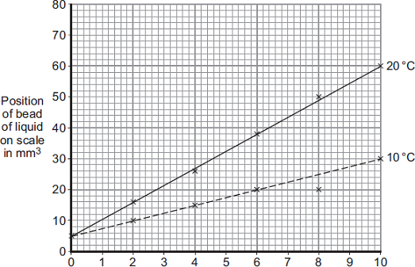
Time in minutes
(i) How much oxygen did the earthworms take in during the 10 minutes at 20°C?
Use information from the graph to work out your answer.
...............................................................................................................
...............................................................................................................
...............................................................................................................
Volume of oxygen taken in = ..................................... mm³

(2)

(ii) The earthworms took in this volume of oxygen in 10 minutes.
Use your answer from part (c)(i) to calculate how much oxygen the earthworms took in each minute.
...............................................................................................................
...............................................................................................................
Volume of oxygen taken in = ........................................ mm³ per minute
(1)

(iii) The earthworms took in less oxygen each minute at 10°C than they took in at 20°C.
Explain why.
...............................................................................................................
...............................................................................................................
...............................................................................................................
...............................................................................................................
(2)

(d) When drawing the line on the graph for the experiment at 10°C, the students ignored the reading at 8 minutes.
(i) Suggest why they ignored the reading at 8 minutes.
...............................................................................................................
...............................................................................................................
(1)

(ii) One student suggested they should repeat the experiment twice more at each temperature.
How would repeating the experiment improve the investigation?
...............................................................................................................
...............................................................................................................
(1)
(Total 10 marks)

Q4.Scientists investigated how exercise affects blood flow to different organs in the body.
The scientists made measurements of blood flow to different organs of:
• a person resting in a room at 20°C
• the same person, in the same room, doing vigorous exercise at constant speed on an exercise cycle.
The table shows the scientists’ results.

Organ | Blood flow in cm³ per minute whilst …
 | resting | doing vigorous exercise
Brain | 750 | 750
Heart | 250 | 1000
Muscles | 1200 | 22 000
Skin | 500 | 600
Other | 3100 | 650

(a) In this investigation, it was better to do the exercise indoors on an exercise cycle than to go cycling outdoors on the road.
Suggest two reasons why.
Do not include safety reasons.
1 .....................................................................................................................
........................................................................................................................
........................................................................................................................
2 .....................................................................................................................
........................................................................................................................
........................................................................................................................
(2)

(b) Blood flow to one organ did not change between resting and vigorous exercise.
Which organ? ................................................................................................
(1)

(c) (i) How much more blood flowed to the muscles during vigorous exercise than when resting?
...............................................................................................................
...............................................................................................................
Answer = .............................. cm³ per minute
(2)

(ii) Name two substances needed in larger amounts by the muscles during vigorous exercise than when resting.
1 ............................................................................................................
2 ............................................................................................................
(2)

(iii) Tick () one box to complete the sentence.
The substances you named in part (c)(ii) helped the muscles to
make more lactic acid.
respire aerobically.
make more glycogen.
(1)

(iv) The higher rate of blood flow to the muscles during exercise removed larger amounts of waste products made by the muscles.
Which two substances need to be removed from the muscles in larger amounts during vigorous exercise?
Tick () two boxes.
Amino acids
Carbon dioxide
Glycogen
Lactic acid
(2)

(d) The total blood flow was much higher during exercise than when resting.
One way to increase the total blood flow is for the heart to pump out a larger volume of blood each beat.
Give one other way to increase the blood flow.
........................................................................................................................
........................................................................................................................
(1)
(Total 11 marks)

Q5. Paula is training for a marathon. When she runs, her heart beats faster than it does when she is resting.
Complete the sentences, using words from the box.
blood breathe carbon dioxide glucose
heat nitrogen oxygen respire

When she is running, Paula‘s muscle activity increases. To do this, her muscle cells
................................................. at a faster rate to give her more energy. Her muscles need to
be supplied with ........................................... and ....................................................................
more quickly. Her heart beats faster to increase the flow of....................................................
which carries the products ................................................................................................ and
............................................................ away from her muscles.
(Total 6 marks)

Q6.Diagram 1 shows a yeast cell.
Diagram 1
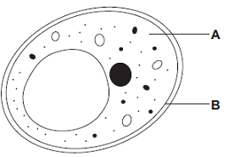
(a) Name structures A and B.
A ............................................................
B ............................................................
(2)

(b) Yeast cells can respire anaerobically.
The equation for anaerobic respiration in yeast is:
glucose alcohol + carbon dioxide (+ energy)
Give one way in which anaerobic respiration in yeast cells is different from anaerobic respiration in human muscle cells.
........................................................................................................................
........................................................................................................................
(1)

(c) Yeast can use other types of sugar instead of glucose.
Some scientists investigated the effect of three different types of sugar on the rate of anaerobic respiration in yeast.
The scientists:
• used the apparatus shown in Diagram 2 with glucose sugar
• kept the apparatus at 20 °C
• repeated the investigation with fructose sugar and then with mannose sugar
• repeated the investigation with water instead of the sugar solution.
Diagram 2
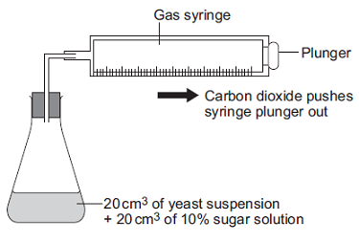
(i) Give two control variables the scientists used in this investigation.
...............................................................................................................
...............................................................................................................
(2)

(ii) The graph shows the scientists’ results.
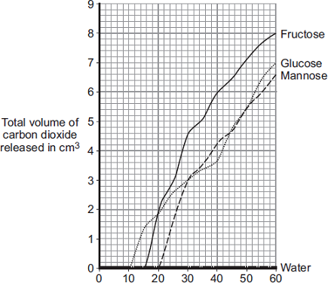
Time in minutes
From this information, a company decided to use fructose to produce alcohol and not mannose or glucose.
Explain the reason for the company’s choice.
...............................................................................................................
...............................................................................................................
...............................................................................................................
...............................................................................................................
(2)
(Total 7 marks)

Q7. Oxygen from our lungs is carried, by our blood, to cells in our body where aerobic respiration takes place.
(i) Complete the two spaces to balance the chemical reaction for aerobic respiration.
C₆H₁₂O₆ + 6O₂ → ....... CO₂ + ...... H₂O
(1)
(ii) Name the substance with the formula C₆H₁₂O₆.
.....................................................................................................................................
(1)

(iii) Name the structures in the cytoplasm of our cells where aerobic respiration takes place.
.....................................................................................................................................
(1)
(Total 3 marks)

##
(a) The table shows the effect of exercise on the action of one person’s heart.
 | At rest | During  exercise
Heart rate in beats per minute | 72 | 165
Volume of blood leaving the heart in each beat  in cm³ | 75 | 120
Heart output in cm³ per minute | 5400

(i) Calculate the heart output for this person during exercise.
Show clearly how you work out your answer.
...........................................................................................................................
...........................................................................................................................
...........................................................................................................................
...........................................................................................................................
Answer = .............................. cm³ per minute
(2)

(ii) During exercise, more oxygen is carried to the working muscles.
Explain why this is helpful during exercise.
...........................................................................................................................
...........................................................................................................................
...........................................................................................................................
...........................................................................................................................
...........................................................................................................................
(2)

(b) Give two other changes in the body that help to increase the amount of oxygen delivered to the working muscles during exercise.
1 ..................................................................................................................................
.....................................................................................................................................
2 ..................................................................................................................................
.....................................................................................................................................
(2)
(Total 6 marks)

﻿
Q9. (a) (i) The table shows an athlete’s breathing rate after the end of a race.
The results can be put onto a graph.
Three of the points are already plotted.
Plot the other points shown in the table.
Then draw the graph.
Time after end of race  (minutes) | Breathing rate  (litres per second)
0 | 4
1 | 2
2 | 1
3 | 1
4 | 1
5 | 1

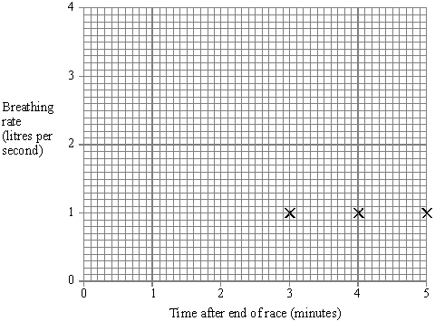
(4)

(ii) What is the athlete’s breathing rate ½ (half) a minute after the end of the race?
.................................................................................................................
(2)

(b) One of the reasons for breathing is to get rid of carbon dioxide from your body.
Choose words from the list to complete the sentences below about how your body does this.
blood heart kidneys lungs urine
Carbon dioxide gets out of your body from your .....................................................
The carbon dioxide is carried to this part of your body by your ................................
(2)

(c) The bar charts show what happens in an athlete’s muscles when running in two races of different distances.
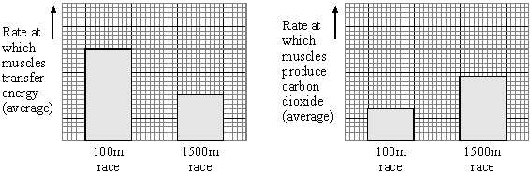

(i) Compare what happens in the athlete’s muscles when running in the two races.
...........................................................................................................................
...........................................................................................................................
...........................................................................................................................
...........................................................................................................................
(3)

(ii) Use the information in the box to explain your answer to (i).
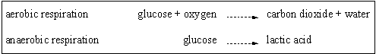
...........................................................................................................................
...........................................................................................................................
(2)
(Total 13 marks)

Q10.Figure 1 shows an athlete running on a treadmill.
Figure 1
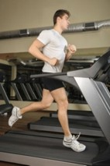
© Starush/istock/Thinkstock

After running for several minutes, the athlete’s leg muscles began to ache.
This ache was caused by a high concentration of lactic acid in the muscles.

(a) The equation shows how lactic acid is made.
glucose lactic acid (+ energy)
Name the process that makes lactic acid in the athlete’s muscles.
........................................................................................................................
(1)

(b) Scientists investigated the production of lactic acid by an athlete running at different speeds.
In the investigation:
• the athlete ran on the treadmill at 4 km per hour
• the scientists measured the concentration of lactic acid in the athlete’s blood after 2 minutes of running.
The investigation was repeated for different running speeds.
Figure 2 shows the scientists’ results.
Figure 2
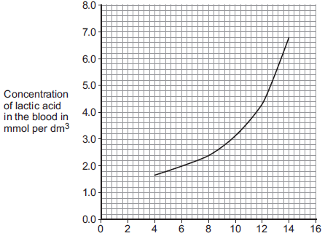
Treadmill speed in km per hour

(i) How much more lactic acid was there in the athlete’s blood when he ran at 14 km per hour than when he ran at 8 km per hour?
...............................................................................................................
...............................................................................................................
...............................................................................................................
Answer = ......................... mmol per dm³
(2)

(ii) Why is more lactic acid made in the muscles when running at 14 km per hour than when running at 8 km per hour?
...............................................................................................................
...............................................................................................................
...............................................................................................................
...............................................................................................................
...............................................................................................................
...............................................................................................................
(3)
(Total 6 marks)

Q11. (a) Respiration is a process which takes place in living cells. What is the purpose of respiration?
.....................................................................................................................................
.....................................................................................................................................
(1)

(b) (i) Balance the equation for the process of respiration when oxygen is available.
C₆H₁₂O₆ + O₂ → CO₂ + H₂O
(1)

(ii) What is the name of the substance in the equation with the formula C₆H₁₂O₆?
..........................................................................................................................
(1)

(c) Oxygen is absorbed through the alveoli in the lungs.
(i) How are the alveoli adapted for this function?
..........................................................................................................................
..........................................................................................................................
..........................................................................................................................
(2)

(ii) Name the gas which is excreted through the alveoli.
..........................................................................................................................
(1)

(d) (i) What is the name of the process of respiration when oxygen is not available?
..........................................................................................................................
(1)

(ii) Describe the process of respiration which takes place in human beings when oxygen is not available and give an effect.
..........................................................................................................................
..........................................................................................................................
..........................................................................................................................
..........................................................................................................................
..........................................................................................................................
..........................................................................................................................
(3)
(Total 10 marks)

Q12. In an investigation four groups of athletes were studied. The maximum rate of oxygen consumption for each athlete was measured and the mean for each group was calculated. The athletes then ran 10 mile races and the mean of the best times was calculated for each group. The results are shown in the table below.
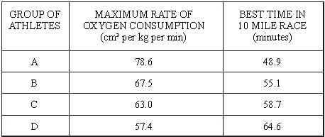

(i) What is the relationship between maximum rate of oxygen consumption and time for a 10 mile race?
.....................................................................................................................................
.....................................................................................................................................
(1)

(ii) Suggest an explanation for this relationship.
.....................................................................................................................................
.....................................................................................................................................
.....................................................................................................................................
.....................................................................................................................................
.....................................................................................................................................
.....................................................................................................................................
(3)
(Total 4 marks)

Q13. The blood system supplies the body tissues with essential materials.
(a) Blood contains red blood cells, white blood cells and platelets.
(i) Give the function of white blood cells.
...............................................................................................................
...............................................................................................................
(1)

(ii) Give the function of platelets.
...............................................................................................................
...............................................................................................................
(1)

(iii) The photograph shows a magnified red blood cell.
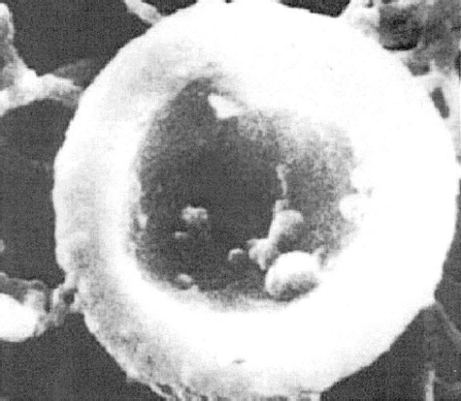

The average diameter of a real red blood cell is 0.008 millimetres.
On the photograph, the diameter of the red blood cell is 100 millimetres.
Use the formula below to calculate the magnification of the photograph.
diameter on photograph = real diameter × magnification
...............................................................................................................
...............................................................................................................
Magnification = .........................................
(2)

(iv) Some blood capillaries have an internal diameter of approximately 0.01 millimetres.
Use information given in part (a)(iii) to explain why only one red blood cell at a time can pass through a capillary.
...............................................................................................................
...............................................................................................................
...............................................................................................................
(2)

(v) Red blood cells transport oxygen.
Describe how oxygen is moved from the lungs to the tissues.
...............................................................................................................
...............................................................................................................
...............................................................................................................
...............................................................................................................
...............................................................................................................
...............................................................................................................
(3)

(b) Two students did the same step-up exercise for 3 minutes.
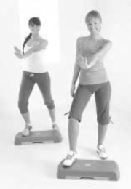

One of the students was fit. The other student was unfit.
The graph shows how the students’ heart rate changed during the exercise and after the exercise.
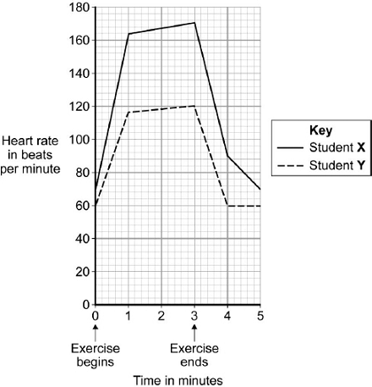

(i) Use the information in the graph to suggest which student was the fitter.
Explain your choice.
...............................................................................................................
...............................................................................................................
...............................................................................................................
...............................................................................................................
...............................................................................................................
...............................................................................................................
(3)

(ii) Explain the advantage to the students of the change in heart rate during exercise.
...............................................................................................................
...............................................................................................................
...............................................................................................................
...............................................................................................................
...............................................................................................................
...............................................................................................................
...............................................................................................................
...............................................................................................................
(4)
(Total 16 marks)

Q14.A student ran on a treadmill for 5 minutes.
The speed of the treadmill was set at 12 km per hour.
The graph below shows the effect of the run on the student’s heart rate.
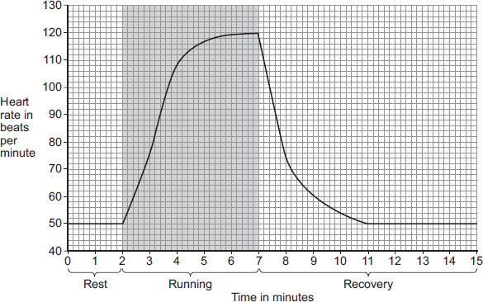
(a) (i) What was the student’s heart rate at rest?
.............................. beats per minute
(1)
(ii) After the end of the run, how long did it take for the student’s heart rate to return to the resting heart rate?
.............................. minutes
(1)

(b) During the run, the student’s muscles needed larger amounts of some substances than they needed at rest.
(i) Which two of the following substances were needed in larger amounts during the run?
Tick () two boxes.

carbon dioxide
glucose
lactic acid
oxygen
protein

(2)

(ii) Why are the two substances you chose in part (b)(i) needed in larger amounts during the run?
Tick () one box.

To help make more muscle fibres
To release more energy
To help the muscles to cool down

(1)

(c) After exercise, a fit person recovers faster than an unfit person.
Let the student’s heart rate at the end of exercise = a.
Let the student’s heart rate after 2 minutes of recovery = b.
The table below shows how the difference between a and b, (a − b), is related to a person’s level of fitness.

 | (a − b) | Level of fitness
 | < 22 | Unfit
 | 22 to 52 | Normal fitness
 | 53 to 58 | Fit
 | 59 to 65 | Very fit
 | > 65 | Top athlete

What is the student’s level of fitness?
Use information from the graph and the table.
a = ......................... beats per minute
b = ......................... beats per minute
(a − b) = ......................... beats per minute
Level of fitness = ......................................................................
(3)

(d) The student repeated the run with the treadmill set at 16 km per hour.
The student’s heart rate took 3 minutes longer to return to the normal resting rate than when running at 12 km per hour.
Give reasons why it took longer to recover after running faster.
........................................................................................................................
........................................................................................................................
........................................................................................................................
........................................................................................................................
........................................................................................................................
........................................................................................................................
........................................................................................................................
........................................................................................................................
........................................................................................................................
........................................................................................................................
(4)
(Total 12 marks)

