BTEC Level 3 National Extended Certificate in Applied Science
Bridging the gap between year 11 and 12
Course leader: Ms Valentine
Overview of the course:
The applied science sector
The applied science sector is diverse and wide ranging, including, for example, biomedical, forensic, physical and chemical sciences. There are approx. 5.8 million people employed in applied science occupations in the UK. This equates to approximately 20% of the workforce. The applied science sector has a crucial role to play in delivering economic growth in the UK and allowing companies to compete in a rapidly enlarging global market.

Who is this qualification for?
The Pearson BTEC Level 3 National Extended Certificate in Applied Science is intended to be an Applied General qualification for post 16 students wanting to continue their education through applied learning and who aim to progress to higher education, and ultimately to employment, possibly in the applied science sector. The qualification is equivalent in size to one A level and makes up a third of a typical study programme, normally alongside other A level or vocational qualifications at level 3.

What does the qualification cover?
The content of this qualification has been developed in consultation with academics to ensure that it supports progression to higher education. In addition, employers and professional bodies have been involved and consulted, in order to confirm that the content is also appropriate and consistent with current practice for students planning to enter employment directly in the applied science sector.
Everyone taking this qualification will study three mandatory units:
● Unit 1 Principles and Application of Science I (exam based- undertaken in Year 12)
●Unit 2 Practical Scientific Procedures and Techniques (coursework- undertaken in Year 12)
● Unit 3 Science Investigation Skills (exam based- undertaken in Year 13)
And one optional unit: Unit 10 Biological Molecules and Metabolic Pathways (coursework- undertaken in Year 13)
Past Success
- 100% Distinction* - Merit
- More than a third of previous STAC BTEC Applied Science students have gone on to study Biomedical Science at University
- Previous students have also been accepted to study Aerospace Engineering and Sport Science

Bridging the Gap Workbook
Each week you will be asked to complete a task related to content you will study in year 12. This work will build upon your knowledge learnt at GCSE, extend this knowledge into what is required in BTEC and hopefully give you an idea of what is required in the course.
The material you will be looking at will be set out like this:
Unit 1- Principals and Applications of Science (Exam based unit)
Topic | Link to GCSE | Challenge | Date due:
Physics | Waves questions | Article on waves and activities based on this | Week 1 (Friday)
Biology | Cells questions | Organelle research task | Week 2 (Friday)
Chemistry | Bonding questions |  | Week 3 (Friday)
Unit 2- Practical Scientific Procedures and Techniques (Coursework based unit)
Chromatography | Chromatography questions | Gas chromatography research | Week 4 (Friday)

You will have a different task to do each week, which Ms Valentine will expect to receive and look over. These tasks are based on only a small section of the course. If you are interested in looking at a more in-depth overview of the course please go to the specification on the BTEC website (found here: https://tinyurl.com/y9nd5qtn).

Week One Tasks
Introduction: In the summer of year 12 you will take an exam based on content you have learnt in Unit 1- Principals and Applications of Science. The unit is split into three sections- Biology, Chemistry and Physics. Over the next three weeks you will complete tasks based on each of these sections. The first tasks is based on the Physics content of the unit. In this topic you will look mainly at waves- something you might remember from GCSE.
This week is split into two tasks (Task 1 and Task 2). Please complete these and send them to Ms Valentine by Friday.

Task 1:
Complete the GCSE exam questions based on waves. This is to help refresh your memory on GCSE Physics content. After completion you will be sent a mark scheme to mark your answers.
Mark: ________/21
Q1.
The diagram below shows types of waves within the electromagnetic spectrum.
Some of the types of waves are represented by letters.

P | microwaves | Q | visible light | R | S | gamma rays
(a) Which letter shows the position of ultraviolet (UV) radiation within the electromagnetic spectrum?
Tick one box.

P |  | Q |  | R |  | S
(1)
(b) A special lamp can produce UV radiation.
Which two statements describe the electromagnetic waves emitted by a UV lamp?
Tick two boxes.

They have a higher frequency than X-rays.
They have the same wave speed as visible light.
They have a longer wavelength than microwaves.
They have a lower frequency than gamma rays.
They have a greater wave speed than radio waves.
(2)
(c) UV radiation is used to treat a vitamin D deficiency.
People should not use a UV lamp for long periods of time.
State two risks of exposure to high levels of UV radiation.
1. _________________________________________________________________
___________________________________________________________________
2. _________________________________________________________________
___________________________________________________________________
(2)
(d) Ionising radiation is used for some medical imaging.
Name two types of electromagnetic waves that are used.
1. _________________________________________________________________
2. _________________________________________________________________
(2)
(Total 7 marks)
Q2.
Bats use the reflection of high pitched sound waves to determine the position of objects.
The image below shows a bat and an insect flying in front of the bat.
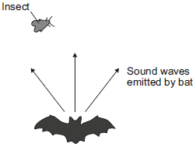
(a) What determines the pitch of a sound wave?
Tick (✔) one box.

Tick (✔)
amplitude
frequency
speed
(1)
(b) State the name given to reflected sound waves.
___________________________________________________________________
(1)
(c) The bat emits a sound wave with a frequency of 25.0 kHz and a wavelength of 0.0136 metres.
Calculate the speed of this sound wave.
___________________________________________________________________
___________________________________________________________________
Speed = ____________ m/s
(2)
(d) Sound waves are longitudinal. Describe a longitudinal sound wave.
___________________________________________________________________
___________________________________________________________________
___________________________________________________________________
___________________________________________________________________
(2)
(Total 6 marks)
Q3.
Infrared and microwaves are two types of electromagnetic radiation.
The diagram below shows the positions of the two types of radiation within part of the electromagnetic spectrum.
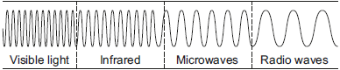
(a) Name one type of electromagnetic radiation which has more energy than infrared.
___________________________________________________________________
(1)
(b) Use the correct answer from the box to complete each sentence.
Each answer may be used once, more than once or not at all.

greater than | less than | the same as
The wavelength of infrared is ____________ the wavelength of microwaves.
The frequency of microwaves is ____________ the frequency of infrared.
The speed of microwaves in a vacuum is ____________ the speed of infrared in a vacuum.
(3)
(Total 4 marks)
Q4.
Infrared and microwaves are two types of electromagnetic radiation.
(a) State one example of the use of each type of radiation for communication.
Infrared: ______________________
Microwaves: ___________________
(2)
(b) Some of the properties of infrared and microwaves are the same.
State two of these properties.
1. _________________________________________________________________
___________________________________________________________________
2. _________________________________________________________________
___________________________________________________________________
(2)
(Total 4 marks)

Task 2: Read through the following article and answer the summary questions below. Send your answers to Ms Valentine at the end of the week.
Waves in Communication Article
As we communicate by voice, modulating the mechanical waves emitted by our vocal cords, great physicists such as Hertz, Tesla, Branly and Marconi understood that it was possible to use electromagnetic waves to convey information through the air.
At the end of the 19th century, an understanding of electromagnetism led to the mastery of electricity, which has populated our daily lives with artificial electromagnetic field sources (or EMF). So today, at home, EMFs are present in light bulbs, microwave ovens, cordless phones, induction cookers and, of course, Wi-fi boxes and all devices connected to it.

A band apart: radio waves
While many different types of EMF are used to convey information over distance, the most common are radio waves, also called radiofrequencies. This is a wide spectrum ranging from tens of kilohertz to 300 gigahertz. Within this spectrum, frequency bands are allocated to each use. This distribution is intended to ensure an efficient service for each user and avoid interference in transmissions and communications – to avoid the interruption of police or fire brigade communications by someone’s personal walkie-talkie, for example.

It was mastery of radio waves that gave birth to the “wireless telegraphy”, then radio, television and modern forms of telecommunication: radio and TV transmitters, GSM mobile networks, etc. One limitation of radio waves is that they reflect off the atmosphere; so when communicating with satellites in space microwaves are used instead.

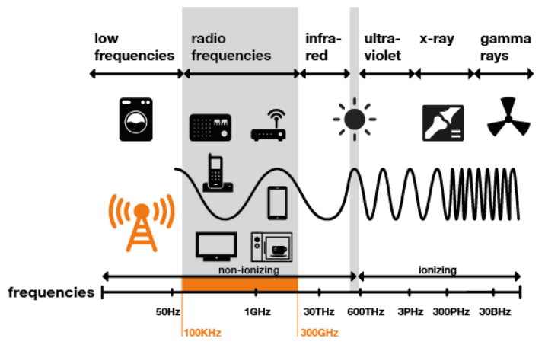

How do radio waves carry information?
The basic principle is simple. At one end, a transmitter “encodes” or modulates messages by varying the amplitude or frequency of the wave – a bit like Morse code. At the other, a receiver tuned to the same wavelength picks up the signal and ‘decodes’ it back to the desired form: sounds, images, data, etc.
All wireless communication systems, from the home remote control up to the satellite, are based on this principle, even though increasingly complex technologies are of course used to encode these electromagnetic signals, improve their quality, increase the amount of information or make transmissions secure.

We use radio waves in almost every aspect of our daily lives. In the morning we get the latest news from an AM or FM radio, newsfeeds on our mobiles, the television; mobiles help us pay for small purchases throughout the day such as our coffee, baguette or parking meter using NFC contactless technology, they enable us to alert the authorities in case of an emergency (police, fire brigade, ambulance); and they also enable connected objects to communicate thanks to consumer devices such as Wi-Fi, Bluetooth, LORA, DECT… and of course private and professional communication. They have become indispensable.

Questions
- Name one electromagnetic wave with a higher frequency than radio waves.
- What is the range of frequencies for radio waves?
- What are the units for frequency?
- State 3 electromagnetic waves that are used for communication.
- Give three uses of radio waves for communication.
- Explain why microwaves are used to communicate with satellites.
- Convert 300kHz into Hz.
- Convert 2.5MHz into Hz.

Week Two Tasks
Introduction: This week’s tasks are based on the biology content you will learn in year 12 BTEC Applied Science. Biology is split into three categories in this Unit 1- cells, specialised cells and communication within the body. You will focus on cells or this task.
This week is split into two tasks (Task 3 and Task 4). Please complete these and send them to Ms Valentine by Friday.

Task 3: Complete the GCSE questions based on cells. Again, this is to refresh your memory on GCSE Biology. Submit the completed task by the end of the week to Ms Valentine, who will then send out the mark scheme to these questions.
Q1.
Living organisms are made of cells.
(a) Animal and plant cells have several parts. Each part has a different function.
Draw one line from each cell part to the correct function of that part.
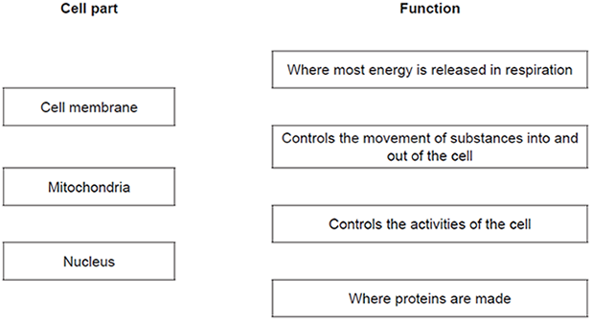
(3)

(b) The diagram below shows a cell from a plant leaf.
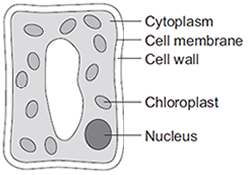
Which two parts in the diagram above are not found in an animal cell?
1. _________________________________________________________________
2. _________________________________________________________________
(2)
(Total 5 marks)
Q2.
Figure 1 shows an animal cell and a bacterial cell.
Figure 1
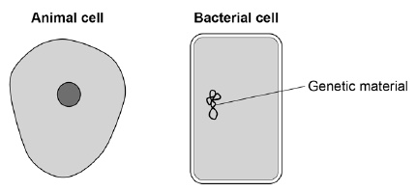
(a) Compare the structure of the cells in Figure 1.
Complete the sentences.
Choose the answers from the box.

cell membrane | cell wall | chloroplast
cytoplasm |  | nucleus
Only the animal cell contains a _________________________________________ .
Only the bacterial cell contains a _______________________________________ .
(2)
Figure 2 shows a section through a leaf.
Figure 2
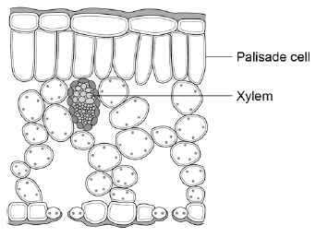

(b) The function of palisade cells is to photosynthesise.
Describe one way palisade cells are adapted to carry out their function.
___________________________________________________________________
___________________________________________________________________
(1)
(c) Complete Table 1 to show whether each structure is a tissue, an organ or an organ system.
Tick one box for each structure.

Table 1
Structure | Tissue | Organ | Organ system
Leaf
Xylem
Roots, stem and leaves
(2)
A student observed palisade cells using a microscope.
The microscope had four objective lenses, each with a different magnification.
(d) Which objective lens should the student use first?
Tick one box.
Give a reason for your answer.

×4 magnification
×10 magnification
×40 magnification
×100 magnification
Reason ___________________________________________________________
___________________________________________________________________
(2)
The student measured the width of 5 different palisade cells at a total magnification of ×400
(e) Eyepiece lenses are usually ×5 or ×10 magnification.
What combination of eyepiece and objective lenses would give a total magnification of ×400?
Eyepiece lens ____________________
Objective lens ____________________
(1)
(f) Table 2 shows the student’s results.

Table 2
Cell | Width of cell image in mm
1 | 12
2 | 13
3 | 16
4 | 10
5 | 11
(f) Calculate the mean width of the palisade cell images.
___________________________________________________________________
___________________________________________________________________
Mean width = ____________________ mm
(1)
(g) Calculate the real width of a palisade cell.
Use the mean width you calculated in part (f).
Use the equation:
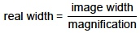
___________________________________________________________________
___________________________________________________________________
Real width = ____________________ mm
(2)
(Total 11 marks)
Q3.
Diagrams A, B and C show cells from different parts of the human body, all drawn to the same scale.
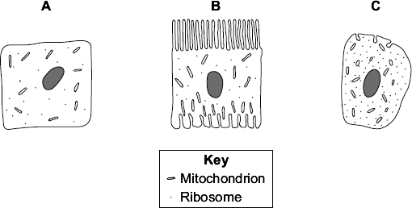
(a) Which cell, A, B or C, appears to have adaptations to increase diffusion into or out

of the cell?
Give one reason for your choice.
___________________________________________________________________
___________________________________________________________________
(1)
(b) (i) Cell C is found in the pancreas.
Name one useful substance produced by the pancreas.
______________________________________________________________
(1)
(ii) Use information from the diagram to explain how cell C is adapted for producing this substance.
______________________________________________________________
______________________________________________________________
_____________________________________________________________
_____________________________________________________________
(2)
(Total 4 marks)
Task Four: In GCSE you will have learnt about some organelles such as mitochondria and ribosomes. In reality cells are much more complex than what you have learnt in GCSE. Your task is to research the cell using the websites below, label the cell diagram and fill in the table. Send the work to Ms Valentine when you are finished.
Use these websites for your research:
https://www.khanacademy.org/test-prep/mcat/cells/eukaryotic-cells/a/organelles-article
https://alevelnotes.com/notes/biology/cells/cell-structure/organelle-structure-and-function
Label the cell:

Fill in the table:
Organelle | What does it look like? (sketch it) | What does it do? (function)
Golgi apparatus
Lysosome
Smooth endoplasmic reticulum
Rough endoplasmic reticulum
Nucleolus

Week Three Tasks
Introduction: Part of your exam at the end of year 12 will be on Chemistry. This course covers a wide range of topics but for this week you will focus on bonding.

Task 5: Answer the GGCSE questions on bonding. This is to refresh your memory of GCSE chemistry. Send your answers to Ms Valentine at the end of the week, who will send you the mark scheme. Q1.
A sodium atom and a fluorine atom react together to form an ionic compound.
Figure 1 shows the electron arrangements in the atoms and the ionic compound.
Only the outer shell electrons are shown.
Figure 1
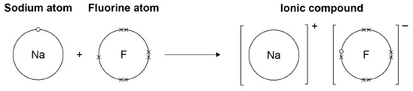
(a) What is the name of the ionic compound shown in Figure 1?
Tick one box.

Sodium fluorate
Sodium fluoride
Sodium fluorine
(1)
(b) What type of force acts between the ions in an ionic compound?
Tick one box.

Electrostatic
Frictional
Gravitational
Magnetic
(1)
(c) What are two properties of ionic compounds?
Tick two boxes.

Conducts electricity when molten
High melting point
Low boiling point
Small molecules
Weak bonds between particles
(2)
(d) Describe what happens when a sodium atom reacts with a fluorine atom to form an ionic compound.
Use Figure 1.
___________________________________________________________________
___________________________________________________________________
___________________________________________________________________
___________________________________________________________________
___________________________________________________________________
___________________________________________________________________
___________________________________________________________________
___________________________________________________________________
(4)

(e) Figure 2 shows the structure of the ionic compound formed in the reaction.
Figure 2
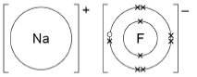
Suggest one limitation of using Figure 2 to show the structure of this compound.
___________________________________________________________________
___________________________________________________________________
(1)
(Total 9 marks)
Q2.
This question is about diamond and graphite.
Figure 1 shows part of the structure of diamond.
Figure 1
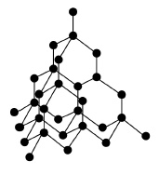
(a) Complete the sentence.
Choose the answer from the box.

calcium | carbon | chromium | cobalt
Diamond is a form of _________________________________________ .
(1)

(b) Which two statements about diamond are correct?
Tick two boxes.

Diamond has a giant structure.
Diamond has ionic bonds.
Diamond is made of layers.
Diamond has weak bonds.
Each atom is joined to four other atoms.
(2)
Figure 2 shows part of the structure of graphite.
Figure 2
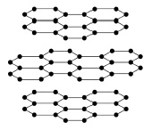
(c) Explain why graphite is soft and slippery.
Use Figure 2 and your own knowledge.
___________________________________________________________________
___________________________________________________________________
___________________________________________________________________
___________________________________________________________________
___________________________________________________________________
___________________________________________________________________
(3)

(d) Graphite has covalent bonds between the atoms.
How many covalent bonds does each atom form?
Tick one box.

1 |  | 2 |  | 3 |  | 4
(1)
(e) Explain why graphite can conduct electricity.
You should include a reference to electrons in your answer.
___________________________________________________________________
___________________________________________________________________
___________________________________________________________________
(2)
(Total 9 marks)
Q3.
This question is about calcium.
(a) What type of compound is calcium oxide?
Tick one box.

An acid
A base
A carbonate
A salt
(1)
(b) Ionic compounds, such as calcium oxide, have high melting points.
Complete the sentences. Use words from the box.

bonds forces ions layers
Calcium oxide has a giant ionic lattice in which there are strong electrostatic
______________________ of attraction in all directions.
(1)
(c) The figure below shows the electronic structure of an oxygen atom and a calcium atom.
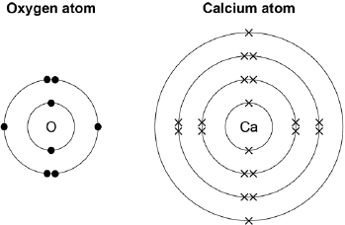
Describe how the calcium atom and the oxygen atom forms calcium oxide.
You should give the charge on each ion formed.
___________________________________________________________________
___________________________________________________________________
___________________________________________________________________
___________________________________________________________________
___________________________________________________________________
___________________________________________________________________
___________________________________________________________________
___________________________________________________________________
(4)
(Total 6 marks)

Task 6: Read through the information below and answer the questions underneath
KEY WORD: Electronegativity - This is the tendency of an atom to attract a bonding pair of electrons towards itself in a covalent bon
INTERMOLECULAR FORCES:
Intermolecular forces also affect how chemical substances behave. A laboratory technician must know where these are present and understand how they will affect the behaviour and reactions of chemical substances they are working with.
LONDON DISPERSION FORCES (VAN DER WAALS):
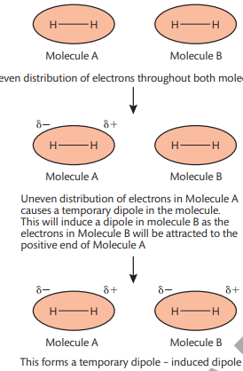
One type of intermolecular force is called London dispersion forces (also called temporary dipole – induced dipole forces). They are weak forces present between non-polar covalent molecules. They are less than 1% of the force of a covalent bond. When the electron distribution in a molecule becomes non-symmetrical (i.e. there are more electrons at one end of the molecule than the other) then one end of the molecule can become more positive and one end can become more negative. This causes a temporary dipole. The positive and negative charge in the dipole can disturb the electrons in a nearby molecule, repelling the electrons and so causing (inducing) a dipole in that molecule. The molecule with the temporary dipole and the molecule with the induced dipole attract each other and pull the molecules together. The forces are temporary because the electrons are constantly moving so electron density in any part of a molecule is constantly changing. Larger molecules have more electrons which can move further so more temporary dipoles can form, meaning the force is bigger.
DIPOLE-DIPOLE FORCES
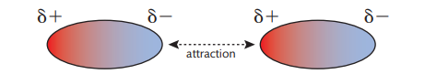
Another form of van der Waals forces are dipole-dipole forces. These are permanent forces between polar molecules . Polar molecules have a permanent negative end and a permanent positive end. These oppositely charged end attract each other. Dipole-dipole forces are slightly stronger than London dispersion forces but are still weak in comparison to a covalent bond. The force is about 1% the strength of a covalent bond. Molecules that have permanent dipole-dipole forces include hydrogen chloride, HCl, and iodine monochloride, ICl. In both cases, the chlorine atom in the molecule is slightly negative. The hydrogen and iodine atoms are slightly positive.

HYDROGEN BONDING
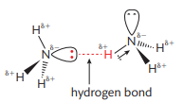
The strongest form of intermolecular force is a hydrogen bond. These are a special type of dipole-dipole bond and are forces that are about 10% the strength of a covalent bond. Hydrogen bonds will form when compounds have hydrogen directly bonded to fluorine, oxygen or nitrogen. This is because there is a large difference in electronegativity between hydrogen and of these three atoms. This large difference means that very polar bonds are formed so the molecules have permanent dipoles. When two of these molecules are close together, there will be an attraction between the positive end of one and the lone pair of electrons of the other. This is a hydrogen bond. This is different to other dipole-dipole forces because there are inner bonding electrons. The single electron in the hydrogen atom is drawn to the nitrogen, oxygen or fluorine atom. There are no non-bonding electrons shielding the nucleus of the hydrogen. The hydrogen proton is strongly attracted to the lone pair of electrons on the nitrogen atom of another molecule.

QUESTIONS:
- Draw a table showing the different types of intermolecular bonding and their properties.
- Explain how each type of intermolecular bond affects the properties of the molecules.
- Hydrogen bonding in water is the reason why water has such unusual properties, e.g. solid water is less dense than liquid water, it has a higher boiling point than expected, it is a good solvent for many chemical substances. Research how hydrogen bonding is caused in a water molecule. List properties of water due to the hydrogen bonding, Explain the properties..

Week Four Tasks
Introduction: You will also complete a coursework based unit in year 12. This unit is based into four different topics- three of which are based on practical’s (Titrations, Chromatography and cooling curves). The last piece of coursework is a summary of the skills you have learnt from these three practical’s. In this week you will focus on chromatography.

Task 7: Answer these questions based on chromatography. Send the completed work to Ms Valentine for the mark scheme.
Mark: __________/21
Q1.
A student used paper chromatography to identify the colours in a black ink.
The diagram below shows the student’s results.
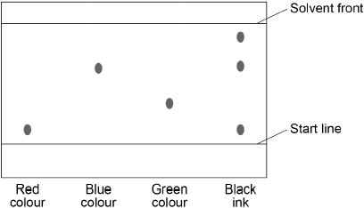
(a) What colours are in the black ink?
___________________________________________________________________
___________________________________________________________________
(2)
(b) Suggest which colour is least soluble in the solvent.
Give a reason for your answer.
Colour ______________________
Reason _____________________________________________________________________________________________________________________________
(2)

(c) Use the diagram above to complete the table below.

Distance in mm
Distance moved by green colour
Distance moved by solvent
Calculate the R_{f} value for the green colour.
Use the equation:
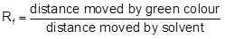
___________________________________________________________________
___________________________________________________________________
___________________________________________________________________
___________________________________________________________________
R_{f} value = ________________________
(4)
(Total 8 marks)
Q2.
Race horses may be given drugs to improve their perfomance in races.
This is illegal in the UK.
After races, urine samples are collected from the horses.
These samples are tested for drugs.
Chromatography is one of the tests used to identify drugs in urine.
The diagram shows a chromatogram.
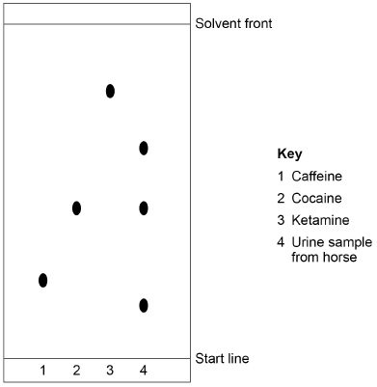
(a) How do we know that sample 1 was a pure sample of caffeine?
___________________________________________________________________
___________________________________________________________________
(1)
(b) Calculate the R_{f} value for cocaine.
Give your answer to 2 significant figures.
Use information from the diagram.
Use the equation:
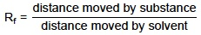
___________________________________________________________________
___________________________________________________________________
___________________________________________________________________
___________________________________________________________________
___________________________________________________________________
R_{f} value of cocaine = ____________________
(4)
(c) Give three conclusions about the urine sample from the horse.
Use information from the diagram.
1. _________________________________________________________________
___________________________________________________________________
2. _________________________________________________________________
___________________________________________________________________
3. _________________________________________________________________
___________________________________________________________________
(3)
(Total 8 marks)
Q3.
Read the article.

Problem food colourings
Scientists say they have evidence that some
food colourings cause hyperactive behaviour in
young children.
These food colourings are added to some sweets.
W, X, Y and Z are food colourings that may cause hyperactive behaviour in young children.
A scientist used chromatography to see if these food colourings were used in two sweets, S and P.
The results are shown on the chromatogram.
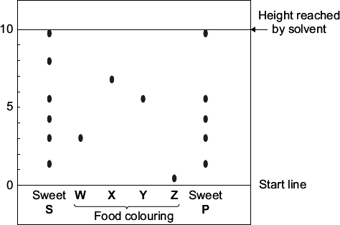
(a) Food colourings, such as W, X, Y and Z, are added to some sweets.
Suggest one reason why.
___________________________________________________________________
___________________________________________________________________
(1)
(b) In chromatography, the R_{f} value = 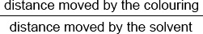
Use the scale on the chromatogram to help you to answer this question.

Which food colouring, W, X, Y or Z, has an R_{f} value of 0.7?
(1)
(c) From the chromatogram, what conclusions can the scientist make about the colourings in sweets S and P?
___________________________________________________________________
___________________________________________________________________
___________________________________________________________________
___________________________________________________________________
___________________________________________________________________
___________________________________________________________________
___________________________________________________________________
___________________________________________________________________
___________________________________________________________________
(3)
(Total 5 marks)

Task 8: In GCSE you would have learnt about paper chromatography. There are several other types of chromatography, such as gas chromatography. Your task is to use the websites below to research gas chromatography and then fill in the tasks below.
Websites to use:
https://www.bbc.co.uk/bitesize/guides/ztkdd2p/revision/3
https://simple.wikipedia.org/wiki/Gas_chromatography
