
  Chemical Calculations (Chapter 4) Exam Questions
  Name: | ________________________
  Class: | ________________________
  Date: | ________________________
Time: | 173 minutes
Marks: | 173 marks
Comments:

Q1.This question is about carbon and gases in the air.
(a) Carbon atoms have protons, neutrons and electrons.
Complete the table by writing the relative mass of a neutron and an electron.

 | Name of particle | Relative mass
 | proton | 1
 | neutron
 | electron

(2)

(b) What is the total number of protons and neutrons in an atom called?

 | Tick () one box.
 | The atomic number | 
 | The mass number
 | One mole of the atom

(1)

(c) An atom of carbon has six electrons.
Which structure, A, B or C, represents the electronic structure of the carbon atom?
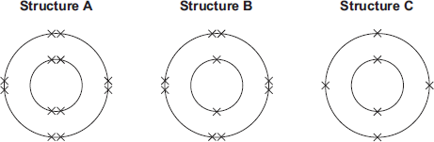

The carbon atom is structure

(1)

(d) Carbon reacts with oxygen to produce carbon dioxide (CO₂).
(i) How many different elements are in one molecule of carbon dioxide?
............................................................
(1)
(ii) What is the total number of atoms in one molecule of carbon dioxide?
............................................................
(1)

(e) Sometimes carbon reacts with oxygen to produce carbon monoxide (CO).
(i) Calculate the relative formula mass (M_{r}) of carbon monoxide.
Relative atomic masses (A_{r}): C = 12; O = 16
...............................................................................................................
...............................................................................................................
M_{r} of carbon monoxide = ..............................
(1)
(ii) Calculate the percentage by mass of carbon in carbon monoxide.
...............................................................................................................
...............................................................................................................
Percentage by mass of carbon in carbon monoxide = ..........%
(1)

(f) Carbon dioxide is one of the gases in the air.
(i) The graph shows the percentage of argon and the percentage of carbon dioxide in the air.
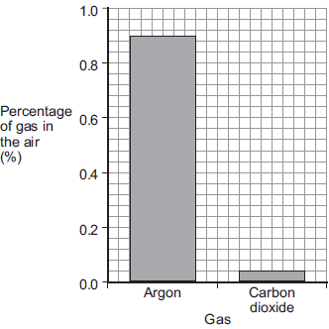
What is the percentage of argon in the air?
Percentage of argon = ........................................ %
(1)
(ii) An instrumental method is used to measure the amount of carbon dioxide in the air.
Give one reason for using an instrumental method.
...............................................................................................................
...............................................................................................................
(1)
(Total 10 marks)

Q2. Calculate the percentage of iron in iron sulphate (FeSO₄).
(Relative atomic masses: Fe = 56, O = 16, S = 32)
...............................................................................................................................................
...............................................................................................................................................
...............................................................................................................................................
...............................................................................................................................................
Percentage of iron in iron sulphate = ..........................%
(Total 3 marks)

Q3.Printed pictures can be made using etchings.
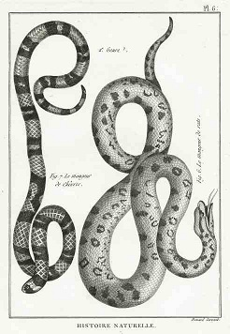
© Eduardo Jose Bernardino/iStock
An etching can be made when a sheet of brass reacts with iron chloride solution.
(a) Brass is a mixture of two metals, copper and zinc.
(i) A mixture of two metals is called ............................................................ .
(1)

(ii) Draw a ring around the correct answer to complete the sentence.
Copper and zinc atoms are different sizes.

 |  | harder
 | This makes brass | more flexible | than the pure metals.
 |  | softer

(1)

(b) Iron chloride has the formula FeCl₃
Relative atomic masses (A_{r}): Cl = 35.5; Fe = 56.
(i) Calculate the relative formula mass (M_{r}) of iron chloride (FeCl₃).
...............................................................................................................
...............................................................................................................
...............................................................................................................
Relative formula mass (M_{r}) of iron chloride = ......................................
(2)

(ii) Calculate the percentage of iron in iron chloride (FeCl₃).
...............................................................................................................
...............................................................................................................
...............................................................................................................
Percentage of iron in iron chloride = .................................................%
(2)
(Total 6 marks)

Q4.Copper is a transition metal.
(a) (i) Where is copper in the periodic table?

Tick () one box.
in the central block
in Group 1
in the noble gas group

(1)

(ii) What is a property of copper?

Tick () one box.
breaks easily
conducts electricity
does not conduct heat

(1)

(b) Copper ores are quarried by digging large holes in the ground, as shown in Figure 1.
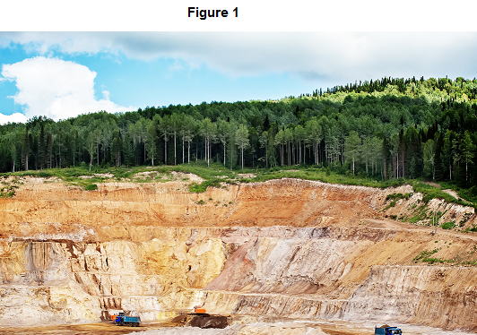
© photllurg/iStock/Thinkstock
Give two reasons why quarrying is bad for the environment.
........................................................................................................................
........................................................................................................................
........................................................................................................................
........................................................................................................................
(2)

(c) Some copper ores contain only 2% copper.
Most of the ore is rock that is not needed.
In one ore, the main compound is copper carbonate (CuCO₃).
Figure 2 shows the stages used in the extraction of copper from this ore.
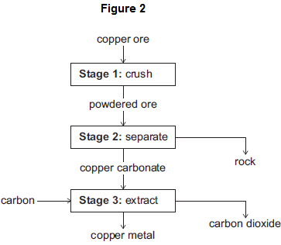
(i) Why is Stage 2 important?
...............................................................................................................
...............................................................................................................
(1)

(ii) The equation for the reaction in Stage 3 is:
2 CuCO₃ + C 2 Cu + 3 CO₂
From the symbol equation, a company calculated that 247 tonnes of copper carbonate are needed to produce 127 tonnes of copper and 132 tonnes of carbon dioxide are released.
Calculate the mass of carbon needed to make 127 tonnes of copper.
...............................................................................................................
...............................................................................................................
(2)

(iii) Suggest one reason why it is important for the company to calculate the mass of reactants in Stage 3.
...............................................................................................................
...............................................................................................................
(1)
(Total 8 marks)

Q5. Ammonium chloride, NH₄Cl, is made up of nitrogen, hydrogen and chlorine atoms.
(i) Complete the table to show the number of atoms of each element present in NH₄Cl.

Element | Number of atoms in NH₄Cl
nitrogen | 1
hydrogen
chlorine

(1)

(ii) Calculate the relative formula mass of ammonium chloride, NH₄Cl.
(Relative atomic masses: H = 1, N = 14, Cl = 35.5)
.....................................................................................................................................
.....................................................................................................................................
.....................................................................................................................................
.....................................................................................................................................
Relative formula mass = .................................................
(2)
(Total 3 marks)

Q6. The chemical equation for the formation of iron is:
Fe₂O₃(s) + 3CO(g) → 2Fe(s) + 3CO₂(g)
Calculate the relative formula mass of iron oxide, Fe₂O₃.
Relative atomic masses: O 16; Fe 56.
...............................................................................................................................................
...............................................................................................................................................
...............................................................................................................................................
Relative formula mass Fe₂O₃ = ................................
(Total 2 marks)

Q7. This question is about methods of treating water.
(a) Chlorine is used to kill microorganisms in water. When chlorine is added to water a chemical reaction takes place. The equation for this reaction is shown below.
Cl₂(g) + H₂O(l) 2H⁺(aq) + OCl–(aq) + Cl–(aq)
An acidic solution is produced when chlorine reacts with water.
Which ion, shown in the equation, makes the solution acidic? ..................................
(1)

(b) Calcium hypochlorite tablets are added to water in some swimming pools to kill microorganisms.

The formula of calcium hypochlorite is CaCl₂O₂

(i) Calculate the relative formula mass (M_{r}) of calcium hypochlorite.
Relative atomic masses: O = 16; Cl = 35.5; Ca = 40.
...........................................................................................................................
...........................................................................................................................
Relative formula mass (M_{r}) of calcium hypochlorite = ...................................
(2)

(ii) Calculate the percentage by mass of chlorine in calcium hypochlorite.
...........................................................................................................................
...........................................................................................................................
Percentage by mass of chlorine in calcium hypochlorite = ......................... %
(2)

(iii) Calculate the mass of chlorine in a 20 g tablet of calcium hypochlorite.
...........................................................................................................................
...........................................................................................................................
Mass of chlorine = ............................................. g
(1)

(c) Waste water from some industrial processes sometimes contains harmful metal ions, such as chromium ions. These ions must be removed from the water before it can be returned to a river.
A method of removing chromium ions (Cr³⁺) from water is represented by this equation.
Cr³⁺(aq) + 3OH–(aq) → Cr(OH)₃(s)
(i) What type of substance would be added to the water to provide the OH– ions?
...........................................................................................................................
...........................................................................................................................
(1)

(ii) A precipitate is formed in this reaction.
What is a precipitate?
...........................................................................................................................
...........................................................................................................................
(1)

(iii) What method could be used to separate the precipitate from the solution?
...........................................................................................................................
...........................................................................................................................
(1)
(Total 9 marks)

Q8. Some students investigated magnesium oxide.
(a) Magnesium oxide has the formula MgO.
(i) Calculate the relative formula mass (M_{r}) of magnesium oxide.
Relative atomic masses: O = 16; Mg = 24.
...............................................................................................................
...............................................................................................................
Relative formula mass = .....................................
(2)

(ii) Calculate the percentage by mass of magnesium in magnesium oxide.
...............................................................................................................
...............................................................................................................
Percentage by mass of magnesium in magnesium oxide = .............%
(2)

(iii) Calculate the mass of magnesium needed to make 25 g of magnesium oxide.
...............................................................................................................
Mass of magnesium = ..................................... g
(1)

(b) The students calculated that if they used 0.12 g of magnesium they should make 0.20 g of magnesium oxide.
They did this experiment to find out if this was correct.

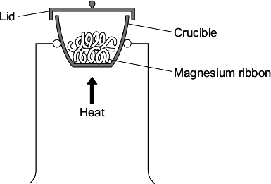
• The students weighed 0.12 g of magnesium ribbon into a crucible.
• They heated the magnesium ribbon.
• They lifted the lid of the crucible slightly from time to time to allow air into the crucible.
• The students tried to avoid lifting the lid too much in case some of the magnesium oxide escaped.
• When all of the magnesium appeared to have reacted, the students weighed the magnesium oxide produced.
The results of the experiment are shown below.

Mass of magnesium  used in grams | 0.12
Mass of magnesium  oxide produced in grams | 0.18

(i) The mass of magnesium oxide produced was lower than the students had calculated.
They thought that this was caused by experimental error.
Suggest two experimental errors that the students had made.
...............................................................................................................
...............................................................................................................
...............................................................................................................
...............................................................................................................
(2)

(ii) The students only did the experiment once.
Give two reasons why they should have repeated the experiment.
...............................................................................................................
...............................................................................................................
...............................................................................................................
...............................................................................................................
(2)
(Total 9 marks)

Q9. Calamine lotion is used to treat itching. The main ingredients are two metal oxides.
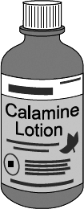
(a) One of the metal oxides has a relative formula mass (M_{r}) of 81.
The formula of this metal oxide is MO.
(M is not the correct symbol for the metal.)
The relative atomic mass (A_{r}) of oxygen is 16.
(i) Calculate the relative atomic mass (A_{r}) of metal M.
...............................................................................................................
...............................................................................................................
...............................................................................................................
Relative atomic mass (A_{r}) = .........................
(2)

(ii) Use your answer to part (a)(i) and the periodic table on the Data Sheet to name metal M.
The name of metal M is ...................................................................... .
(1)

(b) The other metal oxide is iron(III) oxide.
This contains iron(III) ions (Fe³⁺) and oxide ions (O²⁻).
(i) Explain in terms of electrons how an iron atom (Fe) can change into an iron(III) ion (Fe³⁺).
...............................................................................................................
...............................................................................................................
...............................................................................................................
...............................................................................................................
(2)

(ii) The diagram below represents the electronic structure of an oxygen atom (O).
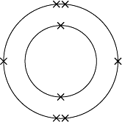
Complete the diagram below to show the electronic structure of an oxide ion (O²⁻).
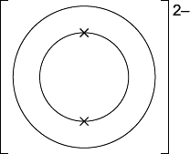
(1)
(Total 6 marks)

Q10. Liquefied petroleum gases such as propane and butane are used as heating fuels for caravans, boats and barbecues.
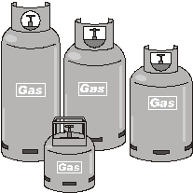
(a) Propane and butane have no smell, so for safety reasons a very small amount of thioethanol – the smelliest substance known – is added, even though it is toxic in large concentrations.
Suggest one safety reason why thioethanol is added to propane and butane.
.....................................................................................................................................
.....................................................................................................................................
(1)

(b) Suggest how mass spectrometry could be used to distinguish between propane (C₃H₈) and butane (C₄H₁₀).
.....................................................................................................................................
.....................................................................................................................................
(1)

(c) When 0.4 g of a hydrocarbon gas was completely burned in oxygen, 1.1 g of carbon dioxide and 0.9 g of water were the only products.
Relative formula masses: CO₂ = 44; H₂O = 18.
Use this information to calculate the number of moles of carbon dioxide and of water produced in this reaction. Use your answers to calculate the empirical formula of this hydrocarbon.
You must show all your working to gain full marks.
.....................................................................................................................................
.....................................................................................................................................
.....................................................................................................................................
.....................................................................................................................................
.....................................................................................................................................
.....................................................................................................................................
.....................................................................................................................................
.....................................................................................................................................
.....................................................................................................................................
Empirical formula is ..............................
(4)
(Total 6 marks)

Q11. Limestone (CaCO₃) is a raw material. On strong heating it is converted to calcium oxide which is a very useful substance.

(a) Calculate the formula mass (M_{r}) of calcium carbonate.
.....................................................................................................................................
M_{r} of calcium carbonate = ...............................................
(2)

(b) About 60 million tonnes of calcium oxide is made in Britain each year.
Calculate the mass of calcium carbonate needed to make this amount of calcium oxide.
....................................................................................................................................
....................................................................................................................................
....................................................................................................................................
....................................................................................................................................
....................................................................................................................................
....................................................................................................................................
Mass of calcium carbonate needed = .............................. million tonnes
(4)

(c) Water is added to some of the calcium oxide produced in a process known as ‘slaking’. The product of this reaction is used to make plaster.
CaO_{(s)} + H₂O₍₁₎→ Ca(OH)_{2(s)}
(i) Give the chemical name of Ca(OH)₂.
..........................................................................................................................
(1)

(ii) What is the physical state of the Ca(OH)₂ formed in the reaction?
..........................................................................................................................
(1)
(Total 8 marks)

Q12. Uranium metal can be produced by reacting uranium hexafluoride with calcium.
UF₆ + 3Ca → 3CaF₂ + U
(a) Describe how calcium and fluorine bond together to form calcium fluoride. The electron arrangement of each atom is shown.
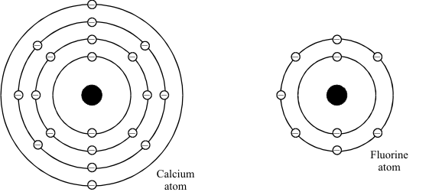
.....................................................................................................................................
.....................................................................................................................................
.....................................................................................................................................
.....................................................................................................................................
.....................................................................................................................................
(5)

(b) Uranium has two main isotopes, and . Use these as examples to explain what is meant by the word isotope.
.....................................................................................................................................
.....................................................................................................................................
.....................................................................................................................................
.....................................................................................................................................
.....................................................................................................................................
(4)

(c) At the start of a reaction there was 174.5 g of uranium hexafluoride, UF₆.
Relative atomic masses: F 19; U 235
(i) Calculate the relative formula mass of uranium hexafluoride, UF₆.
...........................................................................................................................
...........................................................................................................................
...........................................................................................................................
Relative formula mass UF₆ = .................................... g
(1)

(ii) Calculate the mass of uranium that would be produced from 134.5 g of uranium hexafluoride.
...........................................................................................................................
...........................................................................................................................
...........................................................................................................................
...........................................................................................................................
...........................................................................................................................
Mass of uranium = .................................. g
(2)
(Total 12 marks)

Q13. Titanium is a transition metal used as pins and plates to support badly broken bones. Titanium is extracted from an ore that contains the mineral titanium oxide. This oxide is converted into titanium chloride. Titanium chloride is heated with sodium to form titanium metal. This reaction takes place in an atmosphere of a noble gas, such as argon.
4Na(s) + TiCl₄(l) → Ti(s) + 4NaCl(s)
Calculate the mass of titanium that can be extracted from 570 kg of titanium chloride.
Relative atomic masses: Cl 35.5; Ti 48.
...............................................................................................................................................
...............................................................................................................................................
...............................................................................................................................................
...............................................................................................................................................
Mass of titanium = ............................ kg
(Total 3 marks)

Q14. (a) The formula for the chemical compound magnesium sulphate is MgSO₄.
Calculate the relative formula mass (M_{r})of this compound. (Show your working.)
.....................................................................................................................................
.....................................................................................................................................
.....................................................................................................................................
.....................................................................................................................................
(2)

(b) Magnesium sulphate can be made from magnesium and dilute sulphuric acid.
This is the equation for the reaction.
Mg + H₂SO₄ → MgSO₄ + H₂
Calculate the mass of magnesium sulphate that would be obtained from 4g of magnesium.
(Show your working.)
.....................................................................................................................................
.....................................................................................................................................
.....................................................................................................................................
.....................................................................................................................................
.....................................................................................................................................
.....................................................................................................................................
Answer..................................... g
(2)
(Total 4 marks)

Q15. This question is about calcium hydroxide.
Ancient artworks and monuments can be protected from acid rain if the surface is sprayed with calcium hydroxide nanoparticles.
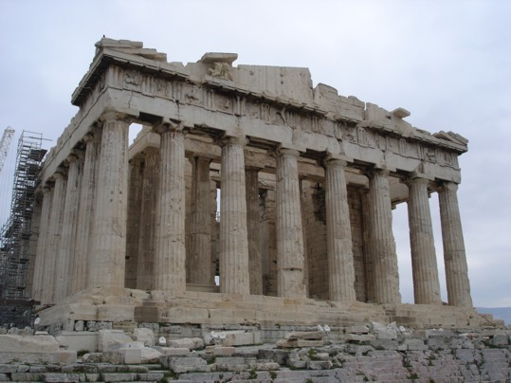
By Svilen Enev (Own work) [GFDL or CC-BY-SA-3.0], via Wikimedia Commons
(a) Calcium hydroxide has the formula Ca(OH)₂
Why are there two hydroxide ions for each calcium ion in the formula?
........................................................................................................................
........................................................................................................................
........................................................................................................................
(1)

(b) The calcium hydroxide is used in the form of nanoparticles.
What are nanoparticles?
........................................................................................................................
........................................................................................................................
(1)

(c) A student added water to calcium oxide to make calcium hydroxide.
The equation for the reaction is shown below.
CaO + H₂O → Ca(OH)₂
Calculate the maximum mass of calcium hydroxide which could be made from 2.00 g of calcium oxide.
Relative atomic masses (A_{r}): H = 1; O = 16; Ca = 40.
........................................................................................................................
........................................................................................................................
........................................................................................................................
........................................................................................................................
........................................................................................................................
........................................................................................................................
Maximum mass of calcium hydroxide = ............................... g
(3)
(Total 5 marks)

Q16. Aspirin tablets have important medical uses.
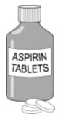

(a) Aspirin is made when salicylic acid reacts with ethanoic anhydride.
The equation for this reaction is:
C₇H₆O₃ + C₄H₆O₃ → C₉H₈O₄ + CH₃COOH
salicylic acid aspirin
Calculate the maximum mass of aspirin that could be made from 100 g of salicylic acid.
Show clearly how you work out your answer.
The relative formula mass (M_{r}) of salicylic acid (C₇H₆O₃) is 138.
The relative formula mass (M_{r}) of aspirin (C₉H₈O₄) is 180.
........................................................................................................................
........................................................................................................................
........................................................................................................................
........................................................................................................................
Maximum mass of aspirin = .................................... g
(2)

(b) (i) In an experiment a chemist calculated that the maximum yield of aspirin is 400 g.
The chemist did the experiment but only made 250 g of aspirin.
Calculate the percentage yield of aspirin for this experiment.
Show clearly how you work out your answer.
...............................................................................................................
...............................................................................................................
...............................................................................................................
...............................................................................................................
Percentage yield of aspirin = ........................... %
(2)

(ii) Suggest one possible reason why the chemist did not have a percentage
yield of 100%.
...............................................................................................................
...............................................................................................................
(1)

(c) The use of a catalyst might reduce costs in the industrial production of aspirin.
Suggest how.
........................................................................................................................
........................................................................................................................
(1)
(Total 6 marks)

Q17. The picture shows a painting which was painted in a cave in France about 17 000 years ago.
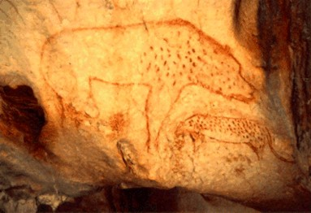
By Carla Hufstedler [CC-BY-SA-2.0], via Wikimedia Commons
One of the pigments in this painting contains:
70 % of iron (Fe) and 30 % of oxygen (O)
Calculate the simplest (empirical) formula of this substance.
Relative atomic masses: O = 16; Fe = 56.
........................................................................................................................
........................................................................................................................
........................................................................................................................
........................................................................................................................
........................................................................................................................
........................................................................................................................
........................................................................................................................
........................................................................................................................
(4)
(Total 4 marks)

Q18. Air bags are used to protect the passengers in a car during an accident. When the crash sensor detects an impact it causes a mixture of chemicals to be heated to a high temperature. Reactions take place which produce nitrogen gas. The nitrogen fills the air bag.
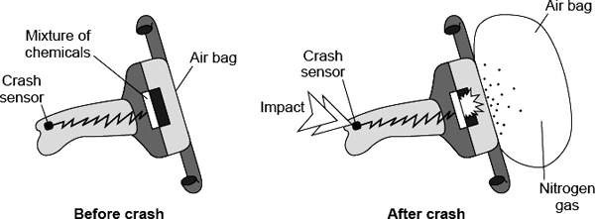
(a) The mixture of chemicals contains sodium azide (NaN₃) which decomposes on heating to form sodium and nitrogen.
2NaN₃ → 2Na + 3N₂
A typical air bag contains 130 g of sodium azide.
(i) Calculate the mass of nitrogen that would be produced when 130 g of sodium azide decomposes.
Relative atomic masses (A_{r}): N = 14; Na = 23
...............................................................................................................
...............................................................................................................
...............................................................................................................
...............................................................................................................
Mass of nitrogen = ..................................... g
(3)

(ii) 1 g of nitrogen has a volume of 0.86 litres at room temperature and pressure.
What volume of nitrogen would be produced from 130 g of sodium azide?
(If you did not answer part (a)(i), assume that the mass of nitrogen produced from 130 g of sodium azide is 80 g. This is not the correct answer to part (a)(i).)
...............................................................................................................
Volume = ..................................... litres
(1)

(b) The sodium produced when the sodium azide decomposes is dangerous.
The mixture of chemicals contains potassium nitrate and silicon dioxide which help to make the sodium safe.
(i) Sodium reacts with potassium nitrate to make sodium oxide, potassium oxide and nitrogen. Complete the balancing of the equation for this reaction.
10Na + ..........KNO₃ → Na₂O + K₂O + N₂
(1)

(ii) The silicon dioxide reacts with the sodium oxide and potassium oxide to form silicates.
Suggest why sodium oxide and potassium oxide are dangerous in contact with the skin.
...............................................................................................................
...............................................................................................................
(1)
(Total 6 marks)

Q19.A spacecraft landed on Mars in 2008.
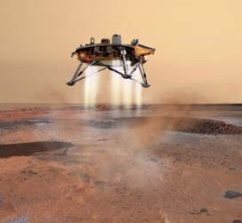
© Stocktrek Images
(a) Probes on the spacecraft analysed some soil.
The probes found a compound in the soil that scientists named compound X.
(i) Compound X had the following percentage composition by mass:
10.8% magnesium, 31.8% chlorine and 57.4% oxygen.
Relative atomic masses: Mg = 24; Cl = 35.5; O = 16
Calculate the empirical formula of compound X.
You must show all of your working to get full marks.
...............................................................................................................
...............................................................................................................
...............................................................................................................
...............................................................................................................
...............................................................................................................
...............................................................................................................
...............................................................................................................
...............................................................................................................
Empirical formula = ............................................................
(4)

(ii) Compound X was shown to be ionic. Compound X had a high melting point.
Use your knowledge of the structure and bonding of ionic compounds to explain why compound X had a high melting point.
...............................................................................................................
...............................................................................................................
...............................................................................................................
...............................................................................................................
...............................................................................................................
...............................................................................................................
(3)

(b) Hydrazine and hydrogen were both carried to be used as fuels on the spacecraft.
Hydrazine is stored as a liquid but hydrogen is stored as a gas.
Suggest three advantages of using a liquid fuel rather than a gaseous fuel.
1 ......................................................................................................................
.........................................................................................................................
2 ......................................................................................................................
.........................................................................................................................
3 ......................................................................................................................
.........................................................................................................................
(3)
(Total 10 marks)

Q20.(a) The diagram shows an atom of magnesium and an atom of chlorine.
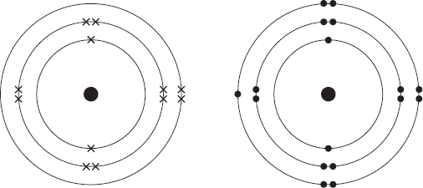

Magnesium Chlorine
Describe, in terms of electrons, how magnesium atoms and chlorine atoms change into ions to produce magnesium chloride (MgCl₂).
.........................................................................................................................
.........................................................................................................................
.........................................................................................................................
.........................................................................................................................
.........................................................................................................................
.........................................................................................................................
.........................................................................................................................
.........................................................................................................................
(4)

(b) Calculate the relative formula mass (M_{r}) of magnesium chloride (MgCl₂).
Relative atomic masses (A_{r}): magnesium = 24; chlorine = 35.5
.........................................................................................................................
.........................................................................................................................
.........................................................................................................................
Relative formula mass (M_{r}) = ...............
(2)
(Total 6 marks)

Q21.The article gives some information about maple syrup.

Maple Syrup – New Superfood!
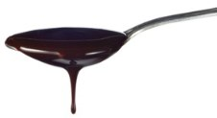
© Picsfive/iStock
Scientists analysed the syrup from maple trees. They have identified some new compounds. These compounds could be used to treat diabetes and bacterial infections.

(a) One new compound identified in maple syrup is Quebecol.
Some scientists tried to produce Quebecol in their laboratory. The scientists produced a mixture containing two compounds, A and B.
The table shows the percentage by mass of carbon in the two compounds the scientists produced.

 | Compound | Percentage by mass  of carbon (%)
 | A | 74.2
 | B | 67.6

Quebecol has the formula C₂₄H₂₆O₇
The relative formula mass (M_{r}) of Quebecol is 426.
Relative atomic mass (A_{r}): C = 12.
Use the data to show that compound B is Quebecol.
You must show your working.
.........................................................................................................................
.........................................................................................................................
.........................................................................................................................
(1)

(b) Scientists separated another compound from the maple syrup.
The compound contained:
5.65 g carbon (C); 2.20 g nitrogen (N); 0.629 g hydrogen (H).
Calculate the empirical formula of the compound.
To gain full marks you must show your working.
Relative atomic masses (A_{r}): H = 1; C = 12; N = 14.
.........................................................................................................................
.........................................................................................................................
.........................................................................................................................
.........................................................................................................................
.........................................................................................................................
.........................................................................................................................
.........................................................................................................................
Empirical formula = ...................................
(4)
(Total 5 marks)

Q22.Hard water causes scale in kettles, as shown in the figure below .
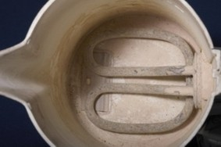
© Steve Gorton/Thinkstock
(a) Acids are used to remove scale.
(i) Give the name of a carbonate in scale.
...............................................................................................................
(1)

(ii) When acids react with scale a gas is produced.
What is the name of the gas?
...............................................................................................................
(1)

(b) Ethanoic acid is used to remove scale.
Complete the displayed structure of ethanoic acid (CH₃COOH).
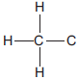
(1)

(c) A student compared the rates at which ethanoic acid and hydrochloric acid react with scale.
Both acids had the same concentration.
(i) The student found that hydrochloric acid reacts faster than ethanoic acid with scale.
Explain why hydrochloric acid reacts faster than ethanoic acid.
...............................................................................................................
...............................................................................................................
...............................................................................................................
...............................................................................................................
(2)

(ii) Hydrochloric acid should not be used to dissolve scale in kettles.
Suggest why.
...............................................................................................................
...............................................................................................................
(1)

(d) A student does a titration to find the concentration of a solution of hydrochloric acid.
The student titrates 25.00 cm³ of hydrochloric acid with sodium hydroxide solution of concentration 0.200 moles per dm³. The equation for the reaction is:
HCl + NaOH NaCl + H₂O
The student added 28.60 cm³ of sodium hydroxide solution to neutralise the hydrochloric acid.
Calculate the concentration of the hydrochloric acid.
........................................................................................................................
........................................................................................................................
........................................................................................................................
........................................................................................................................
........................................................................................................................
Concentration = .................................................. moles per dm³
(3)
(Total 9 marks)

Q23.A student investigated the rate of reaction of magnesium and hydrochloric acid.
Mg(s) + 2HCl(aq) MgCl₂(aq) + H₂(g)
The student studied the effect of changing the concentration of the hydrochloric acid.
She measured the time for the magnesium to stop reacting.
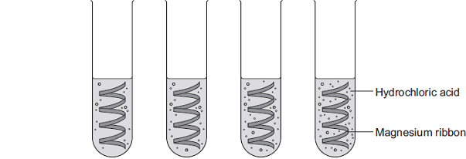
 | Concentration of hydrochloric acid in moles per dm³ | 0.5 | 1.0 | 1.5 | 2.0

(a) The student changed the concentration of the hydrochloric acid.
Give two variables that the student should control.
1 ....................................................................................................................
2 ....................................................................................................................
(2)

(b) (i) The rate of reaction increased as the concentration of hydrochloric acid increased.
Explain why.
...............................................................................................................
...............................................................................................................
...............................................................................................................
...............................................................................................................
(2)

(ii) Explain why increasing the temperature would increase the rate of reaction.
...............................................................................................................
...............................................................................................................
...............................................................................................................
...............................................................................................................
...............................................................................................................
...............................................................................................................
(3)

(c) (i) The student had a solution of sodium hydroxide with a concentration of 0.100 moles per dm³.
She wanted to check the concentration of a solution of hydrochloric acid.
She used a pipette to transfer 5.00 cm³ of the hydrochloric acid into a conical flask.
She filled a burette with the 0.100 moles per dm³ sodium hydroxide solution.
Describe how she should use titration to obtain accurate results.
...............................................................................................................
...............................................................................................................
...............................................................................................................
...............................................................................................................
...............................................................................................................
...............................................................................................................
...............................................................................................................
...............................................................................................................
...............................................................................................................
...............................................................................................................
...............................................................................................................
(4)

(ii) Sodium hydroxide neutralises hydrochloric acid as shown in the equation:
NaOH(aq) + HCl(aq) NaCl(aq) + H₂O(l)
The student found that 27.20 cm³ of 0.100 moles per dm³ sodium hydroxide neutralised 5.00 cm³ of hydrochloric acid.
Calculate the concentration of the hydrochloric acid in moles per dm³.
Give your answer to three significant figures.
...............................................................................................................
...............................................................................................................
...............................................................................................................
...............................................................................................................
...............................................................................................................
...............................................................................................................
Concentration of hydrochloric acid = .............................. moles per dm³
(3)
(Total 14 marks)

Q24. Ammonium sulfate is an artificial fertiliser.
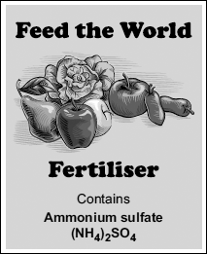
(a) (i) When this fertiliser is warmed with sodium hydroxide solution, ammonia gas is given off.
Describe and give the result of a test for ammonia gas.
Test .......................................................................................................
...............................................................................................................
Result ...................................................................................................
...............................................................................................................
(2)

(ii) Describe and give the result of a chemical test to show that this fertiliser contains sulfate ions (SO₄^{2–}).
Test .......................................................................................................
...............................................................................................................
Result ...................................................................................................
...............................................................................................................
(2)

(b) Ammonium sulfate is made by reacting sulfuric acid (a strong acid) with ammonia solution (a weak alkali).
(i) Explain the meaning of strong in terms of ionisation.
...............................................................................................................
(1)

(ii) A student made some ammonium sulfate in a school laboratory.
The student carried out a titration, using a suitable indicator, to find the volumes of sulfuric acid and ammonia solution that should be reacted together.
Name a suitable indicator for strong acid-weak alkali titrations.
...............................................................................................................
(1)

(iii) The student found that 25.0 cm³ of ammonia solution reacted completely with 32.0 cm³ of sulfuric acid of concentration 0.050 moles per cubic decimetre.
The equation that represents this reaction is:

2H₂SO₄(aq) | + | 2NH₃(aq) | → | (NH₄)₂SO₄ (aq)

Calculate the concentration of this ammonia solution in moles per cubic decimetre.
...............................................................................................................
...............................................................................................................
...............................................................................................................
...............................................................................................................
...............................................................................................................
Concentration = .................................. moles per cubic decimetre
(3)

(iv) Use your answer to (b)(iii) to calculate the concentration of ammonia in grams per cubic decimetre.
(If you did not answer part (b)(iii), assume that the concentration of the ammonia solution is 0.15 moles per cubic decimetre. This is not the correct answer to part (b)(iii).)
Relative formula mass of ammonia (NH₃) = 17.
...............................................................................................................
...............................................................................................................
...............................................................................................................
Concentration = .................................. grams per cubic decimetre
(2)
(Total 11 marks)

Q25. Vinegar can be added to food. Vinegar is an aqueous solution of ethanoic acid.

Ethanoic acid is a weak acid.
(a) Which ion is present in aqueous solutions of all acids?
........................................................................................................................
(1)

(b) What is the difference between the pH of a weak acid compared to the pH of a strong acid of the same concentration?
Give a reason for your answer.
........................................................................................................................
........................................................................................................................
........................................................................................................................
........................................................................................................................
(2)

(c) The diagram shows the apparatus used to find the concentration of ethanoic acid in vinegar.
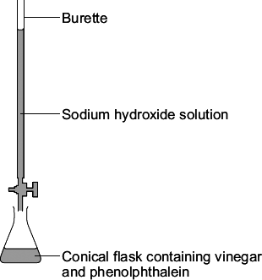
(i) Why should phenolphthalein indicator be used for this titration instead of methyl orange?
...............................................................................................................
...............................................................................................................
(1)

(ii) 25.00 cm³ of vinegar was neutralised by 30.50 cm³ of a solution of sodium hydroxide with a concentration of 0.50 moles per cubic decimetre.
The equation for this reaction is:

CH₃COOH(aq) | + | NaOH(aq) | → | CH₃COONa(aq) | + | H₂O(l)

Calculate the concentration of ethanoic acid in this vinegar.
...............................................................................................................
...............................................................................................................
...............................................................................................................
...............................................................................................................
Concentration of ethanoic acid in this vinegar = .................... moles per cubic decimetre
(2)

(d) The concentration of ethanoic acid in a different bottle of vinegar was 0.80 moles per cubic decimetre.
Calculate the mass in grams of ethanoic acid (CH₃COOH) in 250 cm³ of this vinegar.
The relative formula mass (M_{r}) of ethanoic acid = 60.
........................................................................................................................
........................................................................................................................
........................................................................................................................
........................................................................................................................
Mass of ethanoic acid = ...................................... g
(2)
(Total 8 marks)

