C5 Chemical Changes Exam Question Pack |  | Name: ________________________  Class: ________________________  Date: ________________________
Time: | 119 minutes
Marks: | 119 marks
Comments:

Q1.The table shows some information about acids and alkalis.

 | Name of acid or alkali | Type | Ions produced in solution |  | pH | Effect on Universal Indicator
 | Hydrochloric acid | Strong acid | H⁺ | CI – | 1 | Goes red
 | Sodium hydroxide | Strong alkali | Na⁺ | OH – | 13 | Goes purple

Use the information in the table to help you answer parts (a) and (b).
(a) Draw a ring around the correct answer to complete the sentences.
(i) Hydrochloric acid is acidic.

 |  | Cl–
 | This is because it contains | H⁺ | ions.
 |  | OH–

(1)

(ii) Sodium hydroxide solution is alkaline.

 |  | H⁺
 | This is because it contains | Na⁺ | ions.
 |  | OH–

(1)

(b) Hydrochloric acid is a stronger acid than ethanoic acid.
When Universal Indicator is added to solutions of these acids at the same concentration the results are different.
Describe how the results would show that ethanoic acid is a weaker acid than hydrochloric acid.
........................................................................................................................
........................................................................................................................
........................................................................................................................
........................................................................................................................
(2)

(c) Draw a ring around the correct answer to complete this sentence.

 |  | completely
 | Strong acids and strong alkalis are | not | ionised in water.
 |  | partially

(1)

(d) The diagram shows the apparatus used to find the volume of hydrochloric acid that reacts with 25.0 cm³ of sodium hydroxide solution.
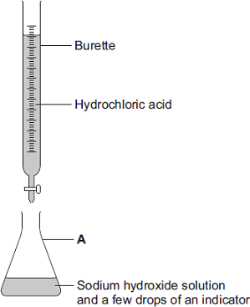
(i) Which one of the following is the correct name for A?
Draw a ring around your answer.

 | beaker | conical flask | pipette

(1)

(ii) Use the correct word from the box to complete the sentence.

 | distillation | filtration | titration

(1)

The method used to find the volume of acid that reacts with a known volume
of alkali is called....................................................................................
(1)

(iii) Suggest one way to make the results more reliable.
...............................................................................................................
...............................................................................................................
(1)
(Total 8 marks)

Q2. A solution of Y was slowly added to a solution of X. The graph shows how the pH of the resulting solution changed.
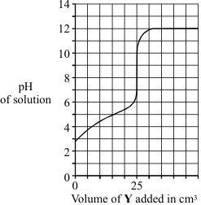

(a) (i) What was the pH of solution X before any of solution Y was added?
...........................................................................................................................
(1)

(ii) State whether solution Y was acidic, alkaline or neutral.
...........................................................................................................................
(1)
(iii) What volume of solution Y was needed to react with all of the substance in solution X?
.................................................................................................................... cm³
(1)

(b) The chemical equation shows the reaction between an acid and an alkali to form a salt and water.
(i) Draw a circle round the formula of the alkali.
H₂SO₄ + 2KOH → K₂SO₄ + 2H₂O
(1)

(ii) What is the formula of the salt?
...........................................................................................................................
(1)
(Total 5 marks)

Q3. The diagrams show what happens when an acid is added to an alkali.
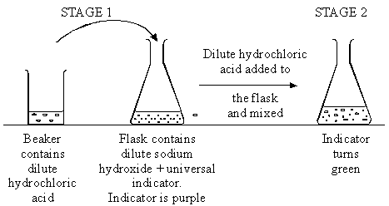

(a) What is present in the flask at stage 2, besides universal indicator and water?
.....................................................................................................................................
(1)

(b) Write an ionic equation to show how water is formed in this reaction and state the sources of the ions.
.....................................................................................................................................
.....................................................................................................................................
.....................................................................................................................................
.....................................................................................................................................
(3)
(Total 4 marks)

Q4. (i) Which acid from the list should the student add to sodium hydroxide solution to make sodium sulphate?
ethanoic acid hydrochloric acid nitric acid sulphuric acid
.....................................................................................................................................
(1)

(ii) When the acid was added to the alkali the beaker became warm.
Name the type of reaction that releases heat.
.....................................................................................................................................
(1)

(iii) Use the Data Sheet to help you to write the formula of sodium sulphate.
Formula: .....................................................................................................................
(1)
(Total 3 marks)

Q5. Powdered magnesium oxide was added in 0.1 g amounts to 25 cm³ of dilute hydrochloric acid and the mixture stirred. The powder soon reacted and disappeared, but after about 1.0 g had been added it took some time for all the solid to react. When a total of 1.1 g of powder had been added, some of the magnesium oxide remained at the bottom of the flask.
(a) On the following axes draw a sketch graph to show how the pH of the liquid is likely to change during the experiment described above. Start the graph with the pH of the acid before any magnesium oxide is added.
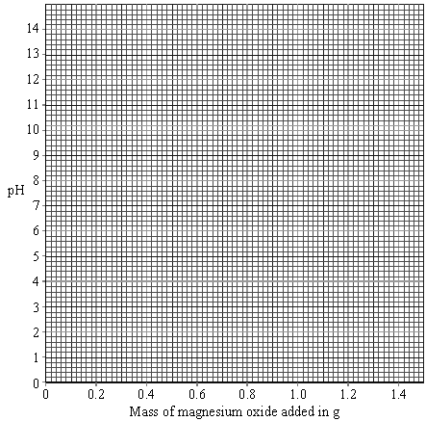
(3)

(b) A second experiment was done using magnesium oxide from the same bottle with
25 cm³ of the same hydrochloric acid.
There is no catalyst for this reaction. Suggest two ways in which the rate of this reaction could have been speeded up.
...................................................................................................................................
...................................................................................................................................
(2)

(c) (i) What is the symbol for the oxide ion?
...........................................................................................................................
(1)

(ii) Complete the ionic equation for the reaction between hydrogen ions and oxide ions.
................................. + ................................. → H₂O
(2)

(iii) The experiment was repeated, but 25 cm³ of dilute sulphuric acid was used instead of hydrochloric acid.
The concentration of the sulphuric acid was the same as the hydrochloric acid
(0.1 M).
Why was twice as much magnesium oxide needed to neutralise the sulphuric acid completely?
...........................................................................................................................
...........................................................................................................................
(1)
(Total 9 marks)

Q6. Copper sulfate (CuSO₄) is a salt that has many uses.
An aqueous solution of copper sulfate can be made by reacting copper oxide (CuO) with an acid.
(a) (i) Name this acid. ...............................................................................................
(1)
(ii) Write a balanced symbol equation, including state symbols, for this reaction.
.........................................................................................................................
(2)

(b) Copper oxide reacts much faster with acid at 40 °C than at 20 °C.
Explain why in terms of particles.
...................................................................................................................................
...................................................................................................................................
...................................................................................................................................
...................................................................................................................................
(2)
(Total 5 marks)

Q7. When a solution of lead nitrate is added to a solution of sodium chloride, a white precipitate of lead chloride is produced.
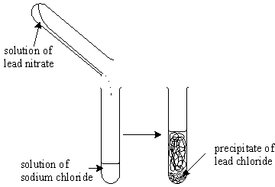

(a) (i) Why is a precipitate formed?
...........................................................................................................................
...........................................................................................................................
(1)

(ii) Complete and balance the equation for this precipitation reaction.
Pb⁺²(aq) + Cl–(aq) →
(3)

(b) Complete the table below by writing in the name and formula of the precipitate formed for each reaction. If there is no precipitate, write “no precipitate”.
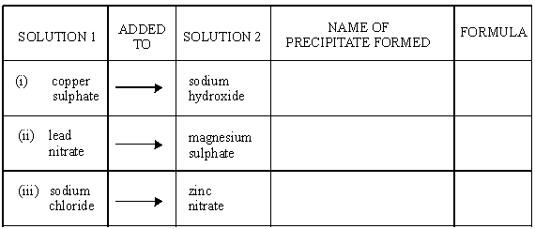
(5)
(Total 9 marks)

Q8. In this question you will get marks on using good English, organising information clearly and using specialist terms correctly.
Copper sulfate crystals can be made from copper oxide powder and dilute sulfuric acid.
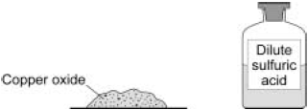
Describe a method to make copper sulfate crystals from copper oxide and dilute sulfuric acid.
For the method you should include:
• the names of the pieces of apparatus used
• a risk assessment.
.................................................................................................................................
.................................................................................................................................
.................................................................................................................................
.................................................................................................................................
.................................................................................................................................
.................................................................................................................................
.................................................................................................................................
.................................................................................................................................
.................................................................................................................................
.................................................................................................................................
.................................................................................................................................
.................................................................................................................................
(Total 6 marks)

Q9.A student investigated the reaction between magnesium and hydrochloric acid.
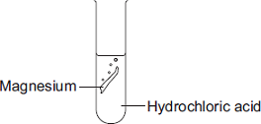
The equation for the reaction is:

 | Mg(s) magnesium | + | 2 HCl(aq) hydrochloric acid |  | MgCl2(aq) magnesium chloride | + | H2(g) hydrogen

(a) Give two observations the student could make during the reaction.
1 ......................................................................................................................
........................................................................................................................
2 ......................................................................................................................
........................................................................................................................
(2)

(b) In this question you will be assessed on using good English, organising information clearly and using specialist terms where appropriate.
The student investigated how the rate of this reaction changed when the concentration of hydrochloric acid was changed.
Write a plan the student could use.
In your plan you should:
• describe how you would carry out the investigation and make it a fair test
• describe the measurements you would make.
........................................................................................................................
........................................................................................................................
........................................................................................................................
........................................................................................................................
........................................................................................................................
........................................................................................................................
........................................................................................................................
........................................................................................................................
........................................................................................................................
........................................................................................................................
........................................................................................................................
........................................................................................................................
........................................................................................................................
........................................................................................................................
(6)
(Total 8 marks)

Q10.Aluminium has many uses.
(a) An aluminium atom has 13 electrons.
(i) Draw the electronic structure of an aluminium atom.
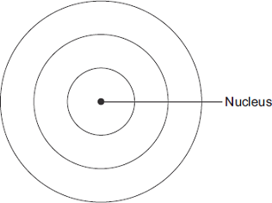
(1)

(ii) Name the two sub-atomic particles in the nucleus of an aluminium atom.
................................................... and ...................................................
(1)

(iii) Why is there no overall electrical charge on an aluminium atom?
...............................................................................................................
...............................................................................................................
(1)

(b) Rail tracks are made from steel.
Molten iron is used to weld rail tracks.
The reaction of aluminium with iron oxide is used to produce molten iron.
(i) Balance the chemical equation for the reaction.
(1)

(ii) Why does aluminium react with iron oxide?
...............................................................................................................
...............................................................................................................
(1)
(Total 5 marks)

Q11. Sodium carbonate reacts with acids.
(i) Complete the word equation.
sodium carbonate + hydrochloric acid → sodium chloride + ...................... + water
(1)
(ii) Name the salt produced if sodium carbonate reacts with dilute nitric acid.
...........................................................................................................................
(1)
(Total 2 marks)

Q12. Explain, in terms of ions and molecules, what happens when any acid reacts with any alkali.
...............................................................................................................................................
...............................................................................................................................................
...............................................................................................................................................
...............................................................................................................................................
...............................................................................................................................................
...............................................................................................................................................
(Total 3 marks)

Q13.This question is about magnesium.
(a) (i) The electronic structure of a magnesium atom is shown below.
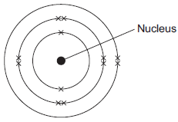

Use the correct answer from the box to complete each sentence.

 | electrons | neutrons | protons | shells

The nucleus contains protons and ..................
The particles with the smallest relative mass that move around the nucleus are
called ..................
Atoms of magnesium are neutral because they contain the same number of electrons
and ..................
(3)

(ii) A magnesium atom reacts to produce a magnesium ion.
Which diagram shows a magnesium ion?
Tick () one box.
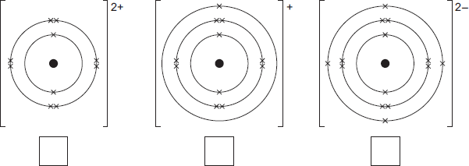
(1)

(b) Magnesium and dilute hydrochloric acid react to produce magnesium chloride solution and hydrogen.
Mg(s) + 2 HCl(aq) MgCl₂(aq) + H₂(g)
(i) State two observations that could be made during the reaction.
1 ............................................................................................................
...............................................................................................................
2 ............................................................................................................
...............................................................................................................
(2)

(ii) In this question you will be assessed on using good English, organising information clearly and using specialist terms where appropriate.
Describe a method for making pure crystals of magnesium chloride from magnesium and dilute hydrochloric acid.
In your method you should name the apparatus you will use.
You do not need to mention safety.
...............................................................................................................
...............................................................................................................
...............................................................................................................
...............................................................................................................
...............................................................................................................
...............................................................................................................
...............................................................................................................
...............................................................................................................
...............................................................................................................
...............................................................................................................
(6)
(Total 12 marks)

Q14.A student was trying to produce hydrogen gas.
Figure 1 shows the apparatus she used.
Figure 1
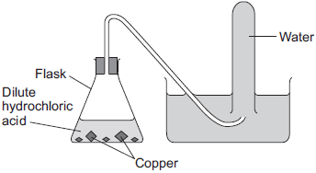
(a) No gas was produced.
The student’s teacher said that this was because the substances in the flask did not react.
(i) Suggest why the substances in the flask did not react.
...............................................................................................................
...............................................................................................................
...............................................................................................................
(1)

(ii) Which two substances could the student have put in the flask to produce hydrogen safely?
Tick (✓) one box.
Gold and dilute hydrochloric acid
Potassium and dilute hydrochloric acid
Zinc and dilute hydrochloric acid

(1)

(b) Another student did produce hydrogen from two substances.
Figure 2 shows the apparatus the student used to collect and measure the volume of the hydrogen gas.
Figure 2
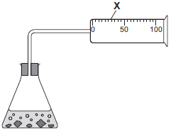
Give the name of the apparatus labelled X.
........................................................................................................................
(1)

(c) The student did the experiment four times. Her results are shown in the table below.

 | Experiment | Volume of hydrogen collected in one minute in cm³
 | 1 | 49
 | 2 | 50
 | 3 | 35
 | 4 | 48

(i) One of the results is anomalous.
Which result is anomalous? Write your answer in the box.
Give a reason for your choice.
...............................................................................................................
(2)

(ii) Calculate the mean volume of hydrogen collected in one minute.
...............................................................................................................
...............................................................................................................
Mean volume = ........................................ cm³
(2)

(iii) Give a reason why the experiment should be repeated several times.
...............................................................................................................
...............................................................................................................
...............................................................................................................
(1)

(d) A teacher collected two tubes full of hydrogen gas, as shown in Figure 3.
Figure 3
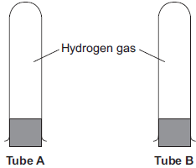
She tested tube A with a lighted splint as soon as she took the bung out.
She tested tube B with a lighted splint a few seconds after taking the bung out.
(i) Suggest why tube B gave a much louder pop than tube A.
...............................................................................................................
...............................................................................................................
...............................................................................................................
...............................................................................................................
(1)

(ii) Complete and balance the chemical equation for the reaction that takes place when the hydrogen reacts in this test.
H₂ + O₂
(2)
(Total 11 marks)

Q15.Calcium chloride (CaCl₂) is a soluble salt.
Calcium chloride can be made by reacting dilute hydrochloric acid with either solid calcium oxide or solid calcium carbonate.
(a) Name the type of reaction that takes place when dilute hydrochloric acid reacts with calcium oxide.
........................................................................................................................
(1)

(b) Write a balanced symbol equation for the reaction of dilute hydrochloric acid with calcium oxide.
........................................................................................................................
(2)

(c) A student added solid calcium oxide to dilute hydrochloric acid in a beaker.
The student added solid calcium carbonate to dilute hydrochloric acid in another beaker.
Describe one difference between the two reactions that the student would see.
........................................................................................................................
........................................................................................................................
(1)

(d) Describe how crystals of calcium chloride can be made from calcium carbonate and dilute hydrochloric acid.
........................................................................................................................
........................................................................................................................
........................................................................................................................
........................................................................................................................
........................................................................................................................
........................................................................................................................
........................................................................................................................
........................................................................................................................
(4)

(e) A student dissolved some crystals of a salt in water.
The student added sodium hydroxide solution to the salt solution.
The student added sodium hydroxide solution until it was in excess.
(i) Describe what the student would see if the salt contained calcium ions.
...............................................................................................................
...............................................................................................................
...............................................................................................................
(2)

(ii) Why does the result you have described in part (e)(i) not prove that the salt contains calcium ions?
...............................................................................................................
...............................................................................................................
(1)

(iii) Describe an additional test the student could do that would prove the salt contains calcium ions.
...............................................................................................................
...............................................................................................................
...............................................................................................................
(2)
(Total 13 marks)

Q16.A student investigated displacement reactions of metals.
The student added different metals to copper sulfate solution and measured the temperature change.
The more reactive the metal is compared with copper, the bigger the temperature change.
The apparatus the student used is shown in Figure 1.
Figure 1
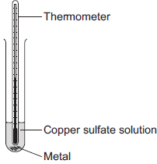
(a) State three variables that the student must control to make his investigation a fair test.
1 ......................................................................................................................
2 ......................................................................................................................
3 ......................................................................................................................
(3)

(b) Figure 2 shows the thermometer in one experiment before and after the student added a metal to the copper sulfate solution.
Figure 2

 | Before adding metal | After adding metal

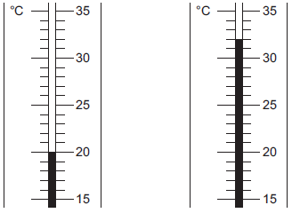
Use Figure 2 to complete Table 1.
Table 1

 | Temperature before adding metal in °C | ...............
 | Temperature after adding metal in °C | ...............
 | Change in temperature in °C | ...............

(3)

(c) The student repeated the experiment three times with each metal.
Table 2 shows the mean temperature change for each metal.
Table 2

 | Metal | Mean temperature change in °C
 | Cobalt | 4.5
 | Gold | 0.0
 | Magnesium | 10.0
 | Nickel | 3.0
 | Silver | 0.0
 | Tin | 1.5

(i) On Figure 3, draw a bar chart to show the results.
Figure 3
(3)

(ii) Why is a line graph not a suitable way of showing the results?
...............................................................................................................
...............................................................................................................
(1)

(iii) Use the results to work out which metal is the most reactive.
Give a reason for your answer.
Most reactive metal ..................................................
Reason ..................................................................................................
...............................................................................................................
(2)

(iv) Explain why there was no temperature change when silver metal was added to the copper sulfate solution.
...............................................................................................................
...............................................................................................................
...............................................................................................................
...............................................................................................................
(2)

(v) It is not possible to put all six metals in order of reactivity using these results.
Suggest how you could change the experiment to be able to put all six metals into order of reactivity.
...............................................................................................................
...............................................................................................................
...............................................................................................................
...............................................................................................................
...............................................................................................................
(2)
(Total 16 marks)

