C6 Electrolysis Exam Question Pack |  | Name: ________________________  Class: ________________________  Date: ________________________
Time: | 114 minutes
Marks: | 114 marks
Comments:

Q1.This question is about electrolysis.
(a) Metal spoons can be coated with silver.
This is called electroplating.
Suggest one reason why spoons are electroplated.
........................................................................................................................
........................................................................................................................
(1)

(b) When sodium chloride solution is electrolysed the products are hydrogen and chlorine.
(i) What is made from chlorine?

Tick () one box.
Bleach
Fertiliser
Soap

(1)

(ii) Sodium chloride solution contains two types of positive ions, hydrogen ions (H⁺) and sodium ions (Na⁺).
Why is hydrogen produced at the negative electrode and not sodium?

Tick () one box.
Hydrogen is a gas.
Hydrogen is less reactive than sodium.
Hydrogen ions move faster than sodium ions.

(1)

(iii) Hydrogen and chlorine can be used to produce hydrogen chloride.
The diagrams in Figure 1 show how the outer electrons are arranged in an atom of hydrogen and an atom of chlorine.
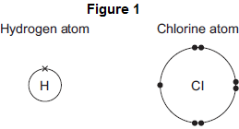
Complete Figure 2 to show how the outer electrons are arranged in a molecule of hydrogen chloride (HCl).
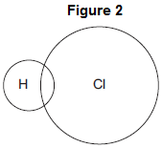
(1)

(iv) What is the type of bond in a molecule of hydrogen chloride?

Tick () one box.
Covalent
Ionic
Metallic

(1)

(v) Why is hydrogen chloride a gas at room temperature (20 °C)?

Tick () two boxes.
Hydrogen chloride has a low boiling point.
Hydrogen chloride has a high melting point.
Hydrogen chloride is made of simple molecules.
Hydrogen chloride does not conduct electricity.
Hydrogen chloride has a giant structure.

(2)

(c) Aluminium is produced by electrolysis of a molten mixture of aluminium oxide and cryolite.
This is shown in Figure 3.
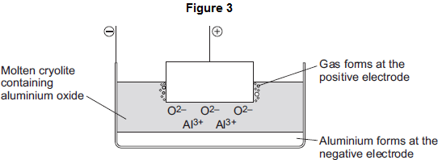
(i) Name a gas produced at the positive electrode.
...............................................................................................................
(1)

(ii) Aluminium ions move to the negative electrode.
Explain why.
...............................................................................................................
...............................................................................................................
...............................................................................................................
...............................................................................................................
(2)

(iii) At the negative electrode, the aluminium ions gain electrons to produce aluminium.
What is this type of reaction called?

Tick () one box.
Combustion
Oxidation
Reduction

(1)

(iv) Aluminium has layers of atoms, as shown in Figure 4.
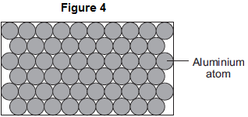
Complete the sentence.
Metals can be bent and shaped because the layers of atoms can ......
(1)

(d) Electrodes used in the production of aluminium are made from graphite.
(i) Which diagram, A, B or C, shows the structure of graphite?
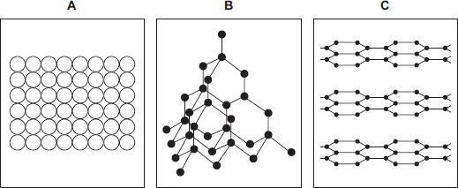

The structure of graphite is shown in diagram

(1)

(ii) The temperature for the electrolysis is 950 °C.
Use the correct answer from the box to complete the sentence.

cross links a giant ionic lattice strong covalent bonds

The graphite does not melt at 950 °C because
graphite has ......................................................... .
(1)
(Total 14 marks)

Q2. The diagrams represent the electronic structure of a magnesium atom and a chlorine atom.
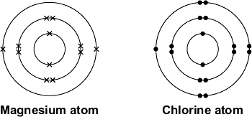
Magnesium reacts with chlorine to make the ionic compound called magnesium chloride. This contains magnesium ions, Mg²⁺, and chloride ions, Cl⁻
(a) (i) Which structure, A, B or C, represents a magnesium ion?
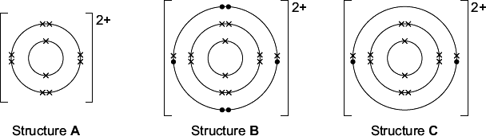

The magnesium ion is Structure

(1)

(ii) Which structure, D, E or F, represents a chloride ion?
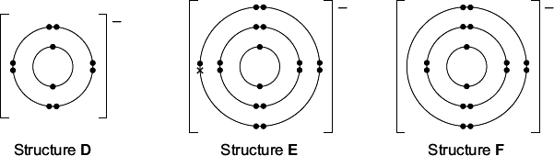

The chloride ion is Structure

(1)

(b) Magnesium metal can be extracted from sea water.
Sea water contains magnesium chloride, MgCl₂
(i) Calcium hydroxide, Ca(OH)₂, is added to the sea water.
Magnesium hydroxide, Mg(OH)₂, is produced as a solid.
This is the equation for the reaction:

MgCl₂(aq) | + | Ca(OH)₂(aq) | → | Mg(OH)₂(s) | + | CaCl₂(aq)

Draw a ring around the correct answer to complete each sentence.

 | soluble
Magnesium hydroxide forms as a solid because it is | insoluble | in water.
 | dissolved

 | precipitation.
This type of reaction is called | neutralisation.
 | thermal decomposition.

(2)

(ii) How is the solid magnesium hydroxide separated from the solution?
...............................................................................................................
(1)

(iii) An acid is then added to the solid magnesium hydroxide to make magnesium chloride.
Draw a ring around the name of this acid.

nitric acid | hydrochloric acid | sulfuric acid

(1)

(c) Electrolysis is used to extract magnesium metal from magnesium chloride.
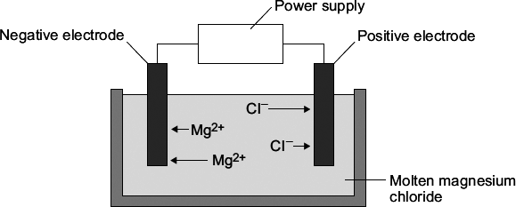
(i) What must be done to solid magnesium chloride to allow it to conduct electricity?
...............................................................................................................
(1)

(ii) Why do the magnesium ions move to the negative electrode?
...............................................................................................................
...............................................................................................................
(1)

(iii) Name the product formed at the positive electrode.
...............................................................................................................
(1)
(Total 9 marks)

Q3.Some students investigated reactions to produce magnesium.
(a) The students used electrolysis to produce magnesium from magnesium chloride, as shown in the figure below.
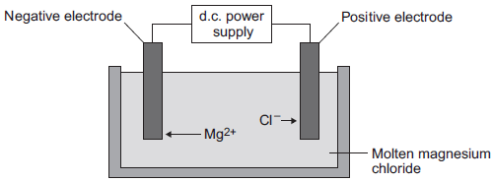
(i) Magnesium chloride contains magnesium ions and chloride ions.
Why does solid magnesium chloride not conduct electricity?
...............................................................................................................
...............................................................................................................
(1)

(ii) One of the products of the electrolysis of molten magnesium chloride is magnesium.
Name the other product.
...............................................................................................................
(1)

(iii) Why do magnesium ions (Mg²⁺) move to the negative electrode?
...............................................................................................................
...............................................................................................................
(1)

(iv) At the negative electrode, the magnesium ions (Mg²⁺) gain electrons to become magnesium atoms.
How many electrons does each magnesium ion gain?
........................................
(1)

(b) The students did the experiment four times and weighed the magnesium produced.
The table below shows their results.

 | Experiment | Mass of magnesium  produced in grams
 | 1 | 1.13
 | 2 | 0.63
 | 3 | 1.11
 | 4 | 1.09

(i) There is an anomalous result.
Suggest one possible reason for the anomalous result.
...............................................................................................................
...............................................................................................................
(1)

(ii) Calculate the mean mass of magnesium produced, taking account of the anomalous result.
...............................................................................................................
...............................................................................................................
...............................................................................................................
Mean mass = ........................................ g
(2)

(c) The formula of magnesium chloride is MgCl₂
The relative formula mass of magnesium chloride is 95.
The relative atomic mass of magnesium is 24.
(i) Use the equation to calculate the percentage mass of magnesium in magnesium chloride.
Percentage mass of magnesium = 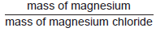× 100%
...............................................................................................................
...............................................................................................................
...............................................................................................................
Percentage mass of magnesium in magnesium chloride = ................... %
(2)

(ii) Draw a ring around the relative mass of chlorine in MgCl₂

 | 71 | 95 | 119

(1)

(d) Magnesium is also produced from the reaction of magnesium oxide with silicon.
(i) The equation for the reaction is:
2 MgO(s) + Si(s) SiO₂(s) + 2 Mg(s)
What is the meaning of this symbol ?
Draw a ring around the correct answer.

 | neutralisation reaction | precipitation reaction | reversible reaction

(1)

(ii) The forward reaction is endothermic.
Draw a ring around the correct answer to complete the sentence.

 | In an endothermic reaction the temperature of the surroundings | decreases.  increases.  stays the same.

(1)
(Total 12 marks)

Q4. The diagram represents an electrolysis cell for extracting aluminium.
The current will only flow when the electrolyte is molten.
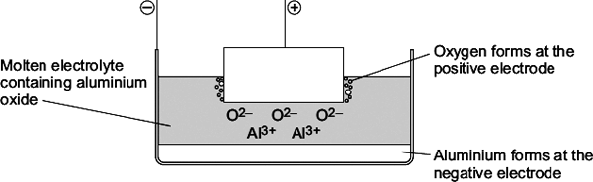
(a) The electrolyte is aluminium oxide mixed with another substance.
(i) What is the name of the other substance in the electrolyte?
Draw a ring around the correct answer.

cryolite | rock salt | limestone

(1)

(ii) Draw a ring around the correct answer to complete the sentence.

 | condense the aluminium oxide.
This other substance is added to | lower the melting point of the aluminium oxide.
 | raise the boiling point of the aluminium oxide.

(1)

(b) (i) Oxide ions (O²⁻) move to the positive electrode.
Explain why.
........................................................................................................................
........................................................................................................................
........................................................................................................................
........................................................................................................................
(2)

(ii) Oxygen is formed at the positive electrode. The oxygen then forms carbon dioxide.
The equation for the reaction is shown below.
C + O₂ → CO₂
Complete the sentence.
The name of the element which reacts with oxygen is .................................
(1)

(iii) The positive electrode gets smaller.
Suggest why.
........................................................................................................................
........................................................................................................................
(1)

(c) Aluminium is used in an alloy with magnesium to make drinks cans.
The diagrams show the arrangement of atoms in pure aluminium and in the alloy.

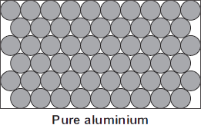 | 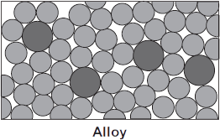
The alloy is harder than pure aluminium.
Explain why. Use the diagrams to help you.
........................................................................................................................
........................................................................................................................
........................................................................................................................
........................................................................................................................
(2)
(Total 8 marks)

Q5. A student investigated the electrolysis of sodium chloride solution.
Five sodium chloride solutions were made. Each solution had a different concentration.
To make each solution the student:
• weighed the amount of sodium chloride needed
• dissolved it in water
• added more water until the total volume was one cubic decimetre (1 dm³).
The solutions were placed one at a time in the apparatus shown below.
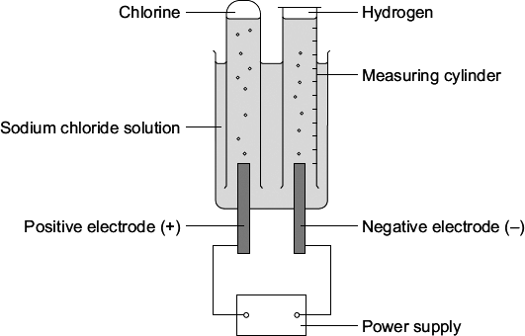
The student measured the volume of hydrogen gas produced in ten minutes.
The results are shown on the graph below.
(a) Sodium chloride does not conduct electricity when it is solid.
Explain, in terms of ions, why sodium chloride solution conducts electricity.
........................................................................................................................
........................................................................................................................
(1)

(b) Chlorine is produced at the positive electrode.
Why are chloride ions attracted to the positive electrode?
........................................................................................................................
(1)

(c) The solution left at the end of each experiment contains sodium hydroxide.
Draw a ring around one number which could be the pH of this solution.

2 | 5 | 7 | 13

(1)

(d) The results for the experiment above are shown on the graph.

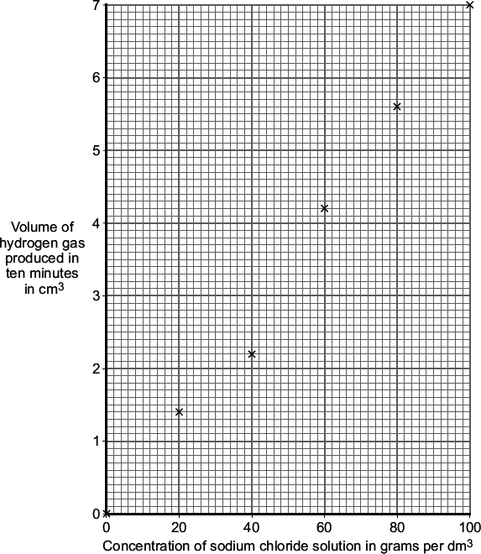
(i) Draw a line of best fit on the graph.
(1)

(ii) The result for one concentration is anomalous.
Which result is anomalous?
The result at concentration ........................ grams per dm³
(1)

(iii) Suggest two possible causes of this anomalous result.
1 ............................................................................................................
...............................................................................................................
2 ............................................................................................................
...............................................................................................................
(2)

(iv) Suggest how the student could check the reliability of the results.
...............................................................................................................
...............................................................................................................
(1)

(iv) How did an increase in the concentration of the sodium chloride solution affect the volume of hydrogen gas produced in ten minutes?
...............................................................................................................
...............................................................................................................
(1)
(Total 9 marks)

Q6. The electrolysis of sodium chloride solution is an industrial process.
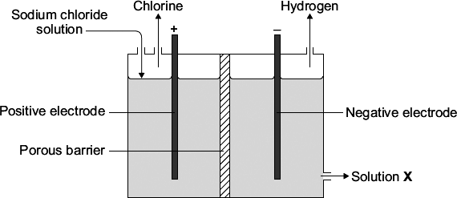
(a) Why do chloride ions move to the positive electrode?
........................................................................................................................
(1)

(b) Sodium chloride solution contains two types of positive ions, sodium ions (Na⁺) and hydrogen ions (H⁺).
Tick () the reason why hydrogen is produced at the negative electrode and not sodium.

Reason | Tick ()
Hydrogen is a gas.
Hydrogen is less reactive than sodium.
Hydrogen is a non-metal.
Hydrogen ions travel faster than sodium ions.
(1)

(c) Solution X is alkaline.
Which ion makes solution X alkaline?
........................................................................................................................
(1)

(d) Electrolysis of sodium chloride solution produces hydrogen and chlorine.
The hydrogen and chlorine can be used to make hydrogen chloride.
(i) The diagrams show how the outer electrons are arranged in atoms of hydrogen and chlorine.
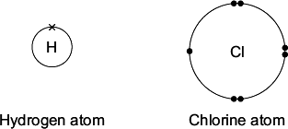
Complete the diagram to show how the electrons are arranged in a molecule of hydrogen chloride (HCl).
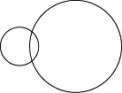
(1)

(ii) Name the type of bond between the hydrogen and the chlorine atoms in a molecule of hydrogen chloride.
................................................................................
(1)

(iii) Some hydrogen chloride was bubbled into water. This made a solution with a pH of 1.
Which ion gave the solution a pH of 1?
................................................................................
(1)
(Total 6 marks)

Q7.This question is about zinc and magnesium.
Zinc is produced by electrolysis of molten zinc chloride, as shown in the figure below.
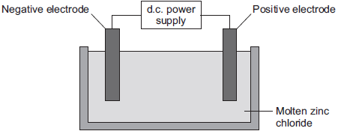
(a) (i) Why must the zinc chloride be molten for electrolysis?
...............................................................................................................
...............................................................................................................
(1)

(ii) Describe what happens at the negative electrode.
...............................................................................................................
...............................................................................................................
...............................................................................................................
...............................................................................................................
...............................................................................................................
...............................................................................................................
(3)

(iii) Complete the half equation for the reaction at the positive electrode.
............... Cl₂ + ............... e–
(1)

(b) Magnesium can be produced from magnesium oxide.
The equation for the reaction is:
Si(s) + 2 MgO(s) SiO₂(s) + 2 Mg(g)
(i) How can you tell from the equation that the reaction is done at a high temperature?
...............................................................................................................
...............................................................................................................
(1)

(ii) This reaction to produce magnesium from magnesium oxide is endothermic.
What is meant by an endothermic reaction?
...............................................................................................................
...............................................................................................................
(1)

(iii) A company made magnesium using this reaction.
Calculate the mass of magnesium oxide needed to produce 1.2 tonnes of magnesium.
Relative atomic masses (A_{r}): O = 16; Mg = 24
...............................................................................................................
...............................................................................................................
...............................................................................................................
...............................................................................................................
Mass of magnesium oxide needed = ........................................ tonnes
(3)

(iv) The company calculated that they would produce 1.2 tonnes of magnesium, but only 0.9 tonnes was produced.
Calculate the percentage yield.
...............................................................................................................
...............................................................................................................
Percentage yield = .................... %
(1)

(v) Give one reason why the calculated yield of magnesium might not be obtained.
...............................................................................................................
...............................................................................................................
(1)
(Total 12 marks)

Q8. Aluminium is extracted from aluminium oxide.
(a) The formula of aluminium oxide is Al₂O₃
The relative formula mass (M_{r}) of aluminium oxide is 102.
Calculate the percentage of aluminium in aluminium oxide.
Relative atomic masses (A_{r}): O = 16; Al = 27.
........................................................................................................................
........................................................................................................................
........................................................................................................................
........................................................................................................................
Percentage of aluminium = ................................ %
(2)

(b) Aluminium is extracted from aluminium oxide using electrolysis.
The diagram shows a cell used for the extraction of aluminium.
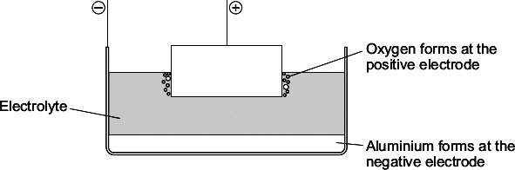
(i) The electrolyte contains cryolite.
Explain why.
...............................................................................................................
...............................................................................................................
...............................................................................................................
...............................................................................................................
(2)

(ii) Oxygen is formed at the positive electrode. Complete and balance the equation for this reaction.
... O²⁻ → O₂ + .............
(2)

(iii) The positive electrode in the cell is used up during the process.
Explain why.
...............................................................................................................
...............................................................................................................
...............................................................................................................
...............................................................................................................
...............................................................................................................
...............................................................................................................
(2)
(Total 8 marks)

Q9.A student investigated the conductivity of different concentrations of sodium chloride solution.
The student set the apparatus up as shown in Figure 1.
Figure 1
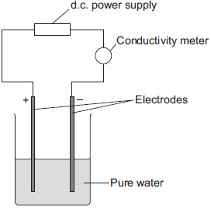
The student measured the conductivity of the pure water with a conductivity meter.
The reading on the conductivity meter was zero.
(a) The student:
• added sodium chloride solution one drop at a time
• stirred the solution
• recorded the reading on the conductivity meter.
The student’s results are shown in the table below.

 | Number of drops of  sodium chloride solution  added | Relative conductivity  of solution
 | 0 | 0
 | 1 | 100
 | 2 | 120
 | 3 | 310
 | 4 | 400
 | 5 | 510
 | 6 | 590
 | 7 | 710
 | 8 | 800

(i) The student plotted the results on the grid shown in Figure 2.
Plot the four remaining results.
Draw a line of best fit, ignoring the anomalous result.
Figure 2
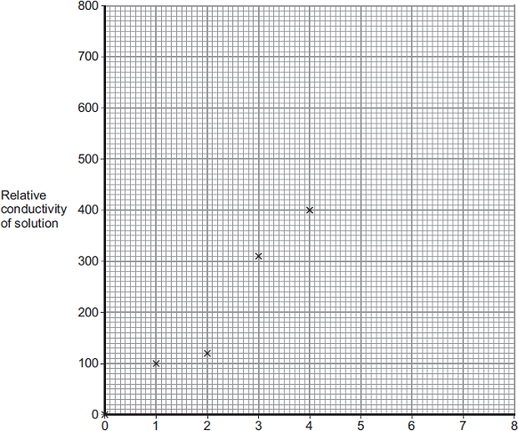
Number of drops of sodium chloride added
(3)

(ii) One of the points is anomalous.
Suggest one error that the student may have made to cause the anomalous result.
...............................................................................................................
...............................................................................................................
(1)

(iii) The student wanted to compare the conductivity of sodium chloride solution with the conductivity of potassium chloride solution.
State one variable he should keep constant when measuring the conductivity of the two solutions.
...............................................................................................................
(1)

(b) (i) Explain, in terms of bonding, why pure water does not conduct electricity.
...............................................................................................................
...............................................................................................................
...............................................................................................................
...............................................................................................................
(2)

(ii) Explain why sodium chloride solution conducts electricity.
...............................................................................................................
...............................................................................................................
...............................................................................................................
...............................................................................................................
(2)

(iii) After he had added sodium chloride solution, the student noticed bubbles of gas at the negative electrode.
Complete the sentence.
The gas produced at the negative electrode is ....................................
(1)
(Total 10 marks)

Q10.Diagram 1 shows the apparatus used to electrolyse magnesium sulfate solution.
Diagram 1
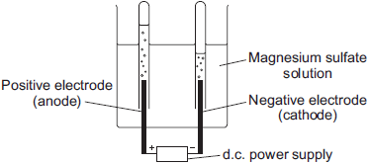
Gases were given off at both electrodes.

(a) The gas collected at the anode was oxygen.
Draw one line from the test for oxygen to the correct result.
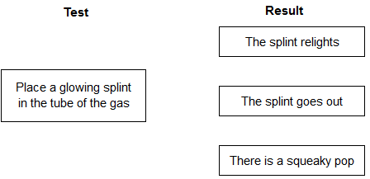
(1)

(b) (i) The gas collected at the cathode was hydrogen.
Describe how to test the gas to show that it is hydrogen.
Test ......................................................................................................
...............................................................................................................
Result ....................................................................................................
...............................................................................................................
(2)

(ii) Why is hydrogen, and not magnesium, produced at the cathode?
...............................................................................................................
...............................................................................................................
(1)

(c) A student wanted to use electrolysis to silver plate a metal spoon.
(i) Give one reason why metal spoons are sometimes silver plated.
...............................................................................................................
...............................................................................................................
(1)

(ii) Diagram 2 shows the apparatus the student used. The student did not set the apparatus up correctly.
Diagram 2
d.c. power
supply
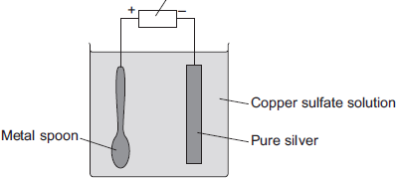
The student found that the metal spoon eroded and a thin layer of copper formed on the pure silver electrode.
Suggest two changes that the student must make to his apparatus to be able to silver plate the metal spoon. Give a reason for each change.
...............................................................................................................
...............................................................................................................
...............................................................................................................
...............................................................................................................
...............................................................................................................
...............................................................................................................
...............................................................................................................
(4)

(iii) Why is it difficult to electroplate plastic spoons?
...............................................................................................................
...............................................................................................................
(1)
(Total 10 marks)

Q11.This question is about copper.
(a) Copper can be extracted by smelting copper-rich ores in a furnace.
The equation for one of the reactions in the smelting process is:
Cu₂S(s) + O₂(g) 2 Cu(s) + SO₂(g)
Explain why there would be an environmental problem if sulfur dioxide gas escaped into the atmosphere.
........................................................................................................................
........................................................................................................................
........................................................................................................................
........................................................................................................................
(2)

(b) The impure copper produced by smelting is purified by electrolysis, as shown below.
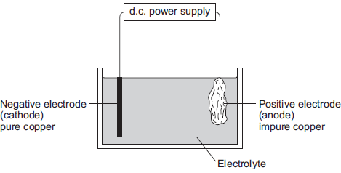
Copper atoms are oxidised at the positive electrode to Cu²⁺ ions, as shown in the half equation.
Cu(s) Cu²⁺(aq) + 2e⁻
(i) How does the half equation show that copper atoms are oxidised?
...............................................................................................................
...............................................................................................................
(1)

(ii) The Cu²⁺ ions are attracted to the negative electrode, where they are reduced to produce copper atoms.
Write a balanced half equation for the reaction at the negative electrode.
...............................................................................................................
(1)

(iii) Suggest a suitable electrolyte for the electrolysis.
...............................................................................................................
(1)

(c) Copper metal is used in electrical appliances.
Describe the bonding in a metal, and explain why metals conduct electricity.
........................................................................................................................
........................................................................................................................
........................................................................................................................
........................................................................................................................
........................................................................................................................
........................................................................................................................
........................................................................................................................
........................................................................................................................
........................................................................................................................
(4)

(d) Soil near copper mines is often contaminated with low percentages of copper compounds.
Phytomining is a new way to extract copper compounds from soil.
Describe how copper compounds are extracted by phytomining.
........................................................................................................................
........................................................................................................................
........................................................................................................................
........................................................................................................................
........................................................................................................................
........................................................................................................................
(3)

(e) A compound in a copper ore has the following percentage composition by mass:
55.6% copper, 16.4% iron, 28.0% sulfur.
Calculate the empirical formula of the compound.
Relative atomic masses (A_{r}): S = 32; Fe = 56; Cu = 63.5
You must show all of your working.
........................................................................................................................
........................................................................................................................
........................................................................................................................
........................................................................................................................
........................................................................................................................
........................................................................................................................
........................................................................................................................
........................................................................................................................
Empirical formula = ............................................................
(4)
(Total 16 marks)

