Energy Resources (Chapter 3) Exam Questions |  | Name: ________________________  Class: ________________________  Date: ________________________
Time: | 109 minutes
Marks: | 109 marks
Comments:

Q1.(a) The pie chart shows the proportions of electricity generated in the UK from different energy sources in 2010.
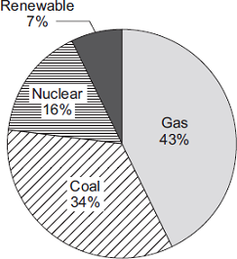
(i) Calculate the percentage of electricity generated using fossil fuels.
...............................................................................................................
Percentage = ............................................ %
(1)

(ii) The pie chart shows that 7% of electricity was generated using renewable energy sources.
Which one of the following is not a renewable energy source?
Tick () one box.

Oil
Solar
Wind

(1)

(b) Complete the following sentence.
In some types of power station, fossil fuels are burned to heat ................................ to produce steam.
(1)

(c) Burning fossil fuels releases carbon dioxide into the atmosphere.
Why do many scientists think adding carbon dioxide to the atmosphere is harmful to the environment?
Tick () one box.

Carbon dioxide is the main cause of acid rain.
Carbon dioxide causes global warming.
Carbon dioxide causes visual pollution.

(1)
(Total 4 marks)

Q2. The bar chart shows the different energy sources used to generate the UK’s electricity in 2007.
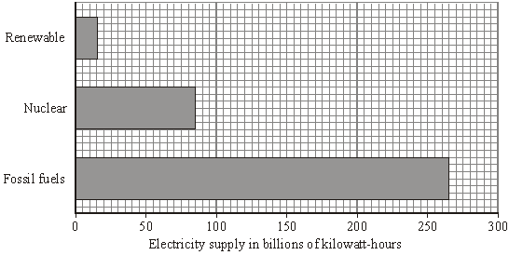

(a) (i) The wind is a renewable energy source.
Name one more renewable energy source used to generate electricity.
...........................................................................................................................
(1)
(ii) Complete the following sentence by drawing a ring around the correct line in the box.

 | decrease
Using less fossil fuels to generate electricity will | not change | the
 | increase

amount of carbon dioxide emitted into the atmosphere.
(1)

(b) The graph shows how the demand for electricity in the UK varied over one day in the winter.
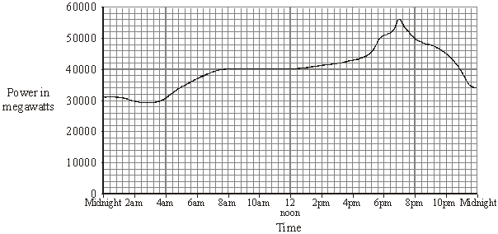

(i) Describe how the demand for electricity varied between 4.00 am and 10.00 am.
...........................................................................................................................
...........................................................................................................................
...........................................................................................................................
...........................................................................................................................
(2)

(ii) Which type of power station has the fastest start-up time?
Draw a ring around your answer.
coal natural gas nuclear oil
(1)
(Total 5 marks)

Q3. (a) The pie chart shows the energy sources used by one company to generate electricity.
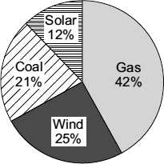
(i) Which two energy sources used by the company do not produce any polluting gases?
............................................. and .............................................
(1)

(ii) Calculate the percentage (%) of electricity that is generated using energy sources that do not produce any polluting gases.
Percentage = .............................................
(1)

(b) Which graph, A, B or C, is most likely to show the electrical power output from a wind turbine over one day?
Write your answer, A, B or C, in the box.

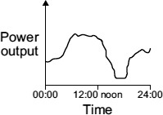  Graph A | 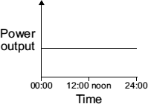  Graph B | 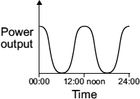  Graph C

Graph

(1)

(c) The government has said that more electricity must be generated from renewable energy sources. A newspaper reported that:
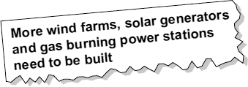
Why is the statement in the newspaper incorrect?
........................................................................................................................
........................................................................................................................
(1)
(Total 4 marks)

Q4. On a very windy hilltop there are two wind generators side by side.
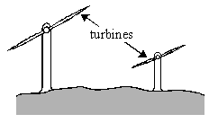

The bar charts show the lengths of the turbine blades and the electrical outputs of the two wind generators.
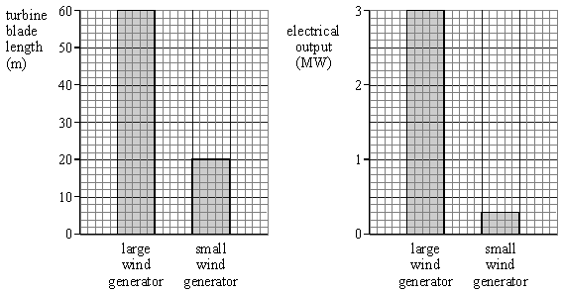

Complete the following table.

 | LENGTH OF TURBINE  BLADE (m) | ELECTRICAL OUTPUT  (MW)
Large wind generator | 60
Small wind generator

(Total 3 marks)

Q5. The table shows the main sources of energy used in Britain in 1990.

coal | 35%
oil | 35%
gas | 24%
nuclear | 5%
moving water  (hydro) | 1%

(a) Finish the pie-chart, using the figures in the table.
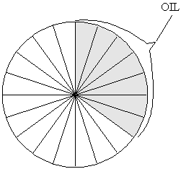
(4)

(b) Complete the following sentences.
To release energy from coal, gas and oil they must be burned.
Coal, gas and oil are all .............................................................
(1)

(c) Which one of the energy sources in the table is renewable? ......................................
Write down the name of one other renewable energy source. ....................................
(2)

(d) How does the amount of energy obtained from nuclear sources in 1990 compare with the amount obtained from moving water?
.....................................................................................................................................
.....................................................................................................................................
(2)
(Total 9 marks)

Q6. There is an increasing demand for electricity and the reserve of fossil fuels is decreasing. A way to meet increasing demand for electricity is to build new nuclear power stations. Some people feel that no new nuclear power stations should be built because of the risks associated with nuclear fuels.
(a) Outline the arguments that a scientist working in the nuclear power industry could use to justify the building of more nuclear power stations in the future.
.....................................................................................................................................
.....................................................................................................................................
.....................................................................................................................................
.....................................................................................................................................
.....................................................................................................................................
(3)

(b) Nuclear waste is a problem that must be dealt with. One possible solution would be to bury the waste deep underground.
Suggest one reason why some people are against burying nuclear waste.
.....................................................................................................................................
.....................................................................................................................................
(1)

(c) Electricity can also be generated using renewable energy sources.
Look at this information from a newspaper report.
• The energy from burning bio-fuels, such as woodchip and straw, can be used
to generate electricity.
• Plants for bio-fuels use up carbon dioxide as they grow.
• Farmers get grants to grow plants for bio-fuels.
• Electricity generated from bio-fuels can be sold at a higher price than electricity generated from burning fossil fuels.
• Growing plants for bio-fuels offers new opportunities for rural communities.

Suggest why, apart from the declining reserves of fossil fuels, power companies should use more bio-fuels and less fossil fuels to generate electricity.
.....................................................................................................................................
.....................................................................................................................................
.....................................................................................................................................
.....................................................................................................................................
.....................................................................................................................................
.....................................................................................................................................
(3)
(Total 7 marks)

Q7.Three energy sources used to generate electricity are given in List A.
Statements about the energy sources used to generate electricity are given in List B.
Draw one line from each energy source in List A to the statement about the energy source in List B.

 | List A  Energy source |  | List B  Statement about energy source
 |  |  | Uses energy from falling water
 | Geothermal
 |  |  | Uses energy from inside the Earth
 | Hydroelectric
 |  |  | Is unpredictable
 | Nuclear
 |  |  | Produces dangerous waste

(Total 3 marks)

Q8.Wind and tides are energy sources that are used to generate electricity.
(a) Complete each sentence by putting a tick ( ) in the box next to the correct answer.
(i) The wind is
a non-renewable energy source.
a constant energy source.
an unreliable energy source.

(1)

(ii) The tides are
a renewable energy source.
a constant energy source.
an unreliable energy source.

(1)

(b) If wood is to be used as a renewable energy source, what must be done each time a tree is chopped down?
........................................................................................................................
........................................................................................................................
(1)

(c) In the UK, electricity is generated using renewable and non-renewable energy sources. The graph shows the percentage of electricity generated using renewable energy sources between 1990 and 2005.
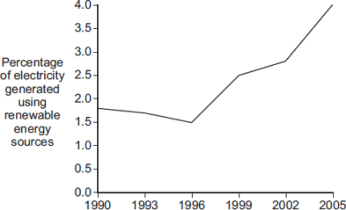
Year
Complete the following sentence by drawing a ring around the correct answer in the box.
In 2015, the percentage of electricity generated using renewable energy sources

 |  | greater than 4 %.
 | is most likely to be | equal to 4 %.
 |  | less than 4 %.

(1)
(Total 4 marks)

Q9. (a) Solar energy is a renewable energy source that can be used to generate electricity.
(i) What is meant by an energy source being renewable?
..........................................................................................................................
(1)
(ii) Name two further renewable energy sources used to generate electricity.
1 .......................................................................................................................
2 .......................................................................................................................
(1)

(b) A householder uses a bank of solar cells to generate electricity for his home.
The solar cells are tilted to receive the maximum energy input from the Sun.
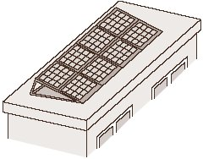

The data in the table gives the average energy input each second (in J/s), to a 1 m² area of solar cells for different angles of tilt and different months of the year.

Month | Angle of tilt
 | 20° | 30° | 40° | 50°
February | 460 | 500 | 480 | 440
April | 600 | 620 | 610 | 600
June | 710 | 720 | 680 | 640
August | 640 | 660 | 640 | 580
October | 480 | 520 | 500 | 460
December | 400 | 440 | 420 | 410

(i) Use the data in the table to describe how the average energy input to the solar cells depends on the angle of tilt.
..........................................................................................................................
..........................................................................................................................
..........................................................................................................................
..........................................................................................................................
(2)

(ii) The bank of solar cells used by the householder has an area of 8 m².
The efficiency of the solar cells is 0.15
Use the equation in the box to calculate the average maximum electrical energy available from the bank of solar cells each second in June.

efficiency = 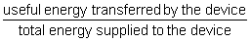

Show clearly how you work out your answer.
..........................................................................................................................
..........................................................................................................................
Maximum energy = .................................................. joules/second
(3)

(c) The graph shows how the householder’s electrical energy needs change over one year.
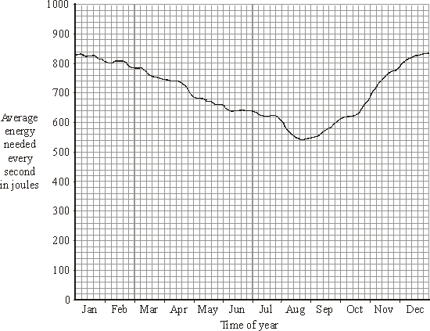
Why would it be advisable for the householder to remain connected to the National Grid?
....................................................................................................................................
....................................................................................................................................
(1)
(Total 8 marks)

Q10.The world’s biggest offshore wind farm, built off the Kent coast, started generating electricity in September 2010.
(a) The graph shows how wind speed affects the power output from one of the wind turbines.
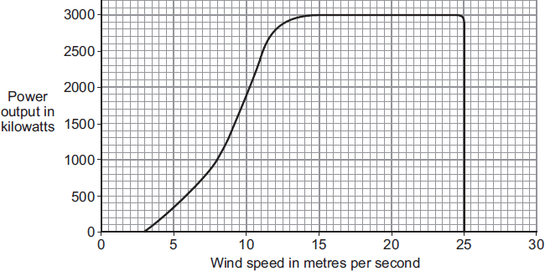
In one 4-hour period, the wind turbine transfers 5600 kilowatt-hours of electrical energy.
Use the equation in the box and the data in the graph to calculate the average wind speed during this 4-hour period.

energy transferred = power × time

Show clearly how you work out your answer.
........................................................................................................................
........................................................................................................................
........................................................................................................................
........................................................................................................................
Average wind speed = ........................................ m/s
(3)

(b) The wind turbines are linked to the National Grid by underwater cables.
(i) What is the National Grid?
...............................................................................................................
...............................................................................................................
(1)

(ii) How is the National Grid designed to reduce energy losses during transmission?
...............................................................................................................
...............................................................................................................
...............................................................................................................
(1)

(c) Read this extract from a newspaper.
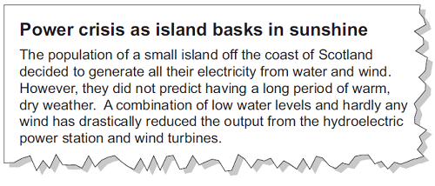
Explain one way in which the islanders could try to ensure that a similar power crisis does not happen in the future.
........................................................................................................................
........................................................................................................................
........................................................................................................................
........................................................................................................................
(2)
(Total 7 marks)

Q11.(a) A student investigated how the number of blades on a wind turbine affects the output voltage of the turbine.
The student used the apparatus shown in the diagram.
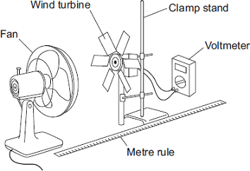
The fan was used to turn the wind turbine.
(i) The fan was always the same distance from the wind turbine.
Why?
...............................................................................................................
...............................................................................................................
(1)

(ii) After switching the fan on, the student waited 20 seconds before taking the voltmeter reading.
Suggest why.
...............................................................................................................
...............................................................................................................
(1)

(iii) The student changed the number of blades on the wind turbine.
The student’s results are shown in the scatter graph.
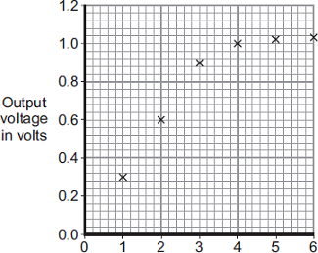
Number of blades
What conclusion can be made from the results in the scatter graph?
...............................................................................................................
...............................................................................................................
...............................................................................................................
...............................................................................................................
(2)

(b) The amount of electricity generated using wind turbines is increasing.
Which graph, A, B or C, is most likely to show the electrical power output from a wind turbine over one day?
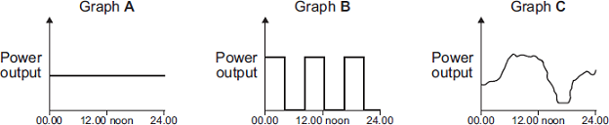
TimeTimeTime

Write the correct answer, A, B or C, in the box.

Give a reason for your answer.
.................................................................................................................................
.................................................................................................................................
.................................................................................................................................
(2)
(Total 6 marks)

Q12.The image shows a solar thermal power station.
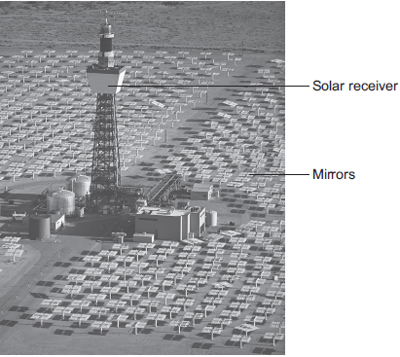
© Kim Steele/Photodisc/Thinkstock
Energy from the Sun is directed at the solar receiver by many mirrors.
(a) (i) Suggest one reason why a solar thermal power station is built in a hot desert.
...............................................................................................................
...............................................................................................................
(1)

(ii) Complete the following sentence to describe how the mirrors direct energy from the Sun towards the solar receiver.
Energy from the Sun is ................................................... by the mirrors
towards the solar receiver.
(1)

(iii) Heated water is used to generate electricity in the solar thermal power station.
Choose the correct answer from the box to complete each sentence.

 | boiler | motor | transformer | turbine

At the solar receiver, water is heated in a ........................................
which turns the water into steam. The steam turns a
....................................which is connected to a water into steam. The
steam turns a .................................... which is connected to a generator.
The generator produces electricity. A ........................................ is used
to change the voltage for transmission along power lines.
(3)

(b) A solar storage power station is a new type of solar power station.
It is able to store energy from the Sun to generate electricity at night.
The solar storage power station can supply a town with a maximum electrical power of 140 000 kW for 15 hours.
Calculate the maximum energy, in kWh, stored by the solar storage power station.
Use the correct equation from the Physics Equations Sheet.
........................................................................................................................
........................................................................................................................
........................................................................................................................
Energy = ............................................................ kWh
(2)

(c) A different method of generating electricity uses wind turbines.
A student researching a wind farm wrote the following.

Top Hill Wind Farm has 25 wind turbines.
Last week, one of the wind turbines generated
electricity for only 42 hours out of a possible 168 hours.
My conclusion is that all wind turbines operate for only
25% of the time.

(i) Give two reasons why the student is not correct in reaching his conclusion.
1.............................................................................................................
...............................................................................................................
2.............................................................................................................
...............................................................................................................
(2)
(ii) Give one reason why wind turbines do not generate electricity all the time.
...............................................................................................................
...............................................................................................................
(1)
(iii) Give one advantage of using wind turbines to generate electricity compared with using fossil fuel power stations.
...............................................................................................................
...............................................................................................................
(1)
(Total 11 marks)

Q13. (a) Nuclear fuels and the wind are two of the energy sources used to generate electricity in the UK.
Explain the advantages of using energy from nuclear fuels to generate electricity rather than using energy from the wind.
Include in your answer a brief description of the process used to generate electricity from nuclear fuels.
........................................................................................................................
........................................................................................................................
........................................................................................................................
........................................................................................................................
........................................................................................................................
........................................................................................................................
........................................................................................................................
........................................................................................................................
(4)

(b) In the UK, most electricity is generated in power stations that emit carbon dioxide into the atmosphere. The impact of these power stations on the environment could be reduced by the increased use of ‘carbon capture’ technology.
Describe how ‘carbon capture’ would prevent the build-up of carbon dioxide in the atmosphere.
........................................................................................................................
........................................................................................................................
........................................................................................................................
........................................................................................................................
........................................................................................................................
(2)
(Total 6 marks)

Q14.(a) The graph shows how the demand for electricity in the UK changes during one 24-hour period.
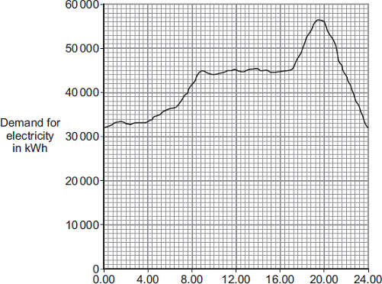
Time of day
The table gives the start-up times for two types of power station.

 | Type of power station | Start-up time
 | Gas | A few minutes
 | Nuclear | Several days

How would these two types of power station be used to meet the demand for electricity during this 24-hour period?
........................................................................................................................
........................................................................................................................
........................................................................................................................
........................................................................................................................
........................................................................................................................
........................................................................................................................
(3)

(b) In this question you will be assessed on using good English, organising information clearly and using specialist terms where appropriate.
A farmer plans to generate all the electricity needed on her farm, using either a biogas generator or a small wind turbine.
The biogas generator would burn methane gas. The methane gas would come from rotting the animal waste produced on the farm. When burnt, methane produces carbon dioxide.
The biogas generator would cost £18 000 to buy and install. The wind turbine would cost £25 000 to buy and install.
The average power output from the wind turbine would be the same as the continuous output from the biogas generator.

Evaluate the advantages and disadvantages of the two methods of generating electricity.
Conclude, with a reason, which system would be better for the farmer to buy and install.
........................................................................................................................
........................................................................................................................
........................................................................................................................
........................................................................................................................
........................................................................................................................
........................................................................................................................
........................................................................................................................
........................................................................................................................
........................................................................................................................
(6)
(Total 9 marks)

Q15.Iceland is a country that generates most of its electricity using geothermal power stations and hydroelectric power stations.
(a) (i) Complete the following sentences to describe how some geothermal power stations work.
In regions where volcanoes are active, the ground is hot.
Cold ............................................. is pumped down into the ground
and is ............................................. by hot rocks.
It returns to the surface as steam. The steam is used to turn a turbine.
The turbine drives a ............................................. to produce electricity.
(3)

(ii) Which one of the following statements about geothermal power stations is true?
Tick () one box.
Geothermal power stations use fossil fuels.
Geothermal power stations produce carbon dioxide.
Geothermal power stations provide a reliable source of electricity.

(1)

(b) What is needed for a hydroelectric power station to be able to generate electricity?
Tick () one box.
Falling water
A long coastline
Lots of sunny days

(1)
(Total 5 marks)

Q16. (a) Geothermal energy and the energy of falling water are two resources used to generate electricity.
(i) What is geothermal energy?
...............................................................................................................
...............................................................................................................
(1)

(ii) Hydroelectric systems generate electricity using the energy of falling water.
A pumped storage hydroelectric system can also be used as a way of storing energy for future use.
Explain how.
...............................................................................................................
...............................................................................................................
...............................................................................................................
...............................................................................................................
...............................................................................................................
...............................................................................................................
(2)

(b) In this question you will be assessed on using good English, organising information clearly and using specialist terms where appropriate.
Read the following extract from a newspaper.
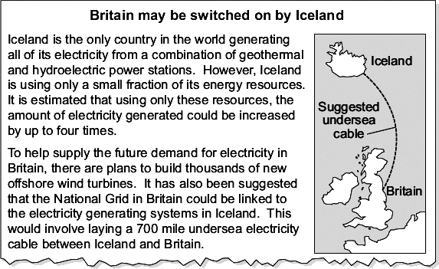

Discuss the advantages and disadvantages of the plan to build thousands of offshore wind turbines around Britain and the suggested electricity power link between Britain and Iceland.
........................................................................................................................
........................................................................................................................
........................................................................................................................
........................................................................................................................
........................................................................................................................
........................................................................................................................
........................................................................................................................
........................................................................................................................
........................................................................................................................
........................................................................................................................
........................................................................................................................
........................................................................................................................
........................................................................................................................
........................................................................................................................
........................................................................................................................
........................................................................................................................
........................................................................................................................
........................................................................................................................
(6)
(Total 9 marks)

Q17. (a) The pie-chart shows how energy is used in a home.
Complete the table using the information on the pie-chart.
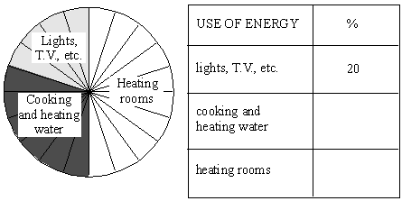
(2)

(b) We get some of the energy we need in our homes from electricity.
The graphs show how the amounts of coal and gas used to generate electricity changed between 1960 and 1990.
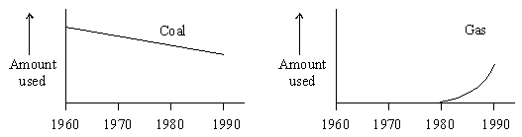

Describe these changes.
Coal ............................................................................................................................
.....................................................................................................................................
.....................................................................................................................................

Gas ..............................................................................................................................
.....................................................................................................................................
.....................................................................................................................................
(4)

(c) Read the information below.
• More carbon dioxide in the air may change the weather. Farmers may then not be able to produce the food we need.
• Burning coal produces sulphur dioxide. Burning gas does not do this.
• It is cheaper to generate electricity from gas than from coal.

• Sulphur dioxide causes acid rain which can kill fish and damage
buildings.
• Two power stations generate the same amount of electricity. The
one which burns gas produces less carbon dioxide than the other
which burns coal.

Many people say that the change from coal to gas is better for the environment.
Why do you think they say this?
.....................................................................................................................................
.....................................................................................................................................
.....................................................................................................................................
.....................................................................................................................................
(3)
(Total 9 marks)

