P4 Electric Circuits Exam Question Pack |  | Name: ________________________  Class: ________________________  Date: ________________________
Time: | 227 minutes
Marks: | 227 marks
Comments:

Q1. (a) A student rubs a nylon comb on the sleeve of his jumper.
(i) Use words from the box to complete the following sentence.

electrons hand jumper protons

The comb becomes negatively charged because ............................................ move
from the student’s ........................................... to the comb.
(2)

(ii) What type of charge is left on the jumper?
.......................................................................
(1)

(iii) The negatively charged comb is placed close to a charged plastic ruler. The comb and the ruler attract each other.
Complete the following sentence by drawing a ring around the correct line in the box.

The ruler is | negatively charged  positively charged  uncharged

(1)

(b) Electrostatic charge can damage computer chips. People working with computer chips may wear a special bracelet, with a wire joining the bracelet to earth (the earth wire). Any negative charge on the person will flow through the wire to earth.
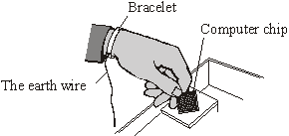
(i) Which one of the following materials should the bracelet be made from?
Draw a ring around your answer.
copper plastic rubber
Give a reason for your answer.
..........................................................................................................................
..........................................................................................................................
(2)

(ii) Which one of the following words is used to describe the rate of flow of charge through a wire?
Draw a ring around your answer.
current resistance voltage
(1)
(Total 7 marks)

Q2.(a) A student uses some everyday items to investigate static electricity.

 | 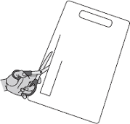 |  | 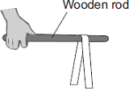
 | 1 A strip of plastic is cut from a plastic carrier bag | 2 The plastic strip is rubbed with a cloth | 3 The plastic strip is hung over a wooden rod

(i) Draw a ring around the correct answer in the box to complete each sentence.
Rubbing the plastic strip with a cloth causes the strip to become negatively charged.

 |  | electrons
 | This happens because | neutrons | move from the cloth onto the plastic strip.
 |  | protons

 |  | a negative
 | The cloth is left with | a positive | charge.
 |  | zero

(2)

(ii) When the plastic strip is hung over the wooden rod, the two halves of the strip move equally away from each other.
What two conclusions should the student make about the forces acting on the two halves of the plastic strip?
1 ............................................................................................................
...............................................................................................................
2 .............................................................................................................
...............................................................................................................
(2)

(b) Electrical charges move more easily through some materials than through other materials.
Through which one of the following materials would an electrical charge move most easily?
Draw a ring around your answer.

 | aluminium | glass | rubber

(1)
(Total 5 marks)

Q3. A circuit diagram is shown below.
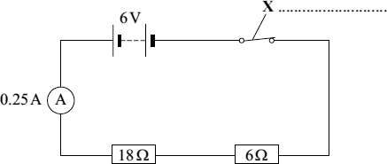
(a) Use a word from the box to label component X.

fuse | switch | thermistor

(1)

(b) Calculate the total resistance of the two resistors in the circuit.
........................................................................................................................
Total resistance = ........................................ Ω
(1)

(c) The reading on the ammeter is 0.25 A.
The current through the 6 Ω resistor will be:

bigger than 0.25 A | equal to 0.25 A | smaller than 0.25 A

Draw a ring around your answer
(1)

(d) The 6 V battery is made by correctly joining several 1.5 V cells in series.
Calculate the number of cells needed to make the battery.
........................................................................................................................
Number of cells = ...........................................
(1)
(Total 4 marks)

Q4.(a) Draw one line from each circuit symbol to its correct name.

 | Circuit symbol |  | Name
 |  |  | Diode
 | 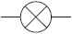
Light-dependent
resistor (LDR)
 | 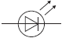
 |  |  | Lamp
 | 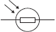
Light-emitting
diode (LED)

(3)

(b) Figure 1 shows three circuits.
The resistors in the circuits are identical.
Each of the cells has a potential difference of 1.5 volts.
Figure 1

 | Circuit 1 |  | Circuit 2 |  | Circuit 3

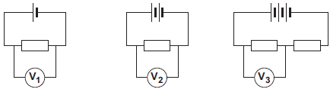
(i) Use the correct answer from the box to complete the sentence.

half twice the same as

The resistance of circuit 1 is ................................................ the resistance of circuit 3.
(1)

(ii) Calculate the reading on voltmeter V₂.
...............................................................................................................
Voltmeter reading V₂ = .............................. V
(1)

(iii) Which voltmeter, V₁, V₂ or V₃, will give the lowest reading?
Draw a ring around the correct answer.

V₁ V₂ V₃

(1)

(c) A student wanted to find out how the number of resistors affects the current in a series circuit.
Figure 2 shows the circuit used by the student.
Figure 2
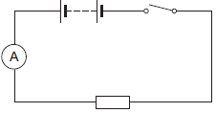
The student started with one resistor and then added more identical resistors to the circuit.
Each time a resistor was added, the student closed the switch and took the ammeter reading.
The student used a total of 4 resistors.
Figure 3 shows three of the results obtained by the student.
Figure 3
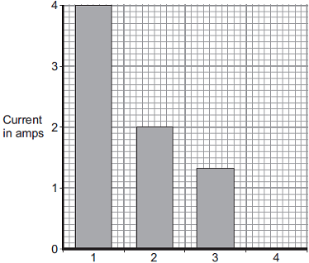
Number of resistors in series
(i) To get valid results, the student kept one variable the same throughout the experiment.
Which variable did the student keep the same?
...............................................................................................................
(1)

(ii) The bar chart in Figure 3 is not complete. The result using 4 resistors is not shown.
Complete the bar chart to show the current in the circuit when 4 resistors were used.
(2)

(iii) What conclusion should the student make from the bar chart?
...............................................................................................................
...............................................................................................................
(1)
(Total 10 marks)

Q5.The graph shows how the current through a filament bulb changes after the bulb is switched on.
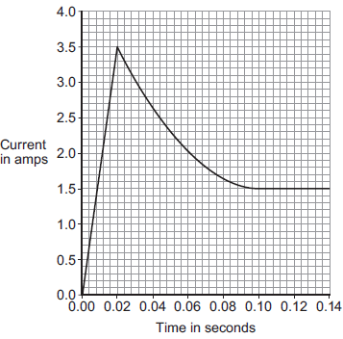
(a) What happens to the current through the bulb in the first 0.02 seconds after the bulb is switched on?
........................................................................................................................
(1)

(b) Between 0.02 seconds and 0.08 seconds the current through the bulb decreases.
(i) What, if anything, happens to the resistance of the bulb between 0.02 seconds and 0.08 seconds?
Draw a ring around the correct answer.

 | decreases | does not change | increases

(1)
(ii) What, if anything, happens to the temperature of the bulb between 0.02 seconds and 0.08 seconds?
Draw a ring around the correct answer.

 | decreases | does not change | increases

(1)

(c) The bulb is connected to a 12 V power supply.
Calculate the power of the bulb when the current through the bulb is 1.5 A.
Use the correct equation from the Physics Equations Sheet.
Choose the unit from the list below.

 | coulomb | joule | watt

........................................................................................................................
........................................................................................................................
Power = ........................................ unit ................................
(3)
(Total 6 marks)

Q6. The diagram shows an electrical circuit.
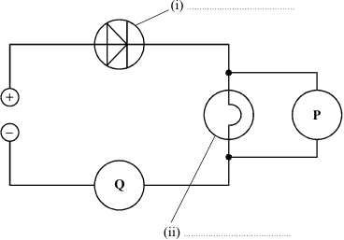

(a) Complete the two labels on the diagram.
(2)
(b) P and Q are meters.
What is meter P measuring? .......................................................................................
What is meter Q measuring? .......................................................................................
(2)
(Total 4 marks)

Q7.(a) Electrical circuits often contain resistors.
The diagram shows two resistors joined in series.
Calculate the total resistance of the two resistors.
........................................................................................................................
Total resistance = .................................................. Ω
(1)

(b) A circuit was set up as shown in the diagram. The three resistors are identical.
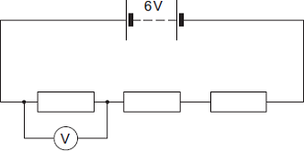
(i) Calculate the reading on the voltmeter.
...............................................................................................................
...............................................................................................................
Reading on voltmeter = .................................................. V
(2)

(ii) The same circuit has now been set up with two ammeters.
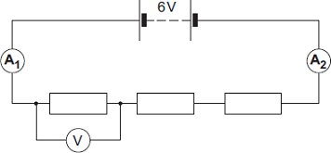
Draw a ring around the correct answer in the box to complete the sentence.

 |  | smaller than
 | The reading on ammeter A₂ will be | equal to | the reading on ammeter A₁.
 |  | greater than

(1)
(Total 4 marks)

Q8. (a) The diagram shows a simple circuit.
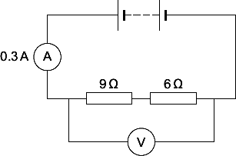
(i) Calculate the total resistance of the two resistors in the circuit.
...............................................................................................................
Total resistance = .................................................. Ω
(1)

(ii) Calculate the reading on the voltmeter.
Use the correct equation from the Physics Equations Sheet.
Show clearly how you work out your answer.
...............................................................................................................
...............................................................................................................
Voltmeter reading = .................................................. V
(2)

(iii) Draw a ring around the correct answer in the box to complete the sentence.

Replacing one of the resistors with a resistor of higher value will | decrease  not change  increase

the reading on the ammeter.
(1)

(b) The voltmeter in the circuit is replaced with an oscilloscope.
Which one of the diagrams, X, Y or Z, shows the trace that would be seen on the oscilloscope?
Write your answer, X, Y or Z, in the box.

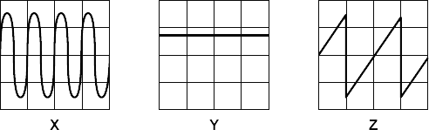

Diagram

Give a reason for your answer.
........................................................................................................................
........................................................................................................................
........................................................................................................................
(2)
(Total 6 marks)

Q9. A student used the apparatus below to find out how the resistance of a light-dependent resistor (LDR) depends on light intensity.
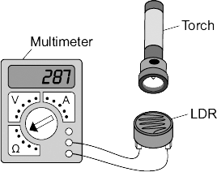
The resistance of the LDR was measured directly using a multimeter.
(a) (i) Which one of the following is the correct circuit symbol for a LDR?
Draw a ring around your answer.
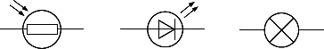
(1)

(ii) Name one factor that will affect the intensity of the light hitting the LDR.
...............................................................................................................
...............................................................................................................
(1)

(b) The manufacturer of the LDR provides data for the LDR in the form of a graph.
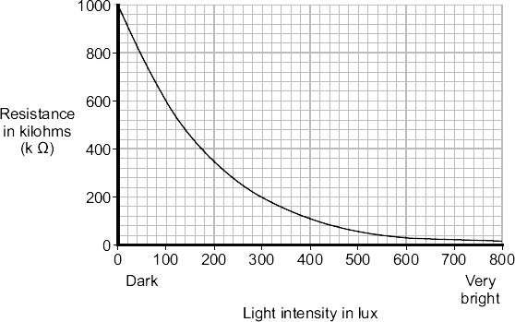
Describe how the resistance of the LDR changes when the light intensity increases from 100 lux to 300 lux.
........................................................................................................................
........................................................................................................................
........................................................................................................................
(2)

(c) The student only obtained three results. These are given in the table.

Light intensity | Resistance in kilohms
Dark | 750
Bright | 100
Very bright | 1

(i) The student could not use the results to draw a line graph.
Why not?
...............................................................................................................
...............................................................................................................
(1)

(ii) Do the student’s results agree with the data the manufacturer provided?

Draw a ring around your answer. | YES | NO

Give a reason for your answer.
...............................................................................................................
...............................................................................................................
...............................................................................................................
(1)

(d) Which one of the following circuits probably includes a LDR?
Tick () one box.

A circuit that automatically switches outside lights on when it gets dark.
A circuit that automatically switches central heating on and off.
A circuit that automatically turns lights off when no one is in the room.

(1)
(Total 7 marks)

Q10. (a) The diagram shows the circuit used by a student to measure the power of a filament lamp.
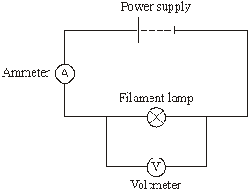
Name a component connected in parallel with the filament lamp.
.....................................................................................................................................
(1)

(b) By adding another component to the circuit, the student is able to obtain a range of ammeter and voltmeter readings.

Ammeter reading in amps | Voltmeter reading in volts
0.10 | 1.0
0.15 | 2.0
0.20 | 4.0
0.25 | 7.0
0.30 | 11.0

(i) Which one of the following components did the student add to the circuit?
Draw a ring around your answer.
fuse switch variable resistor
(1)

(ii) What is the range of ammeter readings taken by the student?
from .............................. amps to .............................. amps
(1)

(iii) Use the data in the table and the equation in the box to calculate the maximum power of the filament lamp.
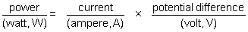
Show clearly how you work out your answer.
...........................................................................................................................
...........................................................................................................................
Power = .............................. W
(3)

(c) Complete the following sentence by drawing a ring around the correct line in the box.
 | increases
As the temperature of a filament lamp increases, its resistance | remains constant
 | decreases

(1)
(Total 7 marks)

Q11.(a) The diagram shows a negatively charged plastic rod held near to a thin stream of water. The water is attracted towards the rod.
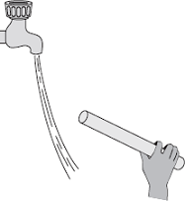
Which one of the following statements explains what is happening to the charge in the water?
Tick ( ) one box.

The positive and the negative charges in the water are attracted to the rod.
The positive and the negative charges in the water are repelled by the rod.
The negative charge in the water is repelled by the rod and the positive charge is attracted to the rod.
The negative charge in the water is attracted to the rod and the positive charge is repelled by the rod.

(1)

(b) A company that produces bottles of mouthwash found a problem with the automatic filling system.
As the bottles go towards the filler, the bottles move around on the conveyor belt and become electrostatically charged. This causes the stream of mouthwash to move sideways, missing the open top of the bottle.
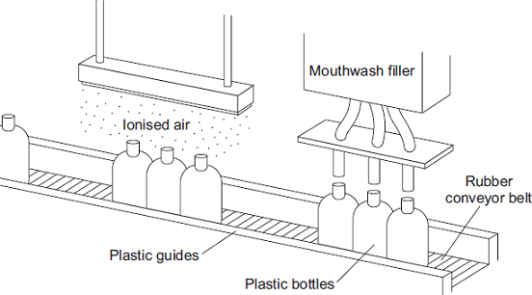
The company came up with an answer to the problem. Before the bottles reach the dfiller, the bottles pass through a stream of ionised air. The ions in the air neutralise the charge on the bottles.
(i) Explain why the plastic bottles became charged.
...............................................................................................................
...............................................................................................................
...............................................................................................................
...............................................................................................................
(2)

(ii) What happens to the structure of an atom to change the atom into an ion?
...............................................................................................................
...............................................................................................................
(1)

(iii) Earthing the conveyor belt with a conducting wire would not have solved this problem.
Give a reason why.
...............................................................................................................
...............................................................................................................
(1)
(Total 5 marks)

Q12.(a) The diagram shows the circuit used to obtain the data needed to plot the current–potential difference graph for a filament bulb.
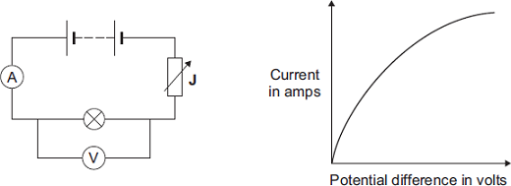
(i) Why is the component labelled ‘J’ included in the circuit?
...............................................................................................................
...............................................................................................................
(1)

(ii) The resistance of the bulb increases as the potential difference across the bulb increases. Why?
...............................................................................................................
...............................................................................................................
(1)

(iii) The bulb is at full brightness when the potential difference across the bulb is 12 V.
The current through the bulb is then 3 A.
Calculate the power of the bulb when it is at full brightness and give the unit.
Use the correct equation from the Physics Equations Sheet.
...............................................................................................................
...............................................................................................................
...............................................................................................................
Power = ..................................................
(3)

(b) In this question you will be assessed on using good English, organising information clearly and using specialist terms where appropriate.
The table gives data about two types of light bulb people may use in their homes.

 | Type of light bulb | Energy efficiency | Cost of one light bulb | Average lifetime in hours
 | Halogen | 10% | £1.95 | 2 000
 | Light Emitting Diode (LED) | 32% | £11.70 | 36 000

Both types of light bulb produce the same amount of light.
Evaluate, in terms of cost and energy efficiency, the use of the two types of light bulb.
To gain full marks you must compare both types of light bulb and conclude which light bulb would be the best to use.
........................................................................................................................
........................................................................................................................
........................................................................................................................
........................................................................................................................
........................................................................................................................
........................................................................................................................
........................................................................................................................
........................................................................................................................
........................................................................................................................
(6)
(Total 11 marks)

Q13. A pupil did an experiment following the instructions below.
1. Take a polythene rod (AB), hold it at its centre and rub both ends with a cloth.
2. Suspend the rod, without touching the ends, from a stand using a stirrup and nylon thread.
3. Take a perspex rod (CD) and rub it with another cloth.
4. Without touching the ends of the perspex rod bring each end of the perspex rod up to, but without touching, each end of the polythene rod.
5. Make notes on what is observed.

The diagram below shows how the apparatus is to be set up.
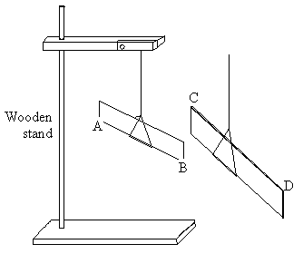

(a) When end C was brought near to end B they attracted each other.
(i) Explain why they attracted each other.
.........................................................................................................................
.........................................................................................................................

(ii) What would happen if end C were brought near end A?
.........................................................................................................................
(3)

(b) The experiment was repeated with two polythene rods.
(i) Describe what you would expect the pupil to observe as the end of one rod was brought near to the end of the other.
.........................................................................................................................
.........................................................................................................................

(ii) Explain your answer.
.........................................................................................................................
.........................................................................................................................
(2)

(c) Explain, in terms of electron movement, what happened as the rods were rubbed with the cloths.
...................................................................................................................................
...................................................................................................................................
...................................................................................................................................
...................................................................................................................................
...................................................................................................................................
(3)
(Total 8 marks)

Q14.Diagram 1 shows a hairdryer.
Diagram 2 shows how the heaters and fan of the hairdryer are connected to a 3-pin plug.
The hairdryer does not have an earth wire.
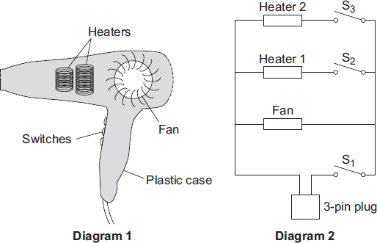
(a) What colour is the insulation around the wire connected to the live pin inside the plug?
............................................................
(1)

(b) Why does the hairdryer not need an earth wire?
........................................................................................................................
........................................................................................................................
(1)

(c) All the switches are shown in the OFF position.
(i) Which switch or switches have to be ON to make:
(1) only the fan work; ............................................................................
(2) heater 2 work? ................................................................................
(2)

(ii) The heaters can only be switched on when the fan is also switched on.
Explain why.
...............................................................................................................
...............................................................................................................
...............................................................................................................
...............................................................................................................
...............................................................................................................
(2)

(d) The table shows the current drawn from the 230 volt mains electricity supply when different parts of the hairdryer are switched on.

 | Current in amps
Fan only | 1.0
Fan and heater 1 | 4.4
Fan and both heaters | 6.5

Use the equation in the box to calculate the maximum power of the hairdryer.

power = current × potential difference

Show clearly how you work out your answer and give the unit.
........................................................................................................................
........................................................................................................................
Maximum power = ............................................................
(3)
(Total 9 marks)

Q15. (a) Fine powders poured through a pipe can become charged. The diagram shows the apparatus used by a student to investigate this effect.
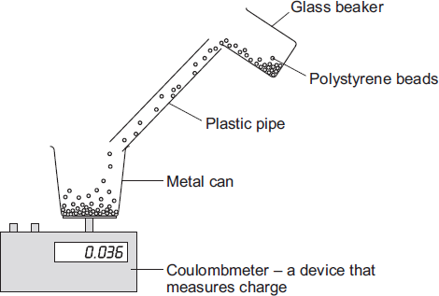
The student poured 75 cm³ of polystyrene beads down the pipe. The beads fell into a metal can and the charge on them was measured directly using a coulombmeter.
The student repeated this twice more, but each time used 75 cm³ of beads of a different size.
(i) When they fell through the pipe, the polystyrene beads became negatively charged.
Explain how this happened.
...............................................................................................................
...............................................................................................................
...............................................................................................................
...............................................................................................................
...............................................................................................................
...............................................................................................................
(3)

(ii) Give one control variable in the student’s investigation.
...............................................................................................................
...............................................................................................................
(1)

(b) The results obtained by the student are shown in the table.

Diameter of polystyrene beads in mm | Charge in microcoulombs
1.0 | 0.080
2.0 | 0.044
3.0 | 0.012

(1 000 000 microcoulombs = 1 coulomb)
(i) Describe the connection between the size of the polystyrene beads and the total charge on the beads.
...............................................................................................................
...............................................................................................................
(1)

(ii) Explain how these results might be different if the student had used a shorter pipe.
...............................................................................................................
...............................................................................................................
...............................................................................................................
...............................................................................................................
(2)

(c) In industry, powders are often pumped through pipes. If the static charge caused a spark, the powder could ignite and cause an explosion.
(i) Is an explosion more likely to happen when pumping very fine powders or when pumping powders that consist of much larger particles?
...............................................................................................................
Give a reason for your answer.
...............................................................................................................
...............................................................................................................
(1)

(ii) Suggest one way that the risk of an explosion could be reduced.
...............................................................................................................
...............................................................................................................
(1)

(d) The table gives the minimum ignition energy (MIE) value for a number of fine powders.
The MIE is the minimum amount of energy required to cause a fine powder to ignite.

Type of powder | MIE in millijoules
Coal dust | 60.00
Aluminium powder | 10.00
Cornstarch dust | 0.30
Iron powder | 0.12

The MIE values for different substances are all measured in the same way and under the same conditions of pressure and temperature.
Why is this important?
........................................................................................................................
........................................................................................................................
(1)
(Total 10 marks)

Q16.(a) Figure 1 shows the apparatus used to obtain the data needed to calculate the resistance of a thermistor at different temperatures.
Figure 1
Power supply
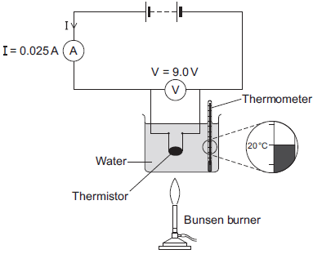
(i) In the box below, draw the circuit symbol for a thermistor.

(1)

(ii) Use the data given in Figure 1 to calculate the resistance of the thermistor at 20 °C.
Use the correct equation from the Physics Equations Sheet.
...............................................................................................................
...............................................................................................................
...............................................................................................................
Resistance = ......................... ohms
(2)

(iii) Figure 2 shows the axes for a sketch graph.
Complete Figure 2 to show how the resistance of the thermistor will change as the temperature of the thermistor increases from 20 °C to 100 °C.
Figure 2
Temperature in °C
(1)

(iv) Which one of the following is most likely to include a thermistor?
Tick (✓) one box.
An automatic circuit to switch a plant watering system on and off.
An automatic circuit to switch an outside light on when it gets dark.
An automatic circuit to switch a heating system on and off.

(1)

(b) The ammeter used in the circuit has a very low resistance.
Why is it important that ammeters have a very low resistance?
........................................................................................................................
........................................................................................................................
(1)

(c) The table below gives the temperature of boiling water using three different temperature scales.

 | Temperature | Scale
 | 100 | Celsius (°C)
 | 212 | Fahrenheit (°F)
 | 80 | Réaumur (°Re)

Scientists in different countries use the same temperature scale to measure temperature.
Suggest one advantage of doing this.
........................................................................................................................
........................................................................................................................
........................................................................................................................
(1)

(d) A student plans to investigate how the resistance of a light-dependent resistor (LDR) changes with light intensity.
The student starts with the apparatus shown in Figure 2 but makes three changes to the apparatus.
One of the changes the student makes is to replace the thermistor with an LDR.
Describe what other changes the student should make to the apparatus.
........................................................................................................................
........................................................................................................................
........................................................................................................................
........................................................................................................................
(2)
(Total 9 marks)

Q17. The diagram shows a type of electric immersion heater in a hot water tank. These hot water tanks are normally found in airing cupboards.
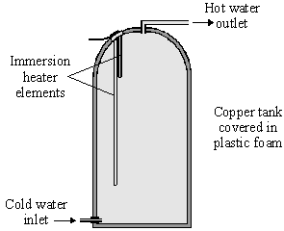
Information on the immersion heater states:
230 V
10 A

(a) (i) What is the equation which shows the relationship between power, current and voltage?
..........................................................................................................................
(1)

(ii) Calculate the power of the heater. Show clearly how you get to your answer and give the units.
..........................................................................................................................
Power = ......................................................
(2)

(b) (i) What rating of fuse should be in the immersion heater circuit?
..........................................................................................................................
(1)

(ii) There are three wires in the cable to the immersion heater. Two of the wires are connected to the immersion heater. The third wire is connected to the copper tank.
Explain the function of this third wire and the fuse in the circuit.
..........................................................................................................................
..........................................................................................................................
..........................................................................................................................
..........................................................................................................................
(3)

(c) (i) What is the equation which shows the relationship between resistance, current and voltage?
..........................................................................................................................
(1)

(ii) Calculate the resistance of the heater. Show clearly how you get to your answer and give the units.
..........................................................................................................................
Resistance = ....................................................
(2)
(Total 10 marks)

Q18.A 12 V filament bulb is connected to a 12 V power supply.
The graph shows how the current changes after the bulb is switched on.
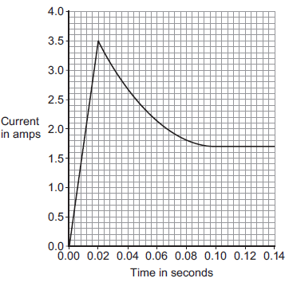
(a) (i) After 0.10 seconds, the bulb works at its normal brightness.
What is the current through the bulb when it is working at normal brightness?
Current = ......................................... A
(1)

(ii) The bulb works at normal brightness for 30 seconds before it is switched off.
Calculate the charge that flows through the bulb in the 30 seconds before it is switched off. Give the unit.
Use the correct equation from the Physics Equations Sheet.
...............................................................................................................
...............................................................................................................
...............................................................................................................
Charge = ................................. unit .................................
(3)

(iii) Calculate the energy transferred by the 12 V bulb when it is working at normal brightness for 30 seconds.
Use the correct equation from the Physics Equations Sheet.
...............................................................................................................
...............................................................................................................
Energy transferred = .......................................... J
(2)

(b) Between 0.02 seconds and 0.08 seconds, there is an increase in both the resistance and the temperature of the metal filament inside the bulb.
Explain, in terms of the electrons and ions inside the filament, why both the temperature and the resistance increase.
........................................................................................................................
........................................................................................................................
........................................................................................................................
........................................................................................................................
........................................................................................................................
........................................................................................................................
(2)
(Total 8 marks)

Q19. The diagram shows a simple light-sensing circuit.
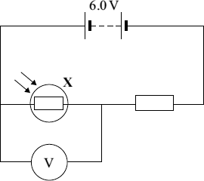
(a) The graph, supplied by the manufacturer, shows how the resistance of the component labelled X varies with light intensity.
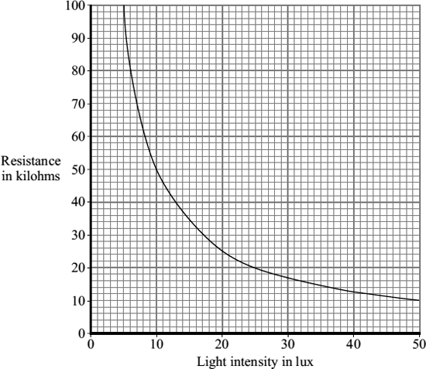
(i) What is component X?
...............................................................................................................
(1)

(ii) Use the graph to find the resistance of component X when the light intensity is 20 lux.
...............................................................................................................
(1)

(iii) When the light intensity is 20 lux, the current through the circuit is 0.0002 A.
Use the equation in the box to calculate the reading on the voltmeter when the light intensity is 20 lux.

potential difference = current × resistance

Show clearly how you work out your answer.
...............................................................................................................
...............................................................................................................
Voltmeter reading =.................................................. volts
(2)

(b) Use the grid below to show how the voltmeter reading in the light-sensing circuit varies with light intensity.
(i) Add a suitable scale to the y-axis (vertical axis).
(1)

(ii) Complete the sketch graph by drawing a line on the grid to show how the voltmeter reading will vary with light intensity.
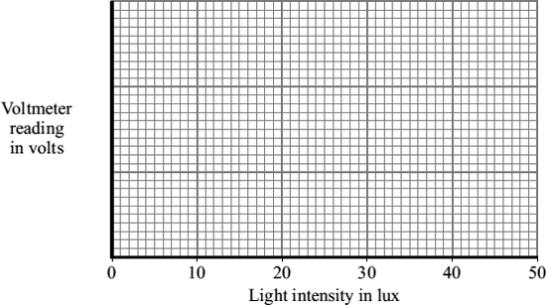
(2)

(c) The following passage is taken from the technical data supplied for component X by the manufacturer.

For any given light intensity, the resistance of this component can vary by plus or
minus 50% of the value shown on the graph of light intensity and resistance.

(i) Calculate the maximum resistance that component X could have at 20 lux light intensity.
...............................................................................................................
Maximum resistance =.................................................. kilohms
(1)

(ii) Explain why this light-sensing circuit would not be used to measure values of light intensity.
...............................................................................................................
...............................................................................................................
...............................................................................................................
(2)
(Total 10 marks)

Q20. The graph shows how the electric current through a 12 V filament bulb varies with the potential difference across the bulb.
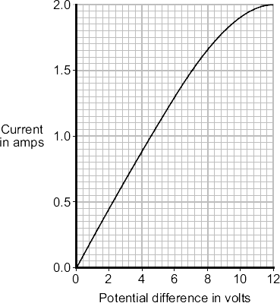
(a) What is the meaning of the following terms?
electric current
........................................................................................................................
........................................................................................................................
potential difference
........................................................................................................................
........................................................................................................................
(2)

(b) The resistance of the metal filament inside the bulb increases as the potential difference across the bulb increases.
Explain why.
........................................................................................................................
........................................................................................................................
........................................................................................................................
........................................................................................................................
........................................................................................................................
........................................................................................................................
........................................................................................................................
........................................................................................................................
(3)

(c) Use data from the graph to calculate the rate at which the filament bulb transfers energy, when the potential difference across the bulb is 6 V.
Use the correct equation from the Physics Equations Sheet.
Show clearly how you work out your answer.
........................................................................................................................
........................................................................................................................
Rate of energy transfer = ................................... W
(2)
(Total 7 marks)

Q21. A homeowner has installed electric underfloor heating in the kitchen. When the heating is switched on, an electric current flows through wires running under the tiled floor surface.
(a) What is an electric current?
........................................................................................................................
(1)

(b) The graph shows how the power output of an underfloor heating system depends on the area of the floor that is heated.
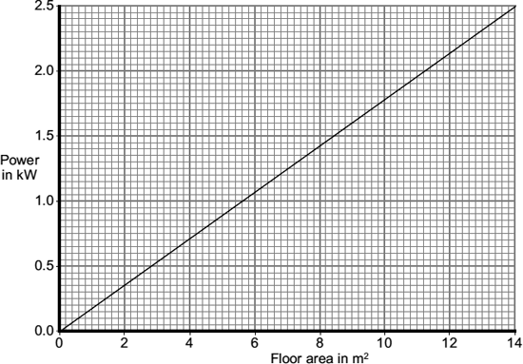
The area of the homeowner’s kitchen floor is 9.0 m^{2.}
Use the graph and the equation in the box to calculate the current drawn from the 230 V mains supply by the heating system.

power = current × potential difference

Show clearly how you work out your answer and give the unit.
........................................................................................................................
........................................................................................................................
........................................................................................................................
........................................................................................................................
Current = ....................................................................
(4)
(Total 5 marks)

Q22.(a) A student set up the circuit shown in the diagram. The student uses the circuit to obtain the data needed to plot a current - potential difference graph for a diode.
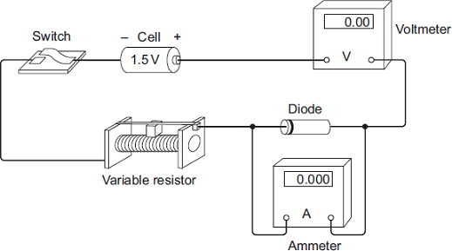
(i) Draw, in the boxes, the circuit symbol for a diode and the circuit symbol for a variable resistor.

 | Diode |  | Variable resistor

(2)

(ii) The student made two mistakes when setting up the circuit.
What two mistakes did the student make?
1 ............................................................................................................
...............................................................................................................
2 ............................................................................................................
...............................................................................................................
(2)

(b) After correcting the circuit, the student obtained a set of data and plotted the graph below.
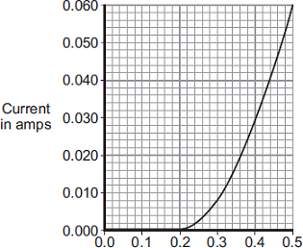
Potential difference in volts
(i) At what potential difference did the diode start to conduct an electric current?
...................................................................... V
(1)

(ii) Use data from the graph to calculate the resistance of the diode when the potential difference across the diode is 0.3 V.
Use the correct equation from the Physics Equations Sheet.
...............................................................................................................
...............................................................................................................
...............................................................................................................
Resistance = ......................... ohms
(3)

(c) The diagram shows the trace produced by an alternating current (a.c.) supply on an oscilloscope.
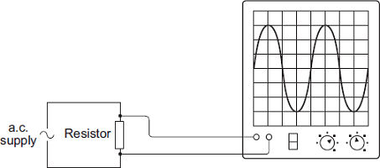
Each horizontal division on the oscilloscope screen represents a time of 0.01s.
(i) Calculate the frequency of the a.c. supply.
...............................................................................................................
...............................................................................................................
...............................................................................................................
Frequency = ............................................. hertz
(2)

(ii) A diode is now connected in series with the a.c. power supply.
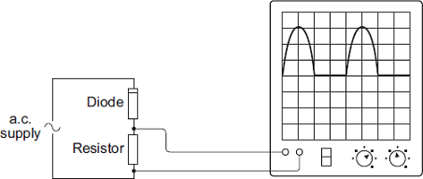
Why does the diode cause the trace on the oscilloscope screen to change?
...............................................................................................................
...............................................................................................................
...............................................................................................................
...............................................................................................................
(2)
(Total 12 marks)

Q23. The drawing shows an experiment using a low voltage supply, a joulemeter, a small immersion heater and a container filled with water.
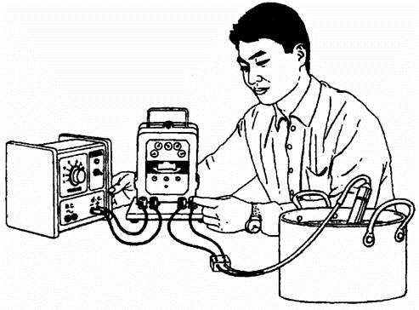
The voltage was set at 6 V d.c. The reading on the joulemeter at the start of the experiment was 78 882 and 5 minutes later it was 80 142.

(i) Use the equation:
voltage = 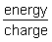
to work out the total charge which flowed through the immersion heater in five minutes. Clearly show how you get to your answer and give the unit.
.....................................................................................................................................
.....................................................................................................................................
.....................................................................................................................................
Charge = ............................................
(3)

(ii) Calculate the current through the immersion heater during the 5 minutes. Write the equation you are going to use, show clearly how you get to your answer and give the unit.
.....................................................................................................................................
.....................................................................................................................................
Current = .........................................
(3)
(Total 6 marks)

Q24. (a) The diagram shows a student touching the metal dome of a Van de Graaff generator.
When the generator is switched on, the metal dome becomes negatively charged.
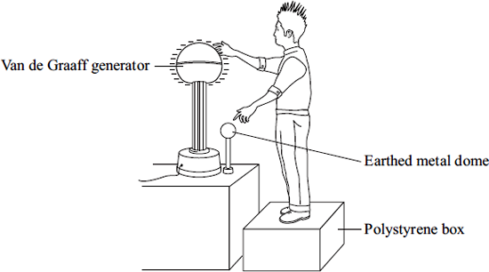
Explain why the student’s hair stands on end when the generator is switched on.
........................................................................................................................
........................................................................................................................
........................................................................................................................
(2)

(b) When the potential difference between the student and a nearby earthed metal dome reached 15 kV, a spark jumped between the student and the earthed dome. The spark transformed 30 mJ of energy into heat, light and sound. (1 mJ = 0.001 J)
Use the equation in the box to calculate the charge carried by the spark.

energy transformed = potential difference × charge

........................................................................................................................
........................................................................................................................
Charge transferred =.................................................. coulombs
(2)

(c) What name is given to the rate of flow of charge?
........................................................................................................................
(1)
(Total 5 marks)

Q25.The current in a circuit depends on the potential difference (p.d.) provided by the cells and the total resistance of the circuit.
(a) Using the correct circuit symbols, draw a diagram to show how you would connect 1.5 V cells together to give a p.d. of 6 V.
(2)

(b) Figure 1 shows a circuit containing an 18 V battery.
Two resistors, X and Y, are connected in series.
• X has a resistance of 3 Ω.
• There is a current of 2 A in X.
Figure 1
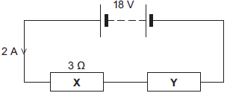
(i) Calculate the p.d. across X.
Use the correct equation from Section C of the Physics Equations Sheet.
...............................................................................................................
...............................................................................................................
P.d. across X = ........................................... V
(2)

(ii) Calculate the p.d. across Y.
...............................................................................................................
...............................................................................................................
...............................................................................................................
P.d. across Y = ........................................... V
(2)

(iii) Calculate the total resistance of X and Y.
...............................................................................................................
...............................................................................................................
...............................................................................................................
Total resistance of X and Y = ........................................... Ω
(2)

(c) Figure 2 shows a transformer.
Figure 2
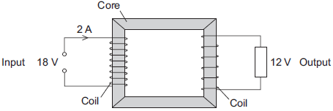
(i) An 18 V battery could not be used as the input of a transformer.
Explain why.
...............................................................................................................
...............................................................................................................
...............................................................................................................
...............................................................................................................
(2)

(ii) The transformer is 100% efficient.
Calculate the output current for the transformer shown in Figure 2.
Use the correct equation from Section C of the Physics Equations Sheet.
...............................................................................................................
...............................................................................................................
...............................................................................................................
Output current = ........................................... A
(2)
(Total 12 marks)

Q26.(a) A resistor is a component that is used in an electric circuit.
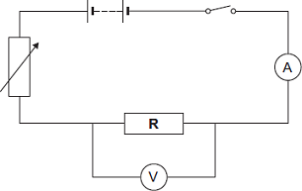
(i) Describe how a student would use the circuit to take the readings necessary to determine the resistance of resistor R.
................................................................................................................
................................................................................................................
................................................................................................................
................................................................................................................
................................................................................................................
................................................................................................................
................................................................................................................
................................................................................................................
................................................................................................................
................................................................................................................
................................................................................................................
................................................................................................................
................................................................................................................
................................................................................................................
(6)

(ii) Explain why the student should open the switch after each reading.
................................................................................................................
................................................................................................................
................................................................................................................
................................................................................................................
(2)

(iii) In an experiment using this circuit, an ammeter reading was 0.75 A.
The calculated value of the resistance of resistor R was 16 Ω.
What is the voltmeter reading?
Use the correct equation from Section C of the Physics Equations Sheet.
................................................................................................................
................................................................................................................
Voltmeter reading = ................................ V
(2)

(iv) The student told his teacher that the resistance of resistor R was 16 Ω.
The teacher explained that the resistors used could only have one of the following values of resistance.

 | 10 Ω | 12 Ω | 15 Ω | 18 Ω | 22 Ω

Suggest which of these resistors the student had used in his experiment.
Give a reason for your answer.
................................................................................................................
................................................................................................................
................................................................................................................
................................................................................................................
(2)

(b) The diagram shows a fuse.
Describe the action of the fuse in a circuit.
.........................................................................................................................
.........................................................................................................................
.........................................................................................................................
.........................................................................................................................
.........................................................................................................................
.........................................................................................................................
.........................................................................................................................
.........................................................................................................................
(3)
(Total 15 marks)

Q27.The current in a circuit depends on the potential difference provided by the cells and the total resistance of the circuit.
(a) Figure 1 shows the graph of current against potential difference for a component.
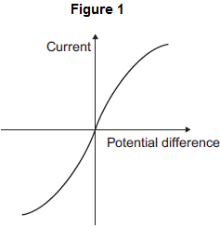
What is the name of the component?
Draw a ring around the correct answer.

 | diode | filament bulb | thermistor

(1)

(b) Figure 2 shows a circuit containing a 6 V battery.
Two resistors, X and Y, are connected in parallel.
The current in some parts of the circuit is shown.
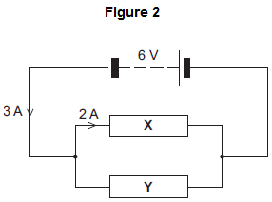
(i) What is the potential difference across X?
Potential difference across X = ............................. V
(1)
(ii) Calculate the resistance of X.
Use the correct equation from Section C of the Physics Equations Sheet.
...............................................................................................................
...............................................................................................................
Resistance of X = ............................. Ω
(2)

(iii) What is the current in Y?
Current in Y = ............................. A
(1)
(iv) Calculate the resistance of Y.
...............................................................................................................
Resistance of Y = ............................. Ω
(1)
(v) When the temperature of resistor X increases, its resistance increases.
What would happen to the:
• potential difference across X
• current in X
• total current in the circuit?
Tick () three boxes.

 |  | Decrease | Stay the same | Increase
 | Potential difference across X
 | Current in X
 | Total current in the circuit

(3)
(Total 9 marks)

Q28.Electrical circuits have resistance.
(a) Draw a ring around the correct answer to complete the sentence.

 | When the resistance of a circuit increases, the current in the circuit | decreases.  increases.  stays the same.

(1)

(b) Use the correct answer from the box to complete each sentence.

 | a filament bulb | an LED | an LDR

An electrical component which has a resistance that increases as the
temperature increases is .................................................. .
An electrical component which emits light only when a current flows through it
in the forward direction is .................................................. .
(2)

(c) When some metals are heated the resistance of the metal changes.
The equipment for investigating how the resistance of a metal changes when it is heated is shown in the diagram.
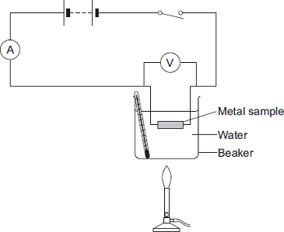

In this question you will be assessed on using good English, organising information clearly and using specialist terms where appropriate.
Describe an investigation a student could do to find how the resistance of a metal sample varies with temperature. The student uses the equipment shown.
Include in your answer:
• how the student should use the equipment
• the measurements the student should make
• how the student should use these measurements to determine the resistance
• how to make sure the results are valid.
.........................................................................................................................
.........................................................................................................................
.........................................................................................................................
.........................................................................................................................
.........................................................................................................................
.........................................................................................................................
.........................................................................................................................
.........................................................................................................................
.........................................................................................................................
.........................................................................................................................
.........................................................................................................................
.........................................................................................................................
.........................................................................................................................
.........................................................................................................................
.........................................................................................................................
.........................................................................................................................
.........................................................................................................................
.........................................................................................................................
(6)

(d) The table shows some data for samples of four metals P, Q, R and S.
The metal samples all had the same cross-sectional area and were the same length.

 | Metal sample | Resistance at 0°C  in ohms | Resistance at 100°C  in ohms
 | P | 4.05 | 5.67
 | Q | 2.65 | 3.48
 | R | 6.0 | 9.17
 | S | 1.70 | 2.23

A graph of the results for one of the metal samples is shown.
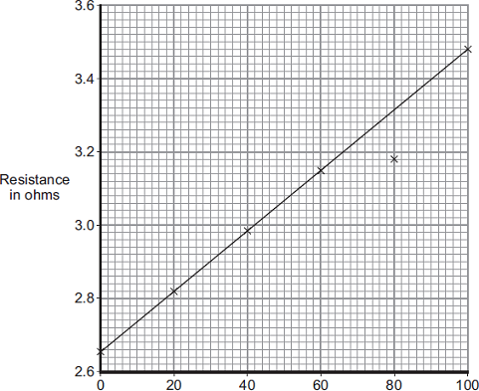
Temperature in °C

(i) Which metal sample, P, Q, R or S, has the data shown in the graph?
(1)

(ii) One of the results is anomalous. Circle this result on the graph.
(1)

(iii) Suggest a reason for the anomalous result.
................................................................................................................
................................................................................................................
(1)

(iv) The same equipment used in the investigation could be used as a thermometer known as a ‘resistance thermometer.’
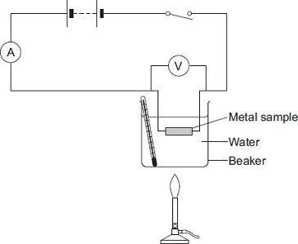

Suggest two disadvantages of using this equipm ent as a thermometer compared to a liquid-in-glass thermometer.
1 .............................................................................................................
................................................................................................................
2 .............................................................................................................
................................................................................................................
(2)
(Total 14 marks)

