P5 Electricity in the Home Exam Question Pack |  | Name: ________________________  Class: ________________________  Date: ________________________
Time: | 115 minutes
Marks: | 115 marks
Comments:

Q1.Figure 1 shows a radio. The radio can be powered by connecting the two-core cable to the mains electricity supply.
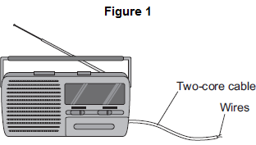
(a) (i) What must be fitted to the cable before it can be connected to the mains electricity supply?
...............................................................................................................
(1)

(ii) There are only two wires inside the cable.
What are the names of the two wires inside the cable?
Tick () one box.

Earth and live
Earth and neutral
Live and neutral

(1)

(iii) Use the correct answer from the box to complete the sentence.

 | double | extra | fully

It is safe to connect the radio to the mains electricity supply using a two-core cable
because the radio is ....................................................... insulated.
(1)

(b) The radio can also be powered by a battery.
What type of current does a battery supply?
Tick () one box.

Alternating current (a.c.) only
Direct current (d.c.) only
Both a.c. and d.c.

(1)

(c) Figure 2 shows a fuse and a circuit breaker.
Fuses and circuit breakers are able to disconnect and switch off circuits.
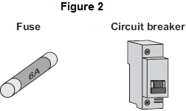
(i) Use the correct answer from the box to complete the sentence.

 | earth | live | neutral

A fuse or a circuit breaker is connected to the ........................................ wire in a circuit.
(1)

(ii) What happens to cause a fuse or circuit breaker to disconnect a circuit?
...............................................................................................................
...............................................................................................................
(1)

(iii) Suggest two advantages of using a circuit breaker to disconnect a circuit compared with using a fuse.
1.............................................................................................................
...............................................................................................................
2.............................................................................................................
...............................................................................................................
(2)
(Total 8 marks)

Q2. The diagrams show the inside of a 13 amp plug.
(a) (i) Which one of the plugs, A, B, C or D, is correctly wired?
Write your answer, A, B, C or D, in the box.

A  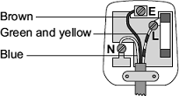 | B  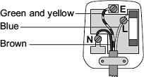

C  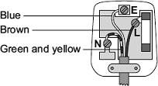 | D  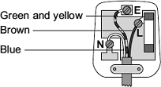

The plug that is correctly wired is

(1)

(ii) What material is the outside casing of a plug made from?
...............................................................................................................
(1)

(b) An electric drill draws a current of 2 amps from the 230 volt mains electricity supply.
Use the equation in the box to calculate the power of the drill.

power = current × potential difference

Show clearly how you work out your answer.
........................................................................................................................
........................................................................................................................
Power .................................................. watts
(2)

(c) A householder needs to replace a damaged plug. Most replacement plugs are sold with a 13 amp fuse fitted inside. The householder thinks it would be better for shops to sell the plugs without a fuse. He could then buy either a 3 A, 5 A or 13 A fuse to fit inside the plug.
Explain an advantage of selling plugs without a fuse, rather than with a 13 amp fuse fitted.
........................................................................................................................
........................................................................................................................
........................................................................................................................
........................................................................................................................
(2)
(Total 6 marks)

Q3.(a) Figure 1 shows the inside of a three-pin plug and a length of three-core cable.
The cable is to be connected to the plug.
Figure 1
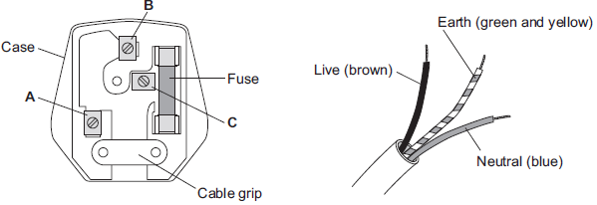
(i) Complete Table 1 to show which plug terminal, A, B or C, connects to each of the wires inside the cable.
Table 1

 | Wire | Plug terminal
 | Live
 | Neutral
 | Earth

(2)

(ii) Name a material that could be used to make the case of the plug.
...............................................................................................................
(1)

(b) Figure 2 shows an electric drill and an extension lead. The drill is used with the extension lead.
Figure 2
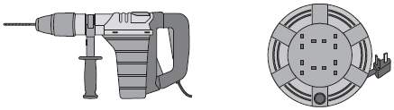
Electric drill Extension lead
(i) The drill is used for 50 seconds.
In this time, 30 000 joules of energy are transferred from the mains electricity supply to the drill.
Calculate the power of the drill.
Use the correct equation from the Physics Equations Sheet.
...............................................................................................................
...............................................................................................................
...............................................................................................................
Power = .................................................. W
(2)

(ii) A second drill is used with the extension lead. The power of this drill is 1200 W.
The instructions for using the extension lead include the following information.

When in use the lead may get hot:
DO NOT go over the maximum power
• lead wound inside the case: 820 watts
• lead fully unwound outside the case: 3100 watts

It would not be safe to use this drill with the extension lead if the lead was left wound inside the plastic case.
Explain why.
...............................................................................................................
...............................................................................................................
...............................................................................................................
...............................................................................................................
...............................................................................................................
...............................................................................................................
(3)

(c) Table 2 gives information about three different electric drills.
Table 2

 | Drill | Power input in watts | Power output in watts
 | X | 640 | 500
 | Y | 710 | 500
 | Z | 800 | 500

A person is going to buy one of the drills, X, Y or Z. The drills cost the same to buy.
Use only the information in the table to decide which one of the drills, X, Y or Z, the person should buy.
Write your answer in the box.
Give a reason for your answer.
........................................................................................................................
........................................................................................................................
........................................................................................................................
(1)
(Total 9 marks)

Q4.Diagram 1 shows a hairdryer.
Diagram 2 shows how the heaters and fan of the hairdryer are connected to a 3-pin plug.
The hairdryer does not have an earth wire.
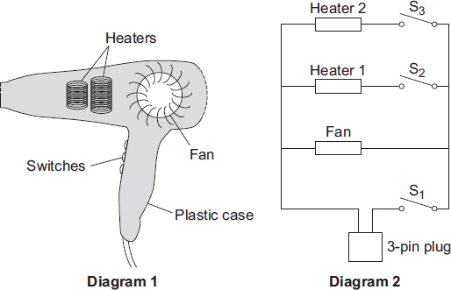
(a) What colour is the insulation around the wire connected to the live pin inside the plug?
............................................................
(1)

(b) Why does the hairdryer not need an earth wire?
........................................................................................................................
........................................................................................................................
(1)

(c) All the switches are shown in the OFF position.
(i) Which switch or switches have to be ON to make:
(1) only the fan work; ............................................................................
(2) heater 2 work? ................................................................................
(2)

(ii) The heaters can only be switched on when the fan is also switched on.
Explain why.
...............................................................................................................
...............................................................................................................
...............................................................................................................
...............................................................................................................
...............................................................................................................
(2)

(d) The table shows the current drawn from the 230 volt mains electricity supply when different parts of the hairdryer are switched on.

 | Current in amps
Fan only | 1.0
Fan and heater 1 | 4.4
Fan and both heaters | 6.5

Use the equation in the box to calculate the maximum power of the hairdryer.

power = current × potential difference

Show clearly how you work out your answer and give the unit.
........................................................................................................................
........................................................................................................................
Maximum power = ............................................................
(3)
(Total 9 marks)

Q5. (a) An adaptor can be used to connect up to four appliances in parallel to one 230 V mains socket. The adaptor is fitted with a 13 A fuse. The table gives a list of appliances and the current they draw from a mains socket.
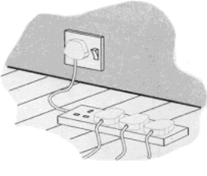

Appliance | Current
computer | 1 A
hairdryer | 4 A
heater | 8 A
iron | 6 A
television | 2 A

(i) What current will flow to the adaptor when the television, computer and hairdryer are plugged into the adaptor?
..........................................................................................................................
Current = .................................. A
(1)

(ii) Write down the equation which links current, electrical power and voltage.
..........................................................................................................................
(1)

(iii) Calculate the electrical power used when the television, computer and hairdryer are plugged into the adaptor. Show clearly how you work out your answer and give the unit.
..........................................................................................................................
..........................................................................................................................
..........................................................................................................................
Electrical power = ......................................
(2)

(iv) What would happen to the fuse if the heater is also plugged into the adaptor?
Give a reason for your answer.
..........................................................................................................................
..........................................................................................................................
(2)

(b) The diagram shows two of the appliances.
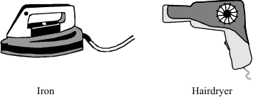

(i) For safety reasons, it is important that the iron has an earth wire connected to its outer metal case. Explain why.
..........................................................................................................................
..........................................................................................................................
..........................................................................................................................
..........................................................................................................................
(2)

(ii) The hairdryer does not have an earth wire. It is safe to use because it is double insulated. Explain what the term double insulated means.
..........................................................................................................................
..........................................................................................................................
..........................................................................................................................
..........................................................................................................................
(2)
(Total 10 marks)

Q6. The information plate on a hairdrier is shown.
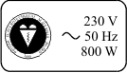

(a) What is the power rating of the hairdrier?
..................................................................................................................................
(1)

(b) (i) Write down the equation which links current, power and voltage.
........................................................................................................................
(1)

(ii) Calculate the current in amperes, when the hairdrier is being used. Show clearly how you work out your answer.
........................................................................................................................
........................................................................................................................
........................................................................................................................
........................................................................................................................
Current = .............................. amperes
(2)

(iii) Which one of the following fuses, 3A, 5A or 13A, should you use with this hairdrier?
........................................................................................................................
(1)
(c) The hairdrier transfers electrical energy to heat energy and kinetic energy.
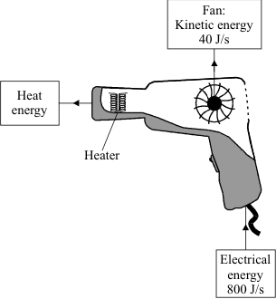
Use the following equation to calculate the efficiency of the hairdrier in transferring electrical energy into heat energy.
efficiency = 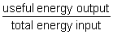
.....................................................................................................................................
.....................................................................................................................................
.....................................................................................................................................
Efficiency = ..............................
(2)
(d) One kilowatt-hour of electricity costs 6p. Use the following equation to calculate how much it will cost to use the hairdrier for 10 minutes.
cost of electricity = energy transferred × price per unit
......................................................................................................................................
......................................................................................................................................
Cost = .............................
(2)
(Total 9 marks)

Q7. (a) The diagram shows a fan heater.
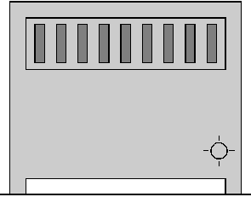

(i) A current of 11A flows when the fan heater is working normally.
Fuses of value 3A, 5A, 10A and 13A are available.
Which one should be used in the plug of the fan heater?
...................................
(1)

(ii) A fault caused a much higher than normal current to flow in the heater.
Describe what happened to the wire in the fuse.
............................................................................................................................
............................................................................................................................
............................................................................................................................
............................................................................................................................
(2)

(b)
You may find this equation useful when answering this part of the question

energy transferred (kWh) = power (kilowatt, kW) × time (hour, h)

(i) The power of the fan heater is 2.75 kW.
Calculate how many kilowatt hours of energy are transferred when the fan heater is used for 6 hours.
............................................................................................................................
............................................................................................................................
............................................................................................................................
Number of kilowatt hours ........................
(2)

(ii) How much will it cost to use the fan heater for 6 hours if one Unit of electricity costs 7p?
............................................................................................................................
............................................................................................................................
Cost ..................... p
(2)
(Total 7 marks)
Q8. In the UK mains electricity is a 230 volt a.c. supply.
(a) What is the frequency of the a.c. mains electricity in the UK?
........................................................................................................................
(1)

(b) (i) What is an electric current?
...............................................................................................................
(1)

(ii) Explain the difference between an a.c. (alternating current) electricity supply and a d.c. (direct current) electricity supply.
...............................................................................................................
...............................................................................................................
...............................................................................................................
...............................................................................................................
(2)

(c) A householder has a 10.8 kW electric shower installed in the bathroom.
(i) Calculate the current drawn from the mains electricity supply by the shower.
Write down the equation you use, and then show clearly how you work out your answer.
...............................................................................................................
...............................................................................................................
...............................................................................................................
...............................................................................................................
Current = .................................... A
(2)

(ii) The table gives the maximum current that can safely pass through electric cables of different cross-sectional area.

Cross-sectional  area  in mm ² | Maximum safe  current  in amps
1.0 | 11.5
2.5 | 20.0
4.0 | 27.0
6.0 | 34.0
10.0 | 46.0
16.0 | 62.0

The existing power sockets in the house are wired to the mains electricity supply using 2.5 mm² cable.
Use the data in the table to explain why the shower must not be connected to the mains electricity supply using 2.5 mm² cable.
...............................................................................................................
...............................................................................................................
...............................................................................................................
...............................................................................................................
(2)

(iii) The circuit connecting the shower to the mains electricity supply must include a residual current circuit breaker (RCCB) and not a fuse.
Give two advantages of using a RCCB to protect a circuit rather than a fuse.
1 ............................................................................................................
...............................................................................................................
2 ............................................................................................................
...............................................................................................................
(2)
(Total 10 marks)
Q9. A set of lights consists of 20 lamps connected in series to the 230 V mains electricity supply.
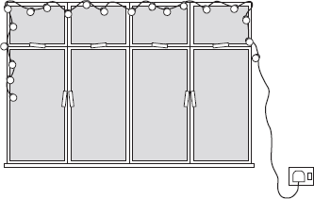
(a) When the lights are switched on and working correctly, the current through each lamp is 0.25 A.
(i) What is the total current drawn from the mains supply?
...............................................................................................................
(1)
(ii) Use the equation in the box to calculate the charge passing through one of the lamps in 5 minutes.

charge = current × time

Show clearly how you work out your answer and give the unit.
...............................................................................................................
...............................................................................................................
...............................................................................................................
Total charge = ..................................................
(3)

(b) One of the lamps in the set is a fuse lamp. This contains a filament which melts if a fault occurs. A short time after the lights are switched on, a fault causes the filament inside the fuse lamp to melt and all the lamps go out.
The householder cannot find another fuse lamp so connects a piece of aluminium foil across the contacts inside the fuse lamp holder.
When switched on, the nineteen remaining lamps work.
What the householder has done is dangerous.
Explain why.
........................................................................................................................
........................................................................................................................
........................................................................................................................
........................................................................................................................
(2)
(Total 6 marks)
Q10. An oscilloscope is connected to an alternating current (a.c.) supply.
The diagram shows the trace produced on the oscilloscope screen.
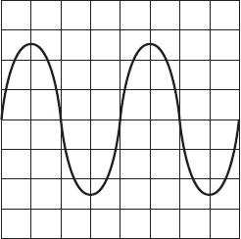
Each horizontal division on the oscilloscope screen represents 0.002 s.
(a) Calculate the frequency of the alternating current supply.
Show clearly how you work out your answer and give the unit.
........................................................................................................................
........................................................................................................................
........................................................................................................................
Frequency = ...........................................................................
(3)

(b) What is the frequency of the a.c. mains electricity supply in the UK?
........................................................................................................................
(1)
(Total 4 marks)

Q11.The diagram shows a transformer with a 50 Hz (a.c.) supply connected to 10 turns of insulated wire wrapped around one side of the iron core.
A voltmeter is connected to 5 turns wrapped around the other side of the iron core.
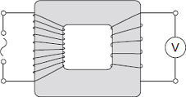

(a) What type of transformer is shown in the diagram?
Draw a ring around the correct answer.

 | step-down | step-up | switch mode

(1)

(b) The table shows values for the potential difference (p.d.) of the supply and the voltmeter reading.

 | p.d. of the supply  in volts | Voltmeter reading  in volts
 | 6.4 | 3.2
 | 3.2
 |  | 6.4

(i) Complete the table.
(2)

(ii) Transformers are used as part of the National Grid.
How are the values of p.d. in the table different to the values produced by the National Grid?
................................................................................................................
................................................................................................................
(1)

(c) Transformers will work with an alternating current (a.c.) supply but will not work with a direct current (d.c.) supply.
(i) Describe the difference between a.c. and d.c.
................................................................................................................
................................................................................................................
................................................................................................................
................................................................................................................
(2)

(ii) Explain how a transformer works.
................................................................................................................
................................................................................................................
................................................................................................................
................................................................................................................
................................................................................................................
................................................................................................................
................................................................................................................
................................................................................................................
(4)
(Total 10 marks)

Q12.Many electrical appliances are connected to the mains supply using a three-core cable and a three-pin plug.
(a) Use the correct answer from the box to complete the sentence.

 | charge | energy | power

Electric current is the rate of flow of .............................................................. .
(1)

(b) The diagram shows a three-pin plug connected to a three-core cable.
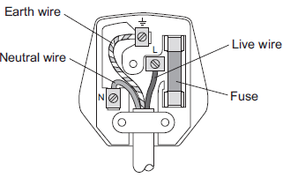
(i) The three wires of the three-core cable have different coloured coverings.
State the colour of the covering of the neutral wire.
..............................................................
(1)

(ii) Which two parts of the plug shown above protect the wiring of a circuit?
Tick () two boxes.

Tick ()
Earth wire
Fuse
Live wire
Neutral wire
(2)

(c) Some electrical appliances are connected to the mains supply using a two-core cable and a three-pin plug. Appliances that are double insulated do not require all three wires.
(i) What does ‘double insulated’ mean?
...............................................................................................................
...............................................................................................................
(1)

(ii) State which of the three wires is not required.
..............................................................
(1)

(d) (i) An electrical appliance is connected to a 20 V supply.
The current in the appliance is 3 A.
Calculate the power of the appliance.
Use the correct equation from Section C of the Physics Equations Sheet.
...............................................................................................................
...............................................................................................................
Power = .................................................. W
(2)

(ii) Another electrical appliance is connected to a 20 V supply.
The appliance transfers 300 J of energy.
Calculate the charge.
Give the unit.
Use the correct equation from Section C of the Physics Equations Sheet.
...............................................................................................................
...............................................................................................................
Charge = ..................................................
Unit .........................
(3)
(Total 11 marks)

Q13.A householder was out shopping when her electricity meter reading should have been taken. The electricity company estimated the reading and sent the following bill. Unfortunately, the bill was damaged in the post.
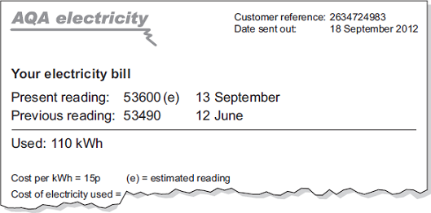
(a) Use the equation in the box to calculate the cost of the electricity used between 12 June and 13 September.

total cost = number of kilowatt-hours x cost per kilowatt-hour

Show clearly how you work out your answer.
........................................................................................................................
........................................................................................................................
Total cost = .............................................................
(2)

(b) The estimated reading shown on the bill was not very accurate. The correct reading was 53782.
How many kilowatt-hours of electricity had the householder actually used between 12 June and 13 September?
........................................................................................................................
........................................................................................................................
(2)
(Total 4 marks)

Q14.The diagram shows a strain gauge, which is an electrical device used to monitor a changing force.
Applying a force to the gauge causes it to stretch.
This makes the electrical resistance of the wire change.

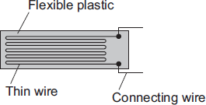

(a) (i) Using the correct symbols, add to the diagram to show how a battery, an ammeter and a voltmeter can be used to find the resistance of the strain gauge drawn above.
(2)

(ii) When in use, the strain gauge is always connected to a d.c. power supply, such as a battery.
How is a d.c. (direct current) power supply different from an a.c. (alternating current) power supply?
...............................................................................................................
...............................................................................................................
...............................................................................................................
(1)

(b) Before any force is applied, the unstretched gauge, correctly connected to a 3.0 V battery, has a current of 0.040 A flowing through it.
(i) Use the equation in the box to calculate the resistance of the unstretched gauge.

potential difference = current × resistance

Show clearly how you work out your answer.
...............................................................................................................
...............................................................................................................
Resistance = ............................................................ Ω
(2)

(ii) Stretching the gauge causes the current flowing through the gauge to decrease.
What happens to the resistance of the gauge when it is stretched?
...............................................................................................................
...............................................................................................................
(1)

(iii) What form of energy is stored in the gauge when a force is applied and the gauge stretches?
...............................................................................................................
(1)
(Total 7 marks)

Q15. (a) Describe the difference between an alternating current (a.c.) and a direct current (d.c.).
.....................................................................................................................................
.....................................................................................................................................
.....................................................................................................................................
.....................................................................................................................................
(2)

(b) The diagram shows the information plate on the bottom of an electric wallpaper steamer.
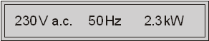

(i) Use the equation in the box to calculate the current used by the steamer.
power = current × potential difference

Show clearly how you work out your answer.
...........................................................................................................................
...........................................................................................................................
Current .............................. A
(2)

(ii) Which one of the following fuses should be used inside the plug of the steamer?
Draw a ring around your answer.
1 A 3 A 5 A 10 A 13 A
(1)
(Total 5 marks)

