P6 Molecules and Matter Exam Question Pack |  | Name: ________________________  Class: ________________________  Date: ________________________
Time: | 61 minutes
Marks: | 61 marks
Comments:

Q1.(a) The diagrams, X, Y and Z, show how the particles are arranged in the three states of matter.
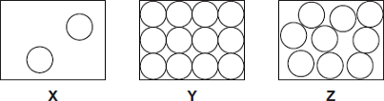
(i) Which one of the diagrams, X, Y or Z, shows the arrangement of particles in a liquid?
Write the correct answer in the box.
(1)

(ii) Which one of the diagrams, X, Y or Z, shows the arrangement of particles in a gas?
Write the correct answer in the box.
(1)

(b) Draw a ring around the correct answer in each box to complete each sentence.

 |  |  | vibrating in fixed positions.
 | (i) | In a gas, the particles are | moving randomly.
 |  |  | not moving.

(1)

 |  |  | stronger than
 | (ii) | In a solid, the forces between the particles are | equal to | the forces between
 |  |  | weaker than

the particles in a liquid.
(1)

(c) The picture shows a puddle of water in a road, after a rain shower.
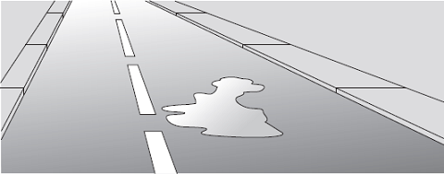
(i) During the day, the puddle of water dries up and disappears. This happens because the water particles move from the puddle into the air.
What process causes water particles to move from the puddle into the air?
Draw a ring around the correct answer.

 | condensation | evaporation | radiation

(1)

(ii) Describe one change in the weather which would cause the puddle of water to dry up faster.
...............................................................................................................
...............................................................................................................
(1)
(Total 6 marks)

Q2.According to kinetic theory, all matter is made up of small particles. The particles are constantly moving.
Diagram 1 shows how the particles may be arranged in a solid.
Diagram 1
(a) One kilogram of a gas has a much larger volume than one kilogram of a solid.
Use kinetic theory to explain why.
........................................................................................................................
........................................................................................................................
........................................................................................................................
........................................................................................................................
........................................................................................................................
........................................................................................................................
........................................................................................................................
........................................................................................................................
........................................................................................................................
........................................................................................................................
(4)

(b) Diagram 2 shows the particles in a liquid. The liquid is evaporating.
Diagram 2
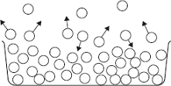
(i) How can you tell from Diagram 2 that the liquid is evaporating?
...............................................................................................................
...............................................................................................................
(1)

(ii) The temperature of the liquid in the container decreases as the liquid evaporates.
Use kinetic theory to explain why.
...............................................................................................................
...............................................................................................................
...............................................................................................................
...............................................................................................................
...............................................................................................................
...............................................................................................................
...............................................................................................................
...............................................................................................................
(3)
(Total 8 marks)

Q3.(a) A company is developing a system which can heat up and melt ice on roads in the winter. This system is called ‘energy storage’.
During the summer, the black surface of the road will heat up in the sunshine.
This energy will be stored in a large amount of soil deep under the road surface.
Pipes will run through the soil. In winter, cold water entering the pipes will be warmed and brought to the surface to melt ice.
The system could work well because the road surface is black.
Suggest why.
........................................................................................................................
........................................................................................................................
(1)

(b) (i) What is meant by specific latent heat of fusion?
...............................................................................................................
...............................................................................................................
...............................................................................................................
...............................................................................................................
(2)

(ii) Calculate the amount of energy required to melt 15 kg of ice at 0 °C.
Specific latent heat of fusion of ice = 3.4 × 10⁵ J/kg.
Use the correct equation from Section B of the Physics Equations Sheet.
...............................................................................................................
...............................................................................................................
Energy = ...................................... J
(2)

(c) Another way to keep roads clear of ice is to spread salt on them.
When salt is added to ice, the melting point of the ice changes.
A student investigated how the melting point of ice varies with the mass of salt added.
The figure below shows the equipment that she used.
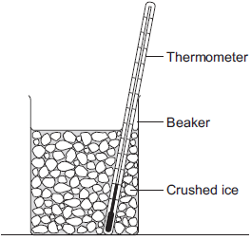
The student added salt to crushed ice and measured the temperature at which the ice melted.
(i) State one variable that the student should have controlled.
...............................................................................................................
...............................................................................................................
(1)

(ii) During the investigation the student stirred the crushed ice.
Suggest two reasons why.
Tick () two boxes.

Tick ()
To raise the melting point of the ice
To lower the melting point of the ice
To distribute the salt throughout the ice
To keep all the ice at the same temperature
To reduce energy transfer from the surroundings to the ice

(2)

(iii) The table below shows the data that the student obtained.

 | Mass of salt added in grams | 0 | 10 | 20
 | Melting point of ice in °C | 0 | -6 | -16

Describe the pattern shown in the table.
...............................................................................................................
...............................................................................................................
(1)

(d) Undersoil electrical heating systems are used in greenhouses. This system could also be used under a road.
A cable just below the ground carries an electric current. One greenhouse system has a power output of 0.50 kW.
Calculate the energy transferred in 2 minutes.
Use the correct equation from Section C of the Physics Equations Sheet.
........................................................................................................................
........................................................................................................................
........................................................................................................................
Energy transferred = ...................................... J
(3)

(e) In this question you will be assessed on using good English, organising information clearly and using specialist terms where appropriate.
A local council wants to keep a particular section of a road clear of ice in the winter.
Describe the advantages and disadvantages of keeping the road clear of ice using:
• energy storage
• salt
• undersoil electrical heating.
........................................................................................................................
........................................................................................................................
........................................................................................................................
........................................................................................................................
........................................................................................................................
........................................................................................................................
........................................................................................................................
........................................................................................................................
........................................................................................................................
........................................................................................................................
........................................................................................................................
........................................................................................................................
Extra space ....................................................................................................
........................................................................................................................
........................................................................................................................
........................................................................................................................
........................................................................................................................
........................................................................................................................
........................................................................................................................
(6)
(Total 18 marks)

Q4.A student investigated the cooling effect of evaporation.
She used the equipment (datalogger and probe) shown in Figure 1 to measure how the temperature of a liquid changed as the liquid evaporated.
Figure 1
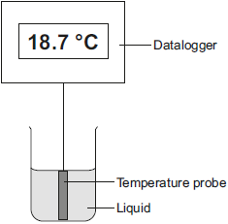
(a) Which type of variable was the temperature in this investigation?
Tick (✔) one box.

Tick (✔)
control
dependent
independent

(1)

(b) Before the investigation started, the student checked the accuracy of three different temperature probes. The student put the probes in a beaker of boiling water that had a temperature of 100.0 °C.
The readings from the three temperature probes are shown in Figure 2.
Figure 2
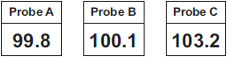

Which one of the temperature probes, A, B or C, was least accurate?
Write the correct answer in the box.
Give a reason for your answer.
.............................................................................................................................
.............................................................................................................................
(2)

(c) Figure 3 shows how the temperature recorded changed during the investigation.
Figure 3
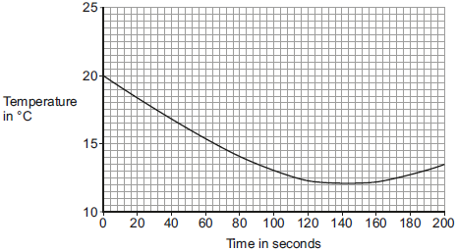
(i) Use Figure 3 to determine the lowest temperature recorded as the liquid evaporated.
Temperature = ............ °C
(1)
(ii) Use Figure 3 to determine how long it took for all the liquid to evaporate.
Give a reason for your answer.
Time = ............... seconds
Reason: ....................................................................................................
...................................................................................................................
(2)
(iii) How would increasing the starting temperature of the liquid above 20 °C affect the rate of evaporation of the liquid?
...................................................................................................................
...................................................................................................................
(1)
(Total 7 marks)

Q5.Two students investigated the change of state of stearic acid from liquid to solid.
They measured how the temperature of stearic acid changed over 5 minutes as it changed from liquid to solid.
Figure 1 shows the different apparatus the two students used.
Figure 1
Student A’s apparatus Student B’s apparatus
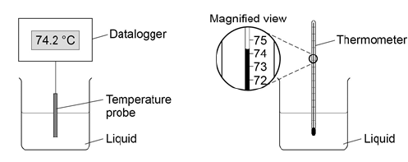
(a) Choose two advantages of using student A’s apparatus.

Tick two boxes.
Student A’s apparatus made sure the test was fair.
Student B’s apparatus only measured categoric variables.
Student A’s measurements had a higher resolution.
Student B was more likely to misread the temperature.

(2)

(b) Student B removed the thermometer from the liquid each time he took a temperature reading.
What type of error would this cause?

Tick one box.
A systematic error
A random error
A zero error

(1)

(c) Student A’s results are shown in Figure 2.
Figure 2

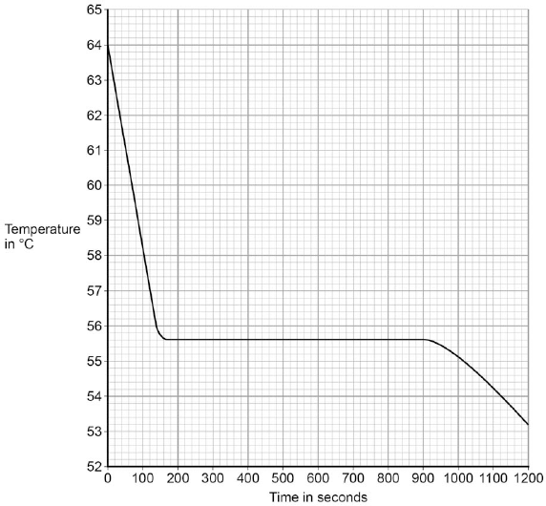

What was the decrease in temperature between 0 and 160 seconds?

Tick one box.
8.2 °C
8.4 °C
53.2 °C
55.6 °C

(1)

(d) Use Figure 2 to determine the time taken for the stearic acid to change from a liquid to a solid.
Time = ........................ seconds
(1)

(e) Calculate the energy transferred to the surroundings as 0.40 kg of stearic acid changed state from liquid to solid.
The specific latent heat of fusion of stearic acid is 199 000 J / kg.
Use the correct equation from the Physics Equations Sheet.
.............................................................................................................................
.............................................................................................................................
.............................................................................................................................
Energy = ......................................... J
(2)

(f) After 1200 seconds the temperature of the stearic acid continued to decrease.
Explain why.
.............................................................................................................................
.............................................................................................................................
.............................................................................................................................
.............................................................................................................................
(2)
(Total 9 marks)

Q6.The figure below shows a balloon filled with helium gas.
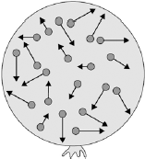
(a) Describe the movement of the particles of helium gas inside the balloon.
.............................................................................................................................
.............................................................................................................................
.............................................................................................................................
.............................................................................................................................
(2)

(b) What name is given to the total kinetic energy and potential energy of all the particles of helium gas in the balloon?

Tick one box.
External energy
Internal energy
Movement energy

(1)

(c) Write down the equation which links density, mass and volume.
.............................................................................................................................
(1)

(d) The helium in the balloon has a mass of 0.00254 kg.
The balloon has a volume of 0.0141 m³.
Calculate the density of helium. Choose the correct unit from the box.

m³ / kg kg / m³ kg m³

.............................................................................................................................
.............................................................................................................................
.............................................................................................................................
.............................................................................................................................
Density = .................................... Unit ..................
(3)
(Total 7 marks)

Q7.A student wants to calculate the density of the two objects shown in the figure below.
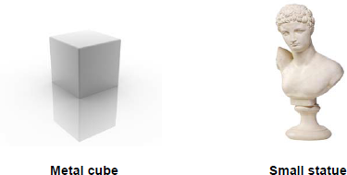
© Whitehoune/iStock/Thinkstock, © Marc Dietrich/Hemera/Thinkstock
Describe the methods that the student should use to calculate the densities of the two objects.
.................................................................................................................................
.................................................................................................................................
.................................................................................................................................
.................................................................................................................................
.................................................................................................................................
.................................................................................................................................
.................................................................................................................................
.................................................................................................................................
(Total 6 marks)

