P7 – Radioactivity Exam Question Pack |  | Name: ________________________  Class: ________________________  Date: ________________________
Time: | 150 minutes
Marks: | 150 marks
Comments:

Q1.(a) The figure below shows a helium atom.
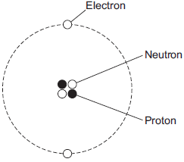
(i) Which one of the particles in the atom is not charged?
Draw a ring around the correct answer.
electron neutron proton
(1)

(ii) Which two types of particle in the atom have the same mass?
................................................... and ....................................................
(1)

(iii) What is the atomic number of a helium atom?
Draw a ring around the correct answer.
2 4 6
Give a reason for your answer.
...............................................................................................................
...............................................................................................................
(2)

(b) Alpha particles are one type of nuclear radiation.
(i) Name one other type of nuclear radiation.
...............................................................................................................
(1)

(ii) Use the correct answer from the box to complete the sentence.

electrons neutrons protons

The difference between an alpha particle and a helium atom is that the alpha particle does not have any .................................................. .
(1)

(iii) Which one of the following is a property of alpha particles?
Tick (✓) one box.
Have a long range in air
Are highly ionising
Will pass through metals

(1)

(c) Doctors may use nuclear radiation to treat certain types of illness.
Treating an illness with radiation may also harm a patient.
(i) Complete the following sentence.
The risk from treating a patient with radiation is that the radiation may
.................................................. healthy body cells.
(1)

(ii) Draw a ring around the correct answer to complete the sentence.
Radiation may be used to treat a patient if the risk from the

 | radiation is | much bigger than  about the same as  much smaller than | the possible benefit of having the treatment.

(1)
(Total 9 marks)

Q2.(a) Sources of background radiation are either natural or man-made.
Which two of the sources listed in the box are natural sources of background radiation?
Draw a ring around each of your answers.

 | cosmic rays | nuclear accidents | X-rays | radon gas

(2)

(b) A teacher used a Geiger-Műller (GM) tube and counter to measure the background radiation in her laboratory. The teacher reset the counter to zero, waited one minute and then took the count reading. The teacher repeated this two more times.
The three readings taken by the teacher are given in the table.

 | 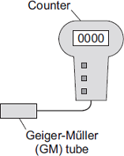 |  | Count
 |  |  | 17
 |  |  | 21
 |  |  | 19

(i) The three readings are different.
What is the most likely reason for this?
Tick ( ) one box.

The teacher did not reset the counter to zero.
Radioactive decay is a random process.
The temperature in the laboratory changed.

(1)

(ii) Calculate the mean (average) value of the three readings given in the table.
...............................................................................................................
Mean (average) value = .................................................. counts
(1)

(iii) The diagram shows how the teacher used the GM tube and counter to measure the radiation emitted from a radioactive source.
The counter was reset to zero. The count after one minute was 159.
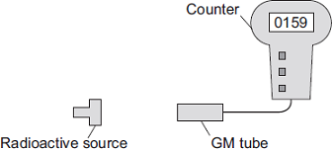
Calculate how many counts were due to the radiation from the radioactive source.
...............................................................................................................
...............................................................................................................
Counts due to the radiation from the radioactive source = ...................
(1)

(iv) The teacher then put a powerful magnet between the radioactive source and the GM tube.
The counter was reset to zero. The number on the counter shows the count after one minute.
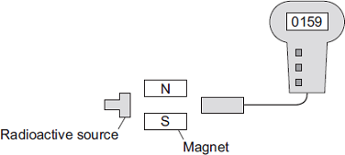
What type of radiation was being emitted from the radioactive source?
Draw a ring around your answer.

 | alpha | beta | gamma

Explain the reason for your answer.
...............................................................................................................
...............................................................................................................
...............................................................................................................
...............................................................................................................
(3)

(c) At the end of the lesson the teacher put the radioactive source back inside its storage box.
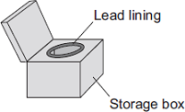
Why is the inside of the box lined with lead?
........................................................................................................................
........................................................................................................................
(1)

(d) Which one of the following questions cannot be answered by scientific study?
Tick ( ) one box.

Where does background radiation come from?
What is meant by the half-life of a radioactive source?
Should radioactive waste be dumped in the oceans?

(1)
(Total 10 marks)

Q3.(a) The names of three types of radiation are given in List A. Some properties of these three types of radiation are given in List B.
Draw one line from each type of radiation in List A to its correct property in List B.
 | List A  Type of radiation |  | List B  Property of radiation
 |  |  | will pass through paper but is stopped by thin metal
 | alpha
 |  |  | has the shortest range in air
 | beta
 |  |  | will not harm human cells
 | gamma
 |  |  | is very weakly ionising

(3)

(b) The radioactive isotope iodine-123 can be used by a doctor to examine the thyroid gland of a patient. The iodine, taken as a tablet, is absorbed by the thyroid gland. The gamma radiation emitted as the iodine atoms decay is detected outside the body.
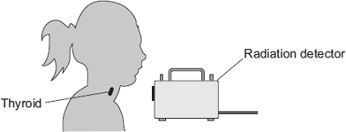
The doctor uses an isotope emitting gamma radiation to examine the thyroid gland rather than an isotope emitting alpha or beta radiation.
Which one of the following gives a reason why gamma radiation is used?
Tick () one box.

Gamma radiation will pass through the body.
Gamma radiation is not deflected by a magnet.
Gamma radiation has a long range in air.

(1)

(c) Iodine-123 has a half-life of 13 hours.
Use a word from the box to complete the sentence.

 | all | half | most

After 13 hours ........................................... of the iodine-123 atoms the thyroid absorbed have decayed.
(1)

(d) Iodine-123 and iodine-131 are two of the isotopes of iodine.
Draw a ring around the correct answer to complete the sentence.

 |  | electrons
 | The nucleus of an iodine-123 atom has the same number of | neutrons | as the
 |  | protons

nucleus of an iodine-131 atom.
(1)
(Total 6 marks)

Q4.(a) Radioactive sources that emit alpha, beta or gamma radiation can be dangerous.
What is a possible risk to health caused by using a radioactive source?
........................................................................................................................
........................................................................................................................
(1)

(b) In an experiment, a teacher put a 2 mm thick lead sheet in front of a radioactive source.
She used a detector and counter to measure the radiation passing through the lead sheet in one minute.
She then put different numbers of lead sheets, each 2 mm thick, in front of the radioactive source and measured the radiation passing through in one minute.
The apparatus the teacher used is shown in Figure 1.
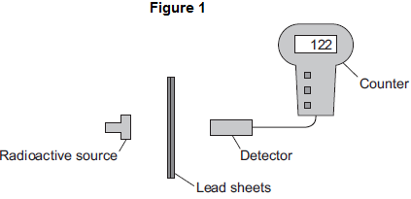
(i) When using a radioactive source in an experiment, how could the teacher reduce the risk to her health?
Suggest one way.
...............................................................................................................
...............................................................................................................
(1)
(ii) The number recorded on the counter is actually higher than the amount of radiation detected from the source.
Complete the following word equation.

 | The number recorded on the counter | = | The amount of radiation detected from the source | + | ..................................... radiation

(1)

(c) The readings taken by the teacher are plotted in Figure 2.
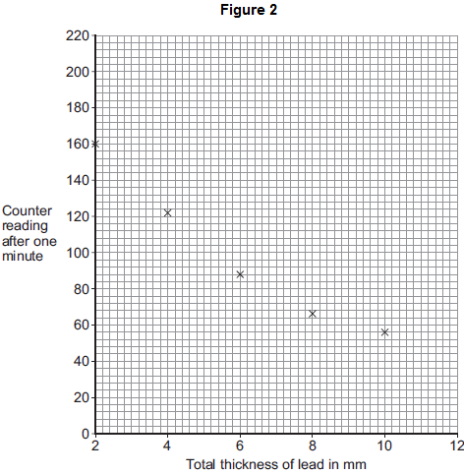
(i) Draw a line of best fit to complete Figure 2.
(1)
(ii) How does the amount of radiation absorbed by the lead change as the total thickness of the lead is increased?
...............................................................................................................
...............................................................................................................
(1)
(iii) Use Figure 2 to estimate the reading on the counter when the total thickness of the lead is increased to 12 mm.
Estimated counter reading = .........................................
(1)

(d) What type of radiation was emitted from the radioactive source?
Draw a ring around the correct answer.

 | alpha | beta | gamma

Give a reason for your answer.
........................................................................................................................
........................................................................................................................
(2)
(Total 8 marks)

Q5. (a) The diagram represents a helium atom.
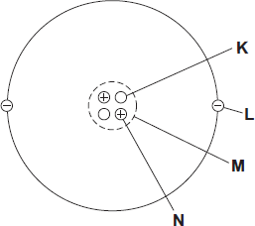
(i) Which part of the atom, K, L, M or N, is an electron?
Part
(1)

(ii) Which part of the atom, K, L, M or N, is the same as an alpha particle?
Part
(1)

(b) A radioactive source emits alpha particles.
What might this source be used for?
Put a tick () in the box next to your answer.

to monitor the thickness of aluminium foil as it is made in a factory

to make a smoke detector work

to inject into a person as a medical tracer

(1)

(c) The graph shows how the count rate from a source of alpha radiation changes with time.
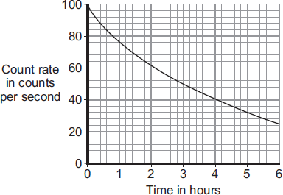
What is the count rate after 4 hours?
............................................. counts per second
(1)
(Total 4 marks)

Q6. (a) The names of the three types of nuclear radiation are given in List A.
Some properties of these types of radiation are given in List B.
Draw a straight line to link each type of radiation in List A to its correct property in List B.
Draw only three lines.

List A  Type of nuclear radiation |  | List B  Property of radiation

Has the same mass as an electron
Alpha
Very strongly ionising
Beta
Passes through 10 cm of aluminium
Gamma
Deflected by a magnetic field but
not deflected by an electric field

(3)

(b) The diagram shows a system used to control the thickness of cardboard as it is made.
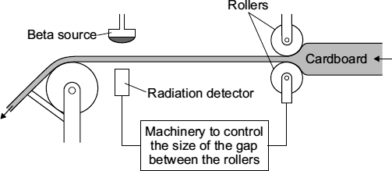
The cardboard passes through a narrow gap between a beta radiation source and a radiation detector.
The table gives the detector readings over 1 hour.

Time | Detector reading
08:00 | 150
08:15 | 148
08:30 | 151
08:45 | 101
09:00 | 149

(i) Between 08:00 and 08:30, the cardboard is produced at the usual, correct thickness.
Explain how you can tell from the detector readings that the cardboard produced at 08:45 is thicker than usual.
...............................................................................................................
...............................................................................................................
...............................................................................................................
...............................................................................................................
(2)

(ii) Which would be the most suitable half-life for the beta source?
Draw a ring around your answer.

six days | six months | six years

(1)

(iii) This control system would not work if the beta radiation source was replaced by an alpha radiation source.
Why not?
...............................................................................................................
...............................................................................................................
(1)
(Total 7 marks)

Q7.The equation below shows the process by which two atomic nuclei join to form a different nucleus.
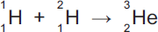
(a) Where does the process shown by the equation above happen naturally?
Tick () one box.

Inside the Earth
Inside a nuclear power station
iroInside the Sun

(1)

(b) Use the correct answer from the box to complete the sentence.

 | fission | force | fusion

The process of joining two atomic nuclei to form a different nucleus is called
nuclear ................................................. .
(1)

(c) What is released during this process?
Draw a ring around the correct answer.

 | charge | energy | force

(1)
(Total 3 marks)

Q8. (a) The diagram represents 3 atoms, K, L and M.
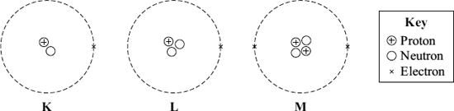
(i) Which two of the atoms are isotopes of the same element?
.................... and ....................
(1)

(ii) Give a reason why the two atoms that you chose in part (a)(i) are:
(1) atoms of the same element ............................................................
...............................................................................................................
(2) different isotopes of the same element. .........................................
...............................................................................................................
...............................................................................................................
(2)

(b) The table gives some information about the radioactive isotope thorium-230.

mass number | 230
atomic number | 90

(i) How many electrons are there in an atom of thorium-230?
..................................................
(1)

(ii) How many neutrons are there in an atom of thorium-230?
..................................................
(1)

(c) When a thorium-230 nucleus decays, it emits radiation and changes into radium-226.
What type of radiation, alpha, beta or gamma, is emitted by thorium-230?
..................................................
Explain the reason for your answer.
........................................................................................................................
........................................................................................................................
........................................................................................................................
........................................................................................................................
........................................................................................................................
(3)
(Total 8 marks)

Q9.Many countries use nuclear power stations to generate electricity.
Nuclear power stations use the process of nuclear fission to release energy.
(a) (i) What is nuclear fission?
...............................................................................................................
...............................................................................................................
(1)
(ii) Plutonium-239 is one substance used as a fuel in a nuclear reactor. For nuclear fission to happen, the nucleus must absorb a particle.
What type of particle must be absorbed?
...............................................................................................................
(1)

(b) Nuclear fusion also releases energy.
Nuclear fusion happens at very high temperatures. A high temperature is needed to overcome the repulsion force between the nuclei.
(i) Why is there a repulsion force between the nuclei of atoms?
...............................................................................................................
...............................................................................................................
(1)
(ii) Where does nuclear fusion happen naturally?
...............................................................................................................
(1)

(c) In 1991, scientists produced the first controlled release of energy from an experimental nuclear fusion reactor. This was achieved by fusing the hydrogen isotopes, deuterium and tritium.
Deuterium is naturally occurring and can easily be extracted from seawater. Tritium can be produced from lithium. Lithium is also found in seawater.
The table gives the energy released from 1 kg of fusion fuel and from 1 kg of fission fuel.

 | Type of fuel | Energy released from  1 kg of fuel in joules
 | Fusion fuel | 3.4 × 10¹⁴
 | Fission fuel | 8.8 × 10¹³

(i) Suggest two advantages of the fuel used in a fusion reactor compared with plutonium and the other substances used as fuel in a fission reactor.
1.............................................................................................................
...............................................................................................................
...............................................................................................................
2.............................................................................................................
...............................................................................................................
...............................................................................................................
(2)
(ii) Some scientists think that by the year 2050 a nuclear fusion power station capable of generating electricity on a large scale will have been developed.
Suggest one important consequence of developing nuclear fusion power stations to generate electricity.
...............................................................................................................
...............................................................................................................
...............................................................................................................
(1)

(d) Tritium is radioactive.
After 36 years, only 10 g of tritium remains from an original sample of 80 g.
Calculate the half-life of tritium.
Show clearly how you work out your answer.
........................................................................................................................
........................................................................................................................
Half-life = .................................... years
(2)
(Total 9 marks)

Q10.The pie chart shows the sources of the background radiation and the radiation doses that the average person in the UK is exposed to in one year.
Radiation dose is measured in millisieverts (mSv).
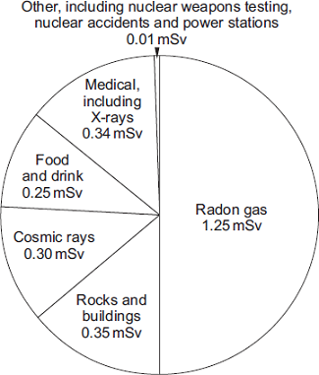
(a) (i) What is the total radiation dose that the average person in the UK receives?
...............................................................................................................
...............................................................................................................
Total radiation dose = .................................................. mSv
(1)

(ii) A student looked at the pie chart and then wrote down three statements.
Which one of the following statements is a correct conclusion from this data?
Put a tick ( ) in the box next to your answer.

In the future, more people will be exposed to a greater proportion of radon gas.
People that have never had an X-ray get
50 % of their radiation dose from radon gas.
The radiation dose from natural sources
is much greater than from artificial sources.

(1)

(b) The concentration of radon gas inside a home can vary from day to day.
The table gives data for the radiation measured in homes in four different parts of the UK. The radiation was measured using two detectors, one in the living room and one in the bedroom. The measurements were taken over 3 months.

 | Area of the UK | Number of homes in the area | Number of homes in the sample | Average radiation  in Bq/m³ | Maximum radiation  in Bq/m³
 | A | 590 000 | 160 | 15 | 81
 | B | 484 000 | 130 | 18 | 92
 | C | 221 000 | 68 000 | 162 | 10 000
 | D | 318 000 | 35 300 | 95 | 6 900

(i) Give one reason why the measurements were taken over 3 months using detectors in different rooms.
...............................................................................................................
...............................................................................................................
(1)

(ii) Use information from the table to suggest why a much higher proportion of homes were sampled in areas C and D than in areas A and B.
...............................................................................................................
...............................................................................................................
...............................................................................................................
(2)
(Total 5 marks)

Q11.A doctor uses the radioactive isotope technetium-99 to find out if a patient’s kidneys are working correctly.
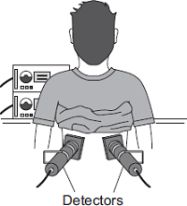
The doctor injects a small amount of technetium-99 into the patient’s bloodstream. Technetium-99 emits gamma radiation.
If the patient’s kidneys are working correctly, the technetium-99 will pass from the bloodstream into the kidneys and then into the patient’s urine.
Detectors are used to measure the radiation emitted from the kidneys.
The level of radiation emitted from each kidney is recorded on a graph.
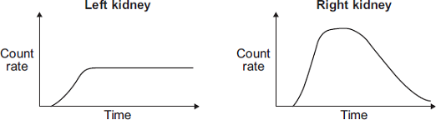
(a) How do the graphs show that technetium-99 is passing from the bloodstream into each kidney?
........................................................................................................................
........................................................................................................................
(1)

(b) By looking at the graphs, the doctor is able to tell if there is a problem with the patient’s kidneys.
Which one of the following statements is correct?
Put a tick ( ) in the box next to your answer.

Only the right kidney is working correctly.
Only the left kidney is working correctly.
Both kidneys are working correctly.

Explain the reason for your answer.
........................................................................................................................
........................................................................................................................
........................................................................................................................
........................................................................................................................
(3)
(Total 4 marks)

Q12. In 1986, a nuclear reactor exploded in a power station at Chernobyl in the Ukraine.
(a) The table gives information about some of the radioactive substances released into the air by the explosion.

Radioactive  substance | Half-life | Type of radiation  emitted
Iodine-131 | 8 days | beta and gamma
Caesium-134 | 2 years | beta
Caesium-137 | 30 years | beta

(i) How is the structure of a caesium-134 atom different from the structure of a caesium-137 atom?
..........................................................................................................................
(1)

(ii) What is a beta particle and from which part of an atom is a beta particle emitted?
..........................................................................................................................
..........................................................................................................................
(1)

(iii) Once a radioactive substance is dissolved in rainwater, it can enter the food chain.
Following the Chernobyl explosion, some milk supplies were found to be radioactive.
If one litre of milk contaminated with iodine-131 gives a count rate of 400 counts/second, how long will it take for the count rate to fall to 25 counts/second?
Show clearly how you work out your answer.
..........................................................................................................................
..........................................................................................................................
..........................................................................................................................
Time taken = ................................................. days
(2)

(iv) After 20 years, the caesium-137 emitted into the atmosphere is a more serious problem than the iodine-131.
Explain why.
..........................................................................................................................
..........................................................................................................................
..........................................................................................................................
..........................................................................................................................
..........................................................................................................................
(2)

(b) The bar chart compares the incidence of thyroid cancer in Ukrainian children, aged 0–14 years, before and after the Chernobyl explosion.
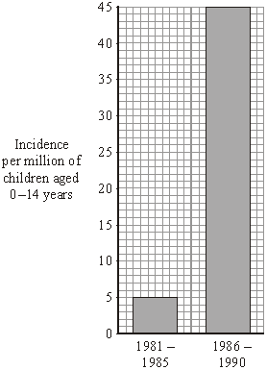
Of the children that developed thyroid cancer, 64% lived in the areas most contaminated by the radiation.

Considering this data, can you be certain that a child who developed thyroid cancer between 1986 and 1990 did so because of the Chernobyl explosion?
Explain the reason for your answer.
....................................................................................................................................
....................................................................................................................................
....................................................................................................................................
....................................................................................................................................
(2)

(c) In 1991, some scientists compared the health of two groups of people: a control group and a group that had been exposed to the radiation from Chernobyl.
What people would have been in the control group?
....................................................................................................................................
(1)

(d) Although there are some risks associated with nuclear power stations, it is likely that new ones will be built.
Give two reasons to justify the use of nuclear power.
1 .................................................................................................................................
....................................................................................................................................
2 .................................................................................................................................
....................................................................................................................................
(2)
(Total 11 marks)

Q13.In 2011 an earthquake caused severe damage to a nuclear power station in Japan.
The damage led to the release of large amounts of radioactive iodine-131 into the atmosphere.
(a) The table gives some information about an atom of iodine-131 .
Complete the table.

 | mass number | 131
 | number of protons | 53
 | number of neutrons

(1)

(b) Complete the sentence.
The number of protons in an atom is called the proton number or
the .............................. number.
(1)

(c) An atom of iodine-131 decays into an atom of xenon (Xe) by emitting a beta particle.
(i) The decay of iodine-131 can be represented by the equation below.
Complete the equation by writing the correct number in each of the two boxes.
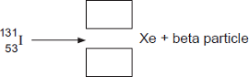
(2)

(ii) A sample of rainwater contaminated with iodine-131 gives a count rate of 1200 counts per second.
Calculate how many days it will take for the count rate from the sample of rainwater to fall to 75 counts per second.
Half-life of iodine-131 = 8 days
Show clearly how you work out your answer.
...............................................................................................................
...............................................................................................................
.............................. days
(2)

(iii) If people drink water contaminated with iodine-131, the iodine-131 builds up in the thyroid gland. This continues until the thyroid is saturated with iodine-131 and cannot absorb any more. The radiation emitted from the iodine-131 could cause cancer of the thyroid.
In Japan, people likely to be drinking water contaminated with iodine-131 were advised to take tablets containing a non-radioactive isotope of iodine.
Suggest why this advice was given.
...............................................................................................................
...............................................................................................................
...............................................................................................................
...............................................................................................................
(2)
(Total 8 marks)

Q14. (a) A radioactive source emits alpha (α), beta (β) and gamma (γ) radiation.
(i) Which two types of radiation will pass through a sheet of card?
...........................................................................................................................
(1)
(ii) Which two types of radiation would be deflected by an electric field?
...........................................................................................................................
(1)
(iii) Which type of radiation has the greatest range in air?
...........................................................................................................................
(1)

(b) A student suggests that the radioactive source should be stored in a freezer at – 20 °C. The student thinks that this would reduce the radiation emitted from the source.
Suggest why the student is wrong.
......................................................................................................................................
......................................................................................................................................
(1)

(c) Phosphorus-32 is a radioactive isotope that emits beta radiation.
(i) How is an atom of phosphorus-32 different from an atom of the stable isotope phosphorus-31?
...........................................................................................................................
...........................................................................................................................
(1)

(ii) The graph shows how the count rate of a sample of phosphorus-32 changes with time.
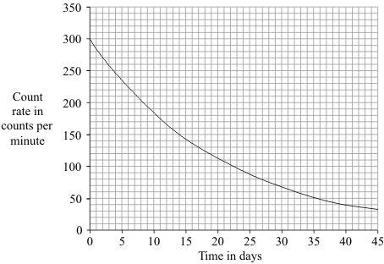
Use the graph to calculate the half-life of phosphorus-32.
Show clearly how you used the graph to obtain your answer.
...........................................................................................................................
...........................................................................................................................
Half-life = ....................................... days
(2)

(iii) Plants use phosphorus compounds to grow. Watering the root system of a plant with a solution containing a phosphorus-32 compound can help scientists to understand the growth process.
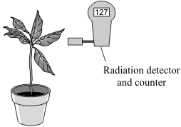
Explain why phosphorus-32 is suitable for use as a tracer in this situation.
...........................................................................................................................
...........................................................................................................................
...........................................................................................................................
...........................................................................................................................
(2)
(Total 9 marks)

Q15. In the early part of the 20th century scientists used the ‘plum pudding’ model to explain the structure of the atom.
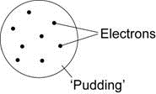

(a) What did scientists think that the ‘pudding’ part of the atom was?
........................................................................................................................
(1)

(b) The scientists Geiger and Marsden devised an experiment to test the ‘plum pudding’ model. They fired positively charged alpha particles at a very thin sheet of gold foil. They then measured the different paths taken by the alpha particles.
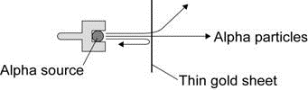

List A gives some of the observations from the experiment. List B gives the conclusions reached from the observations.
Draw one line from each observation in List A to the conclusion reached in List B.
List A List B
Observation Conclusion
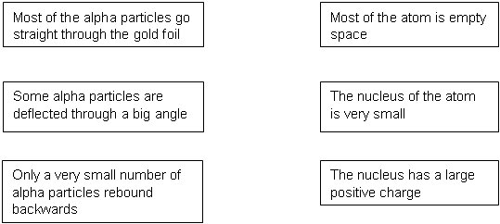
(2)

(c) Following the work of Geiger and Marsden, the ‘plum pudding’ model of the atom was replaced by the ‘nuclear model’ of the atom.
Explain why it is sometimes necessary for scientists to replace a scientific model.
........................................................................................................................
........................................................................................................................
........................................................................................................................
........................................................................................................................
(2)
(Total 5 marks)

Q16.Atoms contain three types of particle.
(a) Draw a ring around the correct answer to complete the sentence.

 | The particles in the nucleus of the atom are | electrons and neutrons.  electrons and protons.  neutrons and protons.

(1)

(b) Complete the table to show the relative charges of the atomic particles.

 | Particle | Relative charge
 | Electron | –1
 | Neutron
 | Proton

(2)

(c) (i) A neutral atom has no overall charge.
Explain this in terms of its particles.
................................................................................................................
................................................................................................................
................................................................................................................
................................................................................................................
(2)

(ii) Complete the sentence.
An atom that loses an electron is called an ..........................................
and has an overall .................................................. charge.
(2)

(d) In this question you will be assessed on using good English, organising information clearly and using specialist terms where appropriate.
Some substances are radioactive. They may emit alpha or beta particles.
Describe the characteristics of alpha particles and beta particles in terms of their:
• structure
• penetration through air and other materials
• deflection in an electric field.
.........................................................................................................................
.........................................................................................................................
.........................................................................................................................
.........................................................................................................................
.........................................................................................................................
.........................................................................................................................
.........................................................................................................................
.........................................................................................................................
.........................................................................................................................
.........................................................................................................................
.........................................................................................................................
.........................................................................................................................
.........................................................................................................................
.........................................................................................................................
.........................................................................................................................
.........................................................................................................................
.........................................................................................................................
.........................................................................................................................
.........................................................................................................................
.........................................................................................................................
(6)
(Total 13 marks)

Q17.Nuclear fission and nuclear fusion are two processes that release energy.
(a) (i) Use the correct answer from the box to complete each sentence.

 | Geiger counter | nuclear reactor | star

Nuclear fission takes place within a ........................................................ .
Nuclear fusion takes place within a ......................................................... .
(2)

(ii) State one way in which the process of nuclear fusion differs from the process of nuclear fission.
................................................................................................................
................................................................................................................
(1)

(b) The following nuclear equation represents the fission of uranium-235 (U-235).

Chemical symbols:
Ba - barium
Kr - krypton
(i) Use the information in the equation to describe the process of nuclear fission.
................................................................................................................
................................................................................................................
................................................................................................................
................................................................................................................
................................................................................................................
................................................................................................................
................................................................................................................
................................................................................................................
(4)

(ii) An isotope of barium is Ba-139.
Ba-139 decays by beta decay to lanthanum-139 (La-139).
Complete the nuclear equation that represents the decay of Ba-139 to La-139.
(3)
(Total 10 marks)

Q18.Different radioactive isotopes have different values of half-life.
(a) What is meant by the ‘half-life’ of a radioactive isotope?
........................................................................................................................
........................................................................................................................
........................................................................................................................
(1)

(b) Figure 1 shows how the count rate from a sample of a radioactive isotope varies with time.
Figure 1
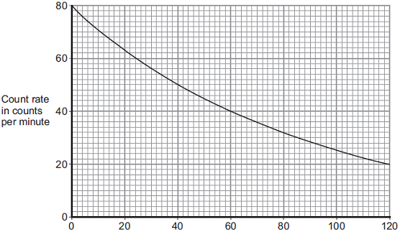
Time in days
Use information from Figure 1 to calculate the half-life of the radioactive isotope.
Show clearly on Figure 1 how you obtain your answer.
Half-life = ...................................... days
(2)

(c) The table below shows data for some radioactive isotopes that are used in schools.

 | Radioactive  isotope | Type of radiation  emitted | Half-life in  years
 | Americium-241 | Alpha and gamma | 460
 | Cobalt-60 | Gamma | 5
 | Radium-226 | Alpha, beta and gamma | 1600
 | Strontium-90 | Beta | 28
 | Thorium-232 | Alpha and beta | 1.4 x 10¹⁰

(i) State which radioactive isotope in the table above emits only radiation that is not deflected by a magnetic field.
Give a reason for your choice.
...............................................................................................................
...............................................................................................................
...............................................................................................................
...............................................................................................................
(2)

(ii) Figure 2 shows a radioactive isotope being used to monitor the thickness of paper during production.
Figure 2
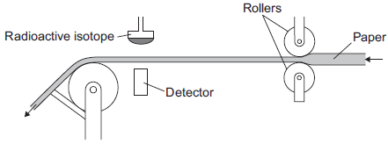
State which radioactive isotope in the table should be used to monitor the thickness of the paper.
Explain your choice.
...............................................................................................................
...............................................................................................................
...............................................................................................................
...............................................................................................................
...............................................................................................................
(3)

All the radioactive isotopes in the table have practical uses.
State which source in the table would need replacing most often.
Explain your choice.
...............................................................................................................
...............................................................................................................
...............................................................................................................
...............................................................................................................
...............................................................................................................
(3)

(iii) When the radioactive isotopes are not in use, they are stored in lead-lined wooden boxes.
The boxes reduce the level of radiation that reaches the surroundings.
Figure 3 shows two of these boxes.
Figure 3
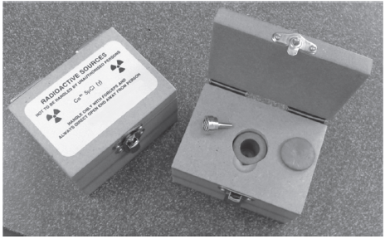
© David McKean
State one source from the table which emits radiation that could penetrate the box.
Explain your answer.
...............................................................................................................
...............................................................................................................
...............................................................................................................
...............................................................................................................
...............................................................................................................
...............................................................................................................
(3)
(Total 14 marks)
Q19.There are many different isotopes of gold. The isotope, gold-198, is radioactive.
An atom of gold-198 decays by emitting a beta particle.
(a) Complete the following sentences.
All atoms of gold have the same number of ................................................................
and the same number of .................................................................... .
The atoms from different isotopes of gold have different numbers of ........................ .
A beta particle is an .................................................................... emitted
from the .................................................................... of an atom.
(3)
(b) The graph shows how the count rate from a sample of gold-198 changes with time.
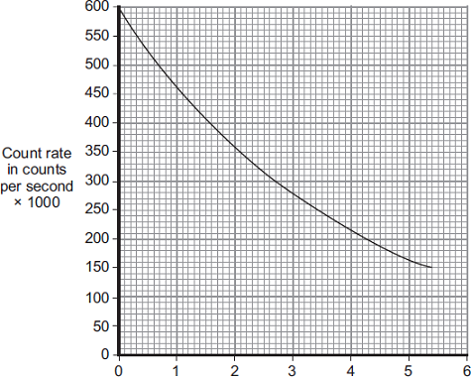
Time in days
Use the graph to calculate the half-life of gold-198.
Show clearly on the graph how you obtain your answer.
........................................................................................................................
........................................................................................................................
Half-life = ............................... days
(2)
(c) The diagram shows a map of a river and the river estuary.
Environmental scientists have found that water flowing into one part of the river estuary is polluted. To find where the pollution is coming from, the scientists use a radioactive isotope, gold-198.
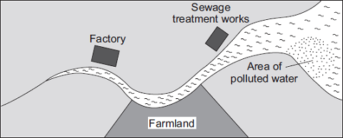
The gold-198 is used to find where the pollution is coming from.
Explain how.
........................................................................................................................
........................................................................................................................
........................................................................................................................
........................................................................................................................
(2)
(Total 7 marks)

