P8 Forces in Balance Exam Question Pack |  | Name: ________________________  Class: ________________________  Date: ________________________
Time: | 142 minutes
Marks: | 142 marks
Comments:

Q1. (a) The diagrams, A, B and C, show the horizontal forces acting on a moving car.
Draw a line to link each diagram to the description of the car’s motion at the moment when the forces act.
Draw only three lines.

stationary
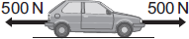
A
constant speed
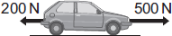
B
slowing down
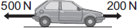
C
accelerating forwards

(3)

(b) The front crumple zone of a car is tested at a road traffic laboratory. This is done by using a remote control device to drive the car into a strong barrier. Electronic sensors are attached to a dummy inside the car.
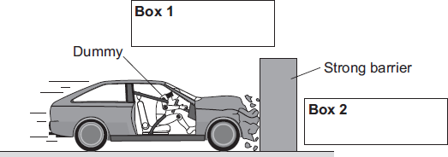
(i) Draw an arrow in Box 1 to show the direction of the force that the car exerts on the barrier.
(1)

(ii) Draw an arrow in Box 2 to show the direction of the force that the barrier exerts on the car.
(1)

(iii) Complete the following by drawing a ring around the correct line in the box.
The car exerts a force of 5000 N on the barrier. The barrier does not move. The force

 | more than
exerted by the barrier on the car will be | equal to | 5000 N.
 | less than

(1)

(iv) Which one of the following gives the most likely reason for attaching electronic sensors to the dummy?
Put a tick () in the box next to your answer.

To measure the speed of the car just before the impact.
To measure the forces exerted on the dummy during the impact.
To measure the distance the car travels during the impact.

(1)
(Total 7 marks)

Q2. Four of the forces that act on this container ship are shown in the diagram as A, B, C and D.
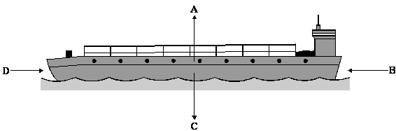

Complete each sentence by choosing the correct letters, A, B, C or D.
The first one has been done for you.
At the start, the ship is not moving because forces B and D are balanced.
The ship begins to move forward when forces ............... and ............... are unbalanced.
When the ship is moving at a steady speed, forces ............... and ............... are balanced.
The ship stops at a port. All of the containers are taken off and this changes
force ............. .
(Total 3 marks)

Q3. The diagram shows the forces acting on a skydiver.
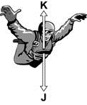

Draw a ring around the correct answer to complete the following sentences.

air resistance.
friction.
gravity.
(a) Force J is caused by

(1)

air resistance.
gravity.
weight.
(b) Force K is caused by

(1)

bigger than
the same as
smaller than
(c) When the skydiver jumps from the aircraft, force J is

accelerates downwards.
accelerates upwards.
falls at a steady speed.
force K and the skydiver

(2)
(Total 4 marks)

Q4.(a) Use the correct answer from the box to complete the sentence.

 | balancing | stretching | turning

A moment is the ................................... effect of a force.
(1)

(b) Figure 1 shows how a lever can be used to lift a heavy rock.
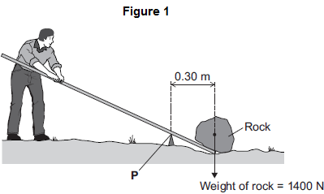
Calculate the moment of the weight of the rock about point P.
Use the correct equation from the Physics Equations Sheet.
........................................................................................................................
........................................................................................................................
Moment = ............................................. newton metres
(2)

(c) Figure 2 shows three positions on the lever, A, B and C, where the person could have applied a force to lift the rock.
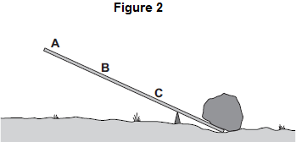
Which position, A, B or C, needs the smallest force to lift the rock?
Draw a ring around the correct answer.

 | A | B | C

Give the reason for your answer.
........................................................................................................................
........................................................................................................................
(2)
(Total 5 marks)

Q5. The centre of mass of an object is where the mass of the object may be thought to be concentrated.
(a) Use a word or phrase from the box to complete the sentence below.

above | below | to the side of

A hanging object will come to rest with its centre of mass directly
............................................................................................ the point from which it hangs.
(1)

(b) The diagram shows the equipment that a student uses to find the centre of mass of a sheet of cardboard.
She intends to draw two lines on the sheet. The centre of mass of the sheet will be where these lines cross.
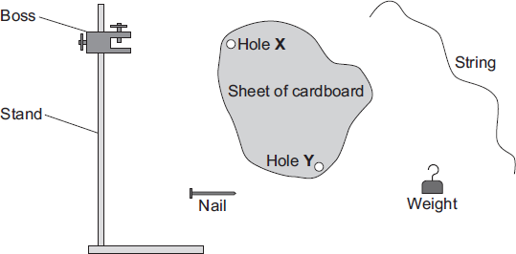
Use words from the box to complete the sentences below.

boss | cardboard | nail | stand | string | weight

The nail is put through hole X in the cardboard sheet. The nail is held in the
......................................................... . The string is tied to the weight and then the other
end of the string is hung from the ..................................................... . A line is drawn on
the cardboard sheet to mark the position of the .................................. . This is repeated
using hole Y.
(3)

(c) The diagram below shows a plastic rectangle.
(i) Use a ruler to draw an axis of symmetry on the rectangle.

(1)

(ii) Draw an X on the diagram so that the centre of the X marks the centre of mass of the rectangle.
(1)
(Total 6 marks)

Q6.(a) Figure 1 shows the horizontal forces acting on a moving bicycle and cyclist.
Figure 1
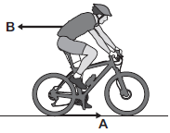
(i) What causes force A?
Draw a ring around the correct answer.
friction gravity weight
(1)

(ii) What causes force B?
...............................................................................................................
(1)

(iii) In this question you will be assessed on using good English, organising information clearly and using specialist terms where appropriate.
Figure 2 shows how the velocity of the cyclist changes during the first part of a journey along a straight and level road. During this part of the journey the force applied by the cyclist to the bicycle pedals is constant.
Figure 2
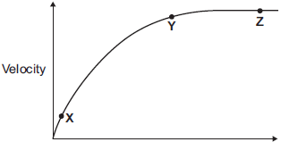
Time
Describe how and explain, in terms of the forces A and B, why the velocity of the cyclist changes:
• between the points X and Y
• and between the points Y and Z, marked on the graph in Figure 2.
...............................................................................................................
...............................................................................................................
...............................................................................................................
...............................................................................................................
...............................................................................................................
...............................................................................................................
...............................................................................................................
...............................................................................................................
...............................................................................................................
...............................................................................................................
...............................................................................................................
...............................................................................................................
Extra space ...........................................................................................
...............................................................................................................
...............................................................................................................
...............................................................................................................
...............................................................................................................
...............................................................................................................
...............................................................................................................
...............................................................................................................
...............................................................................................................
...............................................................................................................
...............................................................................................................
...............................................................................................................
(6)

(b) (i) The cyclist used the brakes to slow down and stop the bicycle.
A constant braking force of 140 N stopped the bicycle in a distance of 24 m.
Calculate the work done by the braking force to stop the bicycle. Give the unit.
Use the correct equation from the Physics Equations Sheet.
...............................................................................................................
...............................................................................................................
...............................................................................................................
Work done = ............................................................
(3)

(ii) Complete the following sentences.
When the brakes are used, the bicycle slows down. The kinetic energy of the
bicycle ............................................................ .
At the same time, the ............................................................ of the brakes increases.
(2)
(Total 13 marks)

Q7.(a) Figure 1 shows a girl standing on a diving board.
Figure 1
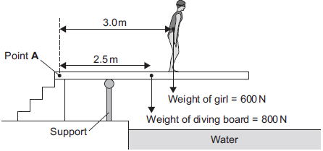
Calculate the total clockwise moment of the weight of the diving board and the weight of the girl about Point A. Give the unit.
Use the correct equation from the Physics Equations Sheet.
........................................................................................................................
........................................................................................................................
........................................................................................................................
........................................................................................................................
........................................................................................................................
........................................................................................................................
........................................................................................................................
Total clockwise moment about Point A = ......................................................
(4)

(b) Figure 2 shows the girl standing at a different place on the diving board.
The support provides an upward force F to keep the diving board balanced.
Figure 2
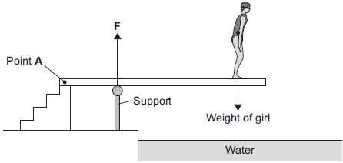
Figure 3 shows how the upward force F varies with the distance of the girl from Point A.
Figure 3
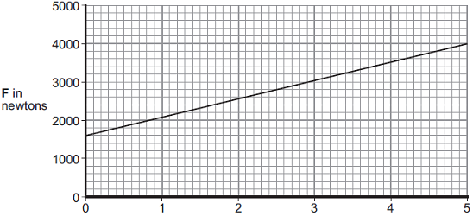
Distance of girl from Point A in metres
Explain, in terms of clockwise and anticlockwise moments, why the upward force F increases as shown in Figure 3.
........................................................................................................................
........................................................................................................................
........................................................................................................................
........................................................................................................................
........................................................................................................................
........................................................................................................................
........................................................................................................................
........................................................................................................................
(3)
(Total 7 marks)

Q8. (a) The diagram shows the horizontal forces acting on a swimmer.
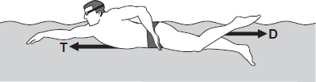
(i) The swimmer is moving at constant speed.
Force T is 120 N.
What is the size of force D?
.................................................. N
(1)

(ii) By increasing force T to 140 N, the swimmer accelerates to a higher speed.
Calculate the size of the initial resultant force acting on the swimmer.
...............................................................................................................
...............................................................................................................
Initial resultant force = .................................................. N
(1)

(iii) Even though the swimmer keeps the force T constant at 140 N, the resultant force on the swimmer decreases to zero.
Explain why.
...............................................................................................................
...............................................................................................................
...............................................................................................................
...............................................................................................................
...............................................................................................................
...............................................................................................................
(3)

(b) A sports scientist investigated how the force exerted by a swimmer’s hands against the water affects the swimmer’s speed.
The investigation involved 20 males and 20 females swimming a fixed distance.
Sensors placed on each swimmer’s hands measured the force 85 times every second over the last 10 metres of the swim.
The measurements were used to calculate an average force.
The average speed of each swimmer over the last 10 metres of the swim was also measured.
The data from the investigation is displayed in the graph.
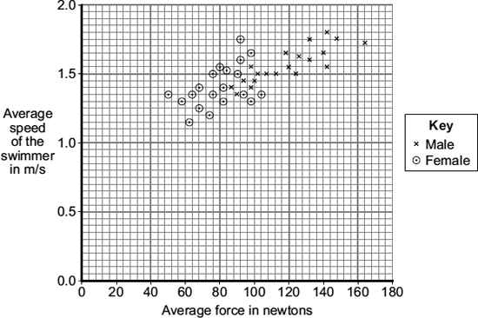
(i) What was the dependent variable in this investigation?
...............................................................................................................
(1)

(ii) Explain one advantage of measuring the force 85 times every second rather than just once or twice every second.
...............................................................................................................
...............................................................................................................
...............................................................................................................
...............................................................................................................
(2)

(iii) Give one way in which the data for the male swimmers is different from the data for the female swimmers.
...............................................................................................................
...............................................................................................................
(1)

(iv) Considering only the data from this investigation, what advice should a swimming coach give to swimmers who want to increase their average speed?
...............................................................................................................
...............................................................................................................
(1)
(Total 10 marks)

Q9. The brick shown in the diagram is being pushed but it is not moving.
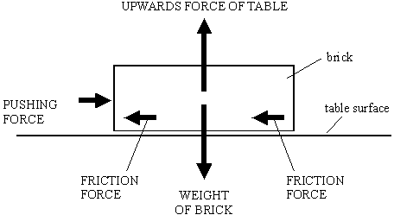

(a) The pushing force does not make the brick move. Explain why.
......................................................................................................................................
(1)

(b) The weight of the brick does not make it move downwards. Explain why.
.....................................................................................................................................
(1)

(c) A bigger pushing force does make the brick slide across the table.
Write down one thing that the sliding brick will do to the surface of the table.
....................................................................................................................................
(1)
(Total 3 marks)

Q10.When two objects interact, they exert forces on each other.
(a) Which statement about the forces is correct?
Tick (✓) one box.
Tick (✓)
The forces are equal in size and act in the same direction.
The forces are unequal in size and act in the same direction.
The forces are equal in size and act in opposite directions.
The forces are unequal in size and act in opposite directions.

(1)

(b) A fisherman pulls a boat towards land.
The forces acting on the boat are shown in Diagram 1.
The fisherman exerts a force of 300 N on the boat.
The sea exerts a resistive force of 250 N on the boat.
Diagram 1

(i) Describe the motion of the boat.
................................................................................................................
................................................................................................................
................................................................................................................
................................................................................................................
(2)

(ii) When the boat reaches land, the resistive force increases to 300 N.
The fisherman continues to exert a force of 300 N.
Describe the motion of the boat.
Tick (✓) one box.
Accelerating to the right
Constant velocity to the right
Stationary

(1)

(iii) Explain your answer to part (b)(ii).
................................................................................................................
................................................................................................................
................................................................................................................
................................................................................................................
(2)

(iv) Another fisherman comes to help pull the boat. Each fisherman pulls with a force of 300 N, as shown in Diagram 2.
Diagram 2 is drawn to scale.
Add to Diagram 2 to show the single force that has the same effect as the two 300 N forces.
Determine the value of this resultant force.
Diagram 2
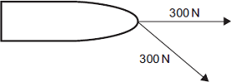
Resultant force = .................................... N
(4)
(Total 10 marks)

Q11. (a) The diagram shows a child’s mobile. The mobile hangs from point P on the ceiling of the child’s bedroom.
(i) Mark the position of the centre of mass of the mobile by drawing a letter X on the diagram. Do this so that the centre of the X marks the centre of mass of the mobile.
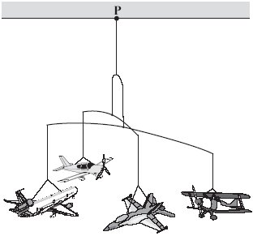
(1)

(ii) Explain why you have chosen this position for your letter X.
...........................................................................................................................
...........................................................................................................................
...........................................................................................................................
...........................................................................................................................
(2)

(b) The diagram shows a device which helps to prevent a ladder from falling over.
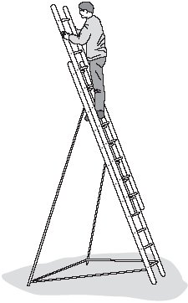
Use the term centre of mass to explain why the ladder, in the situation shown, is unlikely to topple over.
You may add to the diagram to illustrate your explanation.
.....................................................................................................................................
.....................................................................................................................................
.....................................................................................................................................
.....................................................................................................................................
.....................................................................................................................................
.....................................................................................................................................
(3)
(Total 6 marks)

Q12.Before a new bus can be used on the roads, it must pass a stability test.
Figure 1 shows how the bus is tested.
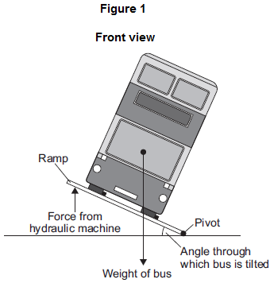
(a) (i) The bus will topple over if the ramp is tilted at too great an angle.
Explain why.
...............................................................................................................
...............................................................................................................
...............................................................................................................
...............................................................................................................
(2)
(ii) The bus is tested to angles of tilt far greater than it would experience in normal use.
Suggest two reasons why.
1.............................................................................................................
...............................................................................................................
2.............................................................................................................
...............................................................................................................
(2)

(b) Figure 2 shows the hydraulic machine that is used to make the ramp tilt.
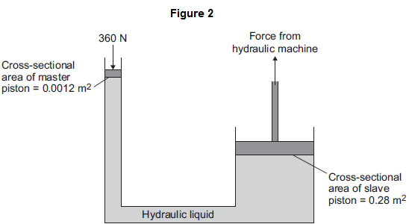
The pressure applied to the hydraulic liquid at the master piston is the same as the pressure applied by the hydraulic liquid to the slave piston.
(i) State the property of the liquid that keeps the pressure at both pistons the same.
...............................................................................................................
(1)

(ii) A 360 N force acts on the master piston.
Use information from Figure 2 to calculate the force applied by the hydraulic liquid to the slave piston.
Use the correct equation from the Physics Equations Sheet
...............................................................................................................
...............................................................................................................
...............................................................................................................
...............................................................................................................
Force = ...................................... N
(3)
(Total 8 marks)

Q13.(a) Figure 1 shows a sheet of card.
Figure 1
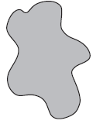
Describe how to find the centre of mass of this sheet of card.
You may draw diagrams as part of your answer.
........................................................................................................................
........................................................................................................................
........................................................................................................................
........................................................................................................................
........................................................................................................................
........................................................................................................................
........................................................................................................................
........................................................................................................................
........................................................................................................................
........................................................................................................................
........................................................................................................................
........................................................................................................................
(5)

(b) Figure 2 shows a person in his wheelchair.
Figure 2
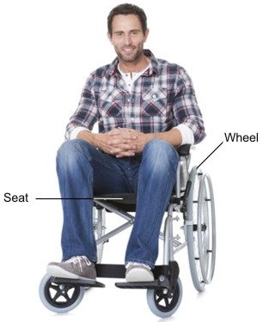
AndreyPopov/iStock/Thinkstock
(i) Tipping the wheelchair at a large angle may cause it to become unstable and to topple over.
Explain why.
...............................................................................................................
...............................................................................................................
...............................................................................................................
...............................................................................................................
...............................................................................................................
(2)

(ii) Some disabled athletes use a wheelchair in sports.
State two ways of changing the design of the wheelchair in Figure 2 so that it is more stable when used by a disabled athlete.
1 .............................................................................................................
...............................................................................................................
2 .............................................................................................................
...............................................................................................................
(2)
(Total 9 marks)

Q14. The diagram shows the horizontal forces acting on a car of mass 1200 kg.
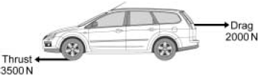

(a) Calculate the acceleration of the car at the instant shown in the diagram.
Write down the equation you use, and then show clearly how you work out your
answer and give the unit.
........................................................................................................................
........................................................................................................................
........................................................................................................................
........................................................................................................................
........................................................................................................................
........................................................................................................................
........................................................................................................................
........................................................................................................................
Acceleration = .............................
(4)

(b) Explain why the car reaches a top speed even though the thrust force remains
constant at 3500 N.
........................................................................................................................
........................................................................................................................
........................................................................................................................
........................................................................................................................
........................................................................................................................
........................................................................................................................
(3)

(c) The diagram shows a car and a van.
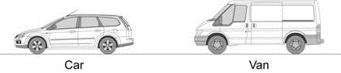
The two vehicles have the same mass and identical engines.
Explain why the top speed of the car is higher than the top speed of the van.
........................................................................................................................
........................................................................................................................
........................................................................................................................
........................................................................................................................
........................................................................................................................
........................................................................................................................
........................................................................................................................
........................................................................................................................
........................................................................................................................
........................................................................................................................
(4)
(Total 11 marks)

Q15. The diagram shows a fork-lift truck with a load of 2.4 kN. The clockwise moment caused by this load is 2880 Nm.
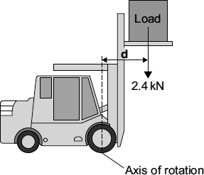
(a) Use the equation in the box to calculate the distance d.

moment = force × | perpendicular distance from the line of  action of the force to the axis of rotation

Show clearly how you work out the answer and give the unit.
........................................................................................................................
........................................................................................................................
........................................................................................................................
Distance d = .......................................................
(3)

(b) This warning notice is in the driver’s cab.
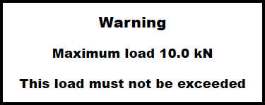
Explain in terms of moments why the maximum load must not be exceeded.
........................................................................................................................
........................................................................................................................
........................................................................................................................
........................................................................................................................
........................................................................................................................
........................................................................................................................
(2)
(Total 5 marks)

Q16. The diagram shows a motorbike of mass 300 kg being ridden along a straight road.
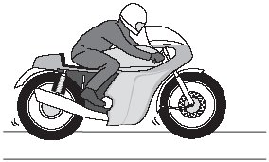
The rider sees a traffic queue ahead. He applies the brakes and reduces the speed of the motorbike from 18 m/s to 3 m/s.

(a) Use the equation in the box to calculate the kinetic energy lost by the motorbike.

kinetic energy = × mass × speed²

Show clearly how you work out your answer.
.....................................................................................................................................
.....................................................................................................................................
.....................................................................................................................................
.....................................................................................................................................
Kinetic energy lost = ............................................................ J
(2)

(b) (i) How much work is done on the motorbike by the braking force?
...........................................................................................................................
(1)
(ii) What happens to the kinetic energy lost by the motorbike?
...........................................................................................................................
(1)
(Total 4 marks)

Q17.The diagram shows a design for a crane. The crane is controlled by a computer.
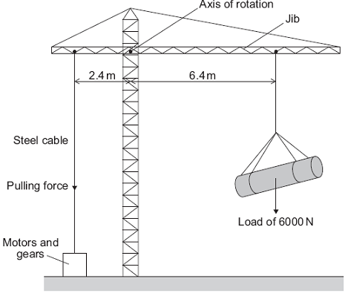
The purpose of the motors and gears is to change the pulling force in the steel cable.
This is done so that the jib stays horizontal whatever the size of the load or the position of the load.
Use the equation in the box to answer questions (a) and (b).

 | moment = force | x | perpendicular distance from the line of action of the force to the axis of rotation

(a) Calculate the moment caused by the load in the position shown in the diagram.
Show clearly how you work out your answer and give the unit.
........................................................................................................................
........................................................................................................................
Moment = ........................................................................
(3)

(b) Calculate the pulling force that is needed in the steel cable to keep the jib horizontal.
Show clearly how you work out your answer.
........................................................................................................................
........................................................................................................................
Pulling force = .................................................. N
(2)
(Total 5 marks)

Q18.Forces have different effects.
(a) (i) Use the correct answer from the box to complete the sentence.

 | slowing | stretching | turning

The moment of a force is the ............................................................... effect of the force.
(1)

(ii) What is meant by the centre of mass of an object?
................................................................................................................
................................................................................................................
(1)

(b) Some children build a see-saw using a plank of wood and a pivot.
The centre of mass of the plank is above the pivot.
Figure 1 shows a boy sitting on the see-saw. His weight is 400 N.

Figure 1
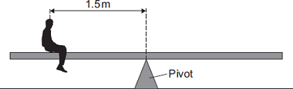

Calculate the anticlockwise moment of the boy in Nm.
Use the correct equation from Section A of the Physics Equations Sheet.
.........................................................................................................................
.........................................................................................................................
Anticlockwise moment = ........................................ Nm
(2)

(c) Figure 2 shows a girl sitting at the opposite end of the see-saw. Her weight is 300 N.

Figure 2
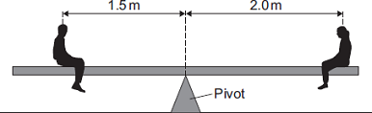

The see-saw is now balanced.
The children move the plank. Its centre of mass, M, is now 0.25 m from the pivot as shown in Figure 3.
Figure 3
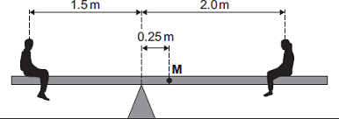

The boy and girl sit on the see-saw as shown in Figure 3.
(i) Describe and explain the rotation of the see-saw.
................................................................................................................
................................................................................................................
................................................................................................................
................................................................................................................
................................................................................................................
................................................................................................................
................................................................................................................
(3)

(ii) The boy gets off the see-saw and a bigger boy gets on it in the same place. The girl stays in the position shown in Figure 3. The plank is balanced. The weight of the plank is 270 N.
Calculate the weight of the bigger boy.
................................................................................................................
................................................................................................................
................................................................................................................
................................................................................................................
................................................................................................................
................................................................................................................
Weight of the bigger boy = ........................................ N
(3)
(Total 10 marks)

Q19.A student carries out an investigation using a metre rule as a pendulum.
(a) Diagram 1 shows a metre rule.
Diagram 1
(i) Draw, on Diagram 1, an X to show the position of the centre of mass of the rule.
(1)

(ii) State what is meant by the ‘centre of mass of an object’.
................................................................................................................
................................................................................................................
(1)

(b) The student taped a 100 g mass to a metre rule.
She set up the apparatus as shown in Diagram 2.
She suspended the metre rule from a nail through a hole close to one end, so she could use the metre rule as a pendulum.
The distance d is the distance between the nail and the 100 g mass.
Diagram 2
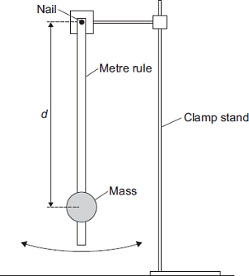
(i) Draw, on Diagram 2, a Y to show a possible position of the centre of mass of the pendulum.
(1)

(ii) The student carried out an investigation to find out how the time period of the pendulum varies with d.
Some of her results are shown in the table.

 |  | Time for 10 swings in seconds
 | d in cm | First  test | Second  test | Third  test | Mean  value | Mean time for  1 swing in  seconds
 | 10.0 | 15.3 | 15.4 | 15.5 | 15.4 | 1.54
 | 30.0 | 14.7 | 14.6 | 14.7 | 14.7 | 1.47
 | 50.0 | 15.3 | 15.6 | 15.4 | 15.4 | 1.54
 | 70.0 | 16.5 | 16.6 | 16.5

Complete the table.
You may use the space below to show your working.
................................................................................................................
................................................................................................................
(3)

(iii) In this question you will be assessed on using good English, organising information clearly and using specialist terms where appropriate.
Describe how the student would carry out the investigation to get the results in the table in part (ii).
You should include:
• any other apparatus required
• how she should use the apparatus
• how she could make it a fair test
• a risk assessment
• how she could make her results as accurate as possible.
................................................................................................................
................................................................................................................
................................................................................................................
................................................................................................................
................................................................................................................
................................................................................................................
................................................................................................................
................................................................................................................
................................................................................................................
................................................................................................................
................................................................................................................
................................................................................................................
................................................................................................................
................................................................................................................
................................................................................................................
................................................................................................................
................................................................................................................
................................................................................................................
(6)

(c) A graph of the student’s results is shown below.
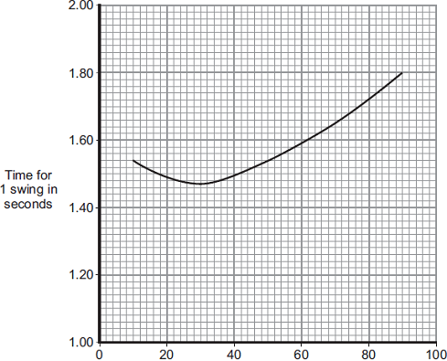
Distance d in cm
(i) Describe the pattern shown by the graph.
................................................................................................................
................................................................................................................
................................................................................................................
(2)
(ii) The student thinks that the measurements of time for d = 10 cm might be anomalous, so she takes a fourth measurement.
Her four measurements are shown below.

 | 15.3 s | 15.4 s | 15.5 s | 15.3 s
State whether you consider any of these measurements to be anomalous.
Justify your answer.
................................................................................................................
................................................................................................................
................................................................................................................
(2)
(Total 16 marks)

